# Introduction and narrative

* Data narrative and contextualising results

# Visualisation Design

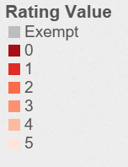Throughout each of the different visualisations some design choices bridge these into a cohesive whole. This meant keeping fonts and other thematic elements constant. This is especially important for colour.

Each visualisation is coloured based on its rating scale, exemption status is not on the scale of good to bad so grey value was chosen to clearly articulate this. The other colours were chosen using the tool colorbrewer2.org. This generates differentiable colour palettes with options to be colour blind friendly. A scale from neutral colour to red was chosen as a high rating is the expected value for the viewer so the colour scale is used to bring attention to the low ratings, and red has negative associations (at least for Western audiences).

Figure 1 Colour Scale used throughout each visualisation. (Source colorbrewer2.org sequential Reds n = 6)

### Map

### Ratings within each postcode

This visualisation displays the distribution or ratings within each postcode. As such there are three main chart types to consider; stacked bar charts with (a) absolute or (b) percentage distribution and (c) pie charts. The distribution of ratings is the most important thing to communicate, therefore percentage distributions of (a) and (c) convey this better. Pie charts have the advantage that they can still communicate some of the absolute value information through their size and have the clearest percentage distributions of the three. The negative of pie charts here is that not all the values can be legibly recorded on one axis, however as the figure shows bar charts attempting to do this are also too messy. In both cases this is fine in the context of the narrative because this visualisation is primarily used to highlight the most important distributions (especially after drilling down through filtering) therefore the user isn’t looking for a picture of the entire set of postcodes.

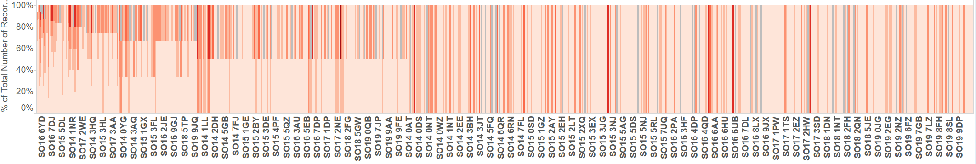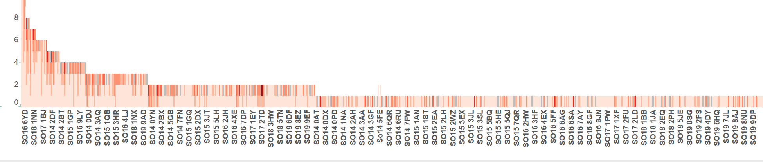

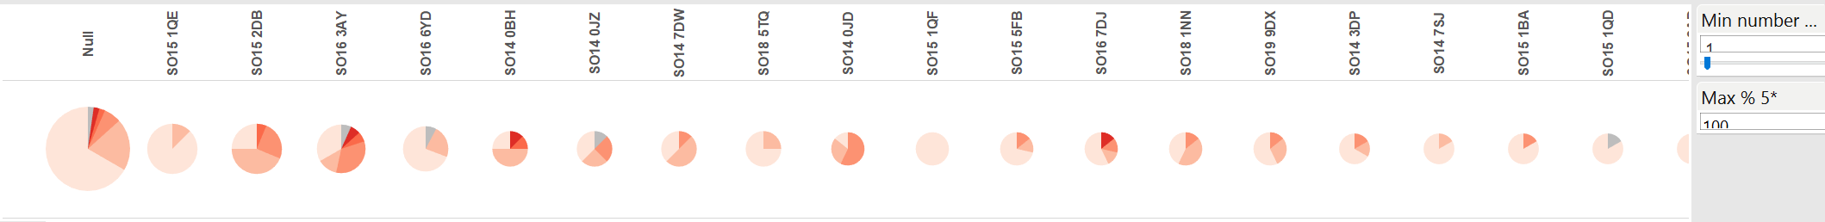

To produce a filter by number of entries in postcode and maximum percentage of 5 ratings unique parameters were made so the user can alter the values with a sliding scale and calculated measures “Percentage of Postcode” and “PoP R5” were made to compute the percentage of each postcode that was rating 5. These were then passed to a filter by formula. Which yielded the 5 postcodes below.

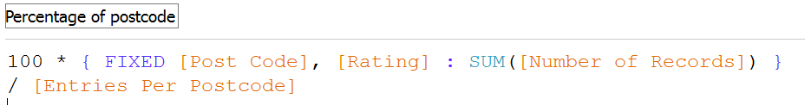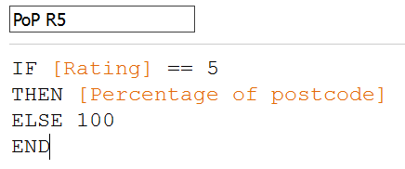

Figure

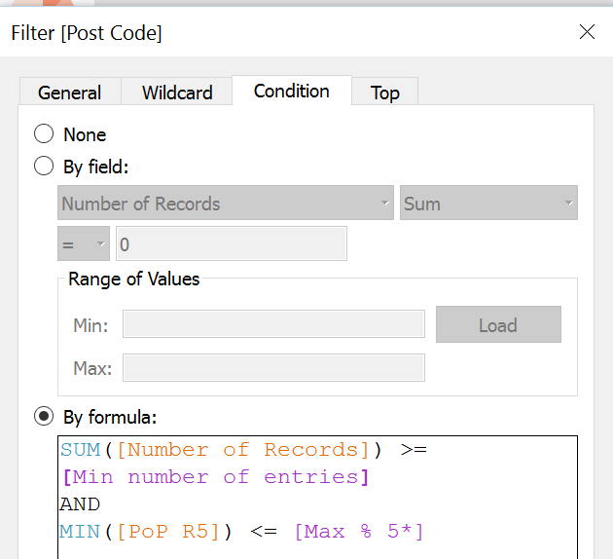

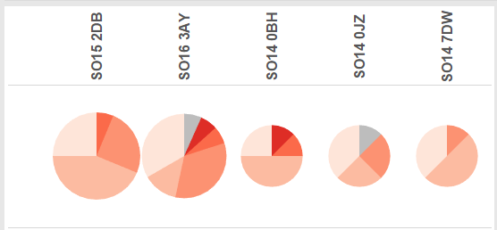

### Breakdown of Business Types

This chart was built to describe the breakdown of business types within each star rating. Bar charts are well suited to display numerical values against a categorical variable. Displaying percentage of star rating as the measure focuses the user attention on the distribution changes rather than which ratings are numerically larger than others. However as we want this information to still be available they are displayed as labels and on the tooltip.

A grouped bar chart was chosen because the number of businesses is high, this makes it difficult to interpret stack bar charts and pie charts. The chart was grouped by star rating rather than business type because the chart is trying to show distribution **within** star ratings rather than within businesses. Colouring the star ratings helps separate these groups to the viewer and have them compare the distributions separately.

Ideally business types with zero recorded values would still be present in the chart, this consistency helps compare the change in distribution from one rating category to the next and clearly communicates that there are 0 recorded values rather than missing data. However this feature is very difficult to achieve as neither the “show missing values” nor “show empty columns / rows feature” enabled this.

To allow users to drill down on one of the ratings a “filter rating” action filter was built into the tooltip. Showing only one rating makes it easier to view the distribution of the rating. Previously we noted the decision to group colour by rating rather than business type. It is still important for distribution within business type to be available to the viewer if not the focus so an action filter was used to highlight all like businesses on selection of one column. This was extended as a linked filter for the dashboard as it is intuitive that clicking on the name of a business type should filter all values of that business. No new information is accessed this way (not gated behind buttons) but only highlights different aspects of the data to the user. This is especially important because the combination of filter actions and linked filtering in the dashboard could overwhelm and confuse users.

Figure 3 Breakdown of business types within each star rating

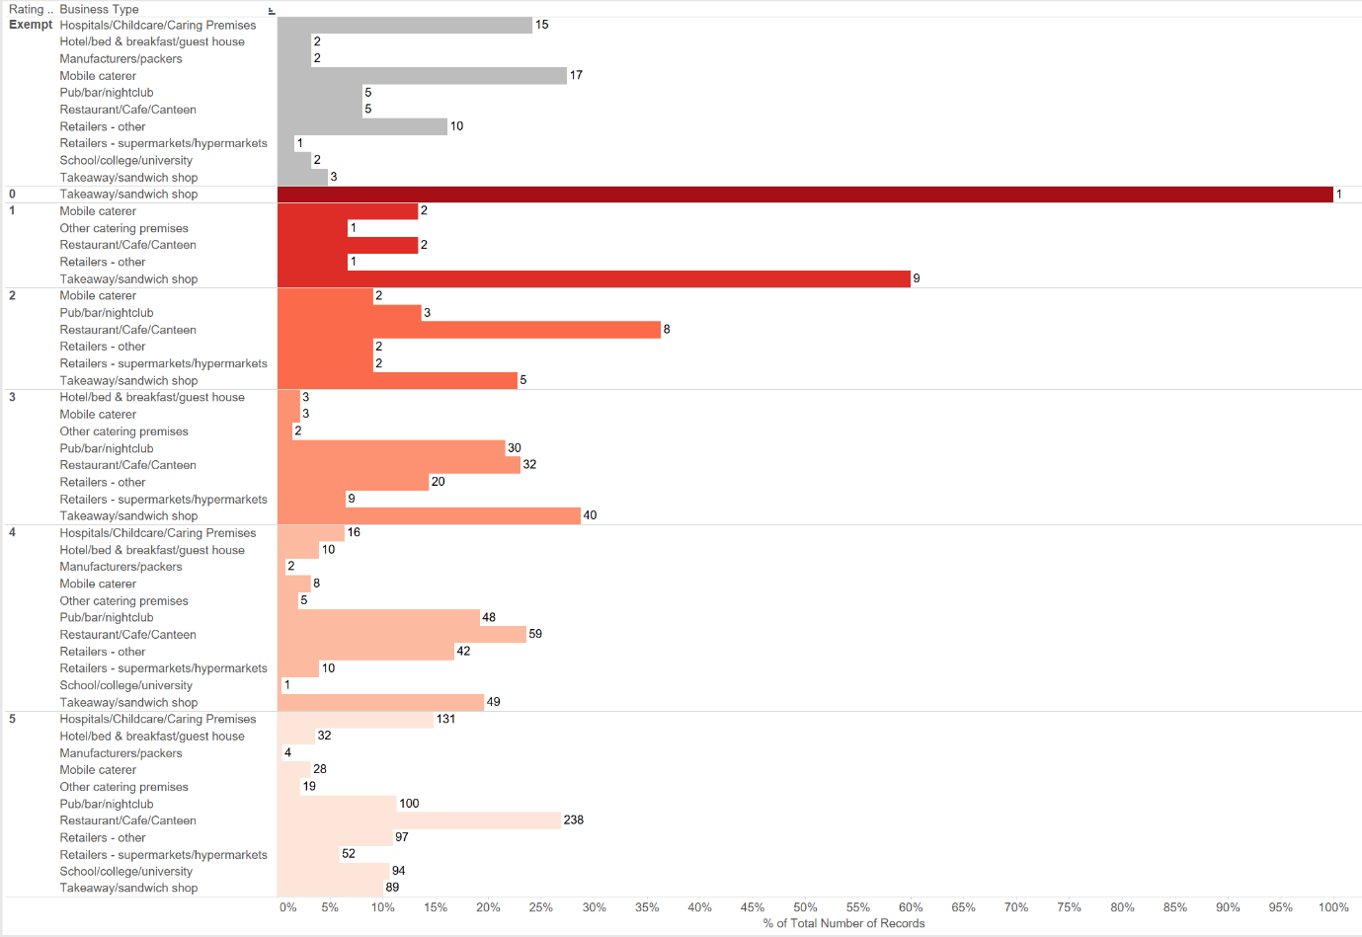

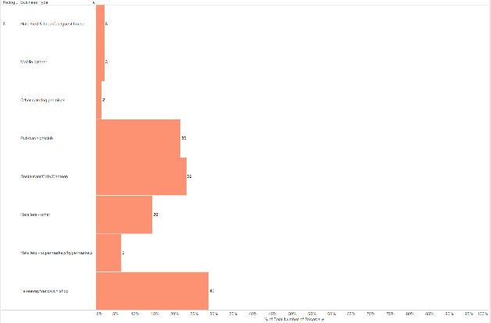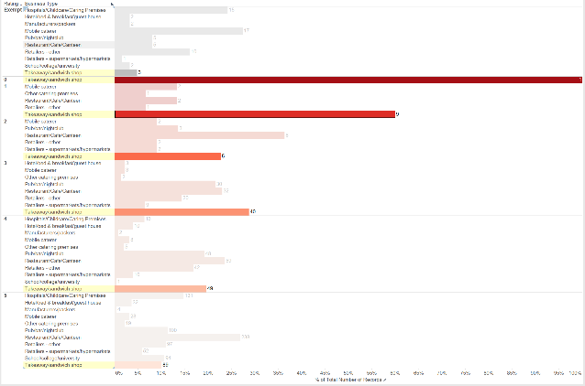

Figure 4 Quality filtering option (accessed through tooltip). Shows distribution of one quality value larger and clearer to read.

Figure 5 Selection highlighting distribution of ratings within a business type.

### Dashboard

**Layout – map bigger because it is where we want to focus the viewer (drill down narrative, see map, interact with it and look at other visualisations to drill down)**

Linked filtering has been used so that highlighting in one chart filters the others. This follows the filtering described in the sections above such that business types can be filtered using the right hand chart, postcodes and ratings within postcodes can be filtered using the bottom chart and custom areas can be filtered using the map. Aside from this, individual selection in the map has been changed to filter based on that entire postcode to limit single business selection which is meaningless for the other two visualisations.

# References

Colorbrewer2

Post confirming how difficult it is to wrap along one dimension