Bayes Classifier: for different covariance matrices, the algebra will be:
$$P\left[ω_{1} | \underline{x}\right]≶P\left[ω_{2} | \underline{x}\right] → \frac{1}{{\left(2π\right)}^{\frac{p}{2}}{\left(\det\left(C_{1}\right)\right)}^{\frac{1}{2}}}exp\left\{(-\frac{1}{2}{\left(\underline{x}-{\underline{m}}_{1}\right)}^{t}{C_{1}}^{-1}(\underline{x}-{\underline{m}}_{1})\right\}P\left[ω_{1}\right]≶\frac{1}{{\left(2π\right)}^{\frac{p}{2}}{\left(\det\left(C_{2}\right)\right)}^{\frac{1}{2}}}exp\left\{(-\frac{1}{2}{\left(\underline{x}-{\underline{m}}_{2}\right)}^{t}{C_{2}}^{-1}(\underline{x}-{\underline{m}}_{2})\right\}P\left[ω_{2}\right]$$
Cancelling terms and taking logarithms and taking into account that in this case $P\left[ω_{1}\right]=P\left[ω_{2}\right]$:
$$-\frac{1}{2}{\left(\underline{x}-{\underline{m}}_{1}\right)}^{t}{C_{1}}^{-1}\left(\underline{x}-{\underline{m}}_{1}\right)≶-\frac{1}{2}{\left(\underline{x}-{\underline{m}}_{2}\right)}^{t}{C_{2}}^{-1}\left(\underline{x}-{\underline{m}}_{2}\right)+\frac{1}{2}log{\frac{\det\left(C_{1}\right)}{\det\left(C_{2}\right)}}=$$
$${\left(\underline{x}-{\underline{m}}_{1}\right)}^{t}{C_{1}}^{-1}\left(\underline{x}-{\underline{m}}_{1}\right)≶{\left(\underline{x}-{\underline{m}}_{2}\right)}^{t}{C_{2}}^{-1}\left(\underline{x}-{\underline{m}}_{2}\right)-\log{\frac{\det\left(C_{1}\right)}{\det\left(C_{2}\right)}}$$
We can see directly that the 2nd order terms don’t cancel as we have not equal covariance matrices, so in this case the Bayes classifier is not going to be a line, so it is going to be:
$${\underline{x}}^{t}A\underline{x}+b\underline{x}+c≶0$$
$$A={C_{1}}^{-1}-{C_{2}}^{-1} b=2\left[{C_{2}}^{-1}m_{2}-{C_{1}}^{-1}m_{1}\right]$$
$$c=\left({m_{1}}^{t}{C_{1}}^{-1}m_{1}-{m_{2}}^{t}{C_{2}}^{-1}m_{2}\right)+\log{\frac{\det\left(C_{1}\right)}{\det\left(C_{2}\right)}}$$
If we compute these parameters the resulting plot is the quadratic classifier shown as black line in FIG, that matches with the 2nd order function expected.
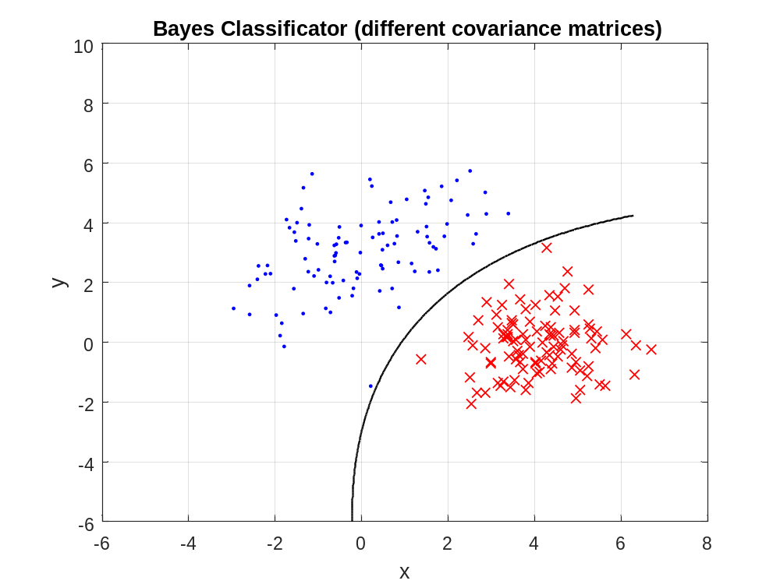
--------------------------------------------------------------------------------------------------------------------------------------------------
Posterior Probability
$$P\left[ω_{1} | \underline{x}\right]=\frac{P\left({\underline{x}|ω}_{1}\right)P\left[ω_{1}\right]}{P\left({\underline{x}|ω}_{1}\right)P\left[ω_{1}\right]+P\left({\underline{x}|ω}_{2}\right)P\left[ω_{2}\right]}=\frac{1}{1+\frac{P\left({\underline{x}|ω}_{2}\right)P\left[ω_{2}\right]}{P\left({\underline{x}|ω}_{1}\right)P\left[ω_{1}\right]}}=\frac{1}{1+\frac{\frac{1}{{(2π)}^{p/2}{(det⁡(C_{2}))}^{1/2}}exp\left\{(-\frac{1}{2}{\left(\underline{x}-{\underline{m}}_{2}\right)}^{t}{C_{2}}^{-1}(\underline{x}-{\underline{m}}_{2})\right\}P\left[ω_{2}\right]}{\frac{1}{{(2π)}^{p/2}{(det⁡(C_{1}))}^{1/2}}exp\left\{-\frac{1}{2}{\left(\underline{x}-{\underline{m}}_{1}\right)}^{t}{C_{1}}^{-1}(\underline{x}-{\underline{m}}_{1})\right\}P\left[ω_{1}\right]}}$$
And since $P\left[ω_{1}\right]=P\left[ω_{2}\right]=100/200$:
$$P\left[ω_{1} | \underline{x}\right]=\frac{1}{1+\left[{\left(\frac{\det\left(C_{1}\right)}{\det\left(C_{2}\right)}\right)}^{1/2}·\frac{exp\left\{\left(-\frac{1}{2}\right){\left(\underline{x}-{\underline{m}}_{2}\right)}^{t}{C_{2}}^{-1}\left(\underline{x}-{\underline{m}}_{2}\right)\right\}}{exp\left\{\left(-\frac{1}{2}\right){\left(\underline{x}-{\underline{m}}_{1}\right)}^{t}{C_{1}}^{-1}\left(\underline{x}-{\underline{m}}_{1}\right)\right\}}\right]}$$
$$=\frac{1}{1+\left[{\left(\frac{\det\left(C_{1}\right)}{\det\left(C_{2}\right)}\right)}^{1/2}·exp\left\{-\frac{1}{2}\left[{\left(\underline{x}-{\underline{m}}_{2}\right)}^{t}{C_{2}}^{-1}(\underline{x}-{\underline{m}}_{2})-{\left(\underline{x}-{\underline{m}}_{1}\right)}^{t}{C_{2}}^{-1}(\underline{x}-{\underline{m}}_{1})\right]\right\}\right]}$$
$$P\left[ω_{1} | \underline{x}\right]=\frac{1}{1+\left[{\left(\frac{\det\left(C_{1}\right)}{\det\left(C_{2}\right)}\right)}^{1/2}·exp\left\{-\frac{1}{2}\left({\underline{x}}^{t}A\underline{x}+b\underline{x}+c\right)\right\}\right]}$$
$$A={C_{1}}^{-1}-{C_{2}}^{-1} b=2\left[{C_{2}}^{-1}m_{2}-{C_{1}}^{-1}m_{1}\right]$$
$$c=\left({m_{1}}^{t}{C_{1}}^{-1}m_{1}-{m_{2}}^{t}{C_{2}}^{-1}m_{2}\right)+\log{\frac{\det\left(C_{1}\right)}{\det\left(C_{2}\right)}}$$
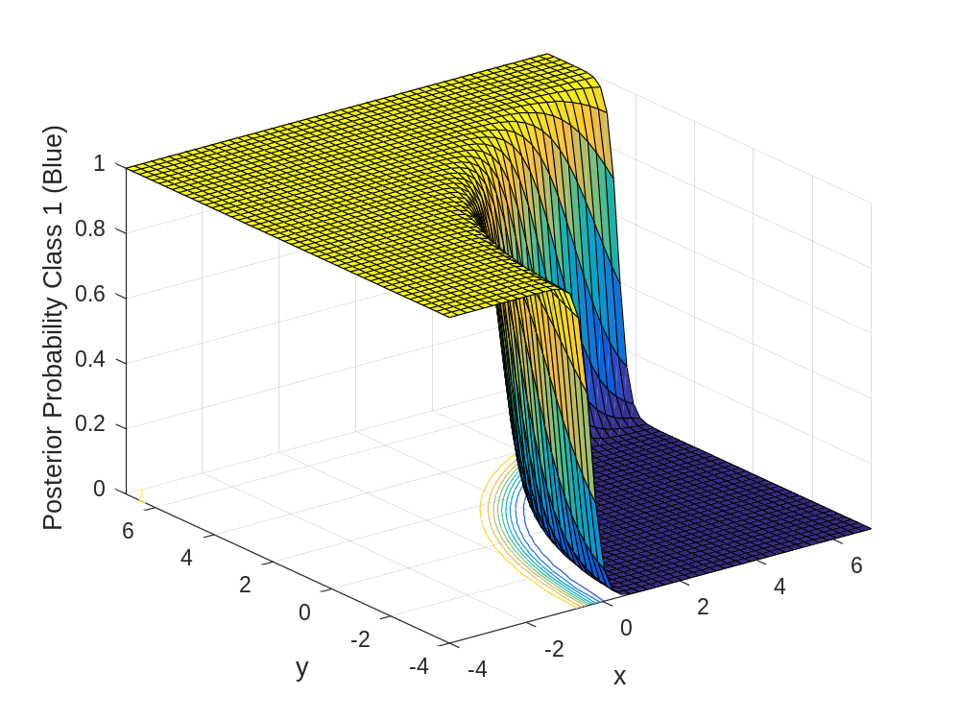

Bayes Classifier using Neural Networks
We are going to train a feedforward network (with 20 hidden functions) giving it as input the data of the two classes and as output the classification corresponding to each point (+1 for blue dots and -1 for red crossers).
The network itself splits the sample
When we compute this trained network the input could be any point in the grid and the output is the predicted classification.
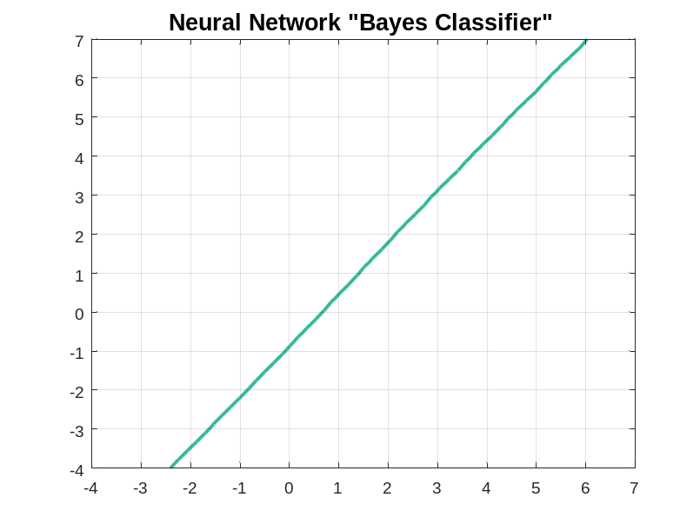
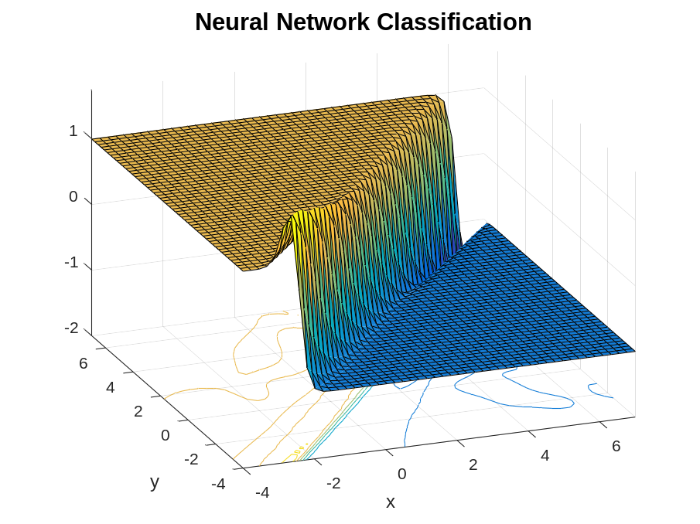
Figure: The result of this classification depends on the samples chosen randomly by the system to train and test the network. The best result given by the network is a linear classifier, as there are parts of the grid with no points to train it.
%%%%%%%%so the classification there is a “guess”.
If we increase the size of the network, it overfits and tries to classify each point given to train it, in addition it “guesses” the classification of the places where we had no points to train it:
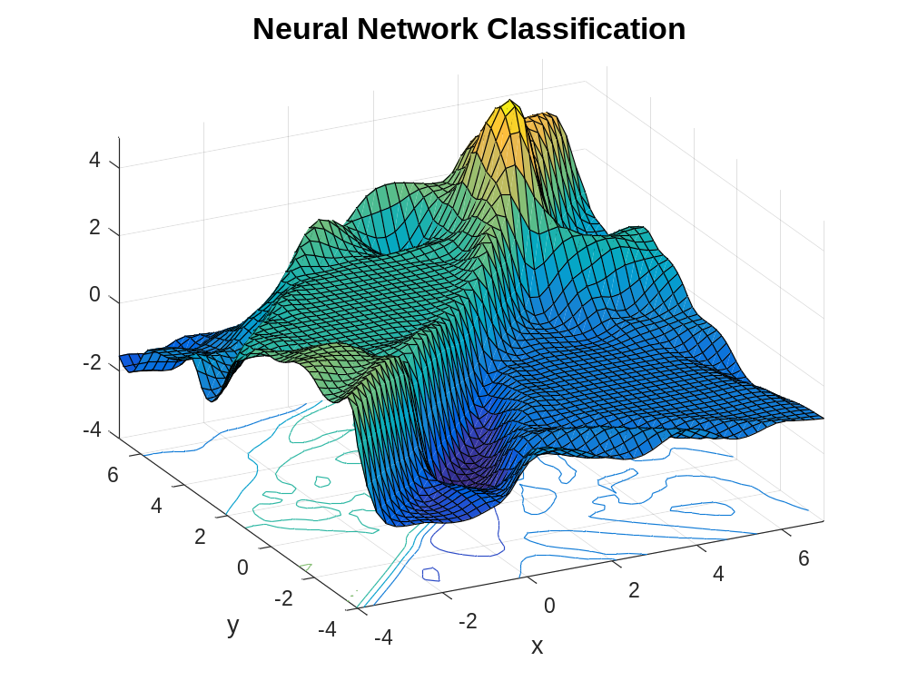
Figure: It still separate the classes in a good way (the boundary is more or less where it should be), but it tries to guess the classification of the parts where we have no points giving us weird results (like classifying some areas like “4”, which makes no sense, or the part left to the Class1: +1, like Class2: -1).

Implementar algo mas? Tal vez probar con mas datos por si se comporta mejor, y/o acercar mas las dos clases para ver como se comporta!
Usar cross validation para evitar overtraining/overfitting??????

Mackey-Glass equation:

$$\frac{dx}{dt}=\frac{ax(t-τ)}{1+x{(t-τ)}^{10}}-bx(t)$$
Variables finales T time, X(T) position dependent on time

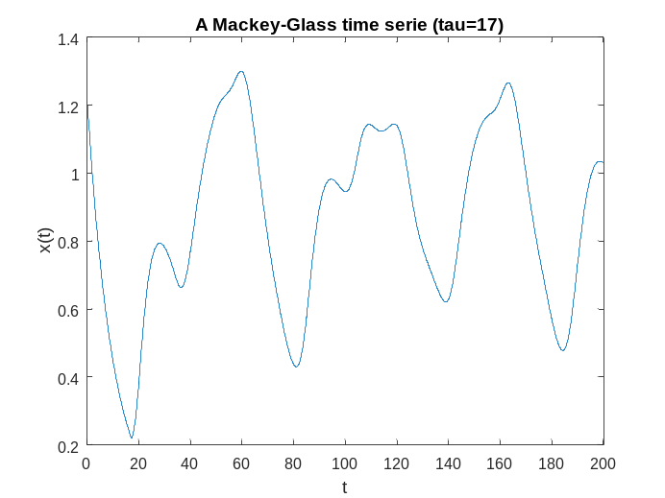
Figure: Mackey-Glass time serie (a=0.2, b=0.1, tau=17, x0=1.2) in 2000 samples.

Time Series prediction Using Regression method

First of all we plot the Mackey-Glass function to check its shape and how the position changes as function of time.
As want to make one step prediction, we have to guess the position of a point given the position previous ones, so we are not going to use the variable time. To do that first we are going to use a regression method using with the first 3/4 points of the simple to train it. To do this we need to créate an Input and Output so:
$$Output=Input*w$$
Where w is our model for the regression.
In this case we are going to use 20 previous points to make the prediction, so our Input has to be a matrix with 20 columns and (N-(p+1)) rows where each row is a time shifted versión of the previous one, the model will be a column vector of 20 and the output a column vector with (N-(p+1)) entries with the next points of the Input rows:
$$\left(\begin{matrix}1 & 2 & 3 \\ 2 & 3 & 4 \\ 3 & 4 & 5\end{matrix}\right)*w=\left(\begin{matrix}4 \\ 5 \\ 6\end{matrix}\right)$$

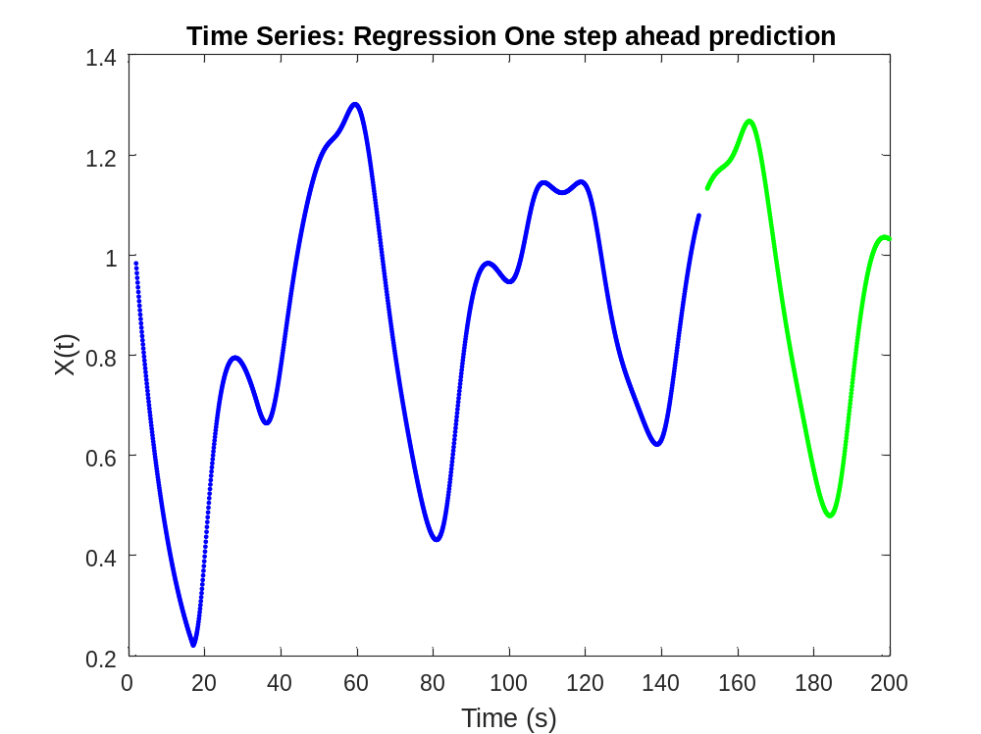
In this figure we can see in blue the original plot of the Mackey-Glass function for the points used to train the regression and in green the one step ahead prediction made in the test simple. It is obvious that this prediction is really precise, fact that we can doublé-check calculating its error:
$$Error (Regression)=2.11*{10}^{-10}$$

Time Series Neural Network
Feedforward Neural Network

This time we are going to make the same prediction but using a neural network, so the Input and Output are going to be the same than in the regression (Input 20 previous points and Output the next point).
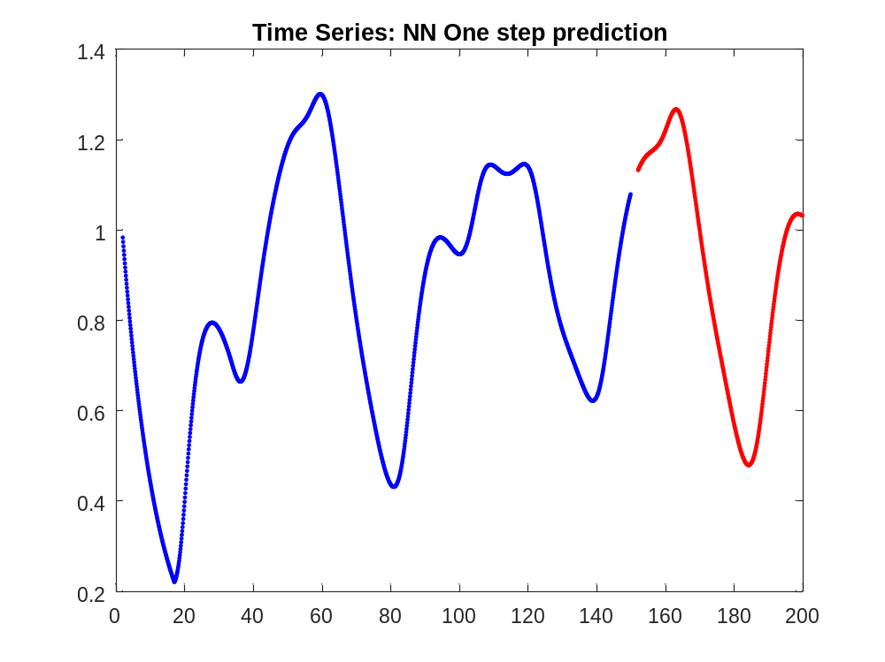
As the previous figure in blue is the real trend of the Mackey-Glass function and in red the one step ahead prediction done by my trained neural network, we can see that its accuracy is really good as well.
$$Error (feedforwaed NN)=1.63*{10}^{-9}$$
And the error is basically the same as they are really near 0.

Feedback Neural Network

The problem comes when we are feedbacking back the system, if we have a look to Fig. we can see that it predicts in a good way the first points but then it starts to miss all the predictions.
As we are feeding back the neural network, we have to substitute the predicted points in the Input matrix. These points we are predicting have an intrinsic error compared to the real ones, and as we are using them as Input this error is accumulative, growing each step.
Read Wan 1977 and comment on that
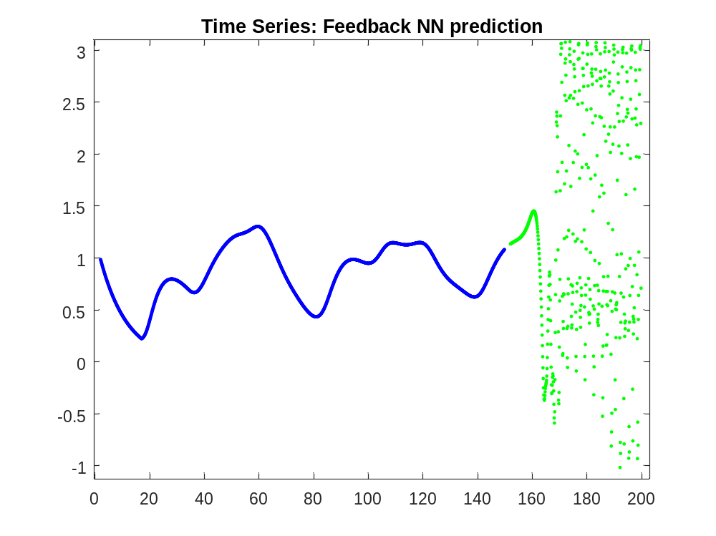
$$Error feedback NN=0.772$$

Probar con diferentes numeros de funciones para la red neuronal y con mas y menos puntos para hacer la prediccion (en vez de 20, 100 o 10) se deberia comportar major cuantos mas puntos elijamos, ya que hasta no lleguemos a la prediccion numero 100 la prediccion no estara recayendo solamente en feedback points, a parte que el modelo sera mas preciso (probar esto con one step ahead y comparer errors, deberia serr mucho menor ya que en este caso al estar predeciciendo el comportamiento de una function nos interesa que el Sistema este overtrained)

Financial Time Series

FTSE100 (Financial Times Stock Exchange): Index composed by the main 100 values of London Stock Market, it was developed from a base level of 1000. The capitalization of these companies suppose the 70% of the total value of the Stock Market (values are weighted by the capitalization criteria). This is revised each trimester and sessions are measured from Monday to Friday.
Max value on December 30th of 1999 6950.6. Rise record on September 19th of 2008 9.33%.
Market close Prices: values of the Stock Market at the end of the day, last value recorded before the starting of the new day.

Steps to follow
I am going to feed a Neural Network with data from the last 5 years to make a prediction about tomorrow (from dec1 2010 to dec8 2015).
First I am going to train it with all the points to predict tomorrow’s value and check it with the real close price to check if it is any chance to make money using NN.
Second I am going to use data from the first 4 years and study the prediction of NN in 2015 (comparing with real data in a graph and measuring error/accuracy of the prediction).
Then I am going to add the value of Volume Traded (buscar info sobre q es esto para poder incluirlo en el analisis!!) to the analysis to see if my prediction improves its performace.

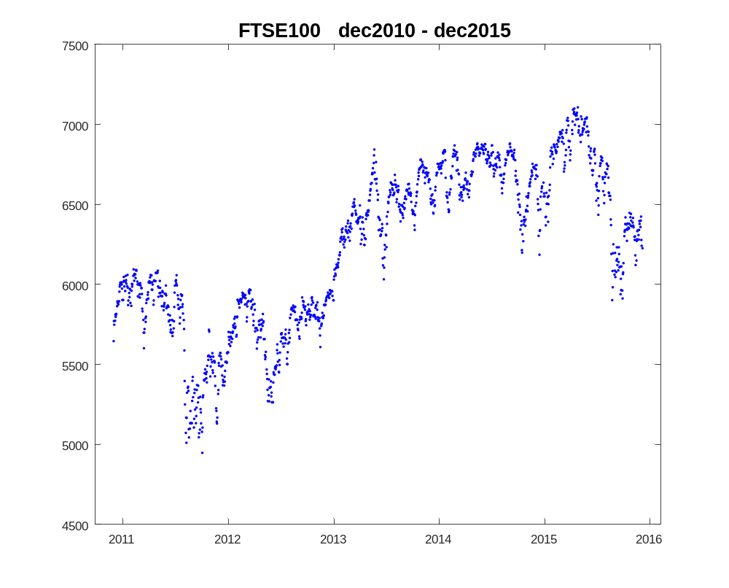

Using regression method (least squares)

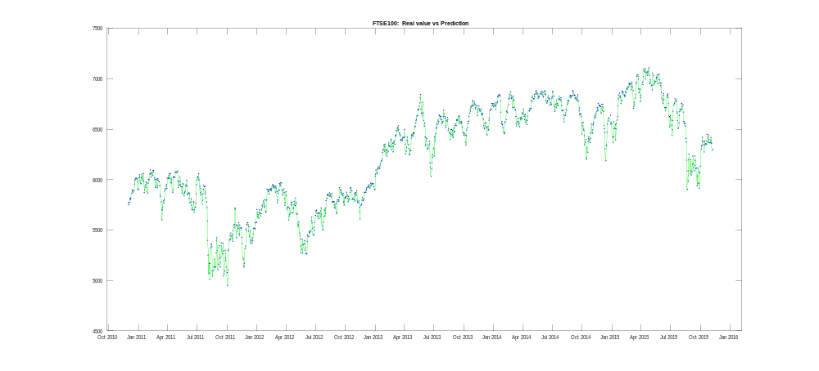
If we estimate a regression from the data of the last 5 years and try to predict one step ahead on the same points we can see that in general it is not working bad Fig., but if we have a closer look Fig. we can see that the prediction is not that good, and in some cases not reliable at all. In fact the error is really high:
$$Error=3254.4$$
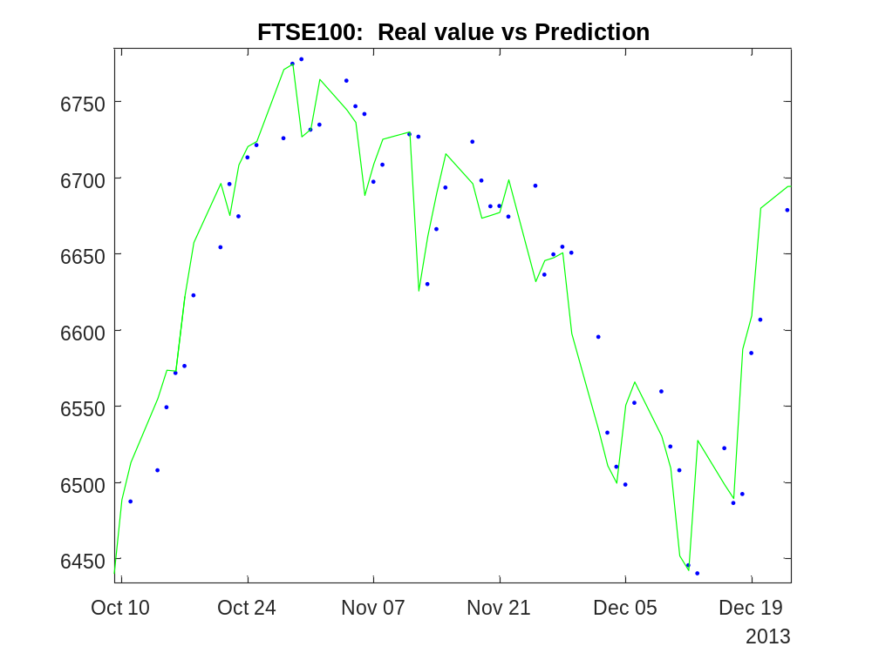

If we use this regression to estimate the Market value tomorrow (Dec12 2015) using 20 past days = 5645.0
Using 50 past days: 5663.5
Using 100 past days: 5641.6
Using past 300 days (from around last year, this is not taking into account weekends): 5592.1

Using Neural Networks

http://www2.astro.psu.edu/statcodes/sc_timeser.html
http://www.academia.edu/3120274/Matlab_code_for_parameter_and_state_estimation_of_chaotic_series
http://mlg.eng.cam.ac.uk/zoubin/papers/ul.pdf
http://es.mathworks.com/help/fuzzy/examples/chaotic-time-series-prediction.html
http://cs.gmu.edu/~jessica/publications/astronomy11.pdf
http://www.macalester.edu/~kaplan/knoxville/science1977.pdf

