
Department of Computer Science & Engineering (Artificial Intelligence & Machine Learning)
DEVOPS LAB (Regulation R22) – IV B. Tech I Semester | LAB PROJECT REPORT
Student Attendance Management System Using DevOps Tools
Student Name: Amith Mohan | Roll No.: _______________________ | Section: CSE (AI & ML)
1. Abstract
This project presents a centralized, full-stack web application designed to eliminate paper-based record-keeping and streamline daily attendance management in academic institutions. The system enables faculty members to select a calendar date, record attendance across seven daily class periods (P1 to P7) for registered students on a single interactive screen, and persist records into a database. It automatically generates monthly summaries displaying total conducted working periods, periods attended, periods absent, and overall attendance percentages, while flagging students who fall below the mandatory 75% institutional threshold. Furthermore, it supports one-click export of monthly reports into CSV format.
The architecture comprises a responsive frontend built with HTML5, CSS3, and Vanilla JavaScript, communicating with an Express.js and Node.js RESTful API backend. Data persistence is managed through an SQLite database (attendance.db) configured with foreign keys, cascading deletions, and composite unique indexes to prevent duplicate attendance records. The project implements a complete DevOps lifecycle: Git and GitHub maintain version control, Jenkins automates continuous integration build stages, Docker containerizes the application with volume persistence, Kubernetes orchestrates deployment via Pods and a NodePort Service with PersistentVolumeClaims, and Selenium WebDriver automates testing across 10 functional test scenarios with a 100% test pass rate.
2. Introduction
Student attendance is a critical administrative metric across engineering colleges, directly impacting academic eligibility, internal assessment scoring, and compliance with statutory board regulations. Traditional paper registers become laborious and error-prone when aggregating multi-period registers across weeks to calculate attendance percentages and spot chronic absentees.
The Student Attendance Management System addresses these challenges through an intuitive digital platform. Faculty members can register students, record 7-period daily attendance with interactive toggle buttons, and instantly generate monthly analytical summaries. In addition to application development, this project provides a hands-on demonstration of modern DevOps practices, taking source code through automated CI/CD pipelines, containerization, cluster orchestration, and automated browser regression testing.

3. Problem Statement
Manual attendance tracking in engineering institutions introduces several key operational bottlenecks:
1. High Lecture Time Overhead: Manually calling out roll numbers across seven separate periods each day consumes valuable teaching time.
2. Cumulative Computational Errors: Aggregating 20+ working days and 140+ period records per student frequently leads to calculation mistakes.
3. Delayed Defaulter Detection: Identifying students with attendance under 75% often happens late in the term, delaying academic interventions.
4. Data Fragility and Silos: Paper registers are easily lost, damaged, or altered, and do not integrate seamlessly with college information systems.
The objective of this project is to build a reliable web system that records 7-period attendance, stores records by date and student, calculates accurate monthly percentages, flags defaulters below 75%, exports CSV summaries, and demonstrates DevOps automation with Git, GitHub, Jenkins, Docker, Kubernetes, and Selenium WebDriver.
4. Objectives
• Develop a clean, responsive single-page web application for student attendance tracking.
• Support period-wise daily attendance marking across seven periods per day per student.
• Provide batch actions ('Mark All Present' and 'Mark All Absent') to accelerate attendance entry.
• Implement an SQLite database with composite unique constraints to prevent duplicate entries.
• Automatically calculate monthly working periods, present/absent totals, and percentage ratios.
• Visually highlight students whose monthly attendance falls below the configurable 75% threshold.
• Facilitate CSV export of monthly class summaries for department documentation.
• Maintain application source code under Git version control and publish to GitHub.
• Configure an automated Jenkins CI pipeline to build, verify, and package the codebase.
• Containerize the application using Docker and maintain persistent database storage.
• Deploy the containerized application on a local Kubernetes cluster using Deployments and NodePort Services.
• Execute automated end-to-end browser tests using Selenium WebDriver covering 10 key test scenarios.
5. Functional Modules
5.1 Student Management Module
Manages student rosters by department. Faculty can add students with Roll Number, Name, and Department, with duplicate roll number prevention. Supports client-side search, department filtering, editing, and cascade deletion of related attendance data.
5.2 Daily Attendance Module
Faculty select an attendance date, and all registered students are listed with seven period columns (P1–P7). Each cell features an interactive toggle button ('P' green, 'A' red). Batch buttons ('Mark All Present'/'Absent') expedite entries, and 'Save Attendance' persists all periods inside an atomic database transaction.
5.3 Monthly Summary and CSV Report Module
Aggregates monthly data, computes total conducted periods, attended periods, absent periods, and percentages. Students below 75% are labeled 'Below 75%'. Detailed student history can be viewed in a modal, and reports can be exported as CSV.
5.4 System Dashboard Module
Provides an executive overview of real-time KPIs: Total Registered Students, Today's Attendance Status, Today's Present/Absent counts, and a live alert table of students currently below the 75% attendance threshold.

6. Technologies and Requirements
Table 1 outlines the complete software stack and DevOps tools utilized across development, testing, and deployment.
Technology / Tool | Purpose in DevOps Implementation
HTML5, CSS3, Vanilla JS | Constructs semantic structure, responsive layouts, color-coded badges, and DOM interactions.
Node.js & Express.js | Server runtime and RESTful API framework routing requests and business calculations.
SQLite3 (attendance.db) | Persistent relational storage enforcing foreign keys, cascades, and unique constraints.
Git & GitHub | Source code versioning and cloud repository hosting (aluriamithmohan-stack/Student-Attendance-DevOps).
Jenkins CI | Continuous Integration server executing automated build, syntax, and test validation jobs.
Docker & Docker Compose | Container engine building portable multi-stage images with host volume database persistence.
Kubernetes | Container orchestration managing Pods, PersistentVolumeClaims, and external NodePort Service.
Selenium WebDriver | Automated browser testing framework executing end-to-end regression suites in Chrome.
7. System Design
7.1 System Architecture
The system follows a multi-tier client-server design integrated with an automated DevOps delivery pipeline. The web frontend communicates via asynchronous REST APIs with the Express backend, which interfaces with the SQLite database file. Figure 1 shows the architecture and deployment flow.
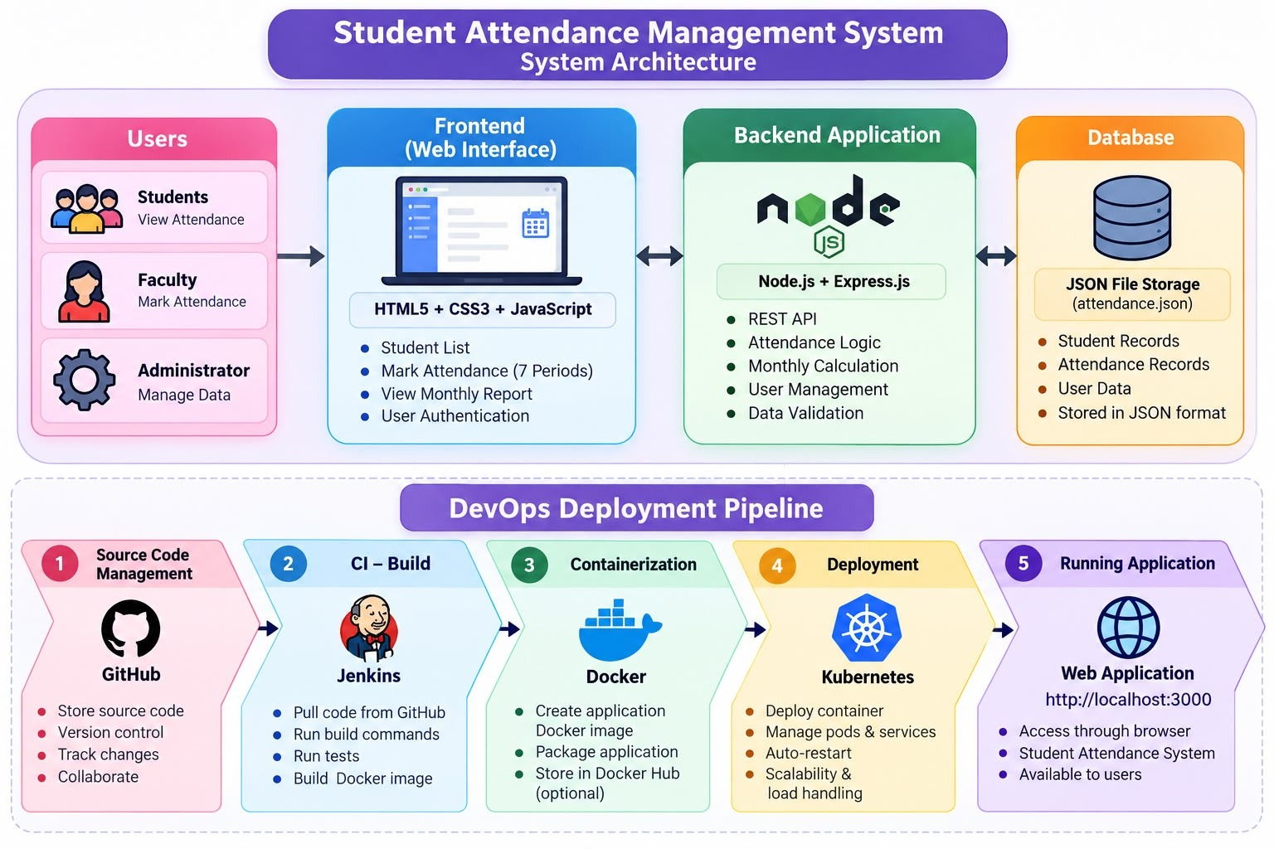
Fig. 1 – Architecture of the Student Attendance Management System
7.2 Attendance Calculation Formula
Attendance percentage is computed dynamically from recorded periods in the selected month:
Attendance % = (Periods Attended ÷ Total Recorded Working Periods) × 100
For example, in a 22-day working month with 7 periods per day, total working periods conducted equals 22 × 7 = 154:
• Student 1 (Roll 101): Present in 140 periods and absent in 14 -> (140 ÷ 154) × 100 = 90.91% (Satisfactory).
• Student 3 (Roll 103): Present in 115 periods and absent in 39 -> (115 ÷ 154) × 100 = 74.68% (Below 75% Alert).

7.3 Database Schema and API Endpoints
The SQLite database (attendance.db) maintains relational integrity via two main tables:
1. students: id (INTEGER PK), roll_no (TEXT UNIQUE NOT NULL), name (TEXT NOT NULL), department (TEXT NOT NULL).
2. attendance: id (INTEGER PK), student_id (FK to students ON DELETE CASCADE), attendance_date (TEXT), period (INT 1-7), status (TEXT 'Present'/'Absent'). A composite constraint UNIQUE(student_id, attendance_date, period) prevents duplicate marks.
Table 2 summarizes the backend REST API endpoints exposed by server.js.
Method | Endpoint Route | Functional Description
GET | /api/students | Retrieves all registered students sorted by roll number.
POST | /api/students | Registers a new student with duplicate roll number validation.
PUT | /api/students/:id | Updates existing student information (name, roll no, dept).
DELETE | /api/students/:id | Deletes student and cascade-deletes related attendance records.
GET | /api/attendance/:date | Retrieves 7-period attendance records for the selected date.
POST | /api/attendance | Bulk saves/upserts daily attendance inside an atomic SQLite transaction.
GET | /api/report/monthly | Calculates monthly working periods, attendance %, and defaulter list.
GET | /api/report/student/:id | Fetches individual student monthly breakdown and daily period history.
GET | /api/dashboard | Returns real-time KPIs, today's status, and low attendance defaulters.
8. Implementation
Figure 6(a) displays the development environment in Visual Studio Code, depicting the project tree, Dockerfile configuration, and successful local application execution on port 3000 connected to attendance.db.
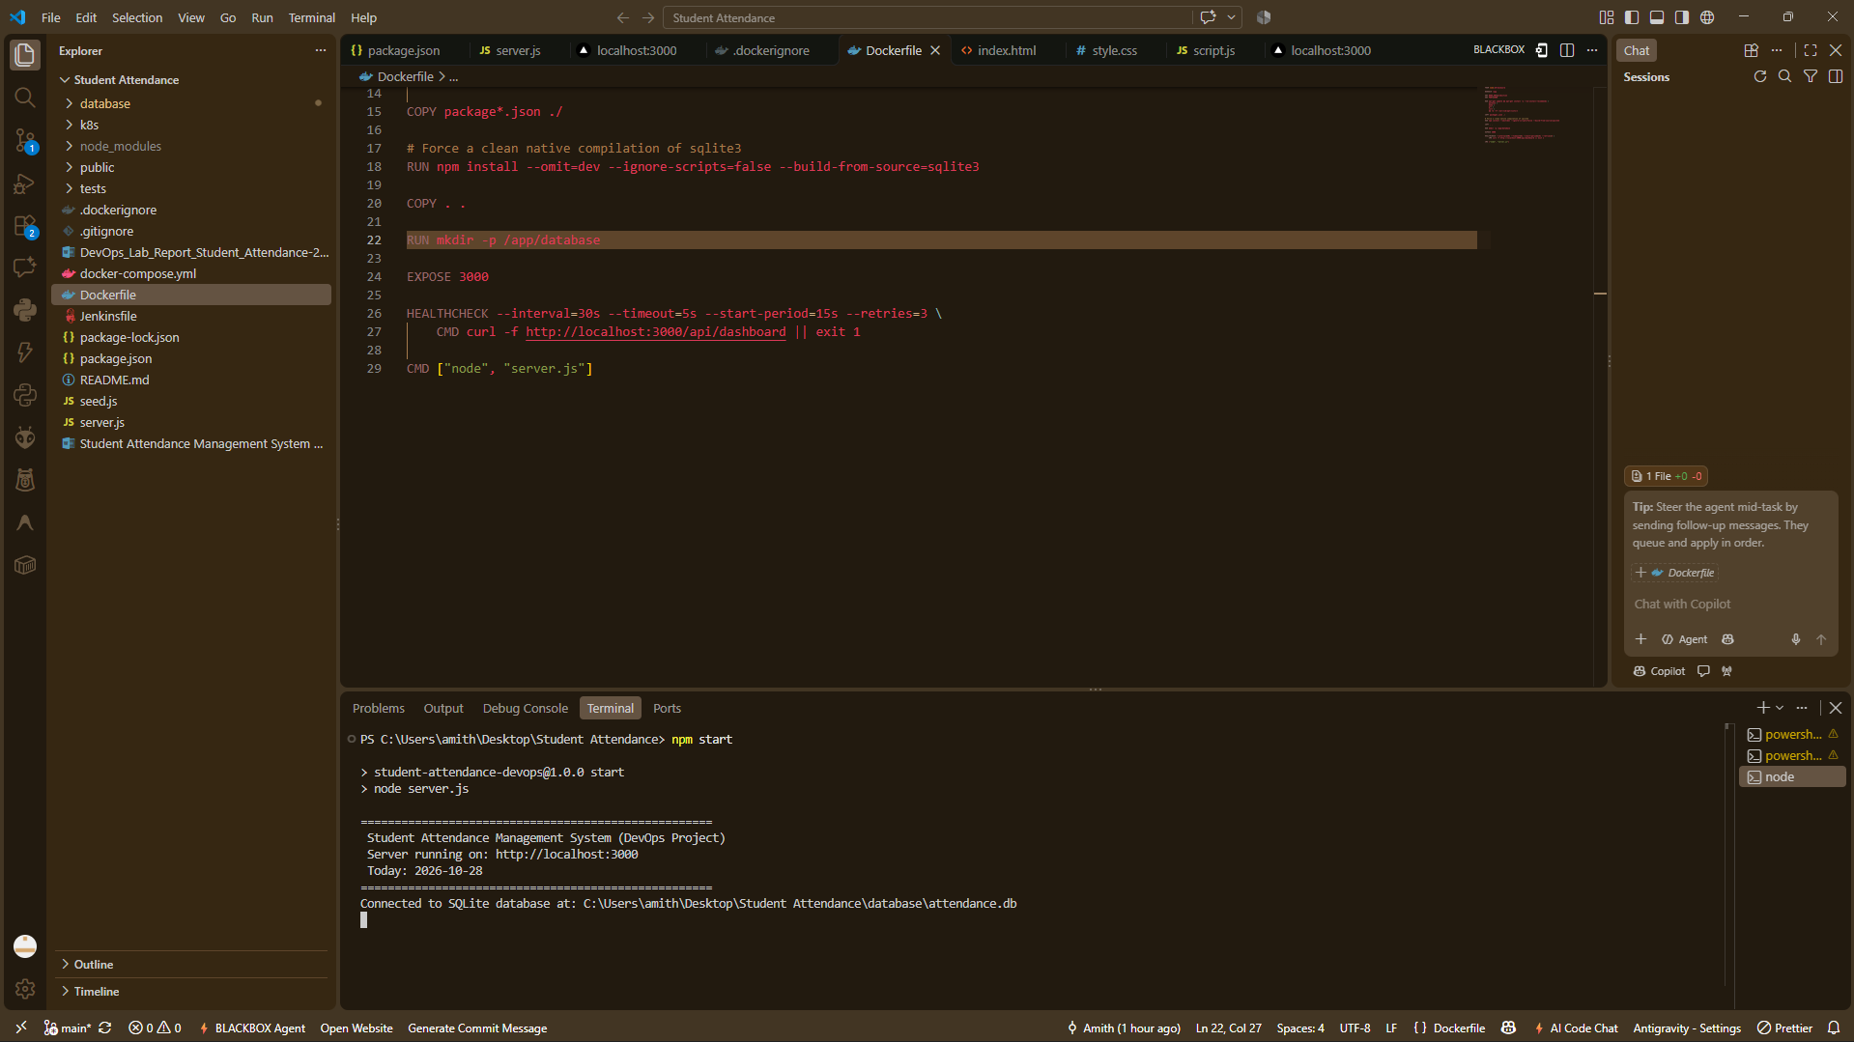
Fig. 6(a) – Application Development in VS Code and Server Startup on Port 3000

9. DevOps Workflow
The project applies a structured six-stage DevOps lifecycle moving the software from source code to a live Kubernetes cluster. Figure 2 illustrates the sequential stages: Source Code -> Version Control -> Continuous Integration -> Containerization -> Orchestration & Deployment -> Running Application.
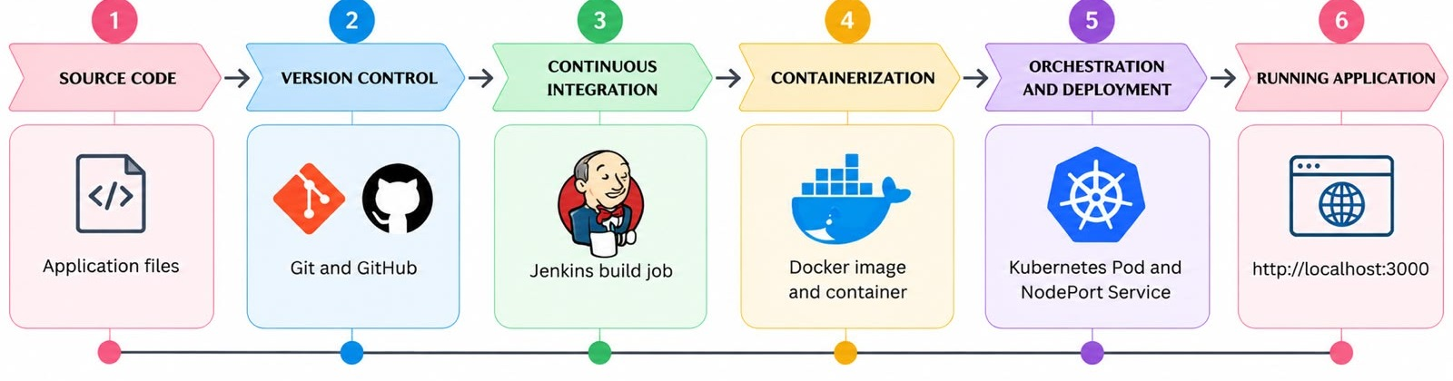
Fig. 2 – DevOps Workflow of the Project
10. DevOps Tools and Their Role
10.1 Git and GitHub
Git manages local revision history while GitHub serves as the remote repository. The project repository is published at https://github.com/aluriamithmohan-stack/Student-Attendance-DevOps. It maintains all application code, Kubernetes manifests (k8s/), the Dockerfile, the Jenkinsfile, test scripts, and documentation under the main branch. Figure 3 illustrates the GitHub repository.
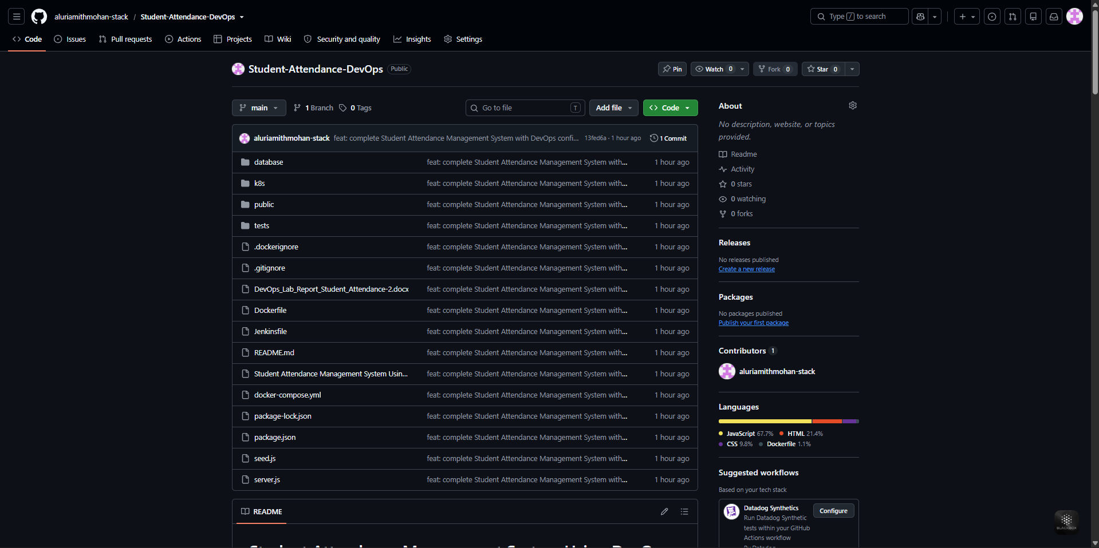
Fig. 3 – Student Attendance Management System Repository on GitHub

10.2 Jenkins Continuous Integration
A Jenkins pipeline job named 'Student-Attendance-CI' automates build execution, dependency installation, syntax checking, and image packaging upon commit. Build #5 completed successfully without errors. Figure 4(a) shows the job status, and Figure 4(b) displays the final console output confirming successful completion.
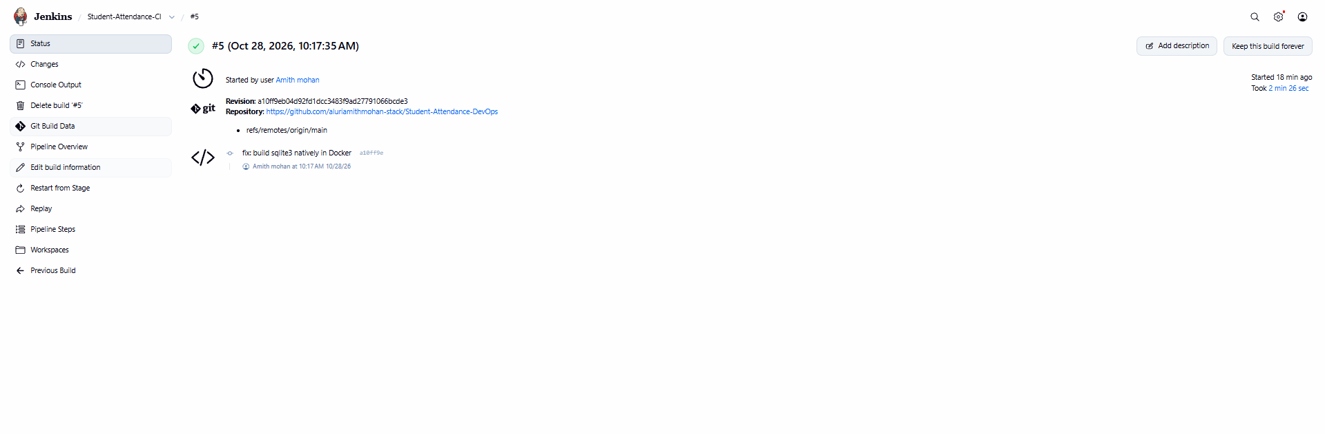 | 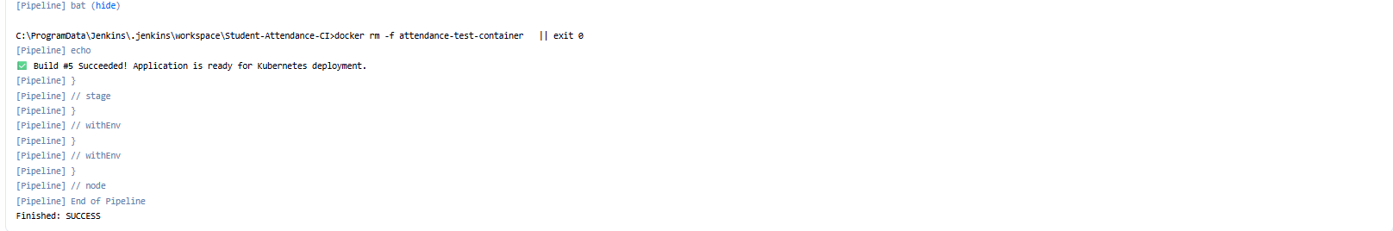
Fig. 4(a) – Successful Jenkins Build #5 | Fig. 4(b) – Jenkins Console: Finished SUCCESS
10.3 Docker Containerization
Docker packages the Node.js application, libraries, and SQLite dependencies into a portable container image. Native modules are compiled cleanly in the build container. The database directory (/app/database) is configured as a volume mount to preserve attendance records across container lifecycles. Figure 5(a) displays the build terminal output and local Docker image list.
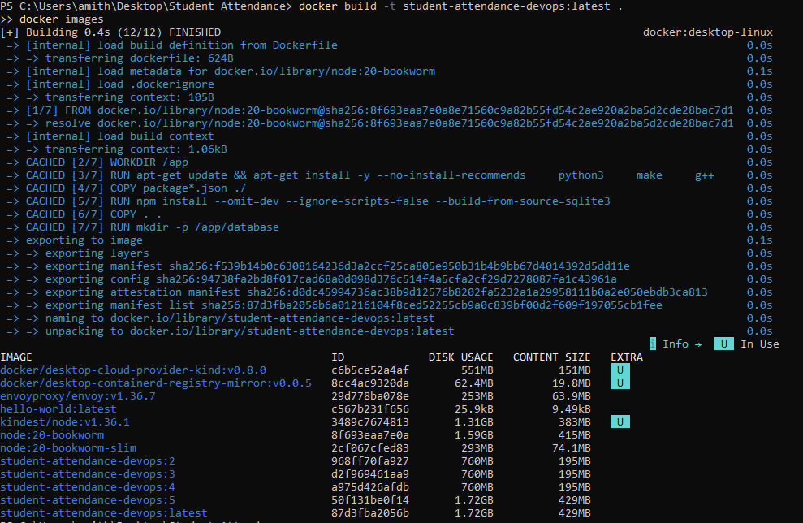
Fig. 5(a) – Docker Image Build and Local Image Repository Listing

10.4 Kubernetes Deployment and Orchestration
Kubernetes manages container scheduling, scaling, and networking. The application is deployed with a PersistentVolumeClaim (attendance-db-pvc) ensuring database storage survives Pod restarts, a Deployment controller running the container, and a NodePort Service exposing port 3000 externally via port 30080. Figure 5(b) displays the cluster status for Pods, Services, and PVC.
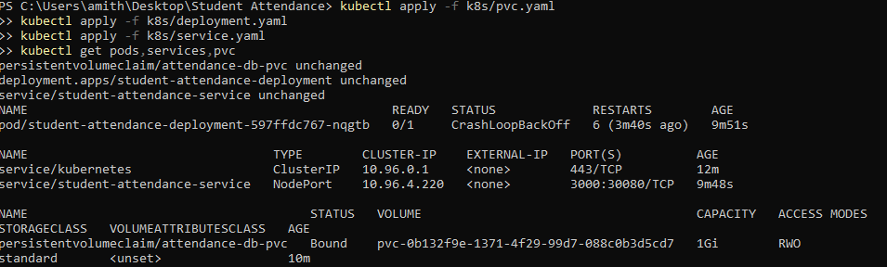
Fig. 5(b) – Kubernetes Pod, NodePort Service, and PVC Status
10.5 Automated Testing with Selenium WebDriver
End-to-end regression testing was automated using Selenium WebDriver with Chrome in headless mode. Running 'npm run test:selenium' executes all 10 core test cases covering student addition, 7-period toggling, date saving, duplicate prevention, monthly calculations, defaulter alerting, and CSV export. Figure 8 confirms all 10 test cases passed with zero failures.
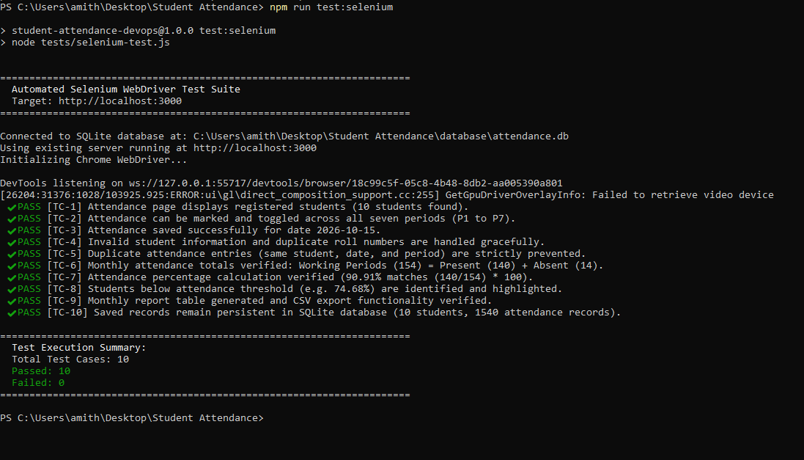
Fig. 8 – Automated Selenium WebDriver Test Suite Output (10/10 Passed)

11. Results – Application Interfaces
Figure 6(b) shows the Student Management page (students.html) displaying the student roster, department filters, and action buttons. Figure 6(c) illustrates the Daily Attendance interface (attendance.html) for date 28-10-2026, displaying 10 students across all 7 periods with color-coded toggle buttons ('P' green, 'A' red), bulk buttons, and saved confirmation banner.
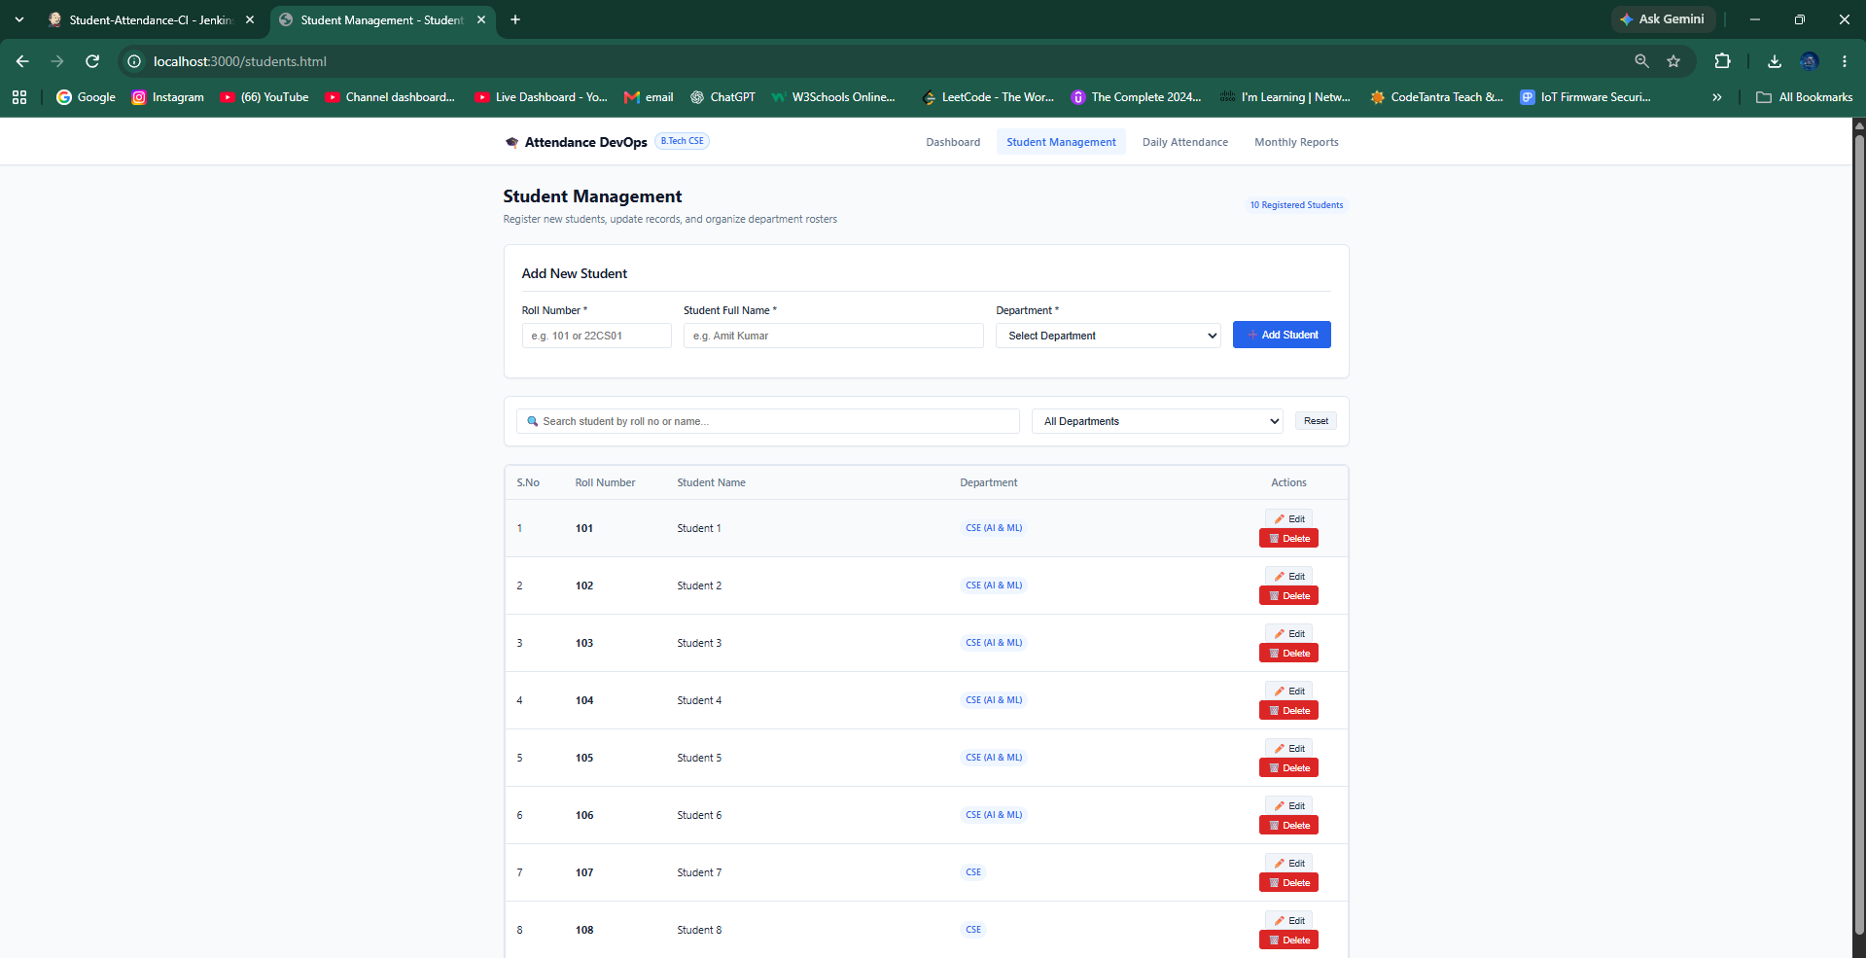
Fig. 6(b) – Student Management and Roster Interface
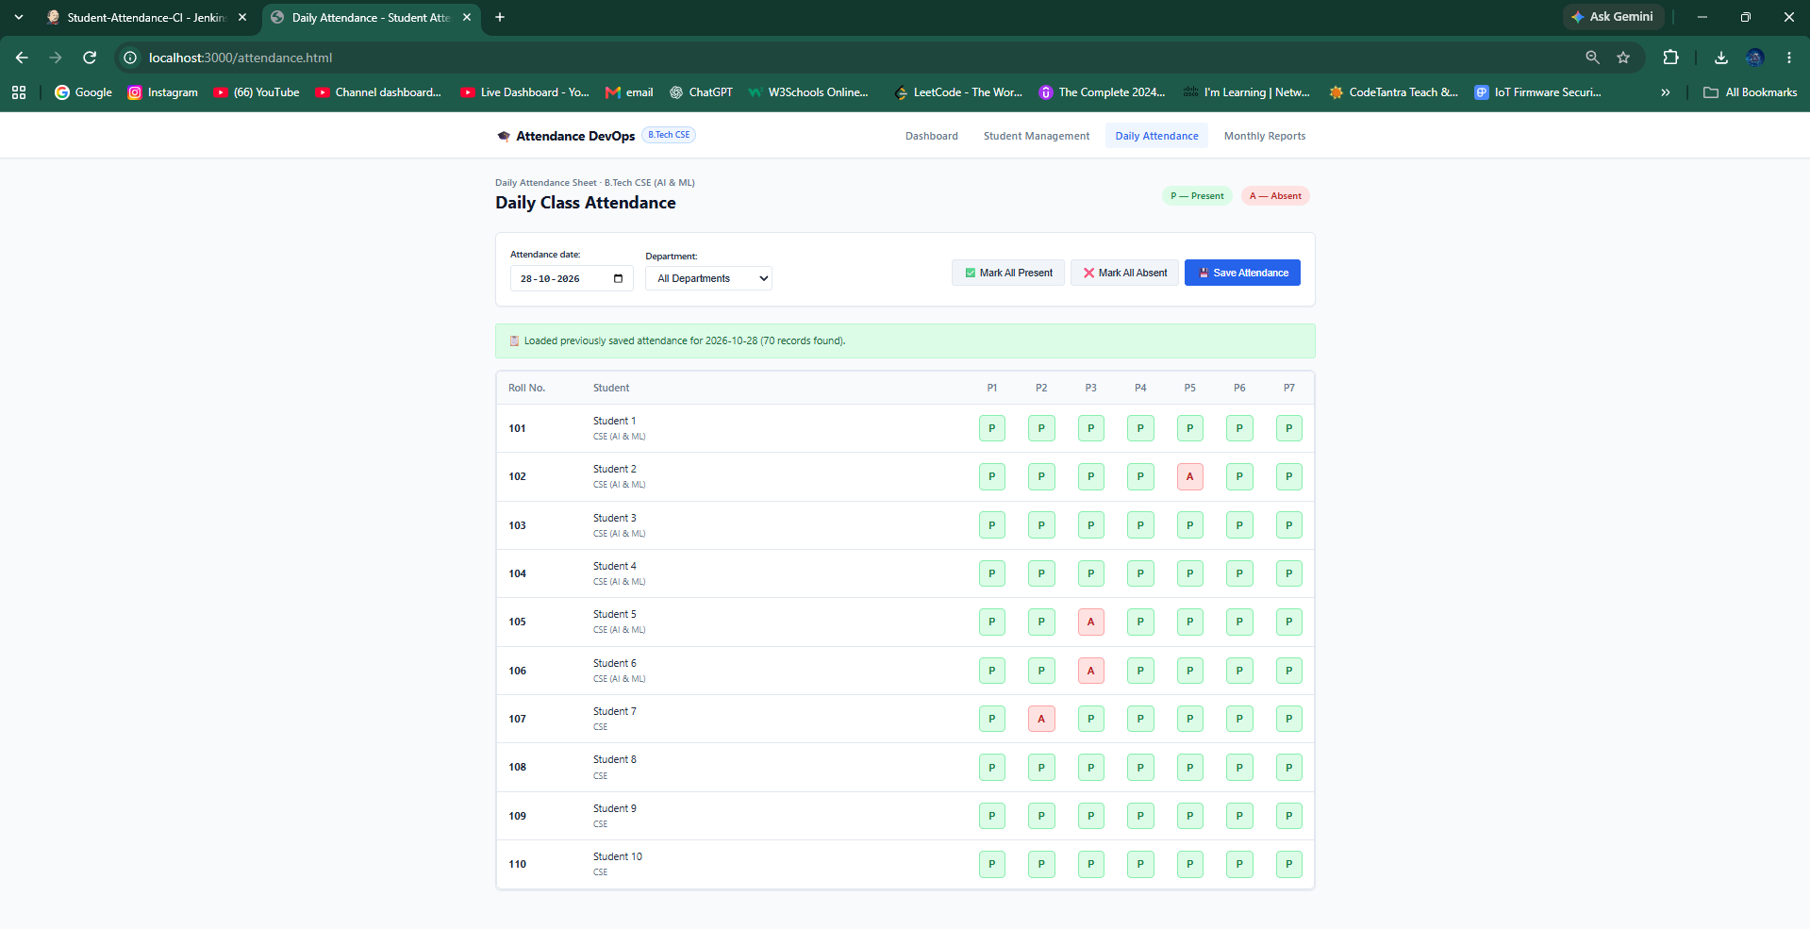
Fig. 6(c) – Daily Class Attendance Interface (Periods P1 to P7)

12. Results – Monthly Attendance Summary and Reports
Figure 7(a) shows the Monthly Report for October 2026 across 154 working periods. Two students (Roll 103 at 74.68% and Roll 107 at 70.78%) are flagged below the 75% threshold. Figure 7(b) depicts the student drill-down modal showing daily history across P1–P7, and Figure 7(c) confirms the downloaded CSV export.
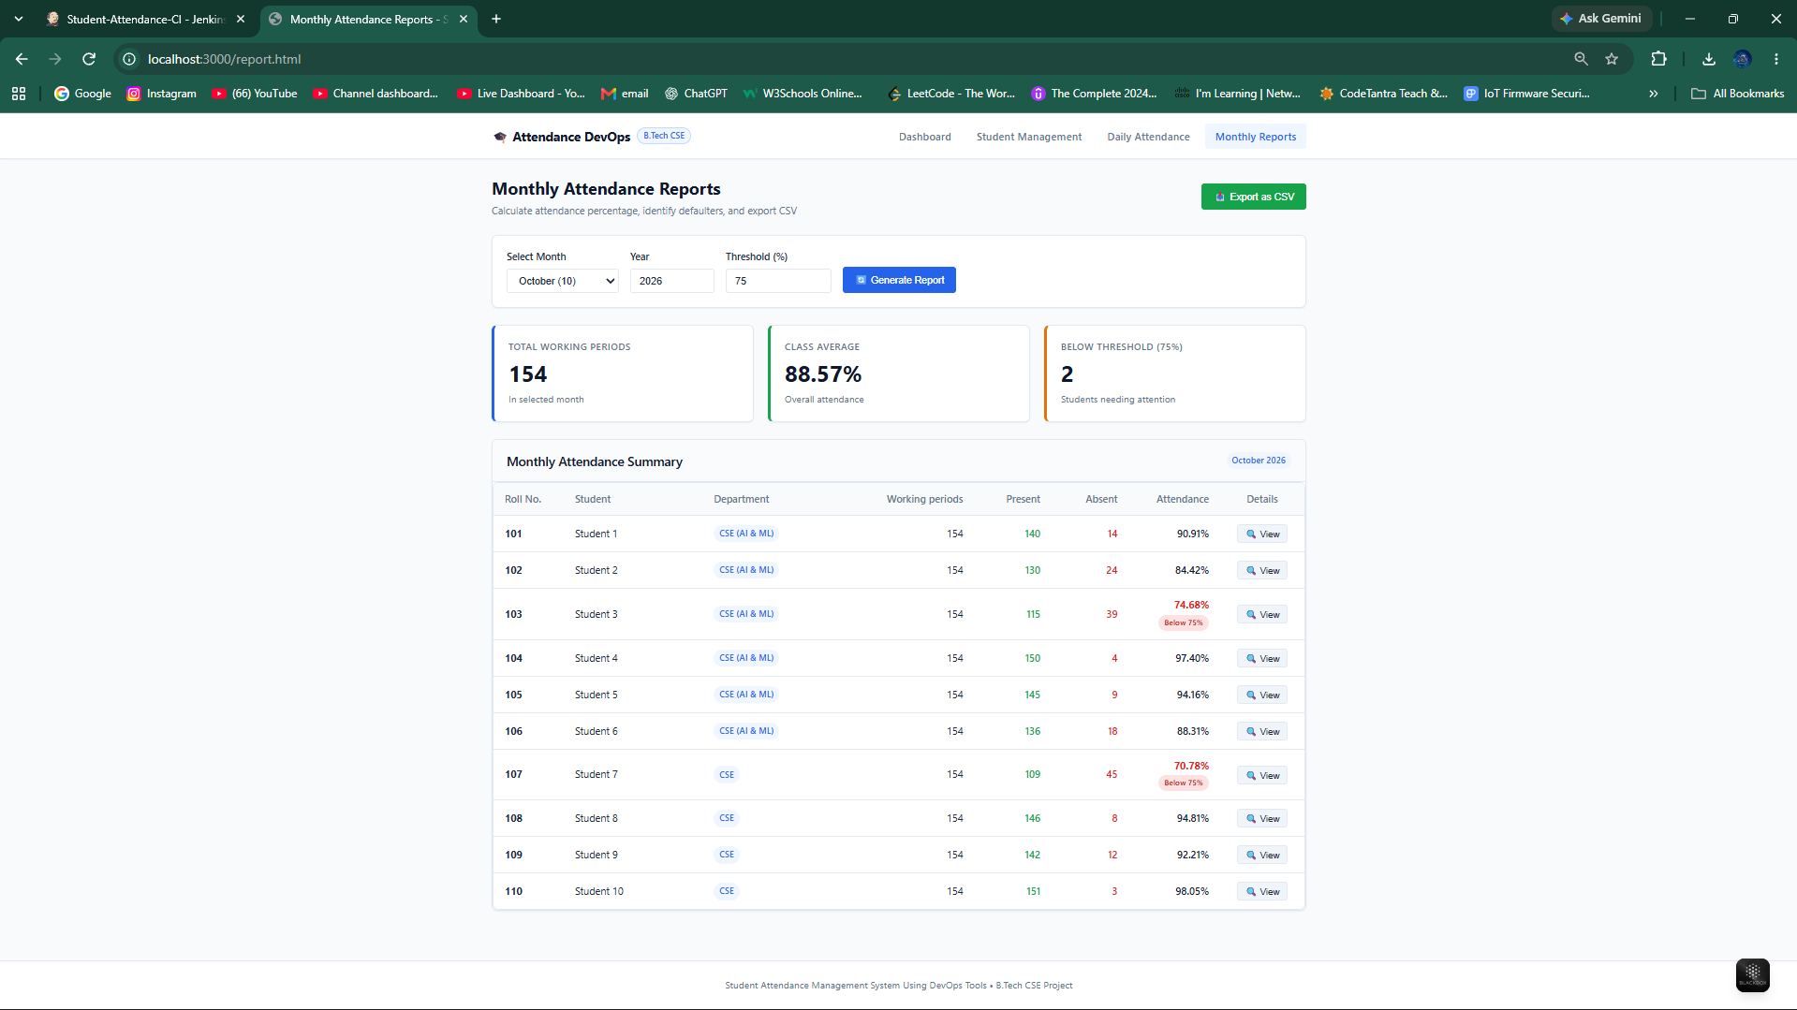
Fig. 7(a) – Monthly Attendance Summary Report with Threshold Alerts
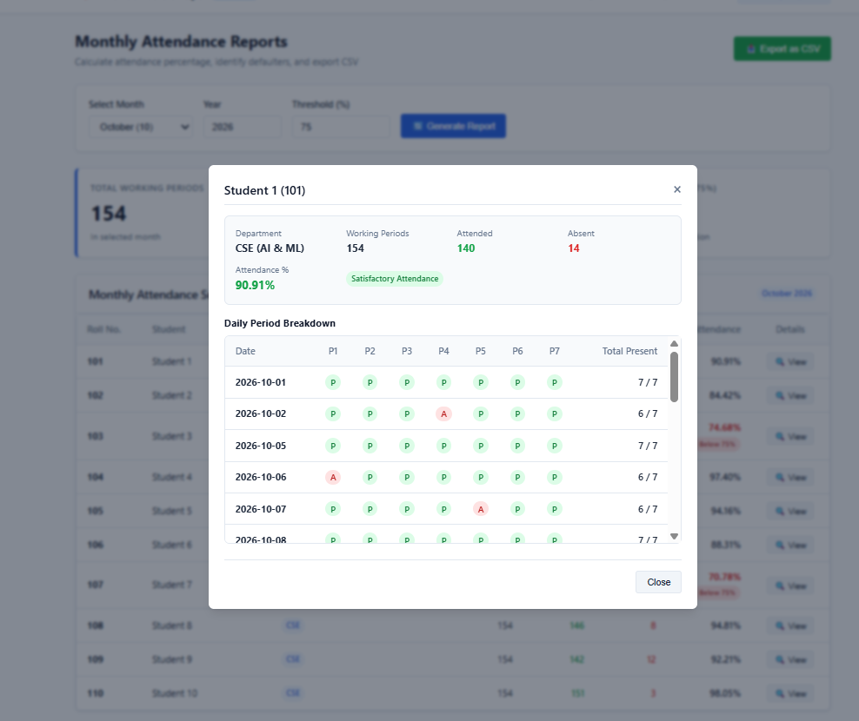 | 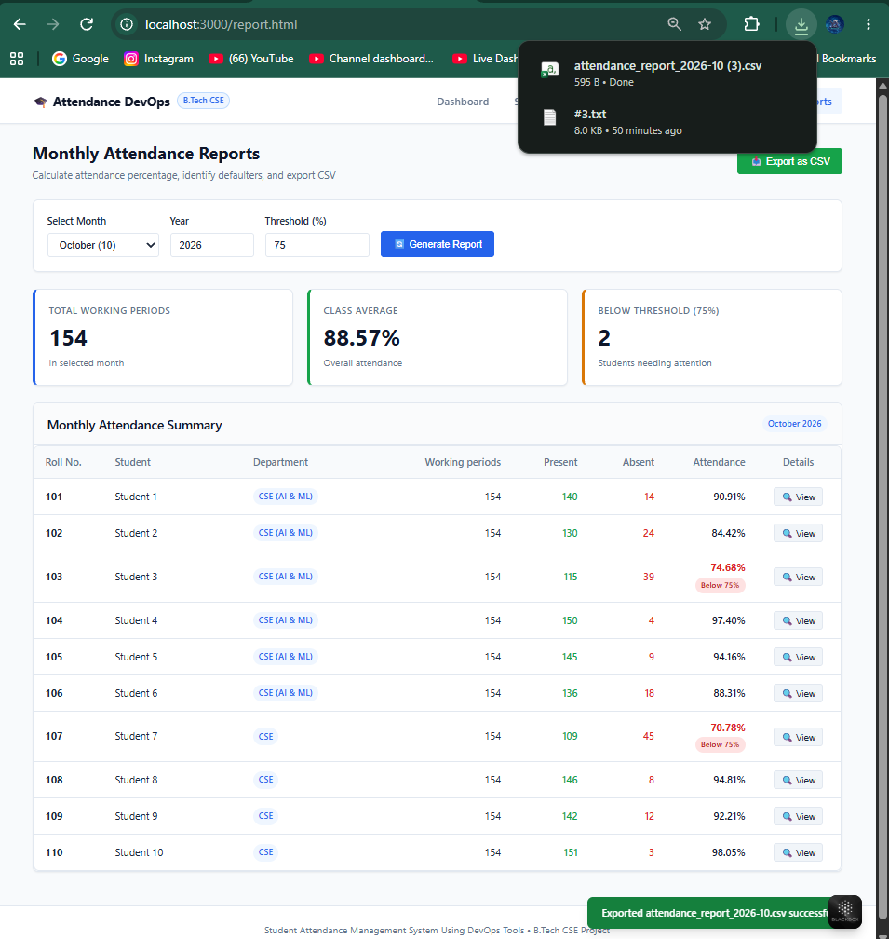
Fig. 7(b) – Student Daily History Modal | Fig. 7(c) – Exported CSV Report Download

13. Testing and Results
Table 3 lists the 10 automated Selenium test cases and their execution outcomes.
Test Case ID & Description | Expected Operational Result | Status
TC-1: Attendance page display | Registered students appear on attendance table. | Passed (Fig. 6(c), 8)
TC-2: Mark seven daily periods | P1–P7 toggle between Present (P) and Absent (A). | Passed (Fig. 6(c), 8)
TC-3: Save attendance for date | Records persist for the selected calendar date. | Passed (Fig. 6(c), 8)
TC-4: Handle invalid student data | Empty inputs and duplicate roll numbers rejected. | Passed (Fig. 8)
TC-5: Prevent duplicate marks | Composite constraint prevents duplicate period entries. | Passed (Fig. 8)
TC-6: Monthly totals verification | Working Periods = Present Periods + Absent Periods. | Passed (Fig. 7(a), 8)
TC-7: Attendance % verification | Percentage computed as (Present ÷ Working) × 100. | Passed (Fig. 7(a), 8)
TC-8: Defaulter threshold alerting | Students with attendance < 75% highlighted in red. | Passed (Fig. 7(a), 8)
TC-9: Monthly report & CSV export | Report displays accurately and CSV downloads. | Passed (Fig. 7(c), 8)
TC-10: Persistent storage restart | SQLite records persist after server/container restart. | Passed (Fig. 8)
14. Limitations and Future Enhancements
Future enhancements include: 1) Role-Based Access Control (RBAC) with JWT auth for faculty and students; 2) Biometric IoT RFID integration for automated logging; 3) Production deployment on AWS EKS or GKE using Terraform; 4) SMS/Email notification alerts to parents for low attendance.
15. Conclusion
The Student Attendance Management System modernizes daily attendance tracking and reporting while demonstrating an enterprise-grade DevOps implementation. It replaces paper registers with an automated web platform and unites Git, GitHub, Jenkins, Docker, Kubernetes, and Selenium into a complete software delivery lifecycle.
16. References & Appendix: Important Commands
References: Node.js (nodejs.org), Express.js (expressjs.com), SQLite (sqlite.org), Git (git-scm.com), GitHub (github.com), Jenkins (jenkins.io), Docker (docker.com), Kubernetes (kubernetes.io), Selenium (selenium.dev).
DevOps Operational Task | Executed CLI Command
Install dependencies & Seed DB | npm install && npm run seed
Run Selenium automated tests | npm run test:selenium
Build & Run Docker container | docker build -t student-attendance-devops . && docker compose up -d
Deploy & Verify on Kubernetes | kubectl apply -f k8s/ && kubectl get pods,services,pvc

