
Department of Computer Science & Engineering (Artificial Intelligence & Machine Learning)
DEVOPS LAB (Regulation R22) – IV B. Tech I Semester | LAB PROJECT REPORT
Student Attendance Management System Using DevOps Tools
Student Name: Gunjan Nashine | Roll No.: _______________________ | Section: CSE (AI & ML)
1. Abstract
This project presents a web-based Student Attendance Management System designed to simplify daily classroom record-keeping and automate monthly attendance calculations for academic institutions. Faculty members can select a specific date, record period-wise attendance across all seven daily lecture periods (P1 to P7) using interactive status drop-down selectors, and persist records directly. The system generates comprehensive monthly summaries detailing total registered students, saved attendance dates, total period records, and individual student attendance percentages, while flagging students who fall below the mandatory 75% threshold. Monthly summaries can also be downloaded as a CSV file for offline academic analysis.
The application architecture uses HTML5, CSS3, and JavaScript on the client side, communicating with a lightweight Node.js and Express.js backend server. Student information and attendance records are stored persistently in a structured JSON file (attendance.json), eliminating the overhead of external database servers while maintaining portability. An end-to-end DevOps pipeline encompasses Git and GitHub for version control (GunjanNashine/StudentAttendanceDevOps), Jenkins for continuous integration build automation (StudentAttendance-CI), Docker for container packaging, and Kubernetes (with Docker Desktop) for container orchestration, exposing the application through a NodePort Service on port 30567.
2. Introduction
Maintaining regular student attendance records is essential in academic institutions to ensure student engagement, evaluate course eligibility, and fulfill university regulatory mandates. Conventional paper registers, while familiar for single-hour roll calls, become exceedingly tedious and susceptible to human calculation errors when faculty must total multi-week records across seven daily periods and identify students falling below the mandatory 75% limit.
The Student Attendance Management System addresses these challenges by providing a streamlined web interface where registered students are displayed in a single unified roster. Faculty can set Present or Absent statuses for periods P1 to P7, utilize quick batch actions ('Mark All Present' and 'Mark All Absent'), and retrieve previously saved dates on demand. In parallel, the project demonstrates a complete DevOps toolchain by maintaining code on GitHub, triggering automated Jenkins builds, packaging the application into a Docker container, and orchestrating deployment on a Kubernetes cluster.

3. Problem Statement
Manual classroom attendance recording introduces multiple operational challenges:
1. Time Consumption: Calling out roll numbers and writing attendance entries across 7 periods daily consumes valuable lecture time.
2. Cumulative Summation Errors: Manually calculating attendance totals across multiple weeks from paper registers leads to frequent discrepancies.
3. Delayed Identification: Spotting students whose attendance has fallen below 75% requires scanning dozens of paper columns row by row.
4. Record Retrieval Inefficiency: Locating historical attendance sheets from physical archives is slow and prone to record loss.
The objective of this project is to implement a lightweight web application that records 7-period daily attendance, stores data in attendance.json, computes monthly percentages, highlights students below the 75% limit, and exports CSV reports, while validating a DevOps pipeline across Git, GitHub, Jenkins, Docker, and Kubernetes.
4. Objectives
• Develop a clean, accessible single-page web interface for student attendance tracking.
• Allow period-wise attendance marking across seven periods (P1 to P7) per student per day.
• Provide batch buttons ('Mark All Present' and 'Mark All Absent') to accelerate entry on full-attendance days.
• Store and retrieve date-wise attendance records persistently using a structured JSON file (attendance.json).
• Automatically compute monthly working periods, present counts, absent counts, and attendance percentages.
• Categorize students as 'Satisfactory' (>=75%) or 'Below 75%' to facilitate prompt academic follow-ups.
• Provide one-click CSV export of monthly reports for offline department records.
• Manage source code using Git and maintain a remote repository on GitHub.
• Automate CI builds using a Jenkins job (StudentAttendance-CI) to verify code integration.
• Package the Node.js application into a standardized Docker container image.
• Deploy and expose the containerized application on a Kubernetes cluster via a NodePort Service.
5. Functional Modules
5.1 Student Management Module
This module manages registered students with their Roll Number, Student Name, and Department (e.g. Roll 301 Ishita Rao, 302 Vivek Singh, 303 Meera Shah, 304 Arnav Gupta, 305 Diya Nair, Department CSE). Registered students automatically populate the daily attendance sheet.
5.2 Daily Attendance Module
Faculty select an attendance date (e.g., 24-10-2026) and set periods P1 to P7 to 'Present' or 'Absent' using drop-down selectors. Batch buttons ('Mark All Present' and 'Mark All Absent') allow rapid population of the entire sheet. 'Save Attendance' persists entries to the backend, while 'Load Date' retrieves saved records for any selected date.
5.3 Monthly Summary and CSV Report Module
Summarizes attendance for a chosen month (e.g., October 2026). It tallies registered students (5), saved days (1), and total attendance records (35). For each student, it calculates present and absent periods, attendance percentage, and assigns status ('Satisfactory' or 'Below 75%'). The 'Export CSV' button downloads the table directly as a spreadsheet.

6. Technologies and Requirements
Table 1 outlines the complete technology stack and DevOps tooling utilized in the implementation.
Technology / Tool | Purpose in Project Implementation
HTML5 | Builds the structural layout of the web pages, tables, and drop-down selectors.
CSS3 | Provides modern visual styling, status badges (Satisfactory/Below 75%), and table styling.
JavaScript | Executes interactive client-side behaviour, batch actions, and asynchronous API calls.
Node.js | Server-side runtime environment executing the backend logic and file operations.
Express.js | Web framework managing RESTful routing and incoming HTTP client requests.
JSON (attendance.json) | Lightweight persistent data storage holding student rosters and attendance records.
Git & GitHub | Tracks version history and hosts repository (GunjanNashine/StudentAttendanceDevOps).
Jenkins | Continuous Integration server executing automated build jobs (StudentAttendance-CI).
Docker | Packages the application into an isolated container image running on host port 3001.
Kubernetes & Docker Desktop | Deploys application Pods and exposes access through NodePort Service (Port 30567).
7. System Design
7.1 System Architecture
The system follows a three-tier client-server architecture coupled with a five-stage DevOps deployment pipeline. The web frontend (HTML5, CSS3, JS) interfaces with the Express.js backend via REST API calls. The backend performs business logic and reads/writes attendance data to attendance.json. Figure 1 shows the system architecture and DevOps deployment pipeline.
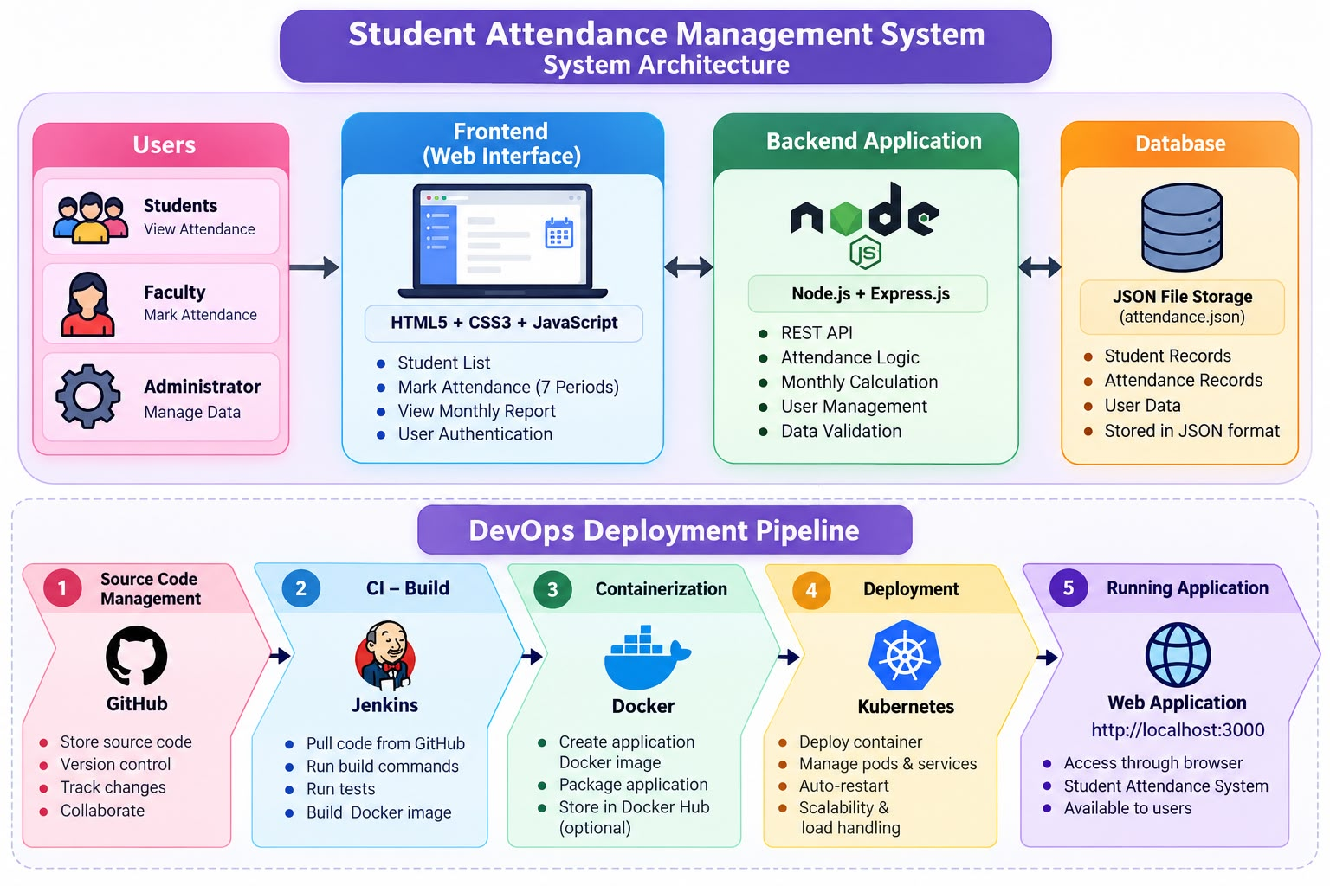
Fig. 1 – Architecture of the Student Attendance Management System
7.2 Attendance Calculation Formula
Attendance percentage is calculated based on recorded class periods for the selected month:
Attendance % = (Present Periods ÷ Total Recorded Working Periods) × 100
In the October 2026 report (Fig. 7), one day of attendance with 7 periods was recorded (working periods = 7):
• Ishita Rao (Roll 301): 6 Present, 1 Absent -> (6 ÷ 7) × 100 = 85.71% (Satisfactory).
• Vivek Singh (Roll 302): 5 Present, 2 Absent -> (5 ÷ 7) × 100 = 71.43% (Below 75%).
• Meera Shah (Roll 303): 4 Present, 3 Absent -> (4 ÷ 7) × 100 = 57.14% (Below 75%).
• Arnav Gupta (Roll 304): 5 Present, 2 Absent -> (5 ÷ 7) × 100 = 71.43% (Below 75%).
• Diya Nair (Roll 305): 6 Present, 1 Absent -> (6 ÷ 7) × 100 = 85.71% (Satisfactory).

7.3 Data Storage Structure and API Endpoints
Data is stored in attendance.json with two primary keys: 'students' containing student profile records (roll, name, department), and 'attendance' storing date-keyed objects where each date maps student roll numbers to seven period statuses ('Present' or 'Absent'). Table 2 lists the REST API routes implemented in server.js.
Method | Endpoint Route | Functional Description
GET | /api/students | Retrieves the list of all registered students from attendance.json.
POST | /api/students | Adds a new student with roll number, name, and department.
GET | /api/attendance/:date | Retrieves period 1-7 attendance records for the selected date.
POST | /api/attendance | Saves the day's 7-period attendance entries into attendance.json.
GET | /api/report/monthly | Calculates monthly working periods, present/absent totals, and percentages.
8. Implementation
8.1 Frontend Implementation
The frontend is implemented with clean HTML, CSS, and vanilla JavaScript. It presents a daily attendance sheet with drop-downs for periods P1 to P7, bulk action buttons ('Mark All Present' and 'Mark All Absent'), a date picker, and a tab to switch to the monthly attendance report.
8.2 Backend & Data Storage Implementation
The backend is built with Node.js and Express.js, listening on port 3000. It reads from and writes to attendance.json on each save operation. Using JSON file storage keeps the setup lightweight and free of database configuration while satisfying project criteria.
8.3 Running the Application Locally
To run the application locally: 1) Open command prompt in project directory; 2) Execute 'npm install' to install dependencies; 3) Run 'npm start' to start the server on port 3000; 4) Open 'http://localhost:3000' in a browser to mark and view attendance.

9. DevOps Workflow
The project implements a six-stage DevOps pipeline moving code from source files to a live Kubernetes cluster. Figure 2 shows the workflow: 1) Source Code (application files, server.js, attendance.json) -> 2) Version Control (Git & GitHub) -> 3) Continuous Integration (Jenkins build job) -> 4) Containerization (Docker image and container) -> 5) Orchestration & Deployment (Kubernetes Pod and NodePort Service) -> 6) Running Application (accessible in browser at http://localhost:3000 or NodePort 30567).
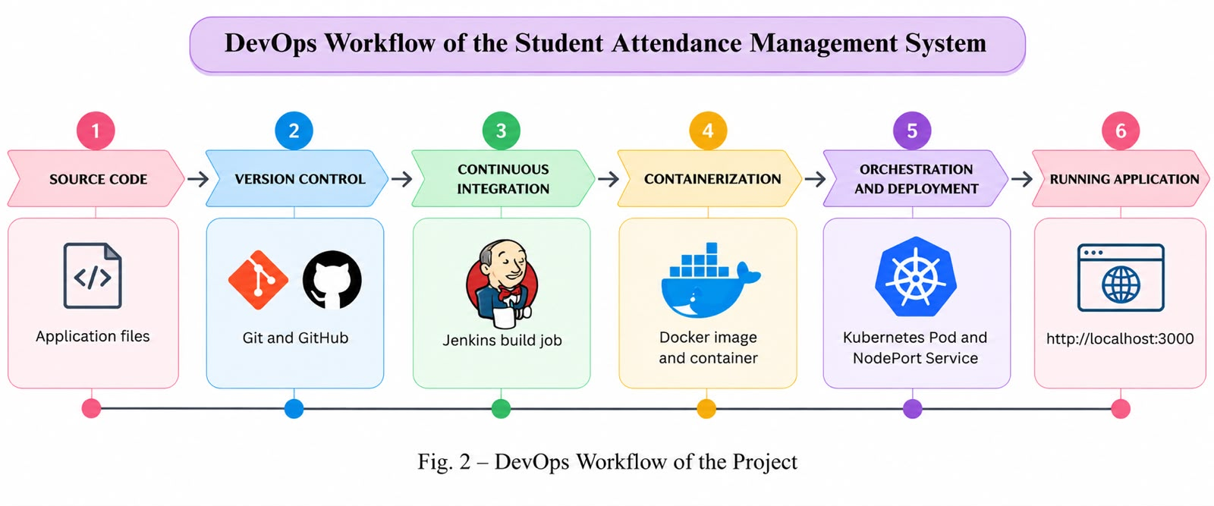
Fig. 2 – DevOps Workflow of the Project
10. DevOps Tools and Their Role
10.1 Git and GitHub
Git is used for local revision control, and GitHub hosts the remote repository under 'GunjanNashine/StudentAttendanceDevOps' (main branch, 3 commits). The repository includes server.js, package.json, package-lock.json, attendance.json, Dockerfile, .gitignore, .dockerignore, and a project README. Figure 3 illustrates the GitHub repository page.
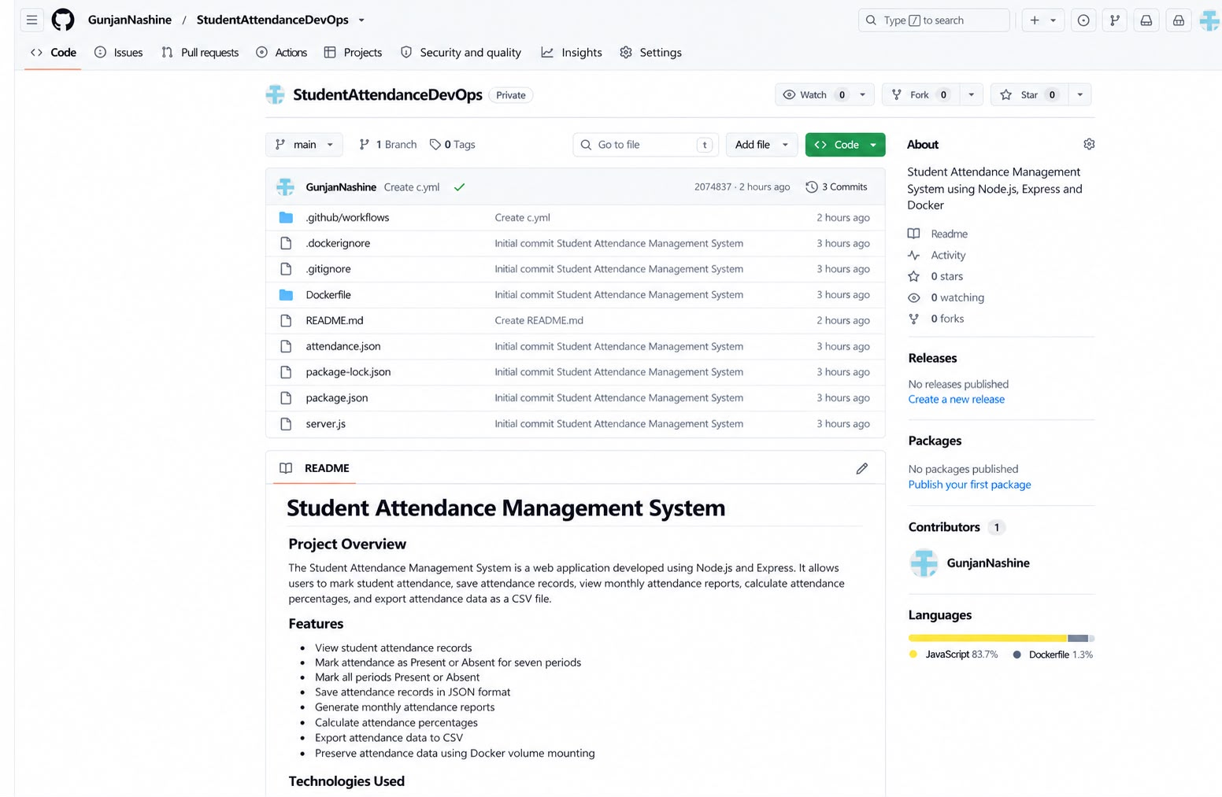
Fig. 3 – Student Attendance Management System Repository on GitHub

10.2 Jenkins Continuous Integration
A Jenkins job named 'StudentAttendance-CI' was configured to pull source code from the GitHub repository and run automated build commands. As shown in Figure 4, the build history lists four consecutive successful builds (#1, #2, #3, and #4) marked with green status indicators, validating continuous integration and automated code verification.
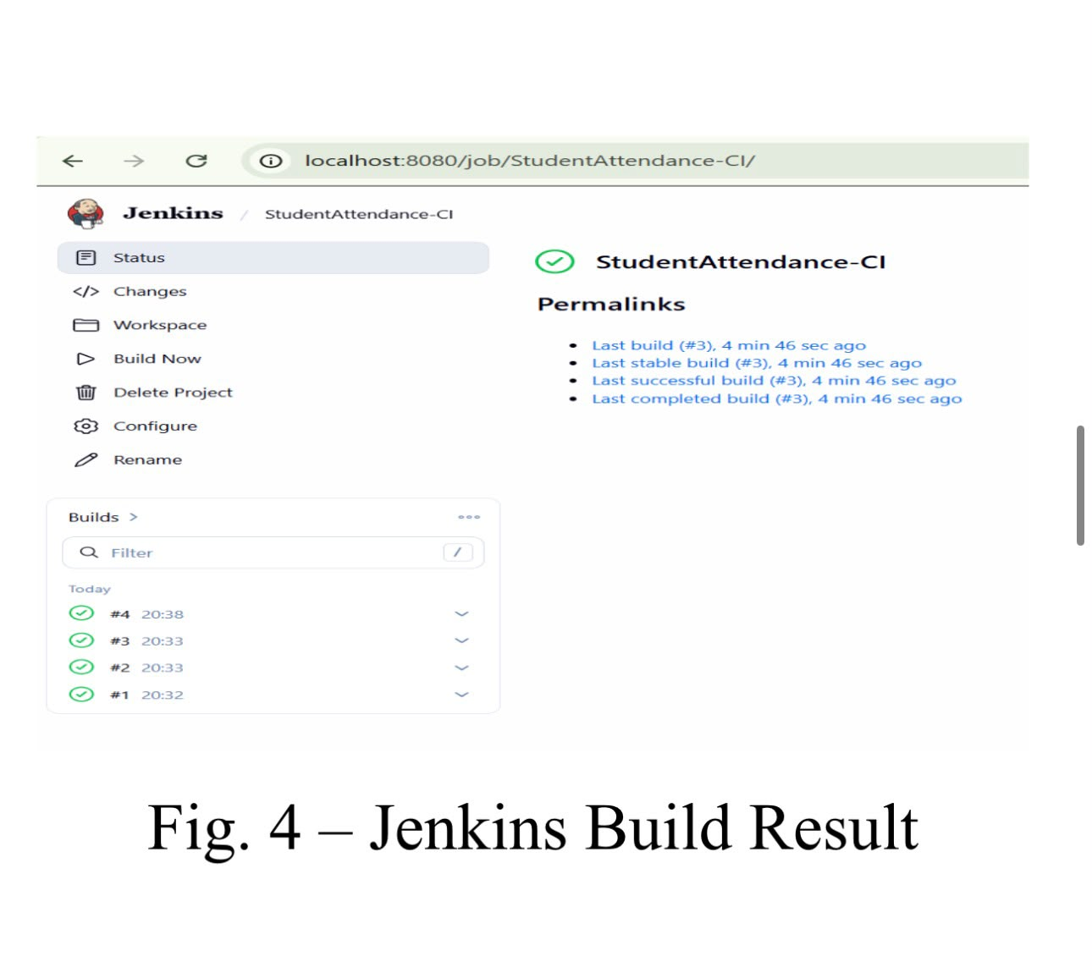
Fig. 4 – Jenkins Build Result (StudentAttendance-CI Successful Builds #1 to #4)
10.3 Docker Containerization
Docker packages the Node.js application, dependencies, and static web assets into a portable container image. The Dockerfile selects a Node.js base image, establishes the working directory, copies dependency definitions, runs 'npm install', copies application files, and specifies the start command. The standalone container was managed via Docker Desktop and exposed on host port 3001, mapped to internal port 3000.

10.4 Kubernetes Deployment and Orchestration
Kubernetes orchestrates deployment and external service access on the local cluster provided by Docker Desktop (kubeadm v1.36.1). Figure 5(a) displays the Docker Desktop Kubernetes dashboard with active single-node cluster, deployment 'student-attendance' (status: Available, 1/1 Pods), and running Pod 'student-attendance-67dfdc558d-f4zx8'.
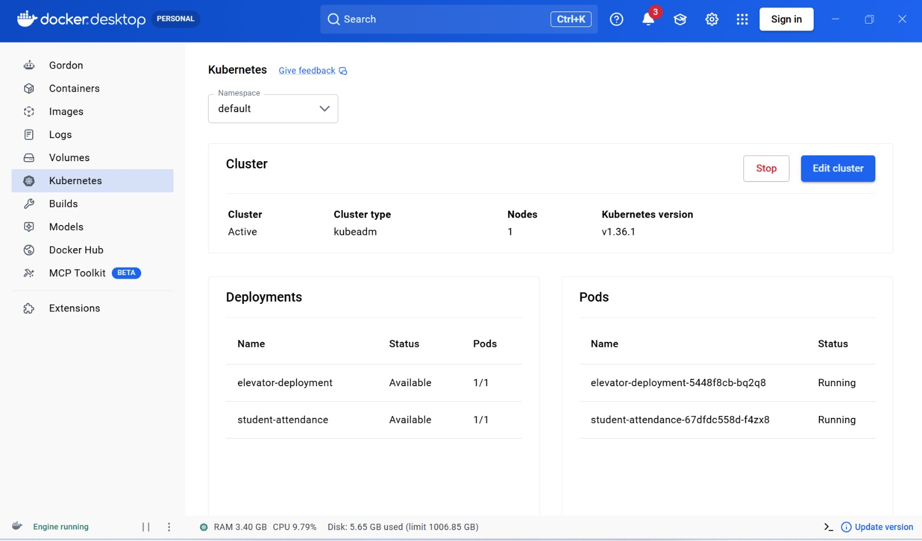
Fig. 5(a) – Docker Desktop Kubernetes Dashboard: Deployments and Running Pods
Figure 5(b) displays the CLI output of 'kubectl get pods,services' executed in C:\Users\GunjanNashine\Desktop\StudentAttendanceDevOps. The Pod 'student-attendance-7b8c9d6f5-km7nz' shows status 1/1 Ready, Running, with 0 restarts. The NodePort Service 'student-attendance-service' forwards internal port 3000 to node port 30567.
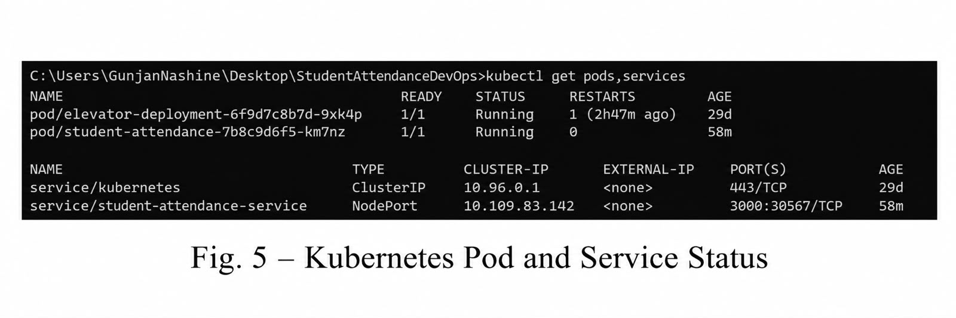
Fig. 5(b) – Kubernetes Pod and Service Status (NodePort Port 30567)

11. Results – Daily Attendance Interface
Figure 6 shows the Daily Attendance interface for date 24-10-2026. The roster lists five registered students: Roll 301 (Ishita Rao, CSE), Roll 302 (Vivek Singh, CSE), Roll 303 (Meera Shah, CSE), Roll 304 (Arnav Gupta, CSE), and Roll 305 (Diya Nair, CSE). For each student, seven drop-down selectors represent periods P1 to P7 with 'Present' or 'Absent' options.
Above the table, four functional buttons are available: 'Load Date' (retrieves saved records), 'Mark All Present' (sets all 35 period selectors to Present), 'Mark All Absent' (sets all selectors to Absent), and 'Save Attendance' (commits records to attendance.json). A confirmation message informs faculty: 'Date loaded. Review attendance and click Save Attendance.' The page loaded correctly and was accessible via the local Kubernetes NodePort deployment.
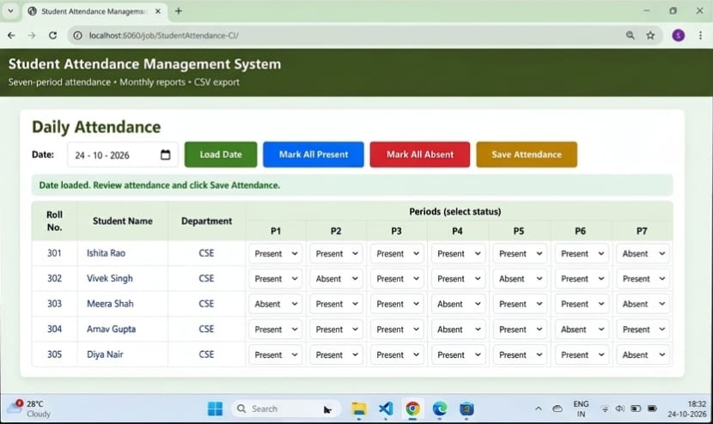
Fig. 6 – Daily Attendance Interface (Date: 24-10-2026, Periods P1 to P7)

12. Results – Monthly Attendance Summary
Figure 7 presents the Monthly Attendance Summary for October 2026. Summary metric cards display: Registered Students (5), Saved Attendance Days (1), and Total Attendance Records (35 = 5 students × 7 periods). The table lists Present periods, Absent periods, Working Periods (7), Attendance Percentage, and academic Status for all students.
• Ishita Rao (Roll 301) and Diya Nair (Roll 305) achieved 85.71% attendance (6 Present, 1 Absent) and are marked 'Satisfactory'.
• Vivek Singh (Roll 302) and Arnav Gupta (Roll 304) achieved 71.43% attendance (5 Present, 2 Absent) and are flagged 'Below 75%'.
• Meera Shah (Roll 303) recorded 57.14% attendance (4 Present, 3 Absent) and is flagged 'Below 75%'.
A note confirms: 'Monthly working periods count only periods in saved attendance records.' The 'Export CSV' button downloads the summary table as a spreadsheet.
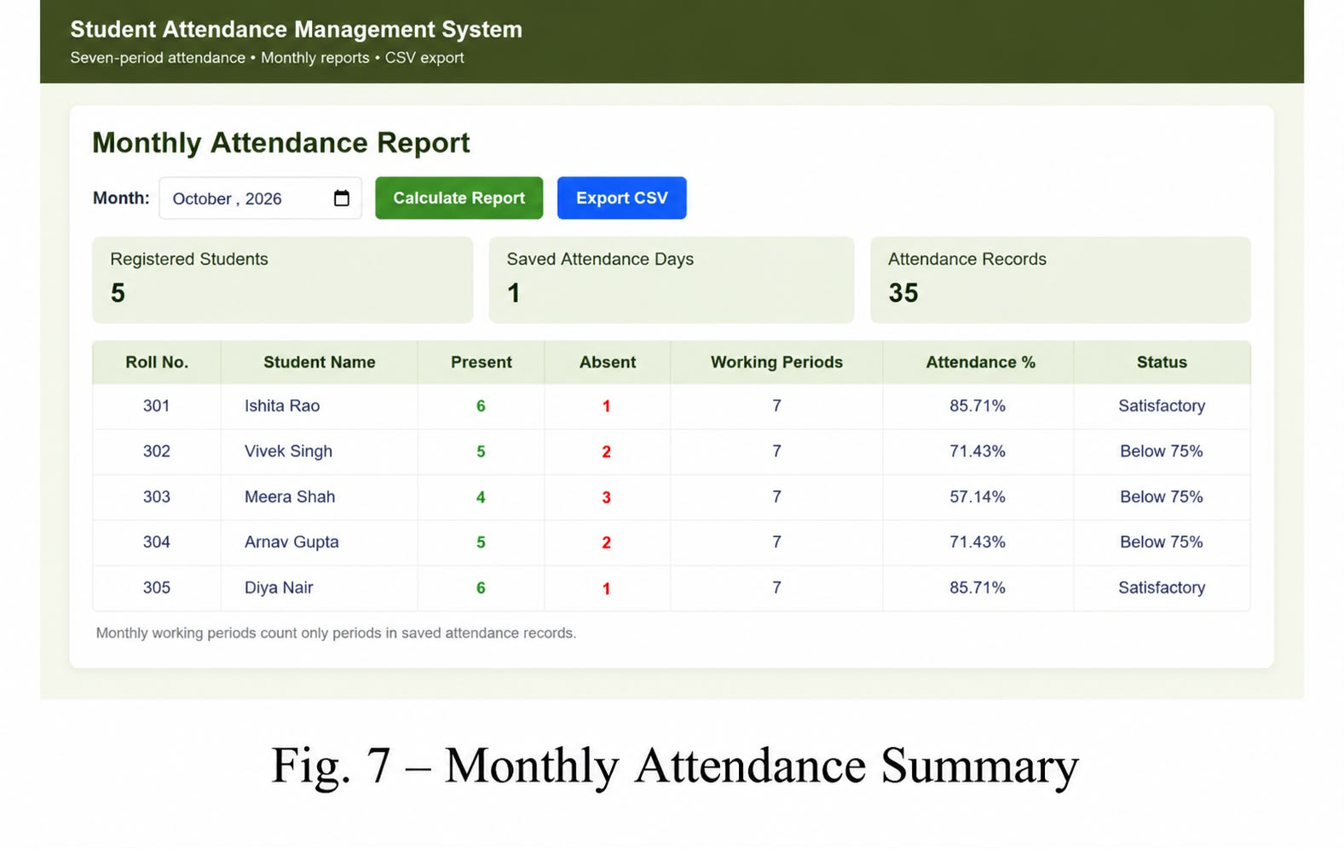
Fig. 7 – Monthly Attendance Summary (October 2026)

13. Testing and Results
Table 3 summarizes the operational test cases executed across the web application and DevOps pipeline.
Test Case Description | Expected Operational Result | Status
Open the application | Attendance page loads correctly in browser. | Passed (Fig. 6)
View student records | Student list (Roll 301-305) is displayed. | Passed (Fig. 6)
Mark seven daily periods | Present/Absent selectable for P1–P7 drop-downs. | Passed (Fig. 6)
Batch attendance actions | Mark All Present/Absent buttons populate table. | Passed (Fig. 6)
Save and load attendance | Records are stored in attendance.json and retrieved. | Passed (Fig. 6, 7)
Generate monthly summary | Summary metrics (5 students, 35 records) render. | Passed (Fig. 7)
Calculate percentages | Percentages accurately computed: (Present ÷ 7) × 100. | Passed (Fig. 7)
Highlight defaulters | Students with <75% attendance labeled 'Below 75%'. | Passed (Fig. 7)
Export CSV report | Report downloads as CSV spreadsheet file. | Passed (Export CSV)
DevOps pipeline execution | Jenkins builds complete, Docker runs, K8s deploys. | Passed (Fig. 4, 5)
14. Limitations and Future Enhancements
Future enhancements include: 1) Transitioning from JSON file storage to a relational database (SQLite/MySQL); 2) Adding user authentication and role-based permissions (admin/faculty); 3) Writing automated Selenium WebDriver test suites; 4) Configuring persistent volume claims in Kubernetes; 5) Deploying the application to cloud clusters (AWS EKS/GCP GKE).
15. Conclusion
The Student Attendance Management System demonstrates an efficient, digital approach to classroom attendance. It eliminates paper registers, streamlines 7-period daily entry, automates monthly calculations, flags defaulters below 75%, and provides CSV exports. It also serves as a comprehensive DevOps exercise across Git, GitHub, Jenkins build automation, Docker containerization, and Kubernetes cluster orchestration.
16. References & Appendix: Important Commands
References: Node.js (nodejs.org), Express.js (expressjs.com), Git (git-scm.com), GitHub (github.com), Jenkins (jenkins.io), Docker (docker.com), Kubernetes (kubernetes.io).
Operational Task | Executed CLI Command
Install dependencies & Start Server | npm install && npm start
Build Docker image | docker build -t student-attendance .
Run Docker container | docker run -d -p 3001:3000 student-attendance
Check Kubernetes Pods and Services | kubectl get pods,services

