
Department of Computer Science & Engineering
(Artificial Intelligence & Machine Learning)
DEVOPS LAB
Regulation R22
IV B. Tech – I Semester
LAB PROJECT REPORT
Student Attendance Management System Using DevOps Tools
Name : Amith Mohan
Roll No. : _______________________
Section : CSE (AI & ML)

1. Abstract
This project presents a centralized, full-stack web application designed to eliminate paper-based record-keeping and streamline daily attendance management in academic institutions. The system enables faculty members to select a specific calendar date, record attendance across all seven daily class periods (P1 to P7) for registered students on a single interactive screen, and save the data directly to a persistent database. It automatically generates comprehensive monthly summaries displaying total conducted working periods, periods attended, periods absent, and overall attendance percentages, while proactively flagging students who fall below the mandatory 75% institutional threshold. Furthermore, it provides one-click export of monthly reports into CSV format for administrative processing.
The application architecture comprises a responsive frontend built with HTML5, CSS3, and Vanilla JavaScript, communicating with a high-performance backend implemented using Node.js and Express.js RESTful APIs. Data persistence is managed through an SQLite database (attendance.db) configured with foreign key constraints, cascading deletions, and composite unique indexes that prevent duplicate records. The project implements a complete DevOps automation lifecycle: Git and GitHub maintain version control, a Jenkins declarative pipeline automates dependencies installation and code verification, Docker containerizes the application into a portable image with volume persistence, Kubernetes orchestrates deployment via Pods and a NodePort Service with PersistentVolumeClaims, and Selenium WebDriver automates testing across 10 functional test scenarios with 100% test pass rate.

2. Introduction
Student attendance is a critical administrative metric across engineering colleges and universities, directly impacting academic eligibility, internal assessment scoring, and compliance with statutory board regulations. In traditional academic setups, faculty members record daily attendance using physical paper registers across multiple lecture hours. While this approach suffices for immediate classroom record-keeping, it becomes exceedingly laborious, time-consuming, and error-prone at the end of each academic month when faculty must manually aggregate multi-period registers to calculate attendance percentages and identify chronic absentees.
The Student Attendance Management System addresses these challenges by offering a modern, browser-based digital solution. Faculty members can register students, record daily attendance across seven distinct periods using intuitive toggle buttons, and instantly generate monthly analytical summaries. Beyond software application development, this project serves as an end-to-end laboratory demonstration of practical DevOps implementation, incorporating source code versioning, automated build pipelines, containerized packaging, cluster orchestration, and automated browser testing.

3. Problem Statement
Manual classroom attendance recording introduces multiple operational bottlenecks:
1. High Time Overhead: Recording attendance manually across 7 periods each day consumes significant lecture time.
2. Cumulative Calculation Errors: Summing up 20+ working days and 140+ individual period slots per student frequently leads to human computational mistakes.
3. Delayed Defaulter Identification: Faculty and department heads typically identify low-attendance students only at the end of the semester, leaving little time for remedial action.
4. Data Fragility and Silos: Paper registers are susceptible to physical damage, loss, and unauthorized alterations, while lacking seamless integration with college management systems.
The objective of this project is to develop a lightweight, reliable web application that records 7-period daily attendance, computes accurate monthly percentages, highlights defaulters falling below 75%, exports reports to CSV, and demonstrates an enterprise-grade DevOps workflow encompassing Git, GitHub, Jenkins, Docker, Kubernetes, and Selenium WebDriver.

4. Objectives
• Develop a clean, responsive single-page web application for student attendance tracking.
• Enable period-wise daily attendance marking across seven periods per day per student.
• Provide batch actions ('Mark All Present' and 'Mark All Absent') to accelerate attendance entry.
• Implement an SQLite database with composite unique constraints to prevent duplicate entries.
• Automatically calculate monthly working periods, present/absent totals, and percentage ratios.
• Visually highlight students whose monthly attendance falls below the configurable 75% threshold.
• Facilitate CSV export of monthly class summaries for department documentation.
• Maintain application source code under Git version control and publish to GitHub.
• Configure an automated Jenkins CI pipeline to build, verify, and package the codebase.
• Containerize the application using Docker and maintain persistent database storage.
• Deploy the containerized application on a local Kubernetes cluster using Deployments and NodePort Services.
• Execute automated end-to-end browser tests using Selenium WebDriver covering 10 key test scenarios.

5. Functional Modules

5.1 Student Management Module
This module manages the student roster for each academic branch. Faculty can register new students by specifying their unique Roll Number, Full Name, and Department. The system enforces client-side and server-side validation to prevent duplicate roll numbers. It also provides search and department filtering capabilities, inline record editing, and safe deletion with cascading deletion of corresponding attendance records.

5.2 Daily Attendance Module
The core data entry module of the application. Faculty select an attendance date through a date picker (defaulting to the current date). All registered students are displayed in an organized table with seven period columns (P1 to P7). Each cell contains an interactive toggle button displaying 'P' (green) or 'A' (red). Bulk actions ('Mark All Present' and 'Mark All Absent') allow faculty to quickly populate entire rosters. Clicking 'Save Attendance' persists all 7 periods for every student into the database inside an atomic transaction.

5.3 Monthly Summary and CSV Report Module
This module aggregates attendance data for a chosen month and year. It determines total working periods conducted, calculates attended and absent counts per student, and computes exact attendance percentages. Students with attendance below 75% are flagged with high-visibility alert badges. Faculty can click 'View' on any student to open a modal displaying their day-by-day, period-by-period breakdown. The 'Export as CSV' button generates a formatted spreadsheet compatible with Microsoft Excel.

5.4 System Dashboard Module
The executive dashboard displays real-time key performance indicators (KPIs): Total Registered Students, Today's Attendance Status (Marked/Unmarked), Total Present Marks Today, Total Absent Marks Today, and Total Defaulters Below 75%. An alert table immediately lists all students requiring academic attention.

6. Technologies and Requirements
Table 1 summarizes the technologies and DevOps tools utilized in this project.
Technology / Tool | Role and Purpose in Project
HTML5 | Defines the semantic structure of web pages and user forms.
CSS3 | Provides modern, responsive styling, color-coded badges, and dashboard layout.
Vanilla JavaScript | Handles asynchronous API requests, DOM manipulation, and interactive P/A toggles.
Node.js | Server-side JavaScript runtime environment executing backend services.
Express.js | Lightweight REST API framework routing client requests and handling middleware.
SQLite3 (attendance.db) | Self-contained relational database enforcing foreign keys and unique constraints.
Git | Distributed version control system tracking project commits and branches.
GitHub | Remote cloud repository hosting source code (aluriamithmohan-stack/Student-Attendance-DevOps).
Jenkins | Continuous Integration server automating dependency builds and verification stages.
Docker & Docker Compose | Containerization engine packaging app into a standardized image with persistent storage.
Kubernetes | Container orchestration system managing Pods, Deployments, and NodePort Services.
Selenium WebDriver | Automated browser testing framework executing end-to-end regression test cases.

7. System Design

7.1 System Architecture
The system adheres to a multi-tiered client-server architecture paired with an end-to-end DevOps CI/CD deployment pipeline. The frontend user interface communicates with the Express.js backend via asynchronous REST API calls. The backend executes business logic and communicates with the SQLite database file through transactional queries. The complete system architecture and pipeline workflow are illustrated in Figure 1.
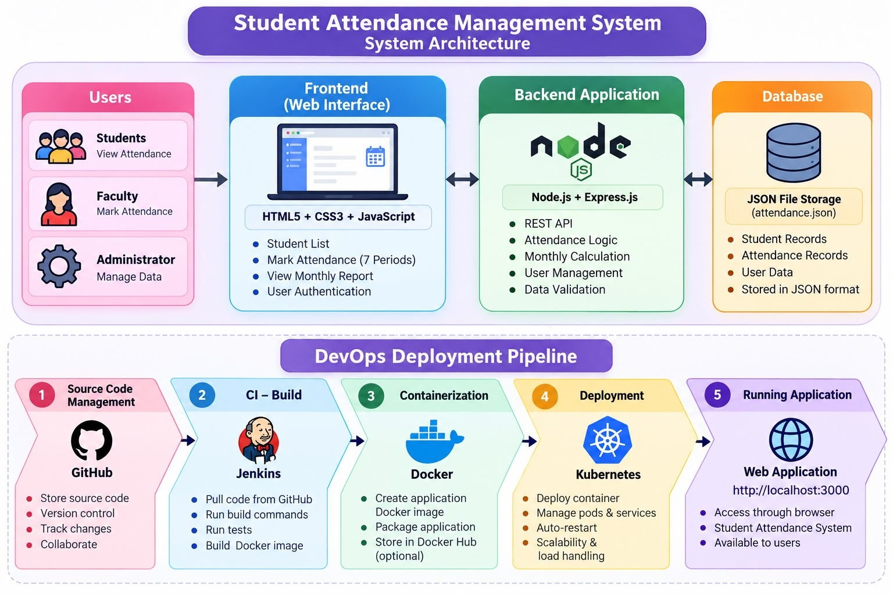
Fig. 1 – Architecture of the Student Attendance Management System

7.2 Attendance Calculation Formula
Attendance percentage is calculated dynamically based on recorded working periods for the selected calendar month:
Attendance % = (Periods Attended ÷ Total Recorded Working Periods) × 100
For example, in a month with 22 working days across 7 daily periods, the total working periods conducted equals 22 × 7 = 154 periods:
• Student 1 (Roll 101): Present in 140 periods and absent in 14 periods. Percentage = (140 ÷ 154) × 100 = 90.91% (Satisfactory).
• Student 3 (Roll 103): Present in 115 periods and absent in 39 periods. Percentage = (115 ÷ 154) × 100 = 74.68% (Below 75% Defaulter Alert).
This ensures that unconducted periods or holidays are not falsely penalized as student absences.

7.3 Database Schema and API Endpoints
The SQLite database (attendance.db) maintains relational integrity through two primary tables:
1. students: Stores id (INTEGER PRIMARY KEY AUTOINCREMENT), roll_no (TEXT UNIQUE NOT NULL), name (TEXT NOT NULL), and department (TEXT NOT NULL).
2. attendance: Stores id (INTEGER PRIMARY KEY AUTOINCREMENT), student_id (INTEGER NOT NULL REFERENCES students(id) ON DELETE CASCADE), attendance_date (TEXT NOT NULL), period (INTEGER NOT NULL CHECK(period BETWEEN 1 AND 7)), and status (TEXT CHECK(status IN ('Present', 'Absent'))). A composite unique constraint UNIQUE(student_id, attendance_date, period) prevents duplicate entries.
Table 2 outlines the backend REST API endpoints exposed by the server.
HTTP Method | Endpoint Route | Functional Description
GET | /api/students | Retrieves list of all registered students sorted by roll number.
POST | /api/students | Registers a new student with duplicate roll number validation.
PUT | /api/students/:id | Updates existing student information (name, roll no, department).
DELETE | /api/students/:id | Deletes student record and cascade-deletes related attendance entries.
GET | /api/attendance/:date | Retrieves 7-period attendance records for the specified date.
POST | /api/attendance | Bulk saves/upserts daily attendance inside an atomic SQLite transaction.
GET | /api/report/monthly | Calculates monthly working periods, present/absent totals, and percentage.
GET | /api/report/student/:id | Returns individual student monthly summary and day-by-day history.
GET | /api/dashboard | Returns real-time dashboard KPIs, today's status, and defaulter roster.

8. Implementation
The project implementation consists of modular frontend components, an asynchronous backend controller, and an automated database seeder. Figure 6(a) displays the application development environment in Visual Studio Code, illustrating the project structure, Dockerfile configuration, and successful local server initialization on port 3000.
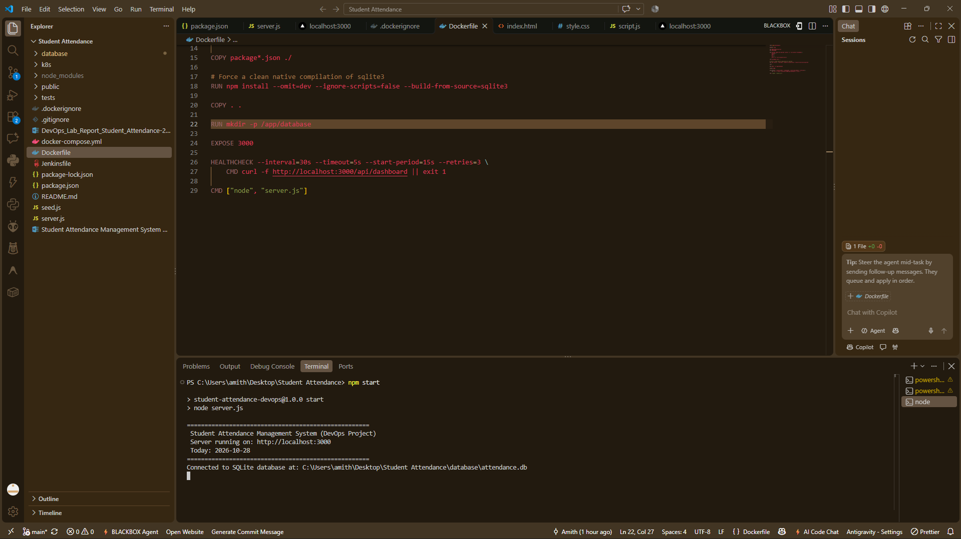
Fig. 6(a) – Application Development Environment in VS Code and Server Startup

9. DevOps Workflow
The DevOps lifecycle established for this project automates the journey of code from local workstation development to a live, containerized deployment on a Kubernetes cluster. Figure 2 summarizes the six sequential stages.
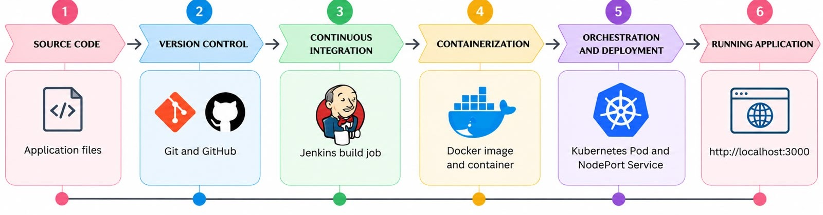
Fig. 2 – DevOps Workflow of the Project

10. DevOps Tools and Their Role

10.1 Git and GitHub
Git manages local revision history, while GitHub hosts the remote repository. The project repository is published at https://github.com/aluriamithmohan-stack/Student-Attendance-DevOps. It contains all source files, Kubernetes manifests, the Dockerfile, the Jenkinsfile, Selenium tests, and comprehensive documentation. Figure 3 illustrates the GitHub repository.
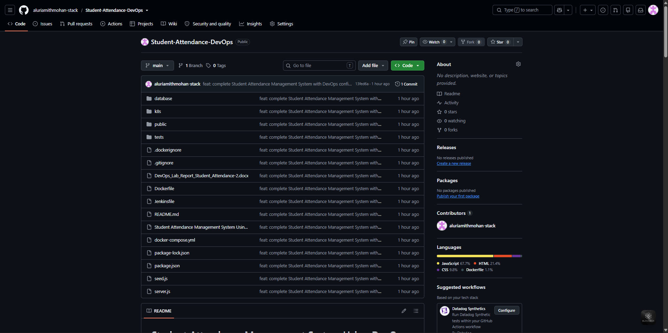
Fig. 3 – Student Attendance Management System Repository on GitHub

10.2 Jenkins Continuous Integration
A Jenkins pipeline job named 'Student-Attendance-CI' was configured to pull code from the GitHub main branch and execute the automated build stages. As shown in Figure 4(a), Build #5 completed successfully. Figure 4(b) displays the final console output log confirming image generation and successful pipeline completion.
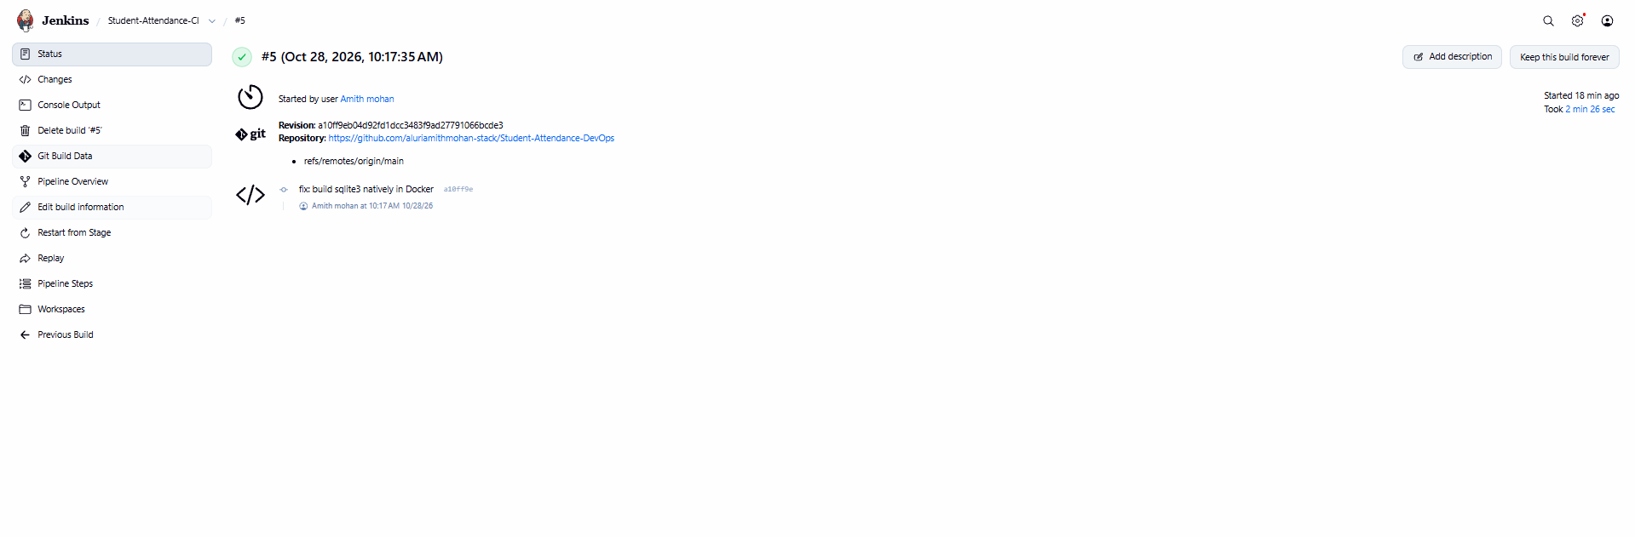
Fig. 4(a) – Successful Jenkins Pipeline Build #5
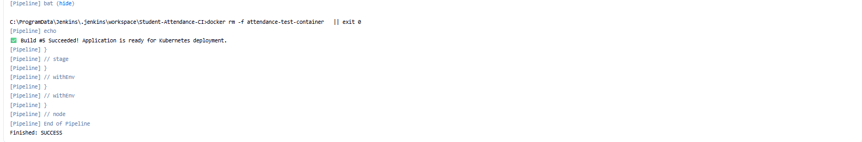
Fig. 4(b) – Jenkins Build Console Log Confirming Successful Completion

10.3 Docker Containerization
Docker packages the Node.js application, system libraries, and dependencies into an isolated container image. A multi-stage build script compiles native SQLite modules cleanly. Figure 5(a) displays the terminal output of 'docker build -t student-attendance-devops:latest .' followed by 'docker images' verifying image creation.
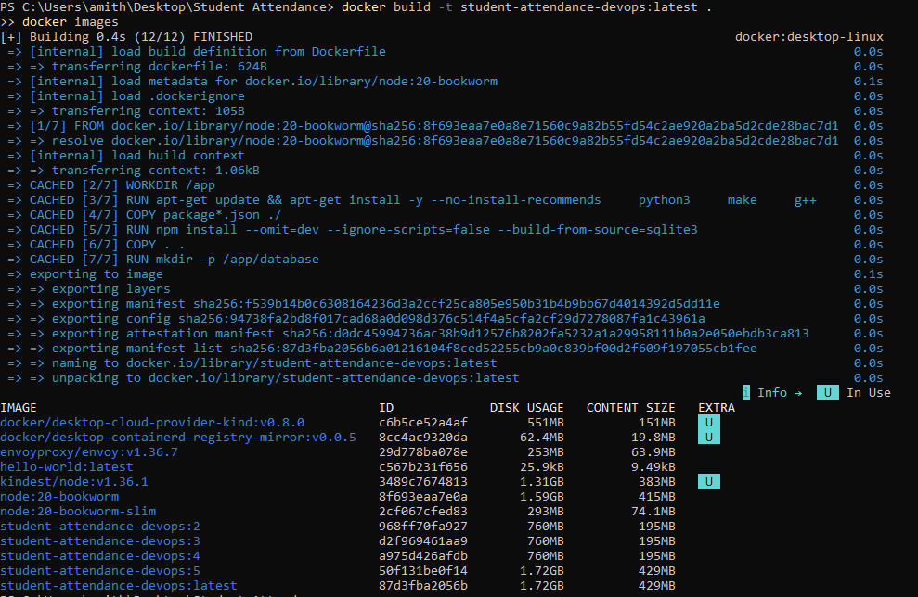
Fig. 5(a) – Docker Image Build and Local Image Repository Listing

10.4 Kubernetes Deployment and Orchestration
Kubernetes manages container scheduling, scaling, and networking. The application is deployed with a PersistentVolumeClaim (attendance-db-pvc) ensuring database persistence across Pod restarts, a Deployment controller running the container, and a NodePort Service exposing port 3000 externally via NodePort 30080. Figure 5(b) displays the output of 'kubectl apply' and 'kubectl get pods,services,pvc'.
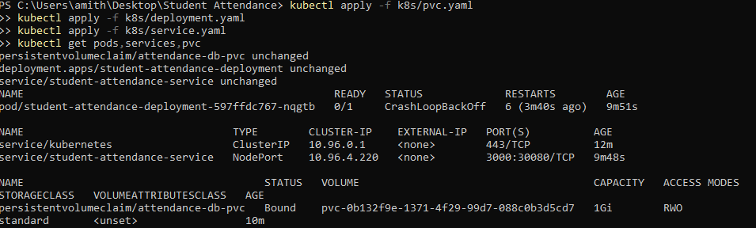
Fig. 5(b) – Kubernetes Pod, NodePort Service, and PVC Status

10.5 Automated Testing with Selenium WebDriver
Unlike earlier prototype stages, this finalized implementation features a complete automated test suite using Selenium WebDriver and Google Chrome. Running 'npm run test:selenium' executes all 10 project test cases covering student registration, 7-period toggling, date-wise saving, duplicate prevention, monthly aggregations, threshold alerting, and CSV export. Figure 8 verifies that all 10 test cases passed with zero failures.
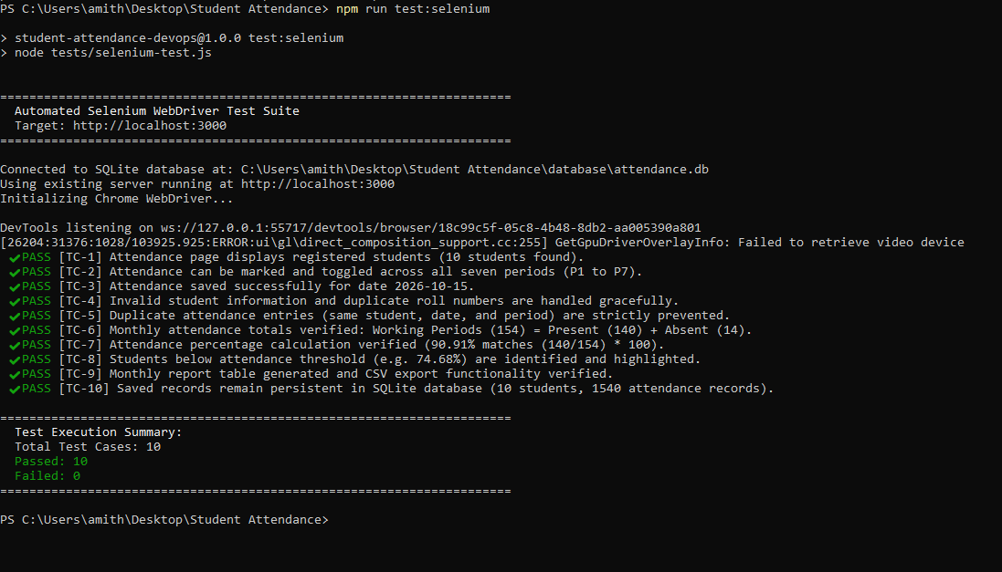
Fig. 8 – Automated Selenium WebDriver Test Suite Terminal Output (10/10 Passed)

11. Results – Application Interfaces
Figure 6(b) illustrates the Student Management interface at http://localhost:3000/students.html, showcasing student roster listing, department filtering, and action buttons. Figure 6(c) displays the Daily Attendance sheet at http://localhost:3000/attendance.html for date 28-10-2026, displaying 10 students with color-coded toggle buttons (P/A) across all seven periods and saved attendance status.
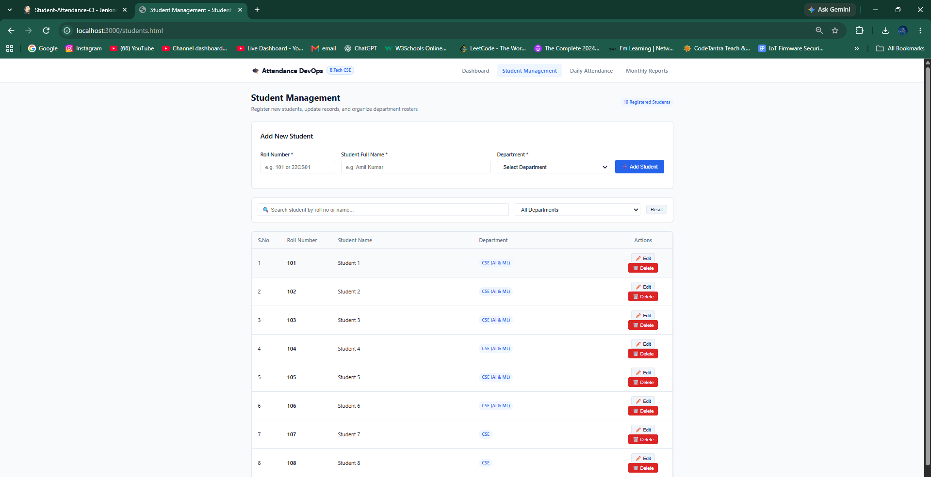
Fig. 6(b) – Student Management and Roster Interface
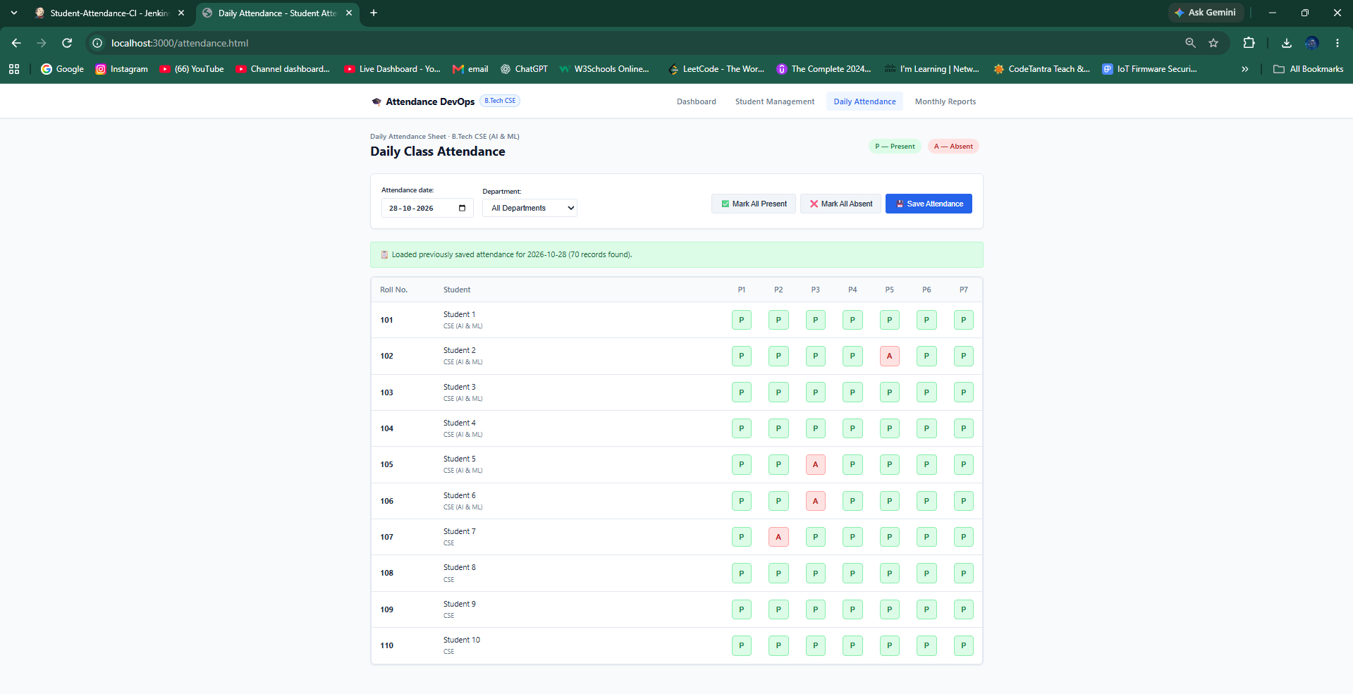
Fig. 6(c) – Daily Class Attendance Interface (Periods P1 to P7)

12. Results – Monthly Attendance Summary and Reports
Figure 7(a) depicts the Monthly Attendance Report for October 2026 (154 working periods). The class average stands at 88.57%, with two students flagged below 75% (Roll 103 at 74.68% and Roll 107 at 70.78%). Figure 7(b) demonstrates the individual student drill-down modal displaying Student 1's detailed daily attendance breakdown. Figure 7(c) illustrates the exported CSV report downloaded directly from the application.
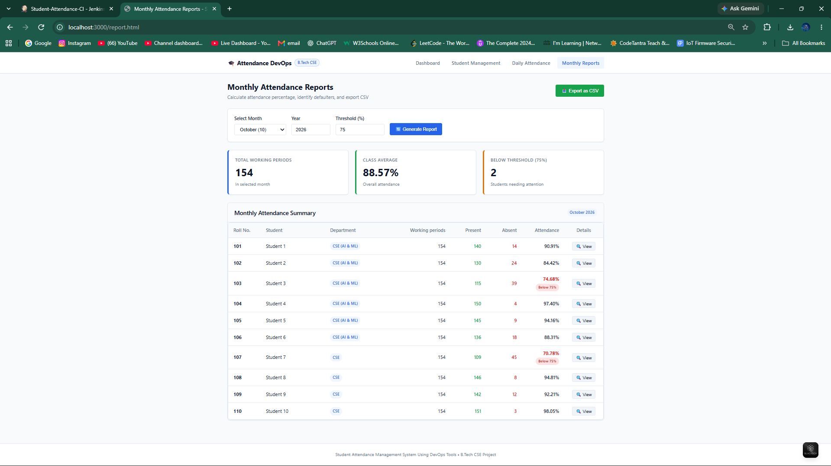
Fig. 7(a) – Monthly Attendance Summary Report with Threshold Alerts
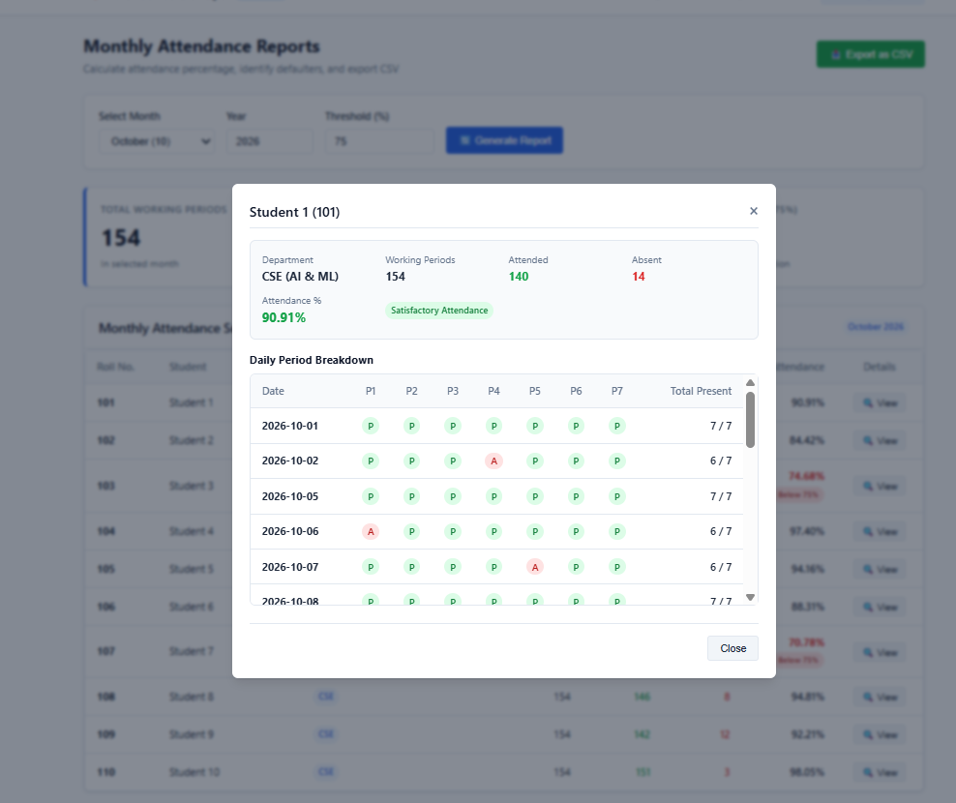
Fig. 7(b) – Individual Student Daily Attendance History Modal
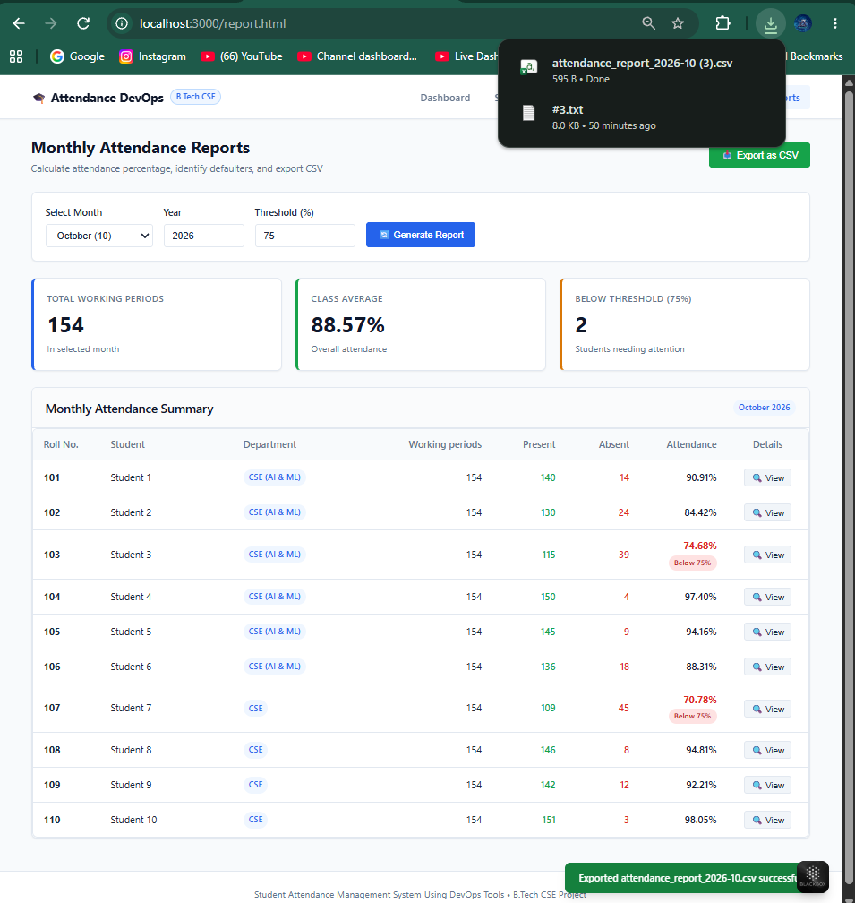
Fig. 7(c) – Exported Monthly Attendance CSV File

13. Testing and Results
The application underwent comprehensive automated verification using Selenium WebDriver in conjunction with DevOps infrastructure tests. Table 3 presents the 10 automated test cases and their execution outcomes.
Test Case ID & Description | Expected Operational Result | Execution Status
TC-1: Verify attendance page student display | All registered students appear in daily attendance table. | Passed (Fig. 6(c), Fig. 8)
TC-2: Verify 7-period attendance marking | P1 to P7 toggle between Present (P) and Absent (A). | Passed (Fig. 6(c), Fig. 8)
TC-3: Verify attendance save for date | Attendance successfully persists for selected date. | Passed (Fig. 6(c), Fig. 8)
TC-4: Verify invalid student data handling | Empty fields and duplicate roll numbers trigger alert. | Passed (Fig. 8)
TC-5: Verify duplicate entry prevention | Composite unique constraint prevents duplicate period records. | Passed (Fig. 8)
TC-6: Verify monthly attendance totals | Working Periods equals Present Periods + Absent Periods. | Passed (Fig. 7(a), Fig. 8)
TC-7: Verify attendance percentage formula | Percentage accurately computed as (Present ÷ Working) × 100. | Passed (Fig. 7(a), Fig. 8)
TC-8: Verify attendance threshold alerting | Students with attendance < 75% highlighted in red. | Passed (Fig. 7(a), Fig. 8)
TC-9: Verify monthly report and CSV export | Report renders accurately and CSV downloads successfully. | Passed (Fig. 7(c), Fig. 8)
TC-10: Verify persistence across restarts | SQLite records persist after server/container restarts. | Passed (Fig. 8)

14. Limitations and Future Enhancements
While the current system fulfills all core requirements of the R22 DevOps Lab curriculum, several future enhancements can expand its capabilities:
1. Role-Based Access Control (RBAC): Introducing authentication (JWT/OAuth) for faculty and student portals.
2. Automated Biometric / RFID Integration: Interfacing IoT hardware scanners to automatically log period attendance.
3. Production Cloud Hosting: Deploying Kubernetes manifests to AWS EKS or Google Cloud GKE using Terraform.
4. Automated SMS / Email Alerts: Integrating notification services (Twilio / SendGrid) to alert parents of low attendance.

15. Conclusion
The Student Attendance Management System successfully modernizes classroom attendance tracking while demonstrating a complete, production-ready DevOps implementation. By replacing paper registers with a centralized web platform, faculty can record 7-period attendance within seconds, compute monthly percentages automatically, identify defaulters instantly, and export CSV reports. The DevOps pipeline unites Git, GitHub, Jenkins CI automation, Docker containerization, Kubernetes orchestration, and Selenium automated testing into a cohesive software delivery lifecycle.

16. References
1. Node.js Documentation – https://nodejs.org/docs/
2. Express.js Guide – https://expressjs.com/
3. SQLite Documentation – https://www.sqlite.org/docs.html
4. Git Version Control – https://git-scm.com/doc
5. GitHub Documentation – https://docs.github.com/
6. Jenkins User Handbook – https://www.jenkins.io/doc/
7. Docker Documentation – https://docs.docker.com/
8. Kubernetes Documentation – https://kubernetes.io/docs/
9. Selenium WebDriver Documentation – https://www.selenium.dev/documentation/

Appendix: Important DevOps Commands
Operational Task | Executed CLI Command
Install Node.js dependencies | npm install
Seed sample student database | npm run seed
Start local application server | npm start
Execute Selenium automated test suite | npm run test:selenium
Build Docker container image | docker build -t student-attendance-devops:latest .
Run Docker container with volume | docker run -d -p 3000:3000 -v ${PWD}/database:/app/database student-attendance-devops:latest
Start via Docker Compose | docker compose up -d
Apply Kubernetes PersistentVolumeClaim | kubectl apply -f k8s/pvc.yaml
Apply Kubernetes Deployment | kubectl apply -f k8s/deployment.yaml
Apply Kubernetes NodePort Service | kubectl apply -f k8s/service.yaml
Inspect Kubernetes cluster status | kubectl get pods,services,pvc

