SQL Transactions and Isolation Levels
3. Setup
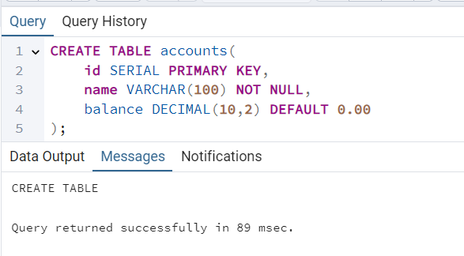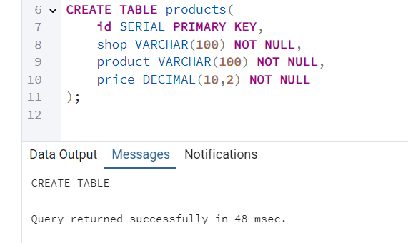
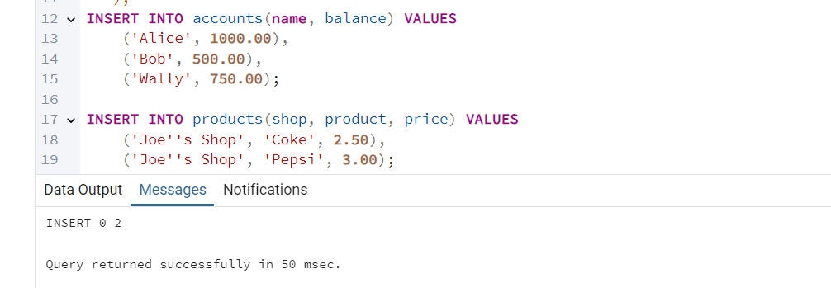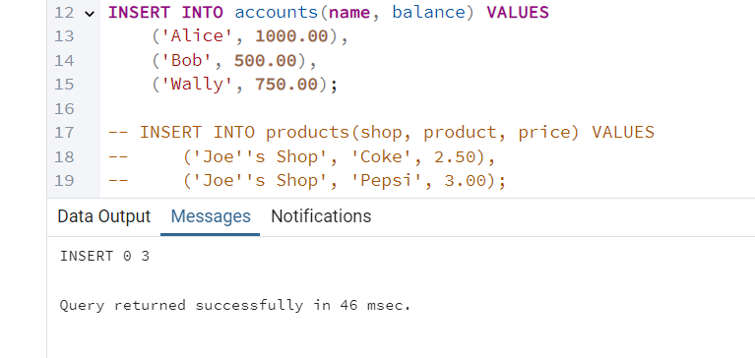
3.2 Task 1: Basic Transaction with COMMIT
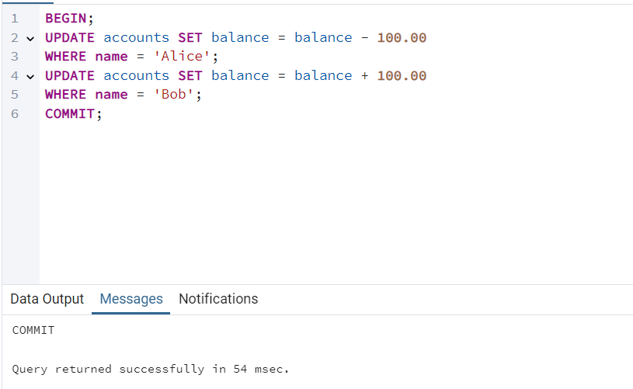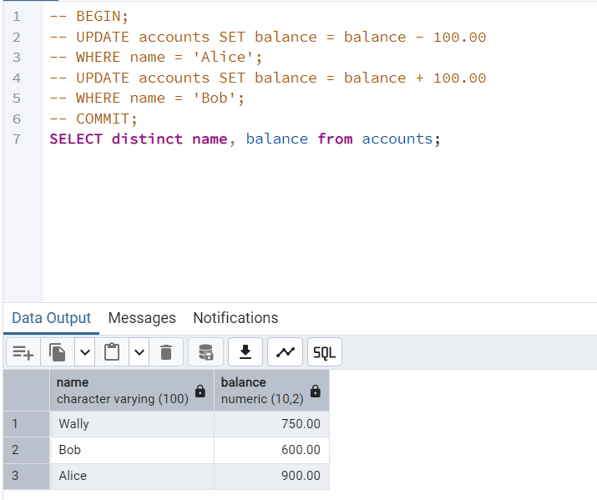
Q&A:
- Alice = 900.00; Bob = 600.00
- Because transferring money requires atomicity: both operations must succeed together (or both must fail). Otherwise, the database could end up inconsistent (Alice loses money but Bob does not receive it).
- Alice’s balance could be reduced, but Bob’s balance would not increase. So, this leads to: lost money, data corruption, violation of atomicity and consistency.
3.3 Task 2: Using ROLLBACK
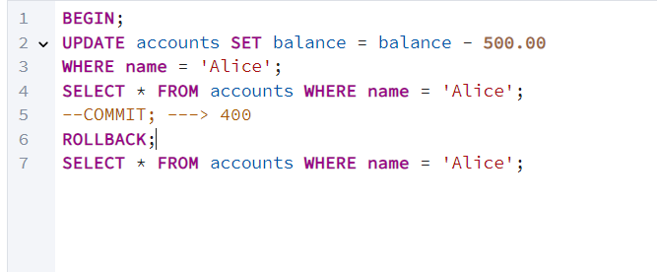
- Alice initially had 900.00. After subtraction 900.00-500.00 = 400.00
- The update in undone, so she returns to previous value - 900.00.
- When incorrect data is entered, a constraint check fails, part of multi-step operation encounters an error, a user cancels a financial operation.

3.4 Task 3: Working with SAVEPOINTs
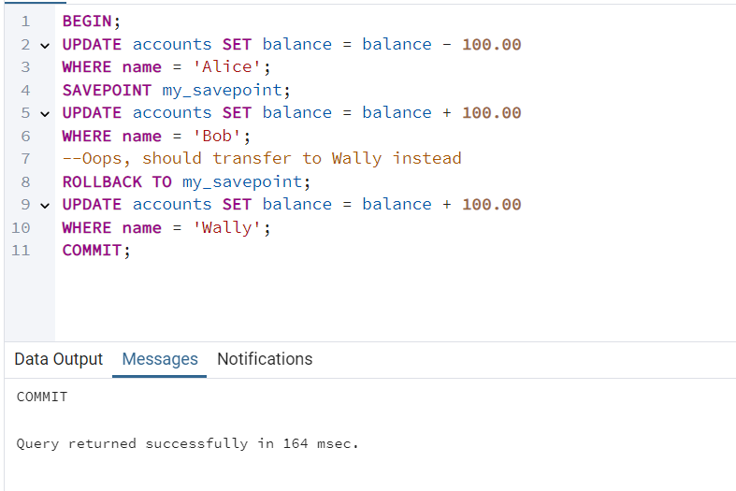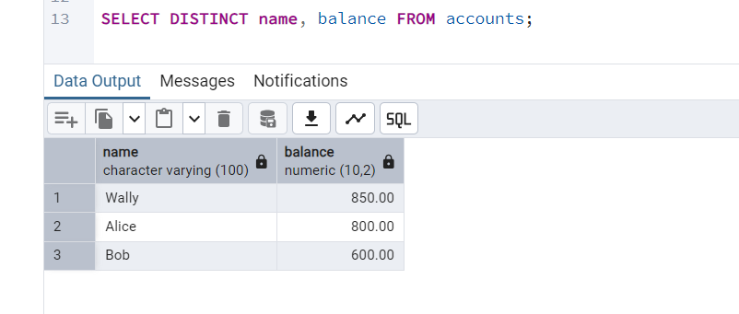
Q&A:
- Alice = 800.00, Bob = 600.00, Wally = 850.00
- Yes, temporarily inside the transaction, but ROLLBACK TO SAVEPOINT undid that change. So, Bob is not credited.
- SAVEPOINT allows partial rollback, keeping earlier work, avoiding re-executing entire transaction. It is more efficient and safer for complex operations.
3.5 Task 4: Isolation Level Demonstration
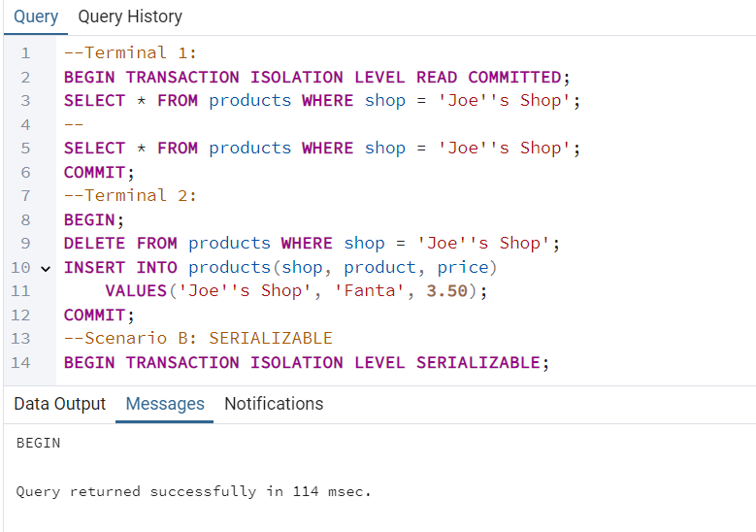
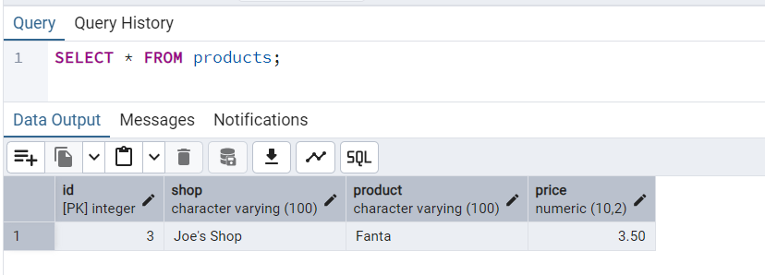
Q&A:
- Before Terminal 2 commits: old data - Coke, Pepsi
After Terminal 2 commits: new data – Fanta
- Terminal 1 creates a snapshot at start. It will always see: Coke, Pepsi. Evem after Terminal 2 commits, because SERIALIZABLE prevents phantom changes.
- READ COMMITED – Each query sees the latest comitted data. Re-query may show changes.
SERIALIZABLE – Entire transaction uses a consistent snapshot. Changes by others are invisible.

3.6 Task 5: Phantom Read Demonstration
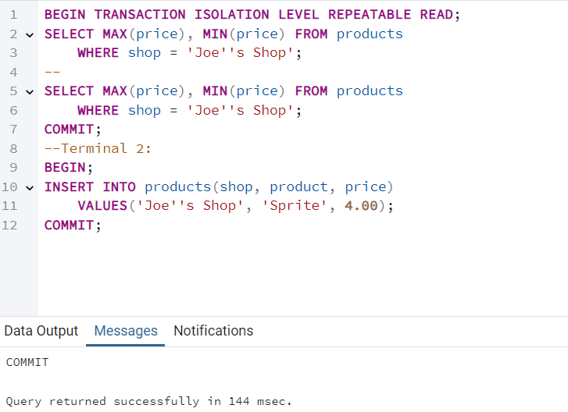
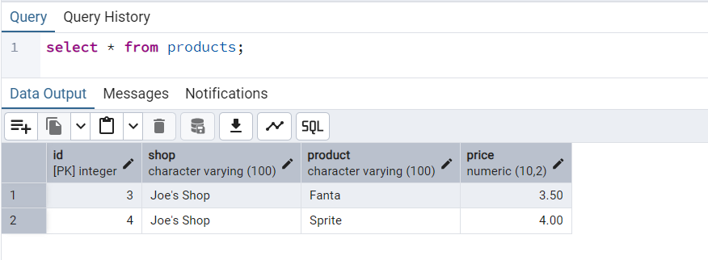
Q&A:
- No. In REPEATABLE READ, the transaction uses a snapshot created at BEGIN. So, Terminal 1 does not see Sprite 4.00.
- When a repeated query returns additional or missing rows inserted/removed by another transaction.
- SERIALIZABLE

3.7 Task 6: Dirty Read Demonstration
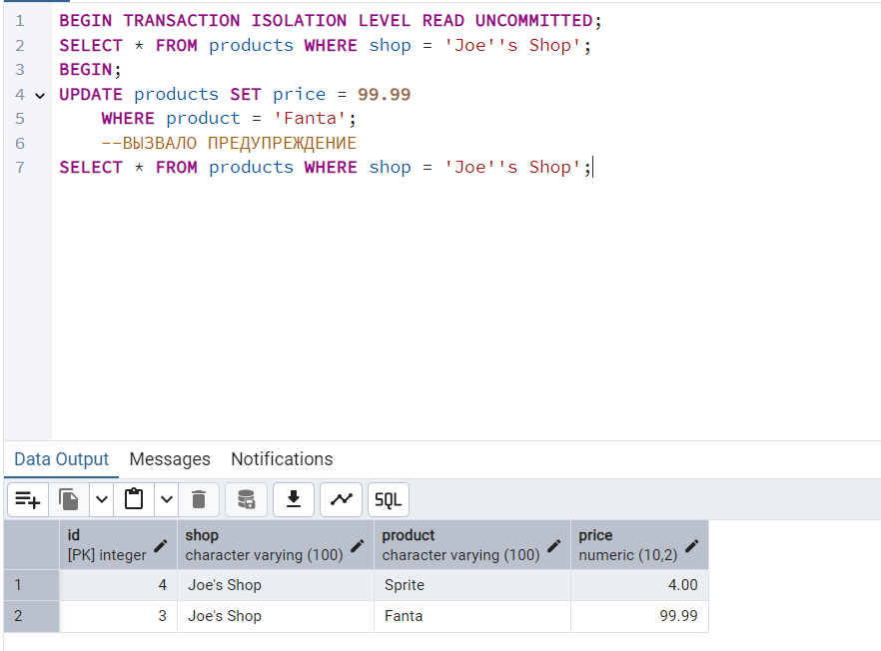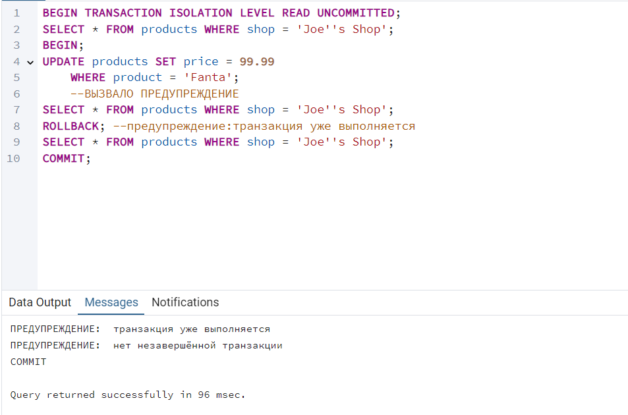
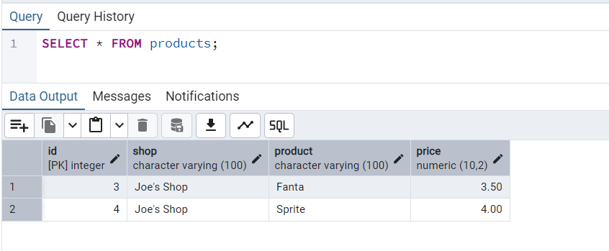
Q&A:
- Yes. It saw uncommitted(“dirty”) data. This is problematic because: the update might be rolled back; Terminal 1 sees data that never actually existed.
- Reading data that was written by another transaction but not yet committed.
- Because it allows dirty reads, can show corrupted or temporary values, breaks consistency. Very few systems use it.

4. Independent Exercises
Exercise 1.
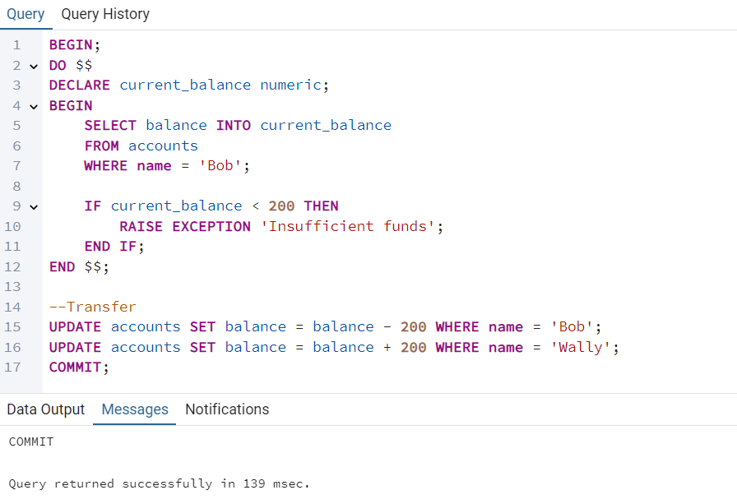
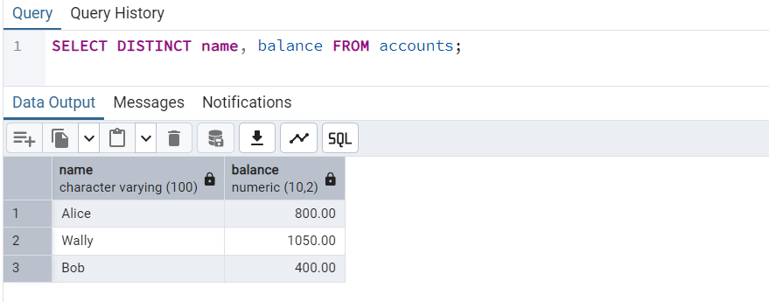
Exercise 2.
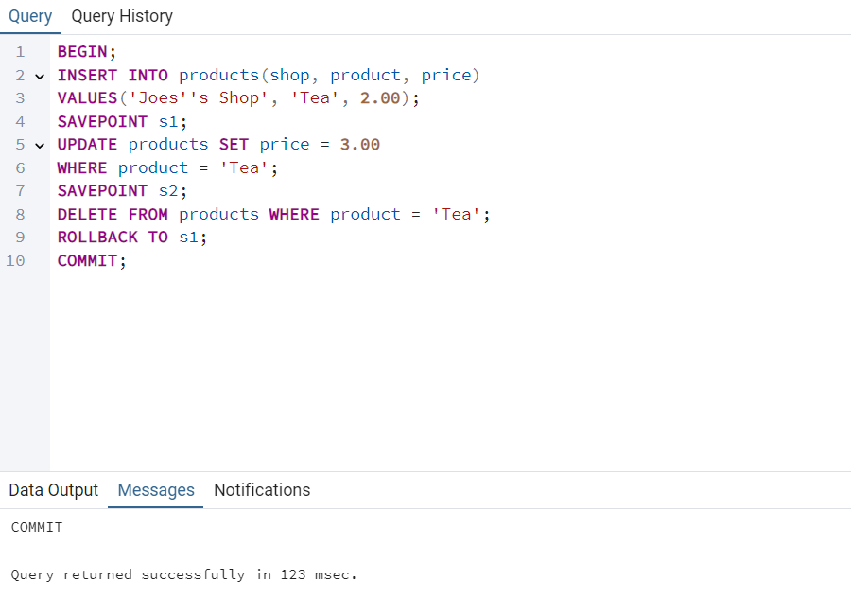
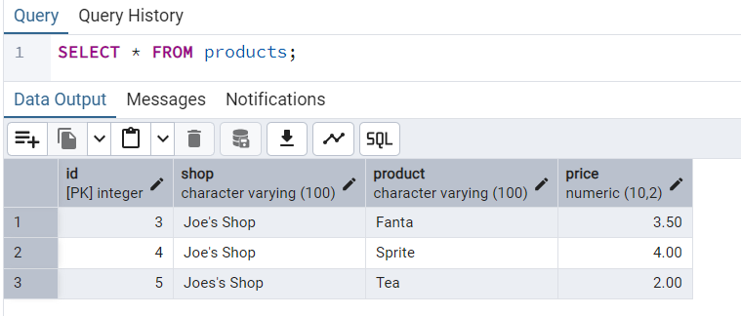
Final State: Tea exists with price = 2.00
Exercise 3.
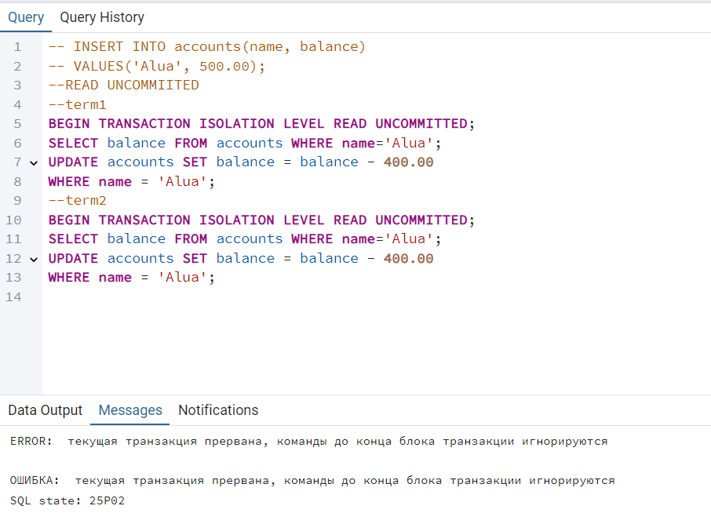
Exercise 4.
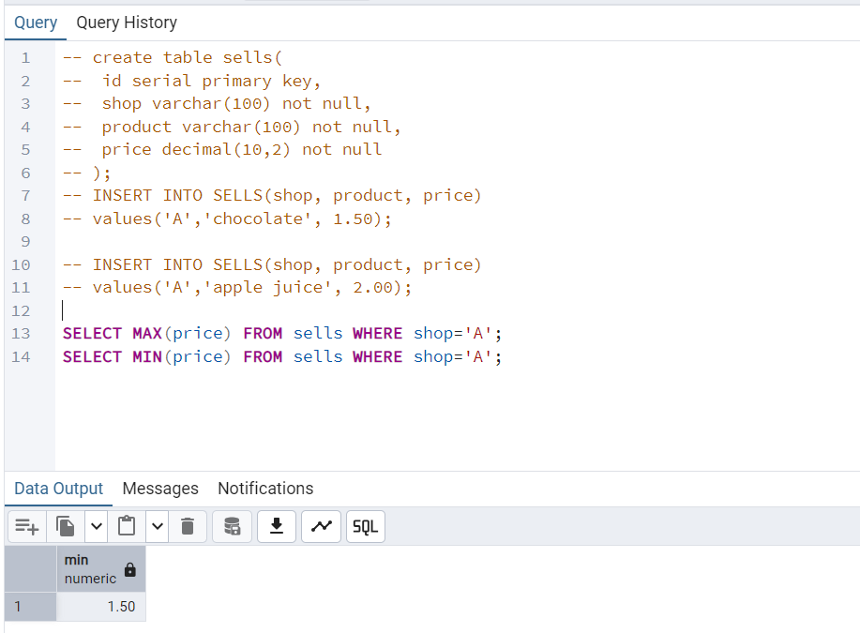
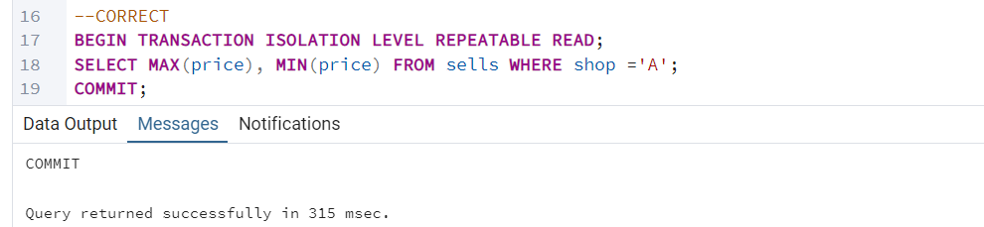

5. Questions for Self-Assessment
1. ACID examples:
• Atomicity: bank transfer succeeds or fails entirely.
• Consistency: balance never becomes negative.
• Isolation: each user acts as if alone.
• Durability: committed data survives power loss.

2. COMMIT vs ROLLBACK
• COMMIT saves changes permanently.
• ROLLBACK undoes all changes since BEGIN.

3. When use SAVEPOINT?
When only part of a transaction needs to be undone.

4. Isolation levels comparison:
• Read Uncommitted - dirty reads
• Read Committed - no dirty reads
• Repeatable Read - no non-repeatable reads
• Serializable - full consistency, no phantoms

5. Dirty read — uncommitted data is visible. Allowed only in READ UNCOMMITTED.

6. Non-repeatable read - reading same row twice returns different results.

7. Phantom read - repeated query returns different rows. Prevented by SERIALIZABLE.

8. Why choose READ COMMITTED? Faster, avoids unnecessary blocking.

9. How transactions maintain consistency? They enforce ACID and isolate concurrent operations.

10. What happens to uncommitted changes if crash? They are automatically rolled back.

