**Lab Worksheet 2**

**CT-2021-027**

**KKDJ Eranda**

1.

package Q_01;  
import java.util.Scanner;  
import static java.lang.Math.*pow*;  
public class Q_01 {  
 public static void main(String[] args) {  
 Scanner S1 = new Scanner(System.*in*);  
  
 // Getting A  
 System.*out*.print("Enter A :");  
 double A = S1.nextDouble();  
  
 // Getting B  
 System.*out*.print("Enter B number :");  
 double B = S1.nextDouble();  
  
 // Getting C  
 System.*out*.print("Enter C number :");  
 double C = S1.nextDouble();  
  
 double result = Math.*sqrt*(Math.*pow*(B, 2) + (4 * A * C));  
 /* Display the result */  
 System.*out*.println("a. The result of (B^2 + 4AC) is: " + result);  
  
 // Getting X  
 System.*out*.print("Enter X :");  
 double Y = S1.nextDouble();  
  
 // Getting Y  
 System.*out*.print("Enter Y number :");  
 double X = S1.nextDouble();  
  
 double result1 = Math.*sqrt*(X + 4 * Math.*pow*(Y, 3));  
 // Display the result  
 System.*out*.println("b. The result of (X+4Y^3) is: " + result1);  
  
 // cube root of the product of X and Y  
 double cube_root = Math.*pow*(X * Y, 1.0/3.0);  
 System.*out*.println("c. The cube root of the product of X and Y: " + cube_root);  
  
 // Get radius input from the user  
 System.*out*.print("Enter the radius of the circle: ");  
 double radius = S1.nextDouble();  
  
 // Calculate the area  
 double area = Math.*PI* * Math.*pow*(radius, 2);  
  
 // Display the result  
 System.*out*.println("d. The area of the circle is: " + area);  
  
 S1.close();  
 }  
}

2.

package Q_02;  
import java.util.Scanner;  
public class Q_02 {  
 public static void main(String[] args) {  
 Scanner S2 = new Scanner(System.*in*);  
  
 // Get input   
 System.*out*.print("Enter length in centimeters: ");  
 double CM = S2.nextDouble();  
  
 // Conversion  
 double inches = CM / 2.54; // 1 inch = 2.54 cm  
 double Feet = inches/12;  
 double rest_feet = inches%12;  
  
 // Display the result  
 System.*out*.println(CM + "cm convert to " + Feet + " feet and " + rest_feet +" inches");  
  
 S2.close();  
 }  
}

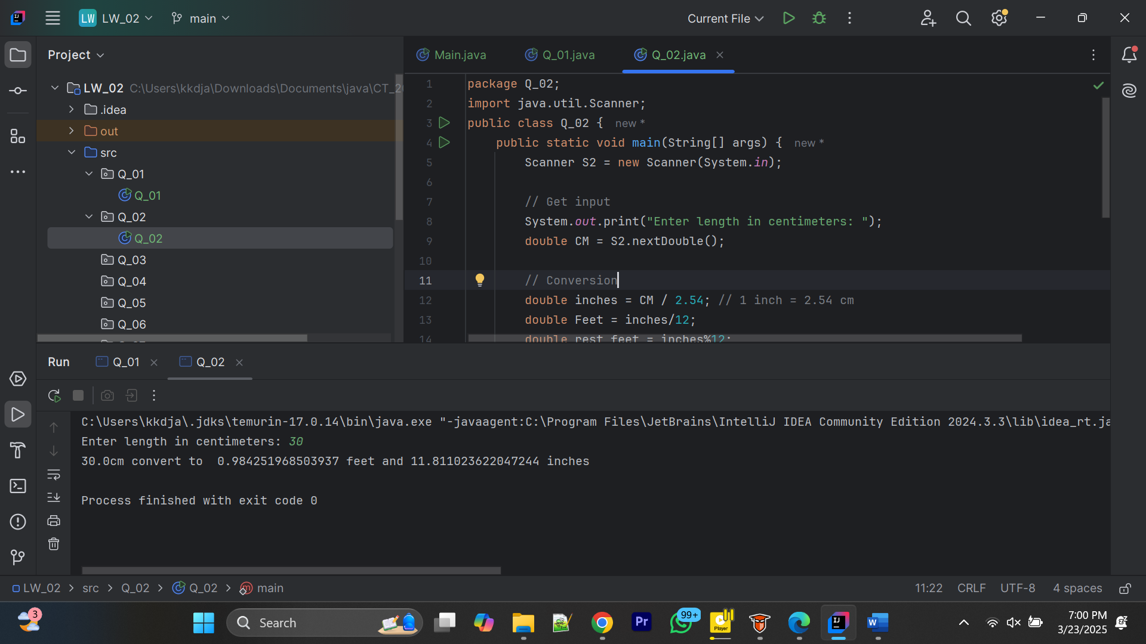

3.

package Q_03;  
import java.util.Scanner;  
public class Q_03 {  
 public static void main(String[] args) {  
 Scanner S3 = new Scanner(System.*in*);  
// Get temperature input  
 System.*out*.print("Enter temperature in Celsius: ");  
 double celsius = S3.nextDouble();  
// Convert to Fahrenheit  
 double fahrenheit = (1.8 * celsius) + 32;  
// Display the result  
 System.*out*.println(celsius + "°C is equal to " + fahrenheit + "°F");  
 S3.close();  
 }  
  
}

4.

package Q_04;  
import java.util.Scanner;  
public class Q_04 {  
 public static void main(String[] args) {  
 Scanner S4 = new Scanner(System.*in*);  
  
 // Get weight input  
 System.*out*.print("Enter your weight : ");  
 double bodyWeight = S4.nextDouble();  
  
 // Calculate daily calorie  
 double calories = bodyWeight * 19;  
  
 // Display the result  
 System.*out*.println("Your Weight is " + bodyWeight);  
 System.*out*.println("You need approximately " + calories + " calories per day.");  
  
 S4.close();  
 }  
}

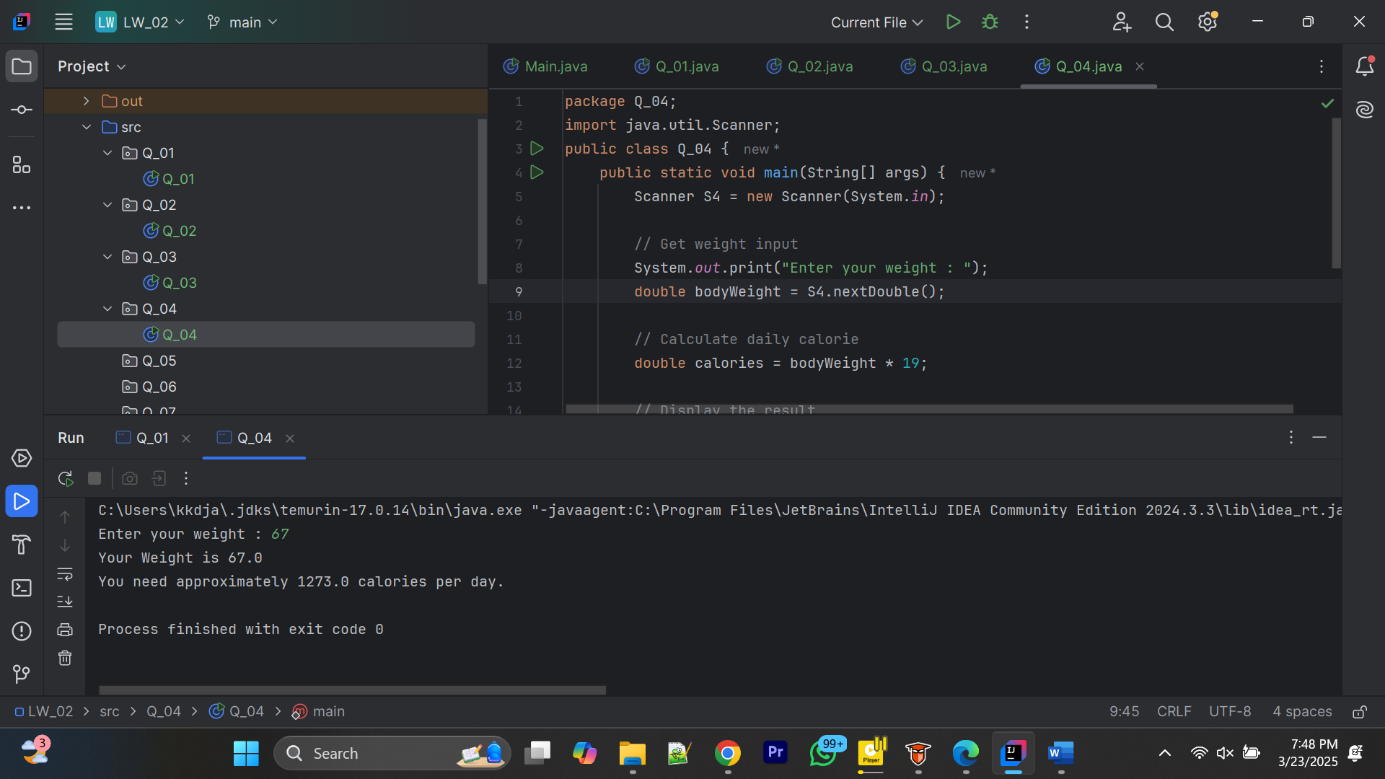

5.

package Q_05;  
import java.util.Scanner;  
public class Q_05 {  
 public static void main(String[] args) {  
 Scanner S5 = new Scanner(System.*in*);  
  
 // Get temperature input  
 System.*out*.print("Enter temperature in Fahrenheit: ");  
 double fahrenheit = S5.nextDouble();  
  
 // Convert to Celsius  
 double celsius = (5.0 / 9) * (fahrenheit - 32);  
  
 // Display the result  
 System.*out*.println(fahrenheit + "°F is equal to " + celsius + "°C");  
  
 S5.close();  
 }  
}

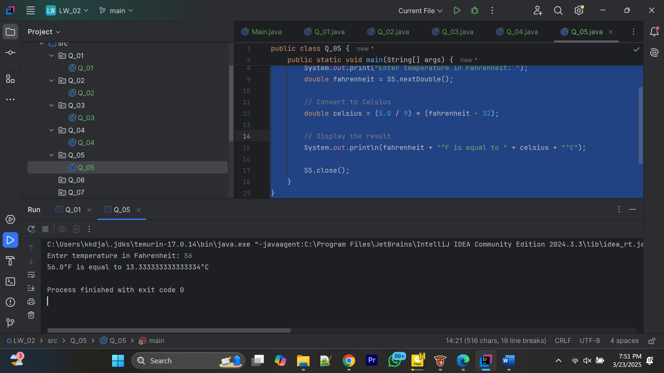

6.

package Q_06;  
import java.util.GregorianCalendar;  
import java.util.Scanner;  
public class Q_06 {  
 public static void main(String[] args) {  
 // Today  
 GregorianCalendar today = new GregorianCalendar();  
 System.*out*.println(today.getTime());  
 int currentYear = today.get(GregorianCalendar.*YEAR*);  
  
 // User bron day  
 Scanner S6 = new Scanner(System.*in*);  
 System.*out*.print("Enter the year you were born: ");  
 int birthYear = S6.nextInt();  
  
 int age = currentYear - birthYear;  
  
 System.*out*.println("You were born in " + birthYear + " and will be " + age + " in this year.");  
  
 S6.close();  
 }  
}

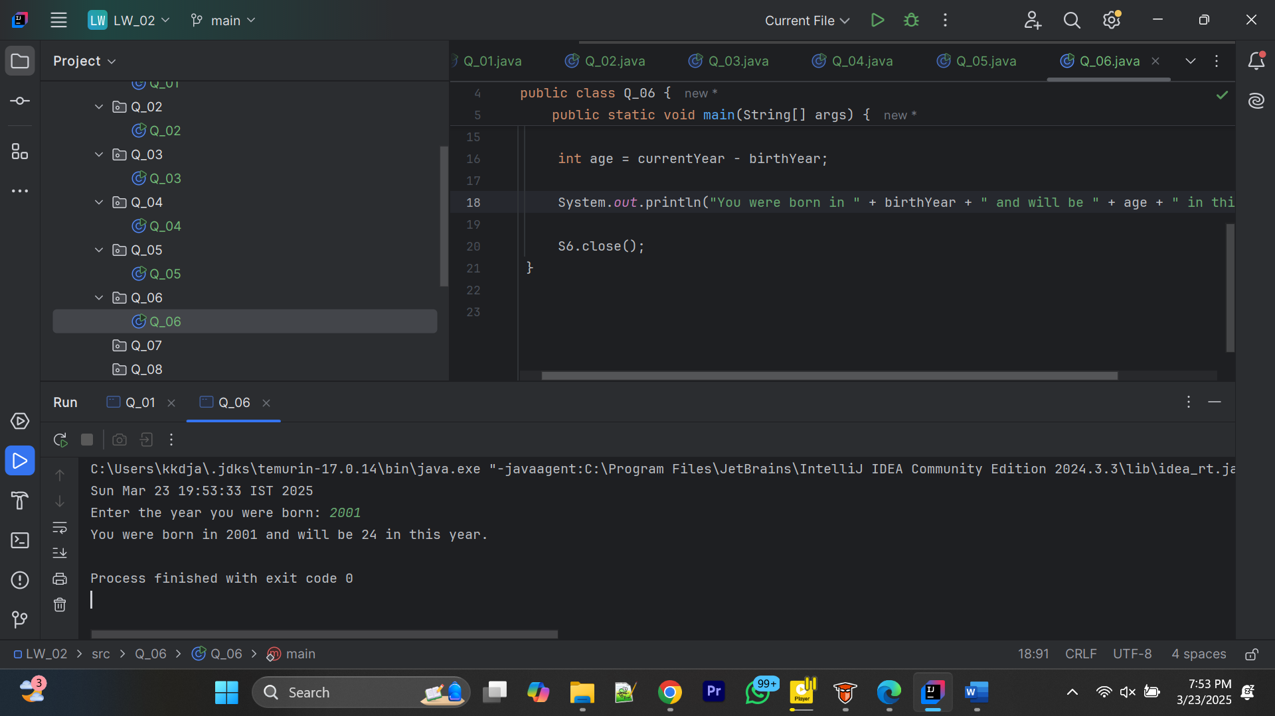

7.

package Q_07;  
import java.util.Scanner;  
public class Q_07 {  
 public static void main(String[] args) {  
 // Create Scanner input  
 Scanner S7 = new Scanner(System.*in*);  
 // Get weight  
 System.*out*.print("Enter your weight in kilograms: ");  
 double weight = S7.nextDouble();  
 // Get height  
 System.*out*.print("Enter your height in centimeters: ");  
 double height = S7.nextDouble();  
 double heightM = height / 100.0;  
 // Calculate BMI using the formula  
 double bmi = weight / Math.*pow*(heightM ,2);  
 // Display the result  
 System.*out*.println("Your Body Mass Index (BMI) is: " + bmi);  
 if (bmi >= 20 && bmi <= 25) {  
 System.*out*.println("You are underweight.");  
 } else if (bmi >= 25) {  
 System.*out*.println("You are overweight.");  
 }  
  
 S7.close();  
 }  
}

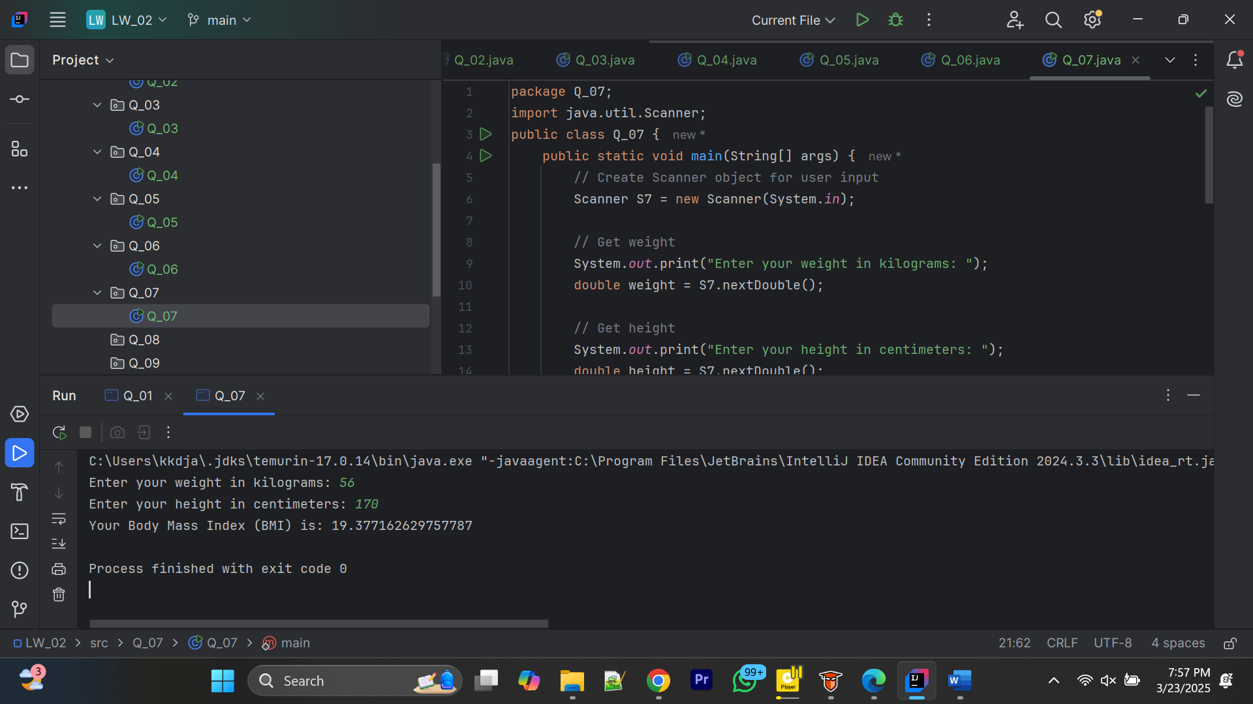

8.

package Q_08;  
import java.util.Scanner;  
public class Q_08 {  
 public static void main(String[] args) {  
 // user input  
 Scanner S8 = new Scanner(System.*in*);  
  
 // Get the radius  
 System.*out*.print("Enter the radius of the sphere: ");  
 double radius = S8.nextDouble();  
  
 // Pi  
 final double PI = 3.14;  
  
 // Calculation  
 double volume = (4.0 / 3.0) * PI * Math.*pow*(radius, 3);  
  
 // Display the result  
 System.*out*.println("The volume of the sphere is: " + volume);  
  
 S8.close();  
 }  
}

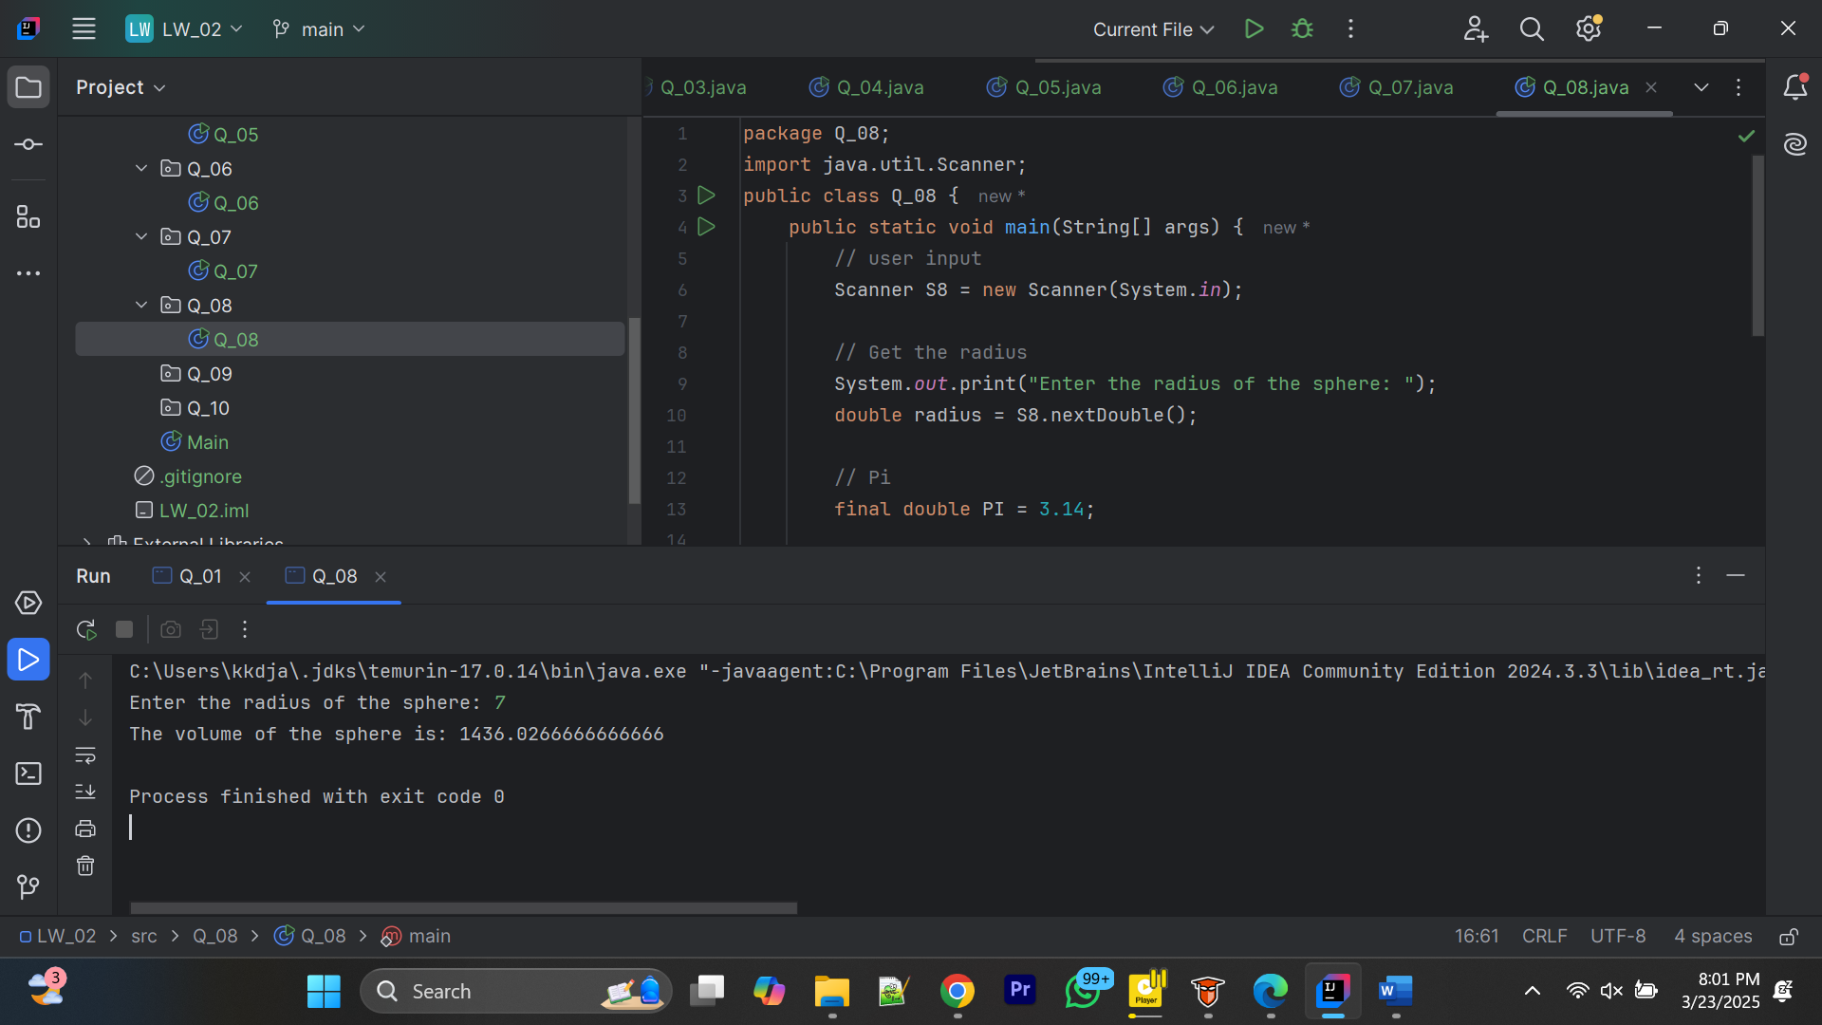

9.

package Q_09;  
import java.util.Scanner;  
public class Q_09 {  
 public static void main(String[] args) {  
 // Create Scanner input  
 Scanner S9 = new Scanner(System.*in*);  
 // Get amount  
 System.*out*.print("Enter the amount : ");  
 double P = S9.nextDouble();  
 // Get interest rate  
 System.*out*.print("Enter the annual interest rate in percentage: ");  
 double R = S9.nextDouble();  
 // Get the number of years  
 System.*out*.print("Enter the number of years : ");  
 int N = S9.nextInt();  
 // Calculate the amount after N years  
 double amount = P * Math.*pow*(1 + (R / 100), N);  
 // Calculate the money earned  
 double money = amount - P;  
 // Display the results  
 System.*out*.println("Amount after " + N + " years: " + "Rs " + amount);  
 System.*out*.println("Money earned after " + N + " years: " + "Rs "+ money);  
  
 S9.close();  
 }  
}

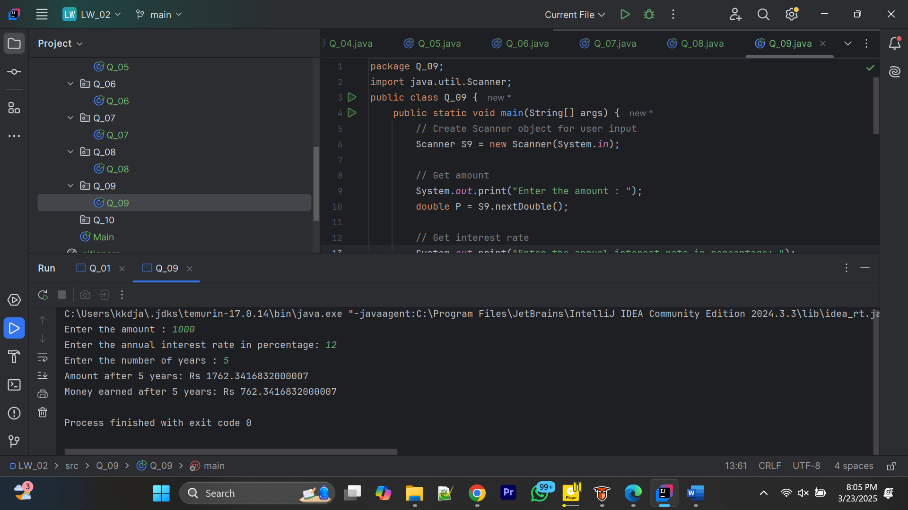

10.

package Q_10;  
import java.util.Scanner;  
public class Q_10 {  
 public static void main(String[] args) {  
 // Create Scanner input  
 Scanner S10 = new Scanner(System.*in*);  
  
 // Get loan amount  
 System.*out*.print("Enter the amount : ");  
 double loan = S10.nextDouble();  
  
 // Get loan period  
 System.*out*.print("Enter the loan period (years) : ");  
 double loanPeriod = S10.nextDouble();  
  
 // Get interest rate  
 System.*out*.print("Enter the annual interest rate in percentage: ");  
 double annualInterestRate = S10.nextDouble();  
  
 final double MONTHS_IN_YEAR = 12;  
  
 //monthly interest rate  
 double monthlyInterestRate = (annualInterestRate / 100.0) / MONTHS_IN_YEAR;  
  
 //no of payments  
 double numberOfPayments = loanPeriod * MONTHS_IN_YEAR;  
  
 //monthly payment  
 double monthlyPayment = (loan * monthlyInterestRate) / (1 - Math.*pow*(1 / (1 + monthlyInterestRate), numberOfPayments));  
  
 //total payments  
 double totalPayment = monthlyPayment * numberOfPayments;  
  
 // Display the results  
 System.*out*.println("Monthly payment: Rs " + "Rs " + monthlyPayment);  
 System.*out*.println("Total payment after " + loanPeriod + " years: Rs " + totalPayment);  
  
 S10.close();  
 }  
}

