Developer: Alex Razon
Git: https://github.com/aluxious/ModularAM

- After backfill – record count:
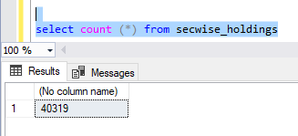

- Incremental update console:
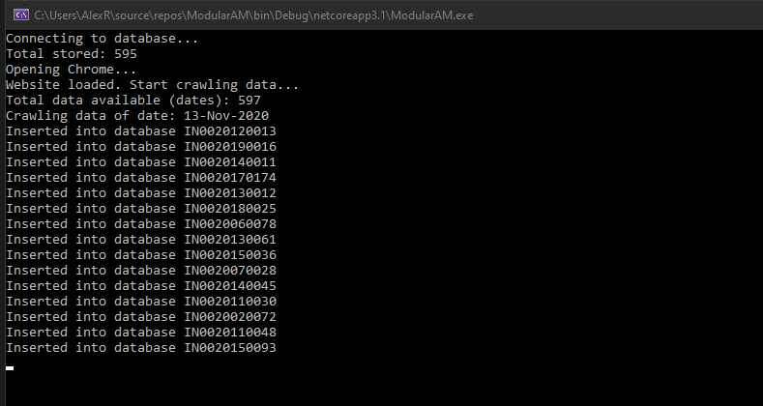
- Dashboard with ISIN selection and graphical representation:
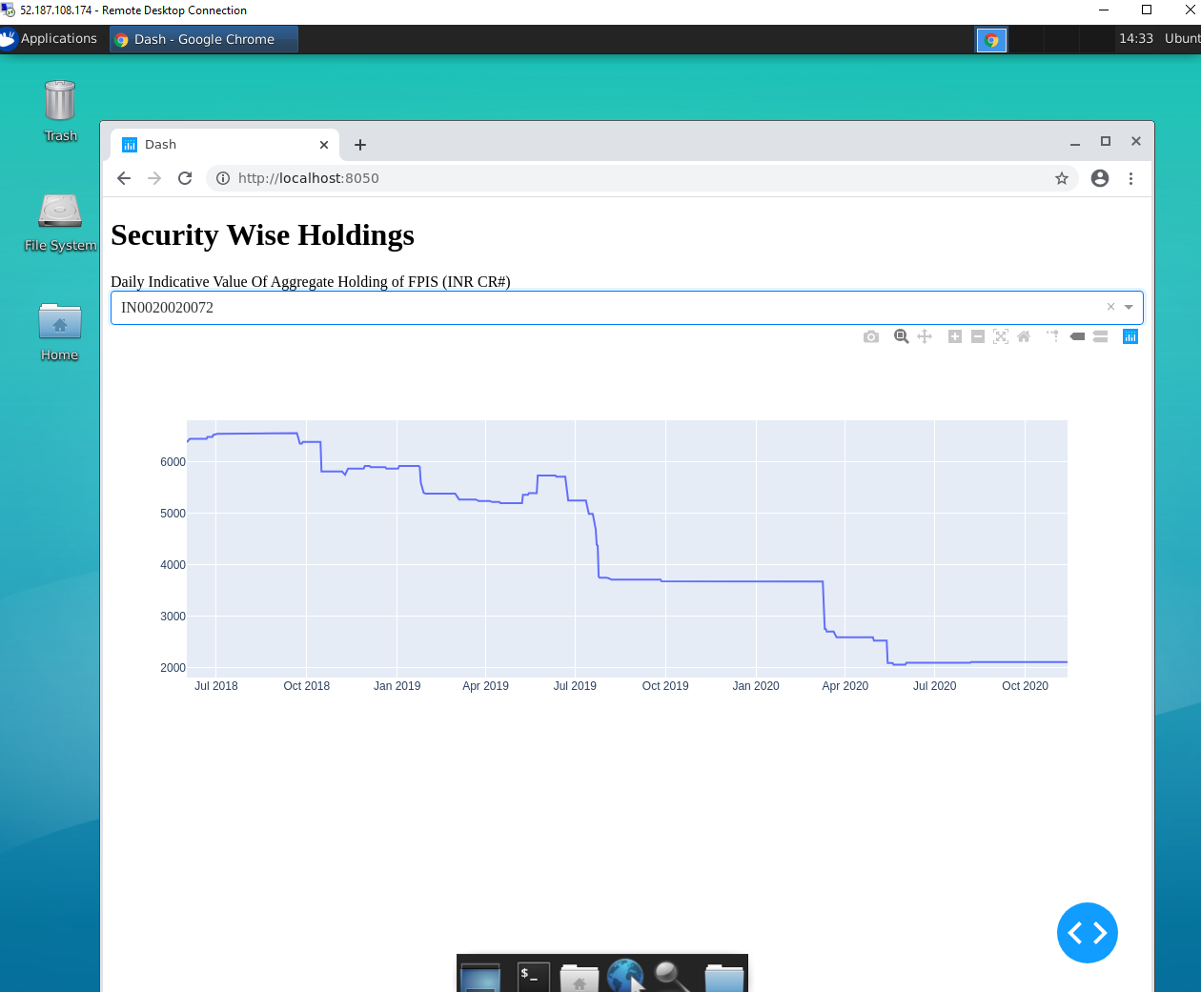
Live site: https://dash-modular.azurewebsites.net/
