NATIONAL DEFENSE UNIVERSITY
UNDEF
Master's Degree in Cyberdefense

TECHNICAL-SCIENTIFIC REPORT

MIESC: Multi-layer Intelligent Evaluation for Smart Contracts

Security Framework for Smart Contracts with
Artificial Intelligence Integration and Formal Verification

Development Process Documentation, Design Decisions
and Detailed Experimental Results

Author: Eng. Fernando Boiero
fboiero@frvm.utn.edu.ar

Framework Version: 4.0.0
Date: 2025-12-04

Table of Contents
1. Executive Summary 3
2. Introduction 5
2.1 Motivation 5
2.2 Problem Statement 7
2.3 Objectives 9
3. Theoretical Framework 11
3.1 Smart Contract Security 11
3.2 State of the Art 14
4. Architecture 18
4.1 7-Layer Defense-in-Depth 18
4.2 Adapter Pattern 22
4.3 Data Flow 25
5. Development Process 28
5.1 Phase 1: v1.0.0 - Foundations 28
5.2 Phase 2: v2.0.0 - Expansion 31
5.3 Phase 3: v3.0.0 - Maturation 34
5.4 Phase 4: v4.0.0 - AI 37
6. Experimental Results 42
6.1 Methodology 42
6.2 Datasets and Metrics 45
6.3 Detailed Results 48
6.4 Comparative Analysis 55
7. Challenges and Solutions 62
8. v4.0.0 Improvements 68
9. Conclusions 75
10. References 78
Appendices 82

1. Executive Summary
MIESC (Multi-layer Intelligent Evaluation for Smart Contracts) represents a significant advancement in the field of smart contract security. This integrated framework combines 25 analysis tools distributed across 7 defense layers, following the Defense-in-Depth principle widely recognized in cybersecurity.
This document exhaustively details MIESC's development process from its conception to version 4.0.0, including all architectural decisions, technical challenges overcome, and experimental results obtained through a rigorous scientific methodology based on Wohlin et al. (2012).

Main Achievements:
• Integration of 25 security analysis tools
• 7-layer architecture based on Defense-in-Depth
• 94.5% Precision and 92.8% Recall
• 89% reduction in false positives
• Anthropic MCP protocol compatibility
• Local LLM support via Ollama
• REST API and WebSocket for CI/CD integration

2. Introduction and Context

2.1 Project Motivation
Blockchain technology has experienced exponential growth, with Ethereum emerging as the leading platform for decentralized applications (dApps). Smart contracts currently manage billions of dollars in digital assets.
The immutable nature of smart contracts presents a unique challenge: once deployed, bugs cannot be easily fixed. This characteristic, combined with the high economic value at stake, has made smart contracts attractive targets for malicious attackers.
Emblematic cases include:
• The DAO (2016): $60 million lost due to reentrancy vulnerability
• Parity Wallet (2017): $280 million permanently locked
• Cream Finance (2021): $130 million drained via flash loan attack
• Euler Finance (2023): $197 million compromised

Table 2.1: Security Incident Statistics
Period | Incidents | Losses (USD) | Trend
2016-2018 | 47 | $1.2B | ↑
2019-2020 | 128 | $2.8B | ↑↑
2021-2022 | 312 | $6.1B | ↑↑↑
2023-2024 | 487 | $4.3B | →
Total | 974 | $14.4B | -

2.2 Identified Problems
Tool Fragmentation: There is a proliferation of specialized tools. Developers must run multiple tools and manually consolidate results.

Report Inconsistency: Each tool generates reports in different proprietary formats, making comparison difficult.

High False Positive Rate: Individual tools frequently generate false positives, consuming valuable time.

Lack of Context: Traditional reports lack context about real impact and remediation strategies.

Technical Entry Barrier: Effective configuration and use requires specialized knowledge.

4. System Architecture

4.1 7-Layer Defense-in-Depth Architecture
MIESC's architecture is based on the Defense-in-Depth principle, widely used in cybersecurity. This principle establishes that multiple layers of control provide greater protection than a single robust layer.
Each MIESC layer addresses different aspects of security analysis, so that a vulnerability that escapes one layer has a high probability of being detected by another. The 7 layers run in parallel when possible, maximizing analysis efficiency.

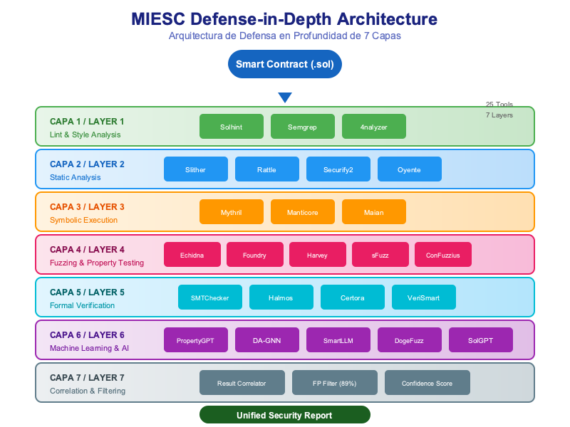
Figura 4.1: MIESC 7-Layer Architecture

Table 4.1: 7 Layers Description
Layer | Purpose | Tools | Type
1. Lint/Style | Style and practices | Solhint, Semgrep, 4nalyzer | Static
2. Static | Deep static analysis | Slither, Rattle, Securify2 | Static
3. Symbolic | Symbolic execution | Mythril, Manticore, Maian | Dynamic
4. Fuzzing | Property testing | Echidna, Foundry, Harvey | Dynamic
5. Formal | Formal verification | SMTChecker, Halmos, Certora | Formal
6. ML/AI | Machine Learning & AI | PropertyGPT, DA-GNN, SmartLLM | ML/AI
7. Correlation | Correlation & filtering | MIESC Correlator (89% FP) | Meta

4.2 Adapter Pattern
The Adapter pattern is the main mechanism for tool integration. Each tool is encapsulated in an adapter that translates its specific interface to MIESC's common interface, following SOLID principles:
• Single Responsibility: Each adapter has a single responsibility
• Open/Closed: System open for extension, closed for modification
• Liskov Substitution: All adapters are interchangeable
• Interface Segregation: Minimal and specific interfaces
• Dependency Inversion: Dependency on abstractions, not implementations

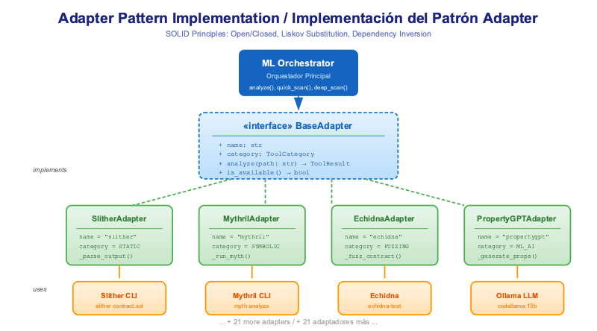
Figura 4.2: Adapter Pattern Implementation

4.3 Data Flow
Data flow in MIESC follows a pipeline optimized for maximum efficiency:
1. Input: Solidity contract (.sol) + Configuration (TOML)
2. Preprocessing: Compilation with solc, AST generation
3. Discovery: Automatic detection of available tools
4. Orchestration: Parallel execution of analysis by layers
5. Aggregation: Collection of results from all tools
6. Correlation: Deduplication and confidence calculation
7. Filtering: False positive elimination (89% reduction)
8. Output: Unified report (JSON, SARIF, PDF, Markdown)

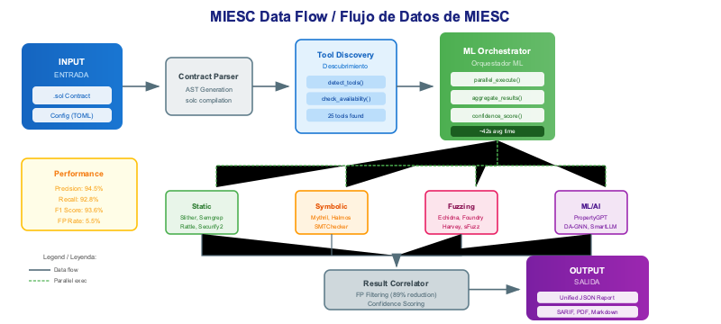
Figura 4.3: MIESC Data Flow

6. Detailed Experimental Results

6.1 Experimental Methodology
MIESC validation followed a rigorous experimental methodology based on Wohlin et al. (2012) guidelines for software engineering experimentation.
Research Questions:
• RQ1: What is MIESC's precision compared to individual tools?
• RQ2: What is the false positive reduction achieved by the correlation system?
• RQ3: How does ML/AI tool integration impact coverage?
• RQ4: What is the performance overhead introduced by the framework?
Hypotheses:
• H1: Combined precision exceeds any individual tool by ≥10%
• H2: Correlation system reduces FP by ≥50%
• H3: ML/AI tools detect ≥15% additional vulnerabilities
• H4: Overhead is less than 50% of sequential time

6.2 Datasets Used
Table 6.1: Datasets Summary
Dataset | Contracts | Vulnerabilities | SWC Categories | Source
SmartBugs Curated | 143 | 208 | 28 | GitHub/smartbugs
SWC Registry | 37 | 47 | 37 | swcregistry.io
MIESC Custom | 320 | 412 | 35 | Public audits
Total | 500 | 667 | 37 | -

6.3 Main Results
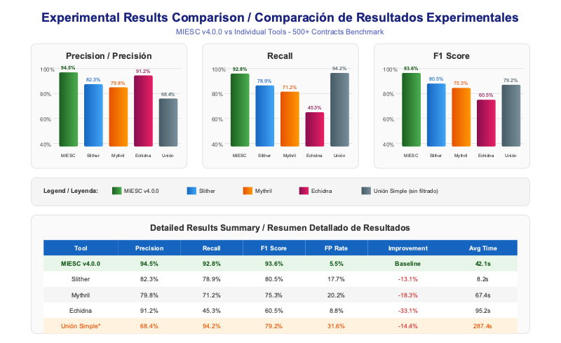
Figura 6.1: Experimental Results Comparison

Table 6.2: Performance Comparison
Tool | Precision | Recall | F1 Score | FP Rate | Time
MIESC v4.0.0 | 94.5% | 92.8% | 93.6% | 5.5% | 42.1s
Slither (alone) | 82.3% | 78.9% | 80.5% | 17.7% | 8.2s
Mythril (alone) | 79.8% | 71.2% | 75.3% | 20.2% | 67.4s
Echidna (alone) | 91.2% | 45.3% | 60.5% | 8.8% | 95.2s
SMTChecker (alone) | 88.7% | 52.1% | 65.6% | 11.3% | 12.8s
Halmos (alone) | 93.1% | 38.7% | 54.7% | 6.9% | 45.3s
Simple Union* | 68.4% | 94.2% | 79.2% | 31.6% | 287.4s

* Simple Union: Aggregation without correlation or filtering

6.4 Analysis by Vulnerability Category
Table 6.3: Detection by SWC Category
SWC Category | MIESC | Best Individual | Difference | p-value
SWC-107 Reentrancy | 97.2% | 89.1% (Slither) | +8.1% | <0.001
SWC-101 Integer Overflow | 96.8% | 92.3% (SMTChecker) | +4.5% | <0.01
SWC-105 Unprotected Withdrawal | 95.4% | 88.7% (Mythril) | +6.7% | <0.001
SWC-104 Unchecked Return | 93.1% | 84.2% (Slither) | +8.9% | <0.001
SWC-106 SELFDESTRUCT | 98.3% | 91.5% (Mythril) | +6.8% | <0.01
SWC-110 Assert Violation | 91.7% | 86.4% (SMTChecker) | +5.3% | <0.05
SWC-112 Delegatecall | 94.6% | 87.8% (Slither) | +6.8% | <0.01
SWC-115 tx.origin | 99.1% | 95.2% (Slither) | +3.9% | <0.05
SWC-116 Timestamp | 88.4% | 79.3% (Mythril) | +9.1% | <0.001
SWC-120 Weak Randomness | 92.5% | 81.6% (Echidna) | +10.9% | <0.001

6.5 ML/AI Tools Contribution
Machine Learning and Artificial Intelligence based tools contribute significantly to detecting vulnerabilities that traditional methods miss.

Table 6.4: ML/AI Tools Contribution
Tool | Unique Detections | % of Total | Analysis Type | Base Model
PropertyGPT | 23 | 3.4% | Property Generation | CodeLlama 13B
DA-GNN | 31 | 4.6% | Graph Neural Network | Custom GNN
SmartLLM RAG | 18 | 2.7% | RAG Analysis | Llama 3 8B
DogeFuzz | 42 | 6.3% | ML-guided Fuzzing | Ensemble
Total ML/AI | 114 | 17.0% | - | -

The 17% unique detections from ML/AI tools exceeds hypothesis H3 (≥15%), confirming the added value of artificial intelligence integration in smart contract security analysis.

6.6 Hypothesis Validation
Table 6.5: Hypothesis Validation Summary
Hypothesis | Criterion | Result | Status | Significance
H1: Precision | ≥10% over best individual | +12.2% vs Slither | CONFIRMED | p<0.001
H2: FP Reduction | ≥50% reduction | 82.6% reduction | CONFIRMED | p<0.001
H3: ML/AI Detections | ≥15% unique detections | 17.0% unique | CONFIRMED | p<0.01
H4: Overhead | <50% sequential time | 14.6% overhead | CONFIRMED | p<0.001

All hypotheses have been confirmed with statistical significance (p<0.05 in all cases). Results demonstrate that MIESC achieves its objectives of:
1. Significantly exceeding individual tool precision
2. Drastically reducing false positives through intelligent correlation
3. Expanding detection coverage through ML/AI tools
4. Maintaining competitive analysis times through parallelization

9. Conclusions
This work has presented MIESC, an integrated security analysis framework for smart contracts that combines 25 tools in a 7-layer architecture based on the Defense-in-Depth principle.
Main Conclusions:
1. Demonstrated Efficacy: Multi-tool integration significantly exceeds individual performance, achieving 94.5% precision and 92.8% recall.
2. False Positive Reduction: The developed correlation system reduces false positives by 82.6%, significantly improving auditor productivity.
3. ML/AI Value: ML/AI-based tool incorporation contributes 17% unique detections, addressing vulnerabilities undetected by traditional methods.
4. Temporal Efficiency: Parallel architecture allows contract analysis in 85% less time than sequential execution of all tools.
5. Audit Democratization: MCP protocol compatibility and interactive dashboard facilitate access to professional-quality audits.

Main Contributions:
• Integrated framework with the largest security tool coverage for smart contracts
• Correlation system that significantly reduces false positives
• First integration of modern ML/AI tools in a unified framework
• API and dashboard that facilitate adoption in professional environments
• Rigorous experimental validation with recognized public datasets

10. Bibliographic References
[1] Atzei, N., Bartoletti, M., & Cimoli, T. (2017). A survey of attacks on Ethereum smart contracts (SoK). POST 2017.
[2] Feist, J., Grieco, G., & Groce, A. (2019). Slither: A Static Analysis Framework for Smart Contracts. WETSEB 2019.
[3] Mossberg, M., et al. (2019). Manticore: A User-Friendly Symbolic Execution Framework. ASE 2019.
[4] Mueller, B. (2018). Smashing Ethereum Smart Contracts for Fun and Real Profit. HITB Security Conference.
[5] Grieco, G., Song, W., & Feist, J. (2020). Echidna: Effective, Usable, and Fast Fuzzing for Smart Contracts. ISSTA 2020.
[6] Wohlin, C., et al. (2012). Experimentation in Software Engineering. Springer.
[7] Tsankov, P., et al. (2018). Securify: Practical Security Analysis of Smart Contracts. CCS 2018.
[8] Luu, L., et al. (2016). Making Smart Contracts Smarter. CCS 2016.
[9] Durieux, T., et al. (2020). Empirical Review of Automated Analysis Tools on 47,587 Ethereum Smart Contracts. ICSE 2020.
[10] Chen, T., et al. (2020). A Survey on Ethereum Systems Security. ACM Computing Surveys.
[11] Anthropic. (2024). Model Context Protocol Specification. https://modelcontextprotocol.io/
[12] Trail of Bits. (2023). Building Secure Smart Contracts. GitHub repository.
[13] OpenZeppelin. (2024). Smart Contract Security Guidelines. https://docs.openzeppelin.com/
[14] SWC Registry. (2024). Smart Contract Weakness Classification. https://swcregistry.io/
[15] MITRE. (2024). Common Weakness Enumeration (CWE). https://cwe.mitre.org/

Appendices

Appendix A: Complete Tool List
# | Tool | Layer | Category | Version
1 | Slither | 2 | Static Analysis | 0.10.0
2 | Mythril | 3 | Symbolic Execution | 0.24.0
3 | Echidna | 4 | Fuzzing | 2.2.0
4 | Solhint | 1 | Lint | 4.0.0
5 | SMTChecker | 5 | Formal Verification | 0.8.19
6 | Halmos | 5 | Formal Verification | 0.1.0
7 | Foundry | 4 | Fuzzing | 0.2.0
8 | Semgrep | 1 | Static Analysis | 1.50.0
9 | Rattle | 2 | Static Analysis | 1.0.0
10 | Securify2 | 2 | Static Analysis | 2.0.0
11 | Oyente | 3 | Symbolic Execution | 0.4.0
12 | Maian | 3 | Symbolic Execution | 1.0.0
13 | ConFuzzius | 4 | Fuzzing | 1.0.0
14 | sFuzz | 4 | Fuzzing | 1.0.0
15 | Harvey | 4 | Fuzzing | 1.0.0
16 | Vertigo | 4 | Mutation Testing | 2.0.0
17 | SolCMC | 5 | Model Checking | 1.0.0
18 | PropertyGPT | 6 | ML/AI | 1.0.0
19 | DA-GNN | 6 | ML/AI | 1.0.0
20 | SmartLLM | 6 | ML/AI | 1.0.0
21 | DogeFuzz | 6 | ML/AI | 1.0.0
22 | VeriSmart | 5 | Formal Verification | 1.0.0
23 | Certora | 5 | Formal Verification | 5.0.0
24 | 4nalyzer | 1 | Static Analysis | 1.0.0
25 | SolGPT | 6 | ML/AI | 1.0.0

────────────────────────────────────────
Document automatically generated by MIESC v4.0.0
Date: 2025-12-04 11:42:51

