**VEHICLE TO EVERYTHING (V2X) TECHNOLOGY**

**What is V2X ?**

Vehicle to Everything (V2X) is a vehicular communication system that allows vehicles to share information with infrastructure, vehicles or pedestrians. The main purpose of V2X technologies is to improve road safety, energy savings and traffic efficiency by the exchange of real-time traffic updates and other road hazard information.

According to the US National Highway Traffic Safety Administration (NHTSA), increasing the use of V2X technology could significantly reduce the number of road accidents.

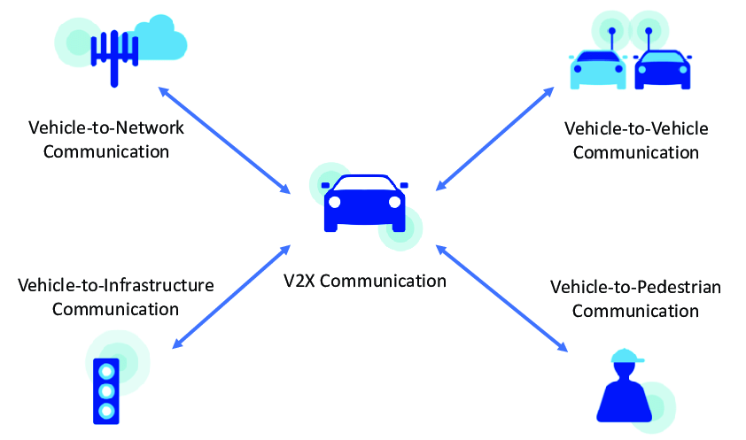

**How V2X works?**

In a V2X communication system, the information is exchanged from the vehicle sensors through high-bandwidth, high-reliability links.

By sharing information, such as speed or braking, with the surrounding entities, the technology allows vehicles to act and take measures to avoid accidents by increasing the driver’s awareness. It also enhances traffic efficiency by warning drivers of upcoming traffic.

There are two potential communication technologies that enables V2X: Dedicated Short Range Communication (DSRC) and C-V2X based on Long-Term Evolution (LTE) cellular communications.

**What is DSRC communication?**

Dedicated Short Range Communication (DSRC) uses radio communication provided by the 802.11p wireless local area network connectivity protocol (vehicle-based Wifi or Wireless LAN architecture). It enables a highly secure and high-speed direct communication between vehicles and the surrounding infrastructures without involving any cellular infrastructure. The main purpose of this technology is to avoid disrupting other communication systems by operating in a short-range (under 1 kilometer). It runs in the 5.9 GHz band providing direct, low latency information exchange between vehicles. Each vehicle sends 10 times per second its location and speed in a secure and anonymously. All surrounding vehicles receive the message, and each estimates the risk imposed by the transmitting vehicle. This allows a perception, detection, and anticipation of a potentially dangerous situation.

**What is C-V2X communication?**

C-V2X is cellular data-based technology and defined by the 3GPP (3rd Generation Partnership Project) standard to achieve V2X requirements. C-V2X technology has been designed to enable communication devices based on this standard to meet the requirements of low latency, high reliability, and adaptability to LTE (Long-Term Evolution) and 5G scenarios. The problem of this technology is the load of the equipment due to the large quantity of data. Also, the increase of the number of nodes causes transmission delays.

C-V2X communication is based either on a single band using the PC5 or on simultaneous inter-band communication using the PC5 and Uu interfaces. With this development, the Uu interface has been extended to ten frequency bands with bandwidths between 10 MHz and 20 MHz. In 3GPP Release 16, C-V2X is extended to 5G. TS 38.101.1 defines frequency ranges called FR1 and FR2, which allow relevant chip and car manufacturers to communicate on this basis for 5G.

Sources:

1. G. Americas. Cellular v2x communications towards 5g, 2018
2. CFI. Vehicle to everything (v2x), 2021
3. A Survey of Vehicle to Everything (V2X) Testing