**Earthquake in Japan**

*Capstone project by Tuan Anh Nguyen*

**Introduction**

Currently, I am living and working in Japan. I intend to settle permanently in this country. Everything here is very good, from culture, food to people. However, as you all know, Japan often has earthquakes, and that's what I'm really scared of. Therefore, as a graduation project for this course, I will investigate Japanese earthquake data in the past and will show it on a map so that when we look at it we will know the locality which is good.

The problem here will be: **Based on the earthquake data in the past, can we know where the earthquake occurs frequently?**

**Data**

To solve this problem, I need to know earthquake data in Japan in the past. And I will use this data at the following web address <https://earthquake.tenki.jp/bousai/earthquake/entries/>

This data provides me with information about **when an earthquake occurs(Time), where it happens(Location), Magnitude, maximum seismic intensity(Maximum)**

**Methodology**

**Summary**

Based on the earthquake data from the earthquake.tenki.jp website, we will structure it into data as required. Because for humans, earthquakes with magnitude of 4.0 or higher will be dangerous, so we will take such data as the object of analysis. After that, it will find the top 5 places with the most earthquake occurrences regardless of magnitude, and perform on Japanese maps. Currently in the place where I live is Osaka, it is in the top 5 locations above, if not in the top 5 locations, it is close to 5 aerial locations. From that point on, the answers to the issues raised in the introduction will be given.

**Procedures**

**Step 1. Get data from website to dataframe**

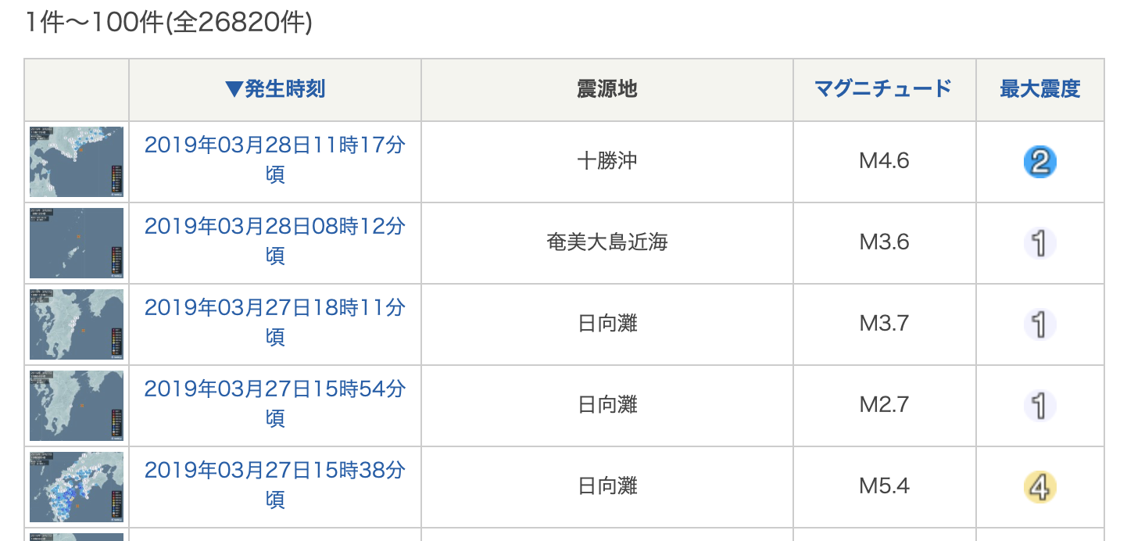

Use BeautifulSoup library to read data from html page and put it into dataframe

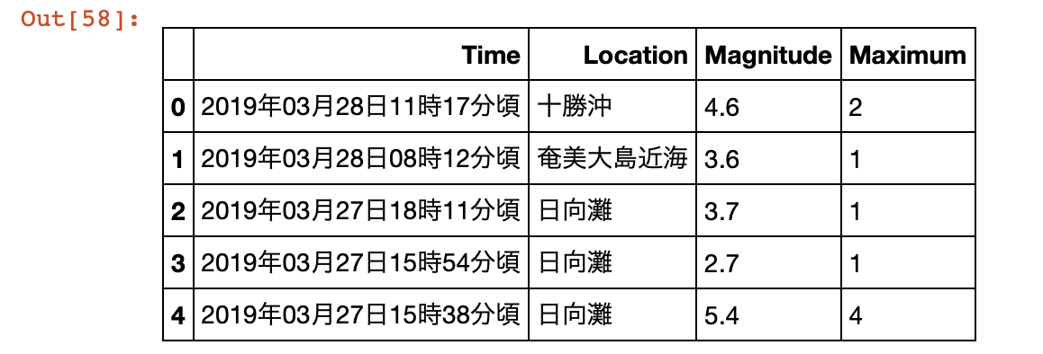

**Step 2. Format data**

Remove rows that is empty, na

The current Field Location is receiving non-stereotyped values, so it has to be reformatted according to Japanese standards 都 道 府 県 for the purpose of being able to group it.

***For example***

Location 福島県中通り and 福島県沖 all belong to 福島県

**Step 3. Get all data Maximum that has greater than 4.**

At this step, all data that has Magnitude greater than 4.0 will be taken

In addition, for each earthquake in an area, we will consider the time (Time) to be 1

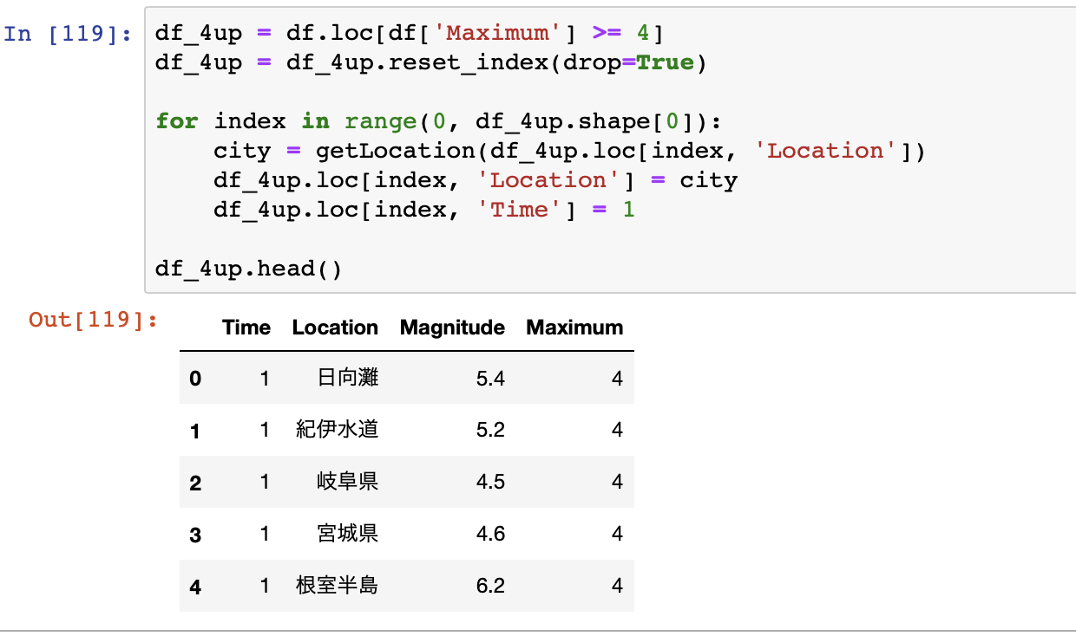

**Step 4. Find the top 5 areas with frequent earthquakes**

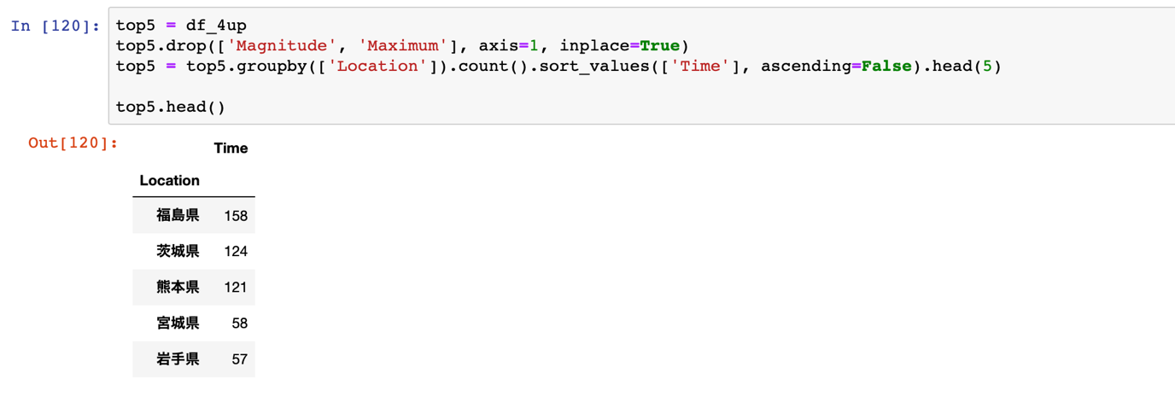

**Step 5. Visualize top 5 regions on Japan's map**

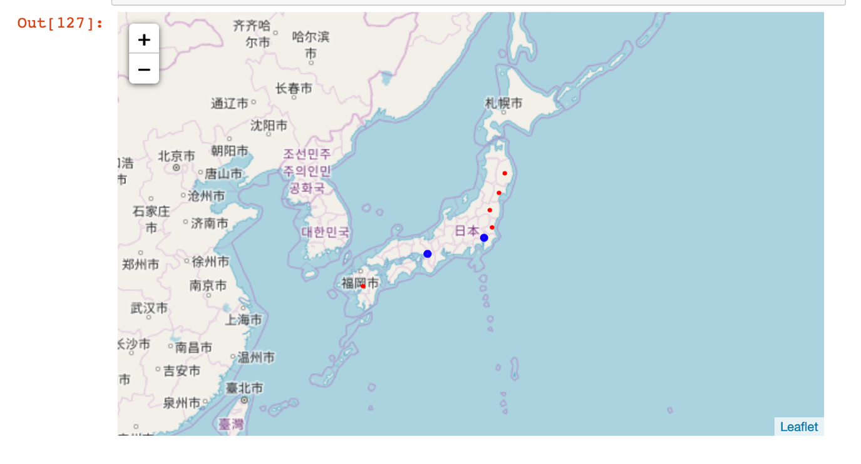

Red is shown for the top 5 places where earthquakes often occur.

**Results**

Currently, I am living in Osaka(大阪） and if I have permanent residence, I will choose Osaka（大阪） and Tokyo（東京）. Based on the analysis results, these two cities do not have many earthquakes, so I can be assured of this problem.

**Discussion**

Concerning whether or not an earthquake occurs and how dangerous it is depends on the nature. I am using past data to make a judgment for my choice, which is not entirely true. Because all of Japan is located on the Pacific Ring of Fire, every earthquake can happen.

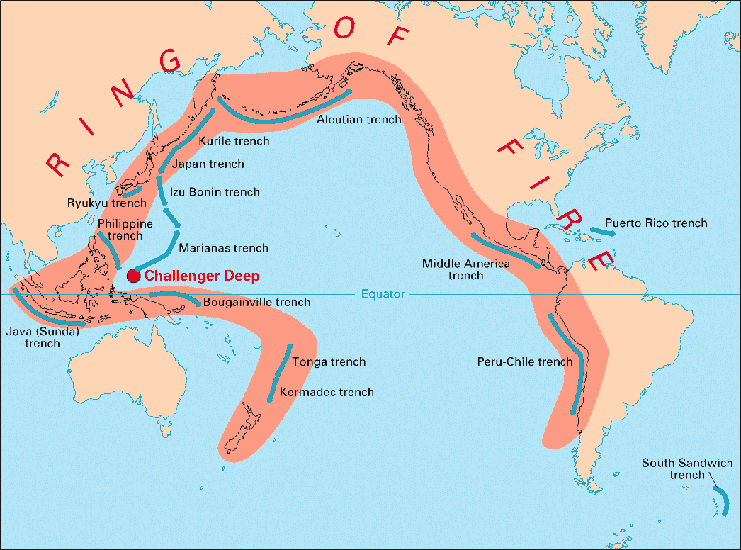

**Conclusion**

Based on the above data processing results, future earthquake predictions can be given, but the results may not be completely correct. But Osaka where I live can be considered a safe place when not in the top 5 localities with frequent earthquakes, and also away from the top 5 localities so I can be assured.