Daniel Alvarez

CIS 310 – Computer Graphics

Assignment: Chapter 7 Project

Illustrator Checkerboard

Step 1: Create document. Launch Illustrator, select file, new.

Step 2: Create a square piece with a border color different than the fill color and the dimensions of 75px width and 75 px height.

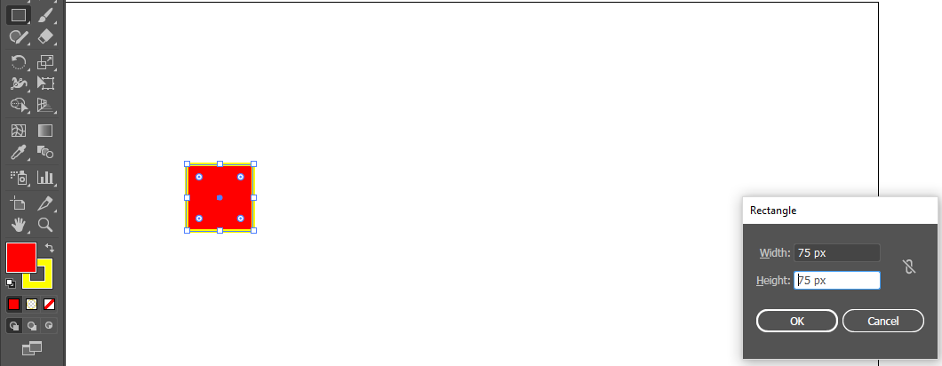

Step 3: Alt+Move the square to duplicate and move to desired location. Align next to initial square to start creating a row.

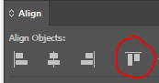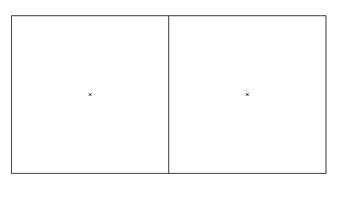

Ensure squares are aligned by changing the view:

View > Preview

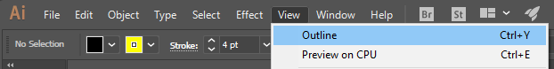

Step 4: Continue adding squares and aligning to create entire row for checkerboard. Alternate colors in the color swatch.



Step 5: Now that we have a full row, copy and move entire row to start adding columns. Rotate copy of initial row to create alternating pattern. Continue this process until you have a full checkerboard.

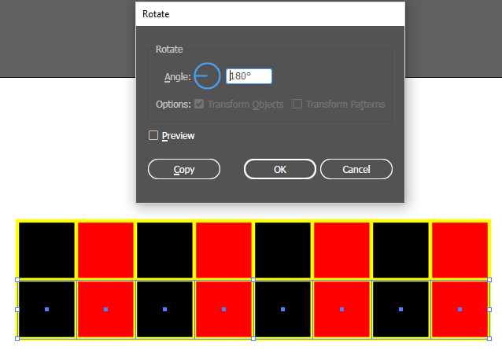

Flipped row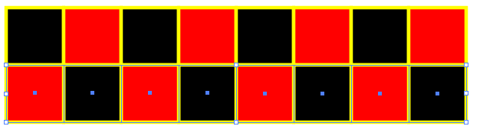

Step 6: Duplicate Layer and lock first layer.

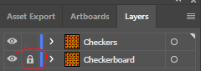

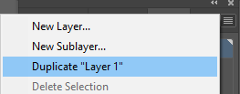

Step 7: To create checker pieces we will utilize the Ellipse tool with 50 px dimensions for width and height.

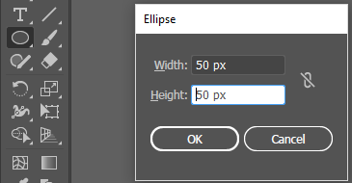

Step 8: Set 2 different colors for the pieces.

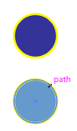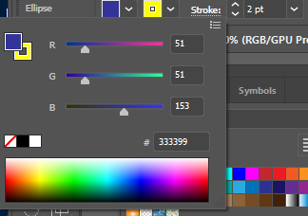

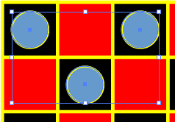Step 9: Follow same copy/paste method (Alt+Move) to add pieces to board. Adjust colors as wanted or needed with swatches menu.

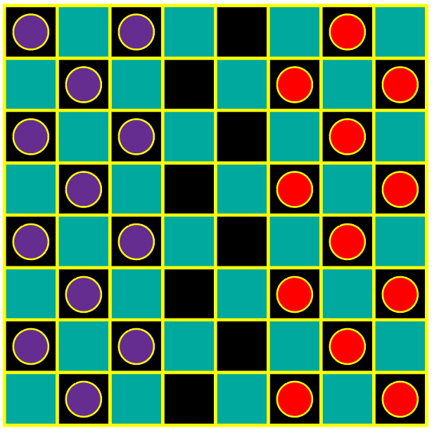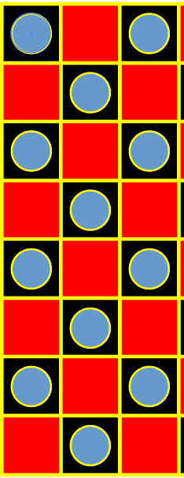

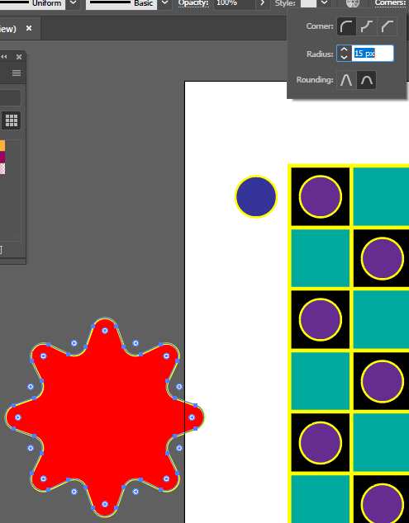Step 10: To add a star to pieces for crowned pieces we will use the start tool with the dimensions shown in the image:

Adjust the corners of star to be rounded:

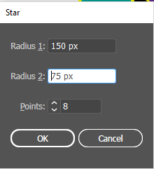

Step 11: Scale the star to fit inside the checker pieces.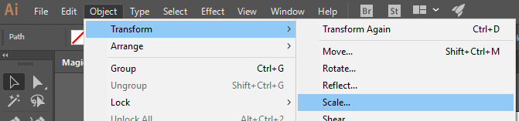

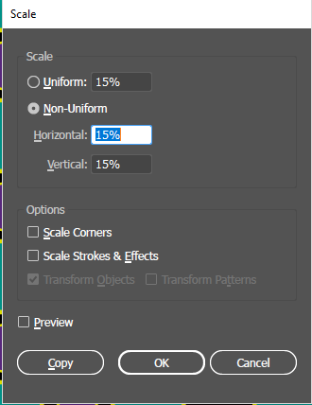

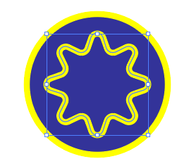

Step 12: Use same Alt+Move method to create all crowned pieces for each side of the board. Adjust colors as described above as well.

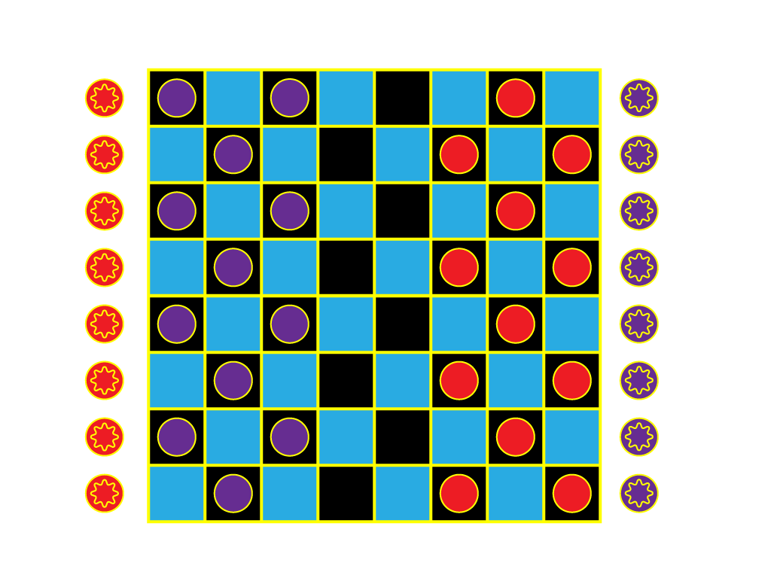



Step 13: Save finalized image as whichever document type needed: .ai to continue working in illustrator, .gif if needed for web and .pdf for a static image that can’t be edited. For this assignment, save as all types and create a zip file to submit to blackboard.