Step 1:Trace the outline of the map using the brush tool

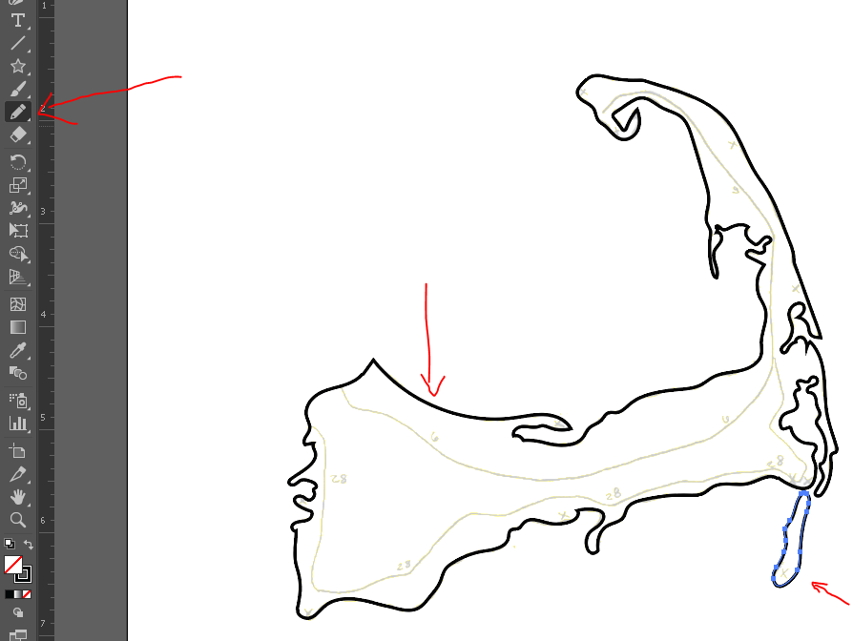

Step 2: Create a dashed line for the highway – add 1-inch layer segment, copy 3 times and select middle line. Under stroke, select “dashed line” and make them 10 pt. Select all 3 lines and Group.

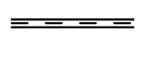

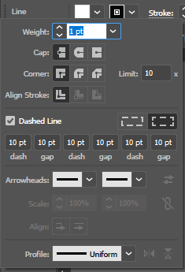

Add art brush to brushes selecting “add new”

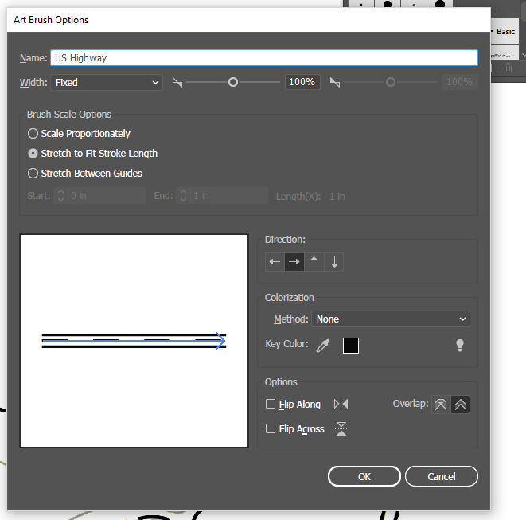

Repeat steps to create new brush, but make it red.

Step 3: Create new layer for Highways. Trace Template highway lines to create highways using the appropriate brush type.

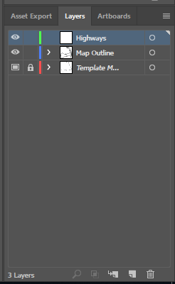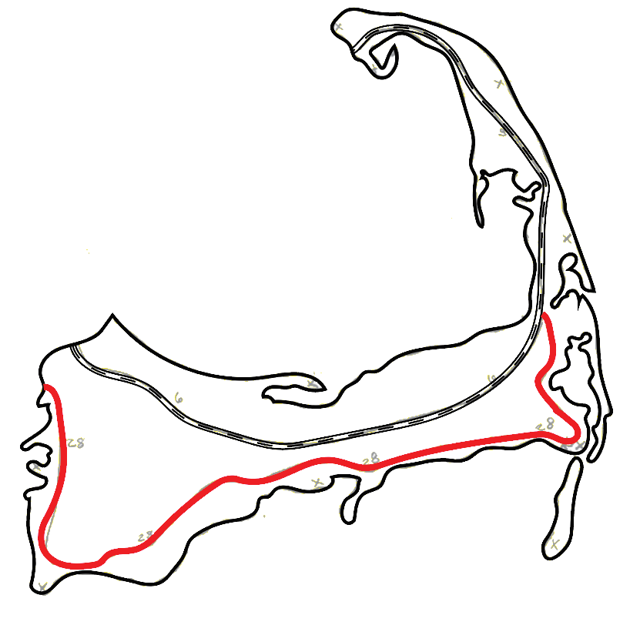

Step 4: Create sign – trace default image and copy to map. Repeat with lighthouse image. Create additional sign with ellipse tool. Transform > scale to appropriate size. 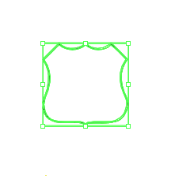

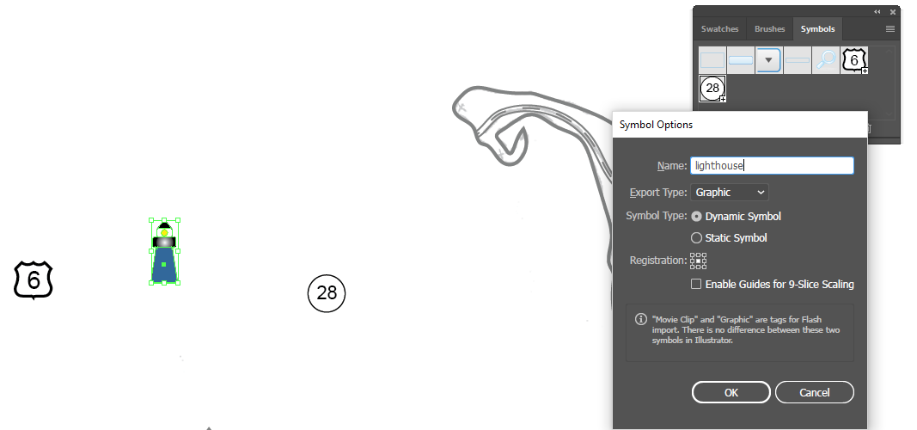

Add images to symbol library by selecting “create new” and naming it.

Step 5: Create symbols layer and add symbols to map

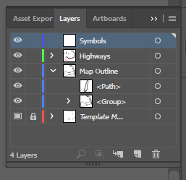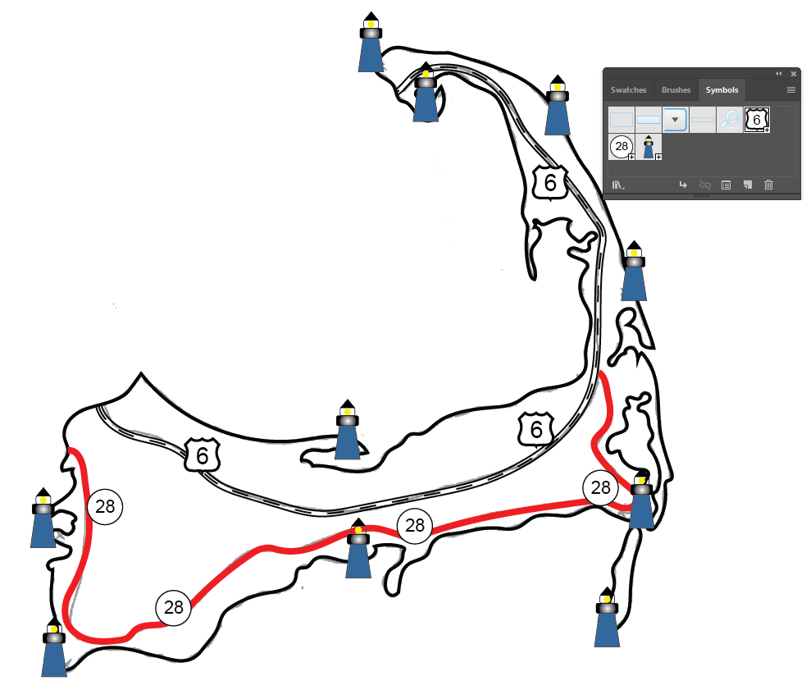

Step 6: Add text layer and add names to Map, Towns and number the lighthouses

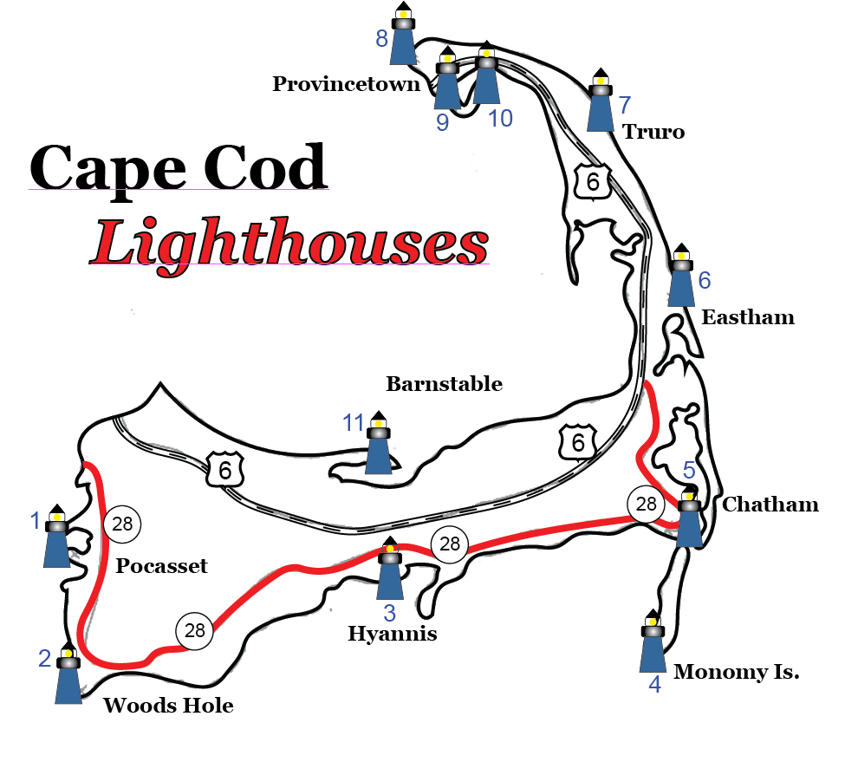

Step 7: Add list of lighthouses from word document. Format size and position accordingly

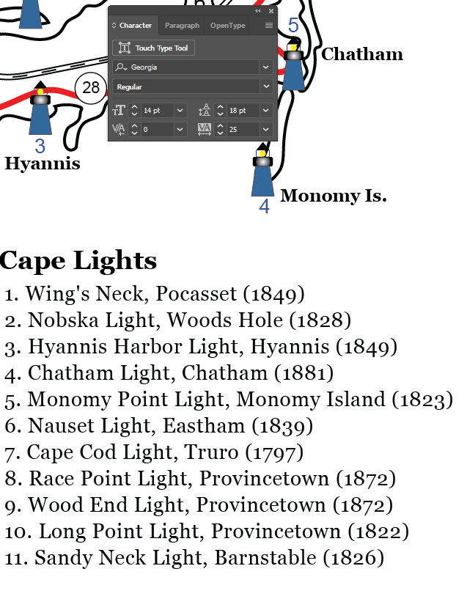

Step 8: Add fish symbols and place where desired

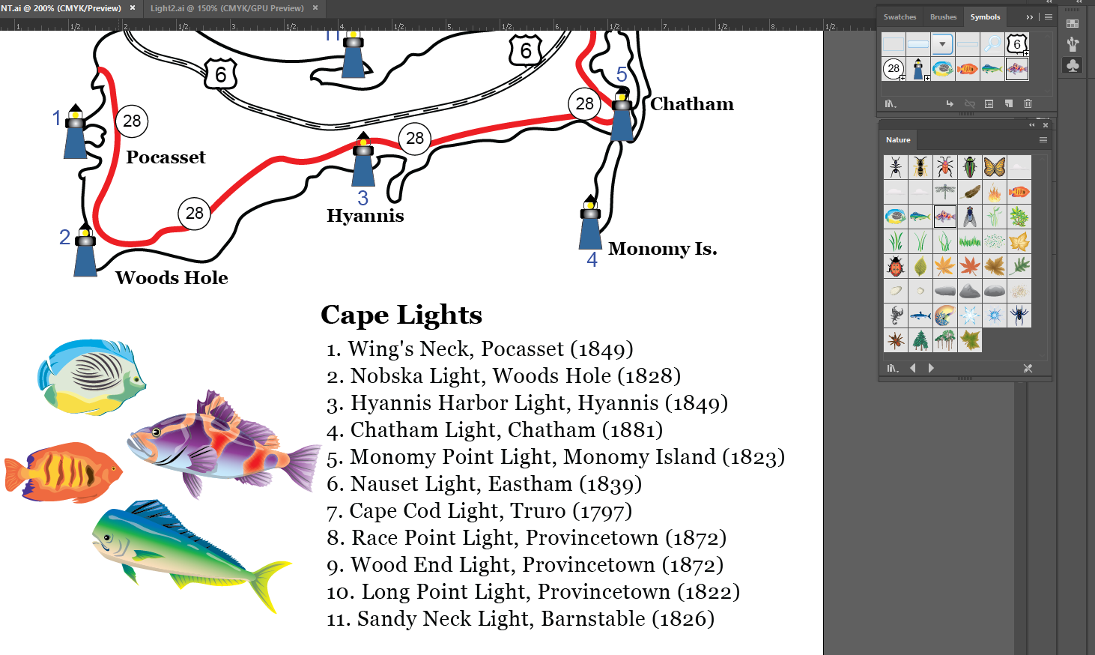

Step 9: Change background color

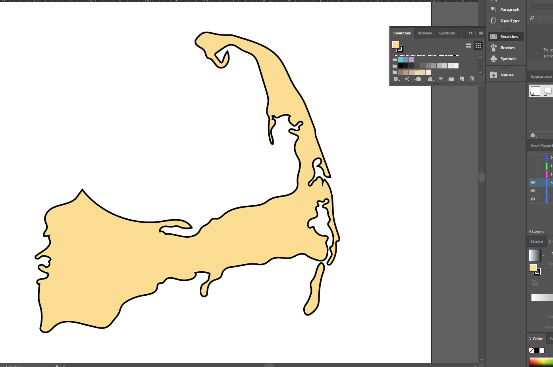

Step 10: Remove template layer and save

