Chapter 9 Project

1. Create the document

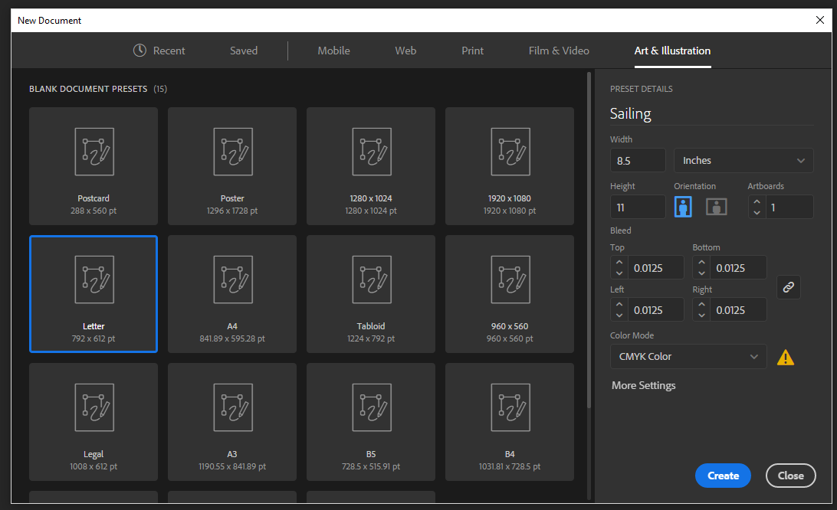

1. Upload the template of the boat

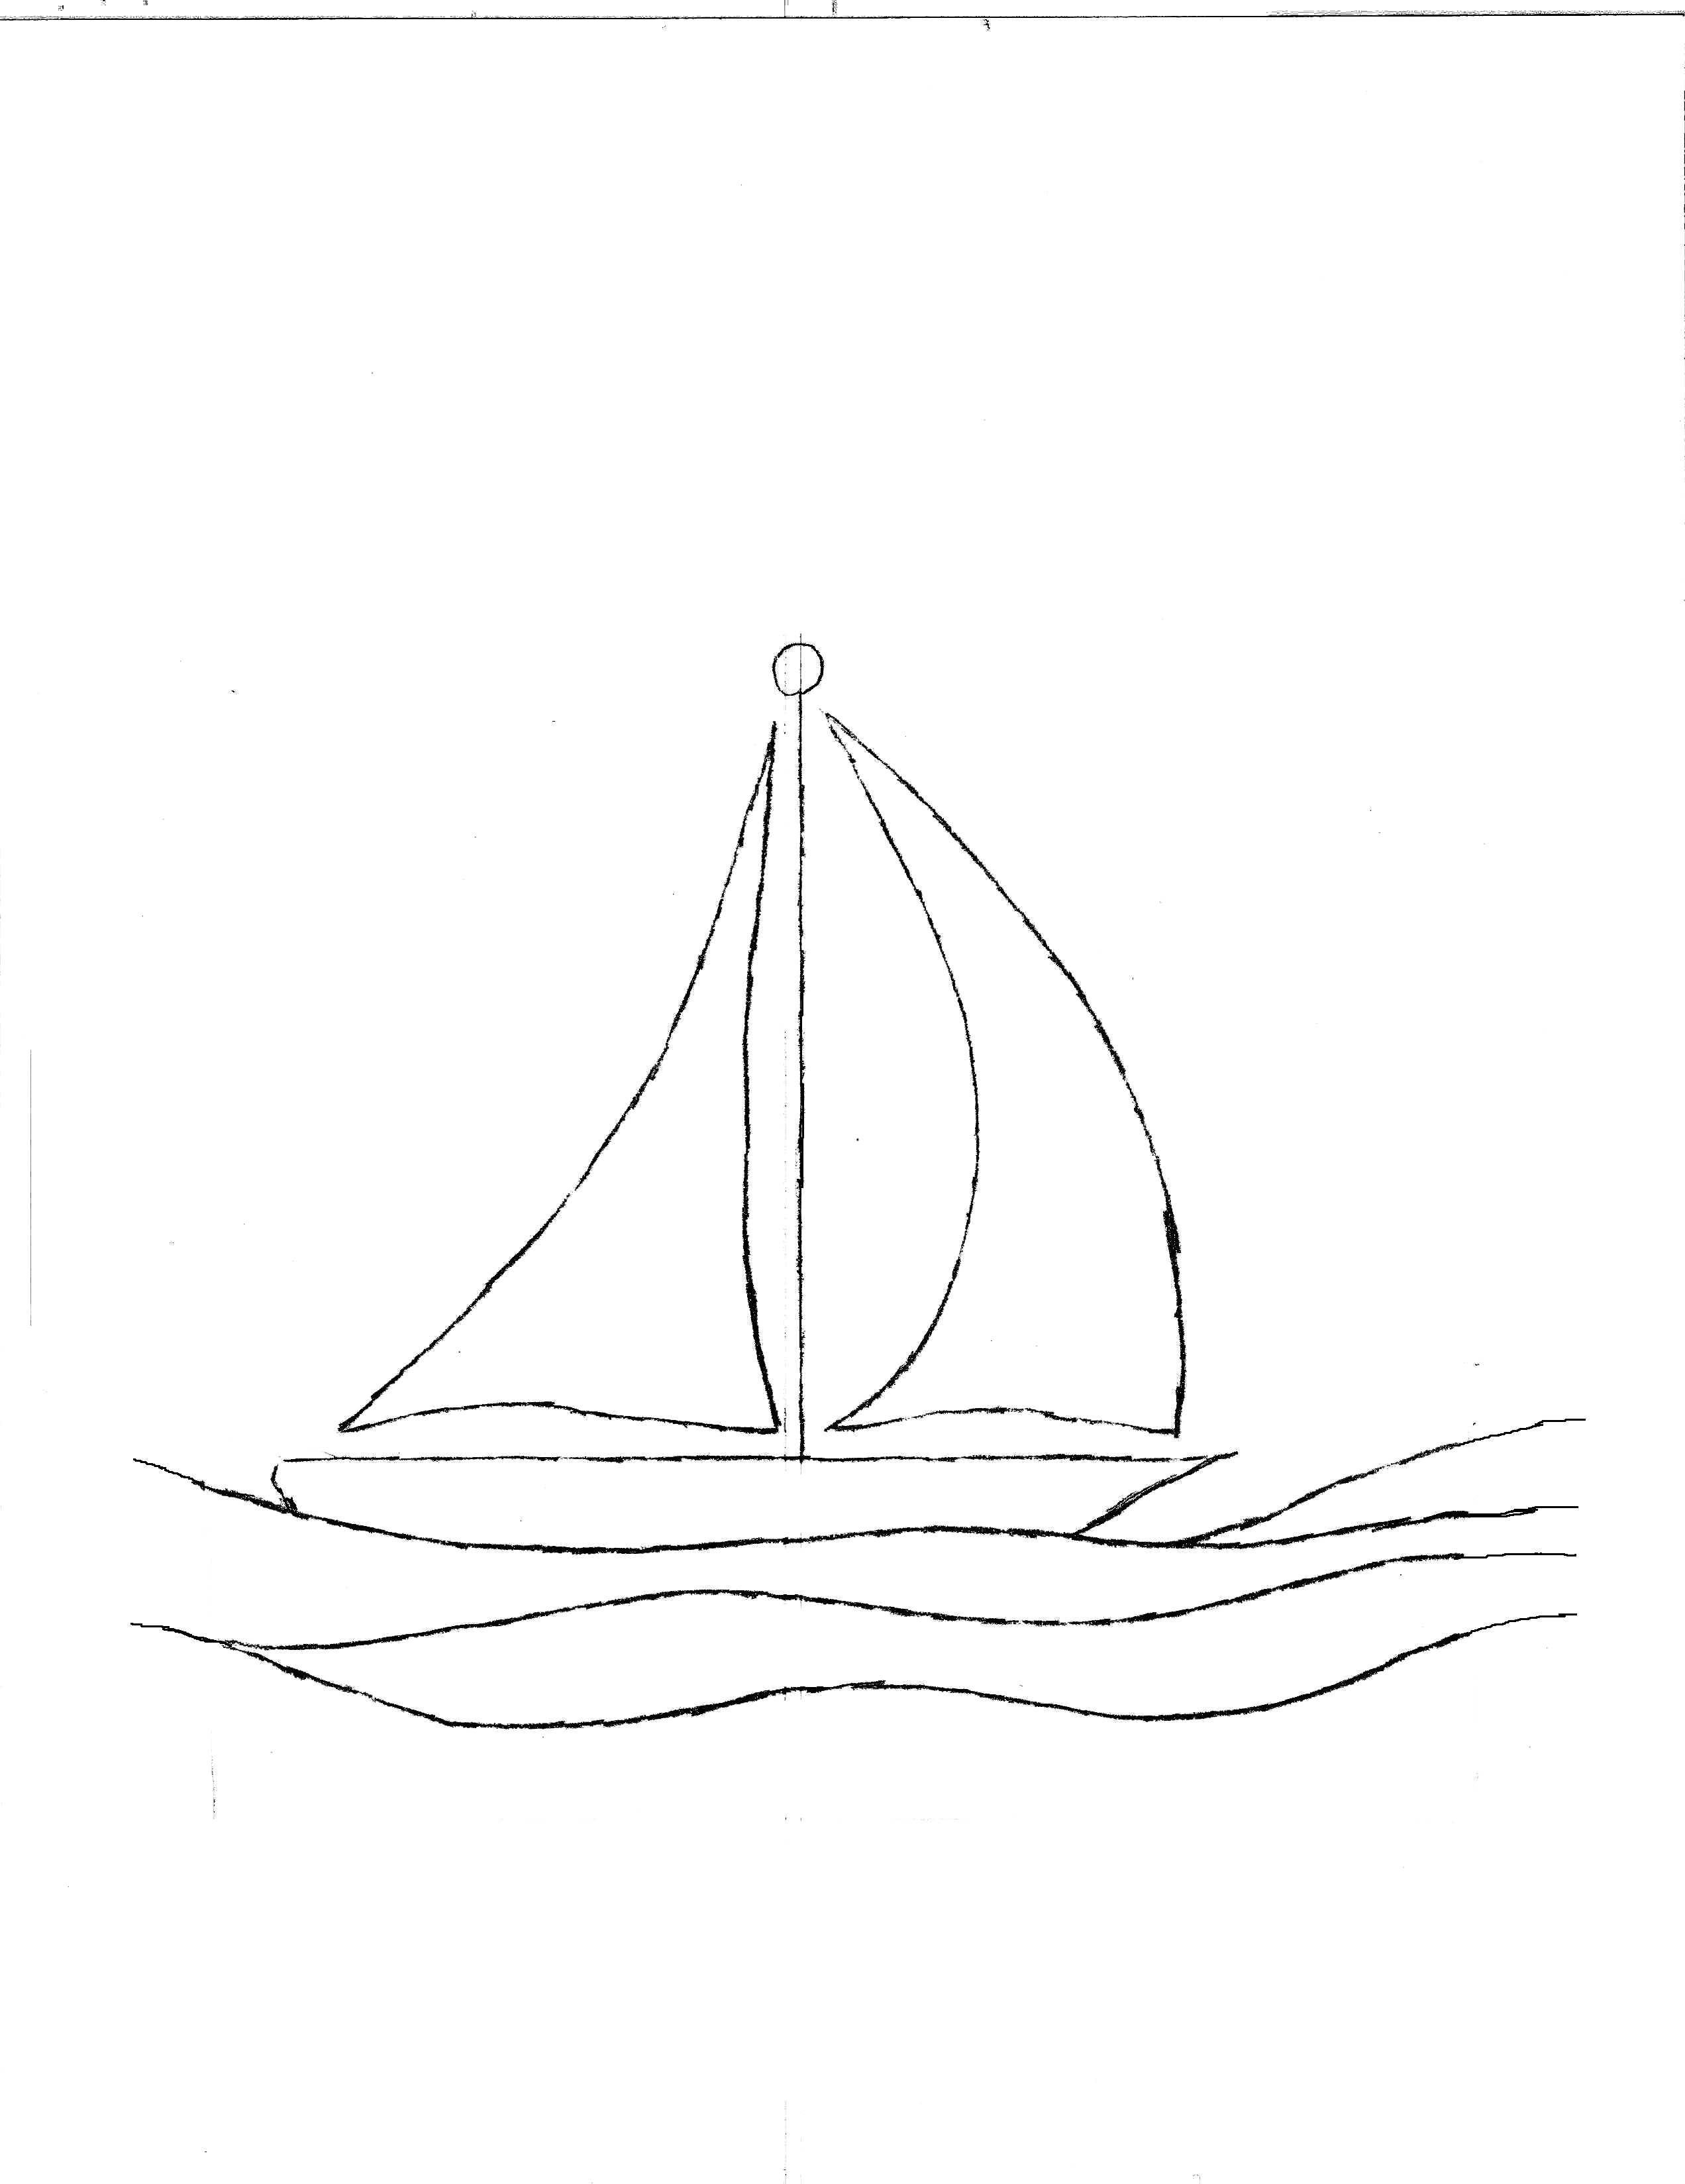

1. With the pen tool, click on the points of the outline to create the body of the boat. Adjust fill and color after you are satisfied with the result.

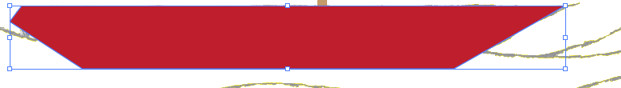

1. Continue to utilize the pen too to create the different areas of the boat, such as the mast and the sail. Adjust the colors and shape as wanted with the direct selection tool and the color swatch.

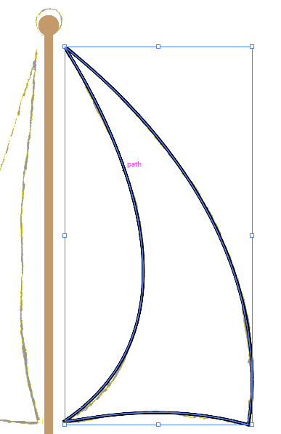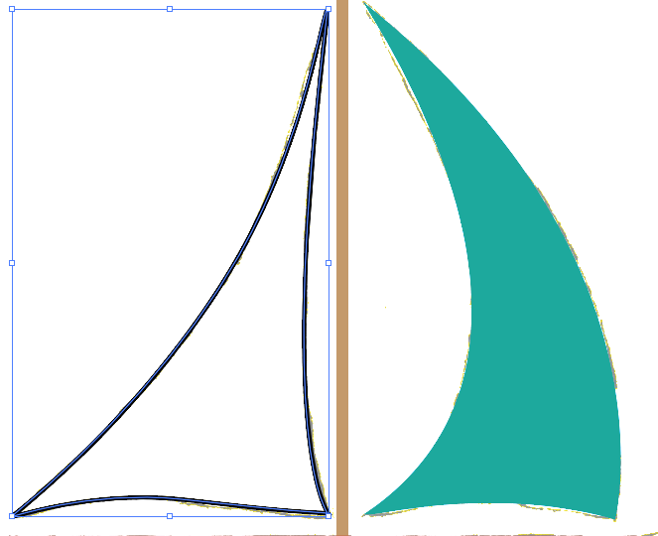

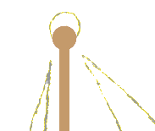

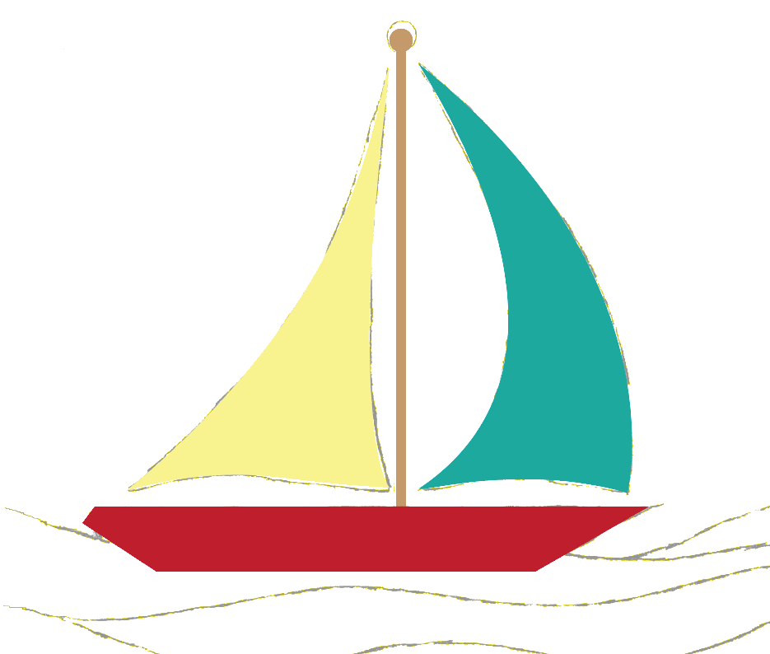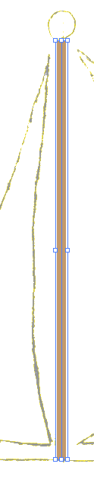

Here are the layers of the boat:

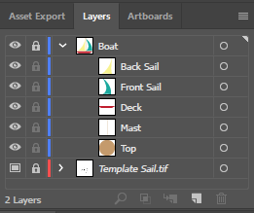

1. Continue utilizing the pen tool to create the layers of water, and adjusting shape and size (same as above.

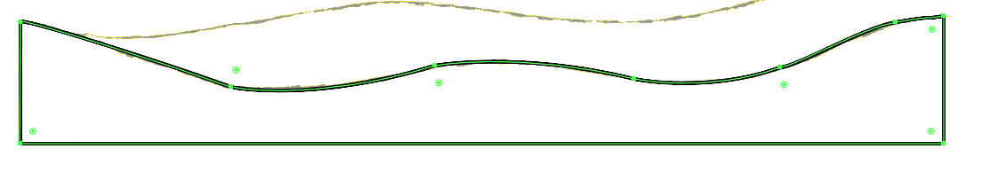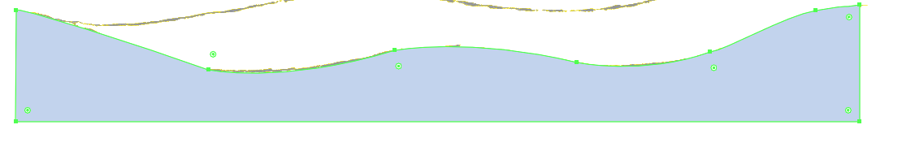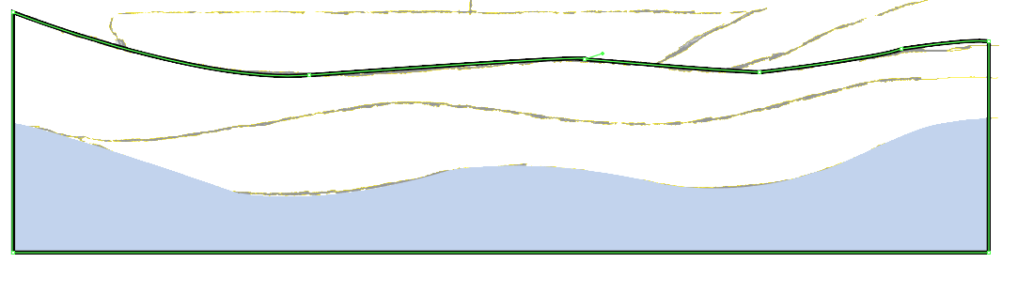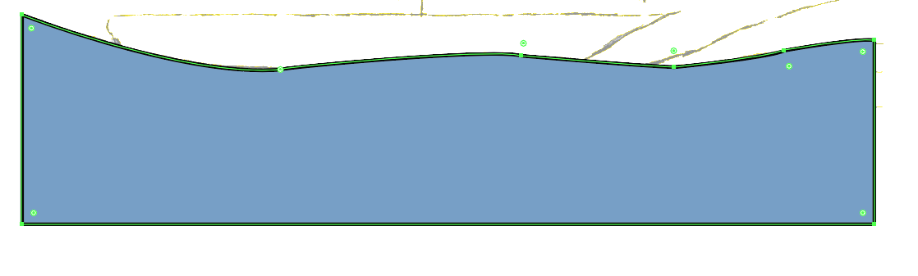

Here are the layers of water:

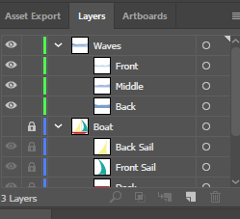

1. Bring the water layers forward to create the water effect after adjusting the colors

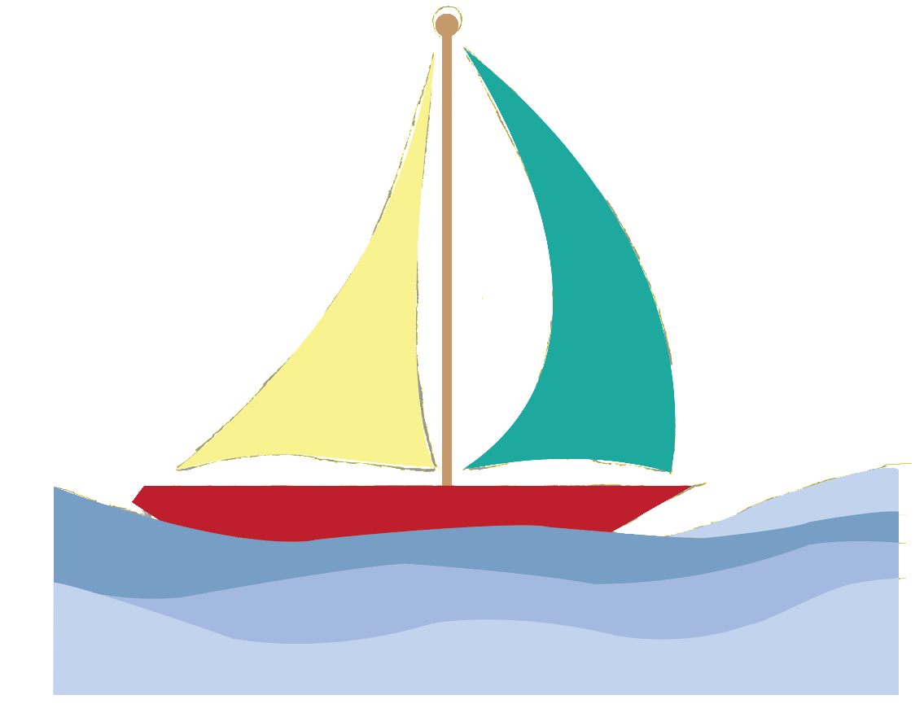

1. Create a circle and add text along a shape. Also add any other text that might be required.

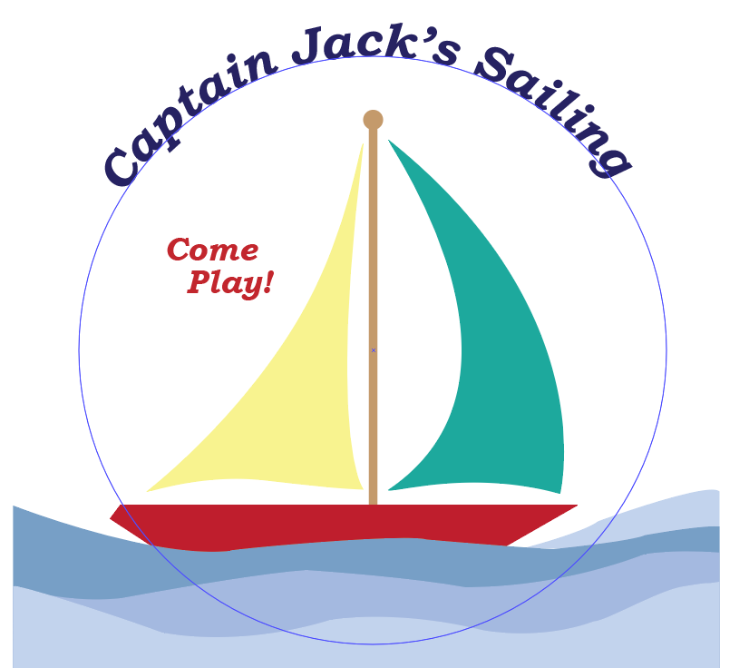

1. Finalize by cropping in a circular shape

