Despite access to “gold-standard” treatments, individuals with opioid use disorder (OUD) continue to engage in drug use, with relapse as the modal outcome (Blum et al., 2018). Thus, it would be important to characterize and isolate the underlying mechanisms that perpetuate this drug use despite treatment. Now given that opioid, and specifically heroin use, has high possibility of relapse, infection, and even death, drug use in this population is widely viewed as “risky”. Therefore, much emphasis has been placed on quantifying risky behavior in OUD. In prior work, it was found that people with OUD engage in more risky decisions than healthy individuals where people with OUD are more tolerant of known risk --have the explicit knowledge about the chance of an outcome (Chen et al., 2020). Furthermore, when these individuals are asked about partially unknown or ambiguous outcomes, also known as ambiguous risk, people with OUD also display an increased tolerance for ambiguity, especially during heighten risk for relapse (Chen et al., 2020; Konova et al., 2020). Work in neuroimaging support that frontostriatal circuits (e.g., striatum and ventromedial prefrontal cortex) are at the core of valuation of risk and ambiguity tolerance (Levy et al., 2010) with additional evidence supporting altered connectivity in patients with OUD within these regions compared to healthy controls (Li et al., 2013; Tolomeo & Yu, 2022). However, it is not well understood how altered connectivity gives rise to increased tolerance for risky and ambiguous contexts. Thus, in the current study, I sought to identify how potential differences in resting-state connectivity in patients with OUD compared to healthy individuals may yield altered patterns of risky decision-making. Consistent with prior literature independently examining altered brain connectivity and heighten risk taking in people with opioid use disorder, I expect there would be (1): dysfunctional resting state connectivity in patients with OUD compared to controls; (2) that patients would be more risk and ambiguity tolerant than healthy controls and that this would correlate with neural activity; and (3) the way that activity flows in resting-state networks would predict task-level activations across the sample.

In the current project, we collected eight-minute functional resting-state scans from 35 treatment-engaged individuals with OUD (Mage=45.40, SEage=2.06, 26 % female) and 30 controls (Mage=47.31, SEage=2.71, 37% female). While collecting resting state, subjects were asked to stare at a cross for the duration of the scan. In addition to resting state, we also collected task data, where subjects completed a validated risk task (**Fig. 1A**; Levey et al., 2010). Using this task, we probed individuals’ make preferences risky and ambiguous outcomes. Subjects were presented a binary choice where they either selected a “safe” option (i.e., a sure monetary gain), or selected a lottery option, that while was for usually a larger monetary gain, had only some likelihood to occur. The alternative to the lottery was that the person would receive no money. In this task, individuals are either given: (1) explicit information about the percent likelihood of an outcome (i.e., known risk trials); or (2) only some information about the likelihood of an outcome with the remaining information occluded (i.e., unknown, or ambiguous trials). Given that this was a lottery task, outcomes were completely up to chance, thus individuals could not learn from their previous options. Subjects also preformed this task for real monetary incentives. We fit subjects’ choice data with a modified power utility model (Gilboa et al., 1989; **Fig. 1B**) that separately parametrizes known risk and ambiguity tolerance.

Behaviorally, I found that controls and patients were sensitive to known risk (*F*(2,126)=65.95, *p*<0.01), preferring less risky option. Both groups were also sensitive to ambiguous risk *F*(2,126)=28.00, *p*<0.01) where all subjects prefer less ambiguous outcomes. There were no significant differences between groups for risk (*p*>0.35; **Fig. 2A**) and ambiguity preferences (*p*>0.90; **Fig. 2B**).

Functional scans were preprocessed using fMRIPrep 1.5.4 [ (Esteban, 693Markiewicz, et al. (2018); Esteban, Blair, et al. (2018), which is based on Nipype 6941.3.1 (Gorgolewski et al. (2011); Gorgolewski et al. (2018)]. As a follow-up from my midterm project, I revised the fMRIPrep preprocessing pipeline to output CIFTI-formatted files (e.g., ‘.dtseries.nii’). Here, I was able to generate timeseries fMRI data for all CIFTI grayordinates for both resting-state and task fMRI. Using these CIFTI-formatted files, allows me to not only have volumetric information but also surface information. To be able to compare resting and task data, I also generate NIFTI files using the same pipeline. These preprocessed non-CIFTI files for resting-state and task data were subsequently smoothed with a 6mm smoothing kernel in SPM.

In the previous project I used an anatomical parcellation (AAL) that was likely not optimized for resting-state connectivity analyses. I thus improved my previous study by using the newly generated CIFTI-formatted files for resting-state data as inputs for the Cole-Anticevic Brain-wide Network Partition (Ji et al., 2019). These subjects’ data were then parcellated into 720 cortical and subcortical functional parcels. Parcels were subsequently intercorrelated and correlation coefficients were then converted to Fisher's Z to approximate a normal distribution. Here, I found that there were some connectivity differences between patients and controls, where, as expected, patients displayed hypoconnectivity between frontal circuits compared to healthy controls. Additionally, consistent with prior work, patients also displayed hyperconnectivity within value-related regions (**Fig. 3**).

For activity flow mapping using ActFlow (Cole et al., 2016), I again used NIFTI-formats for resting state to better correlate neural activity extracted from task-related data (see below). I focused again on 15 regions of interest associated with decision-making and addiction: amygdala, ventral striatum, dorsolateral prefrontal cortex, orbitofrontal cortex, thalamus, inferior frontal gyrus, anterior cingulate cortex, midbrain, and ventromedial prefrontal cortex. Using these regions of interest, I calculated partial correlations between each region of interest while controlling for motion regressors, white matter, and cerebral spinal fluid (obtained from fMRIPrep). Similar to the correlation coefficients calculated using the Cole-Anticevic parcellation, partial correlation coefficients transformed using Fisher’s Z.

SPM12 (http://www.fil.ion.ucl.ac.uk/spm/).) unfortunately does not handle CIFTI-formatted files particularly well. As a result, the generalized-linear model (GLM) was estimated using the NIFTI-formatted files for task data. To assess, independent encoding of subjective value (which accounts for risk and ambiguity tolerance of the person; Levy et al., 2010). I constructed a first-level GLM for each subject where I will include decision trials and missed trials as conditions. In the decision condition, I included the amount of money that in presented in each lottery, the level of known risk during the trial, and the level of ambiguity during the trial. One- and two-sample t-tests were used to assess significant effects of the task on brain activity and test differences in neural response to risk and ambiguity between patients with OUD and healthy controls. Neural analyses revealed a significant encoding of subjective values in both vmPFC and ventral striatum (p<0.05; **Fig. 4B**). This was confirmed by whole brain analyses where the vmPFC (*t*=4.86, *p*=0.049), and right ventral striatum (*t*=6.11, *p*=0.002) significantly encoded subjective value (**Fig. 4A**). No group difference was observed between controls and OUD patients (*p*>0.05).

Following this GLM, I attempt to convert contrasts and t-statistic maps from a NIFTI to a CIFTI file format. This would allow me to parcellate the data into 720 cortical and subcortical regions of interest and engage and larger network analyses. What I understood was that CIFTI files included not just volumetric information, but also the surface information. Here, I needed to combine contrast maps (i.e., volumetric files) with label files (i.e., information about where voxels are), and with surfaces files. To achieve this process, I became acquainted with Connectome Workbench (Marcus et al., 2011). To obtain a template for the t-maps to “map” onto, I took subjects’ task data that was in already in a CIFTI format. The CIFTI file was then separated into a volume map and label file (using the function ‘cifiti-separate’). This new volume file served as a template to resample the t-map into the proper space so that labels were then match the volume (using the function ‘volume-resample’). Surface data was also restructured by taking outputs from FreeSurfer (http://surfer.nmr.mgh.harvard.edu/)). Using the surface GIFTI-formatted data, which contains a map for surface data, I transformed these into metric files “shape” GIFTI files, that contain information about where data arrays lie on the surface files (using ‘volume-to-surface-mapping’). I also generated surface spheres which are files that surface files and metric files map onto (using ‘surface-create-sphere’ and ‘surface-flip-lr’) to generate equal and flipped left and right copies). These files where then combined and converted into a CIFTI-formatted file (e.g., “.dscalar.nii”; using ‘cifti-create-dense-scalar’). This did generate a CIFTI format that I attempted to parcellate using the Cole-Anticevic partition. Unfortunately, I received an error message that the number of surface vertices did not match between the data and the label. So, I attempted to resample the CIFTI file to attempt to match all variables (using ‘cifti-resample’). I again generated a CIFTI file but came with the same error message when I attempted to parcellate the data. As a result, using an in-house ROI-extraction function, I extracted the activity related to risk level and the amount of money of each trial in the previously mentioned 15 regions of interest.

Given clinical observations that patients are typically risk and ambiguity seeking, it was interesting to see that there were no group differences at either the behavioral or neural level. Despite this, evidence does suggest that there are still resting state differences between patients with OUD and healthy individuals (Chen et al., 2020), and in other samples, resting state connectivity may have an effect on task neural activations (Cole et al., 2016). Therefore, it would be useful to examine whether how neural activity flows through resting state connections influence task activity. At the overall sample level, it was found that activity flow models did not predict task activity in response to monetary value and risk level (r = 0.13). Similarly, activity flow models did not predict task activity in response to monetary value and risk level for patients (r = 0.12) nor controls (r = 0.15; see **Fig 5**).

In summary, I found functional connectivity differences between patients and controls, particularly in regions related to valuation and in frontal circuits. Additionally, as predicted, it was found that the vmPFC and ventral striatum encode subjective value. However, there were no differences between patients and controls, which may suggest a mechanism for how clinically observed risk-taking comes to fruition. Last, activity flow models did not significantly predict task-related activations. Despite this, neural responses to other task characteristics that might be influenced by the underlying connections. As for the project, I learned how to preprocess resting-state and task-data in a CIFTI format that could later be parcellated using a larger functional partition. While I was unable to generate CIFTI formats for task-level betas, I was still able to extract activity in 15 ROIs and correlate this data with resting state data in patients and controls. From this, I felt that I could better understand how multiple networks could be at play (e.g., resting and active) in how behaviors are presented. Thus, I think it is imperative for most studies that include task-data to complete a follow-up in how the way information flows in the brain could correlate with task-related activations.

References

Blum, K., Han, D., Modestino, E. J., Saunders, S., Roy, A. K., Jacobs, W., Inaba, D. S., Baron, D., Oscar-Berman, M., Hauser, M., Badgaiyan, R. D., Smith, D. E., Femino, J., & Gold, M. S. (2018). A Systematic, Intensive Statistical Investigation of Data from the Comprehensive Analysis of Reported Drugs (CARD) for Compliance and Illicit Opioid Abstinence in Substance Addiction Treatment with Buprenorphine/naloxone. *Substance Use & Misuse*, *53*(2), 220-229. <https://doi.org/10.1080/10826084.2017.1400064>

Chen, S., Yang, P., Chen, T., Su, H., Jiang, H., & Zhao, M. (2020). Risky decision-making in individuals with substance use disorder: A meta-analysis and meta-regression review. *Psychopharmacology (Berl)*, *237*(7), 1893-1908. <https://doi.org/10.1007/s00213-020-05506-y>

Cole MW, Ito T, Bassett DS, Schultz DH (2016). "Activity flow over resting-state networks

shapes cognitive task activations". Nature Neuroscience. 19:1718–1726. doi.org/10.1038/nn.4406

Konova, A. B., Lopez-Guzman, S., Urmanche, A., Ross, S., Louie, K., Rotrosen, J., & Glimcher, P. W. (2020). Computational Markers of Risky Decision-making for Identification of Temporal Windows of Vulnerability to Opioid Use in a Real-world Clinical Setting. *JAMA Psychiatry*, *77*(4), 368-377. <https://doi.org/10.1001/jamapsychiatry.2019.4013>

Esteban, O. et al. fMRIPrep: a robust preprocessing pipeline for functional MRI. Nat Methods **16**, 111-116, doi:10.1038/s41592-018-0235-4 (2019).

Gilboa I, Schmeidler D. Maxmin Expected Utility with Non-Unique Prior. J Math Econ.

1989;18(2):141-53.

Ji JL*, Spronk M*, Kulkarni K, Repovs G, Anticevic A**, Cole MW** (2019). "Mapping the human brain's cortical-subcortical functional network organization". NeuroImage. 185:35–57. doi:10.1016/j.neuroimage.2018.10.006. [* = equal contribution; ** = senior authors] <https://doi.org/10.1016/j.neuroimage.2018.10.006> and <https://github.com/ColeLab/ColeAnticevicNetPartition/>

Levy I, Snell J, Nelson AJ, Rustichini A, Glimcher PW. Neural representation of subjective value under risk and ambiguity. Journal of neurophysiology. 2010;103(2):1036-47.

Marcus DS, Harwell J, Olsen T, Hodge M, Glasser MF, Prior F, Jenkinson M, Laumann T, Curtiss SW, and Van Essen DC. (2011). [Informatics and data mining: Tools and strategies for the Human Connectome Project](http://www.frontiersin.org/neuroinformatics/10.3389/fninf.2011.00004/abstract). Frontiers in Neuroinformatics 5:4.

Tolomeo, S. & Yu, R. Brain network dysfunctions in addiction: a meta-analysis of resting-state functional connectivity. Transl Psychiatry **12**, 41, doi:10.1038/s41398-022-01792-6 (2022).

**Figures**

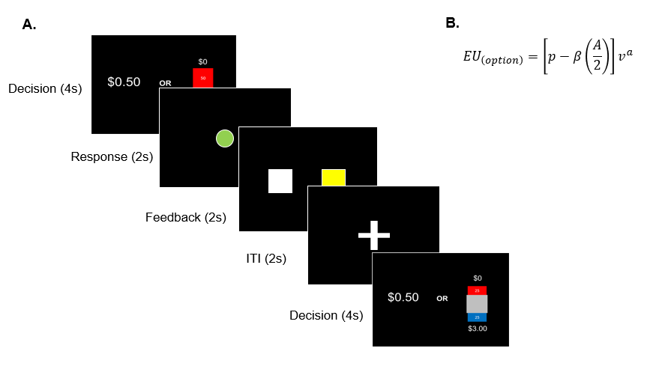

Figure 1. *Risk task*. (A) Risk task presentation in the scanner. (B) Modified power utility function to estimate risk and ambiguity tolerances

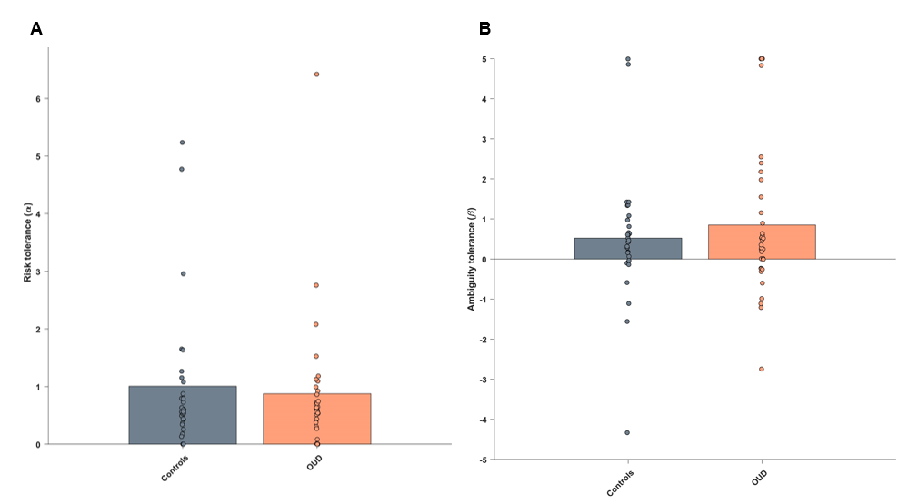

Figure 2. *Fitted risk and ambiguity tolerances*. (A) There were no differences between patients and controls for known risk tolerance with both groups sensitive to risk. (B) There were no differences between patients and controls for unknown risk tolerance with both groups sensitive to ambiguity.

Figure 4. *Neural response to risk and ambiguity.* (A) whole-brain analyses. (B). Regions of interests: ventromedial prefrontal cortex (vmPFC) and ventral striatum (vStr).

Figure 3. *Resting state correlation matrices for patients and controls.*

Figure 5. *Activity flow mapping of lottery amount and risk level in 15 regions of interest.*