Authentication process of the TP
Following the protocol of Z-cash[1] and the following proposal[2], the authentication protocol of the TP will be as follow:
- The voter would identify to the organization to prove elegibility of the vote.
- Once verification acknowledged, voter generate a pair of public / private key (p_b, p_v) and gives the p_b to the organization
- The organization deploys the TP, with a Merkle tree of the p_bs of verified users as input parameter
- In order to receive the vote from the TP, the voter has to construct a zk-proof, π s.t:
  - π proves that the voter has knowledge of a p_b in the Merkle tree
  - π proves that the voter has knowledge of a p_v that construct p_b

Sequence Diagram
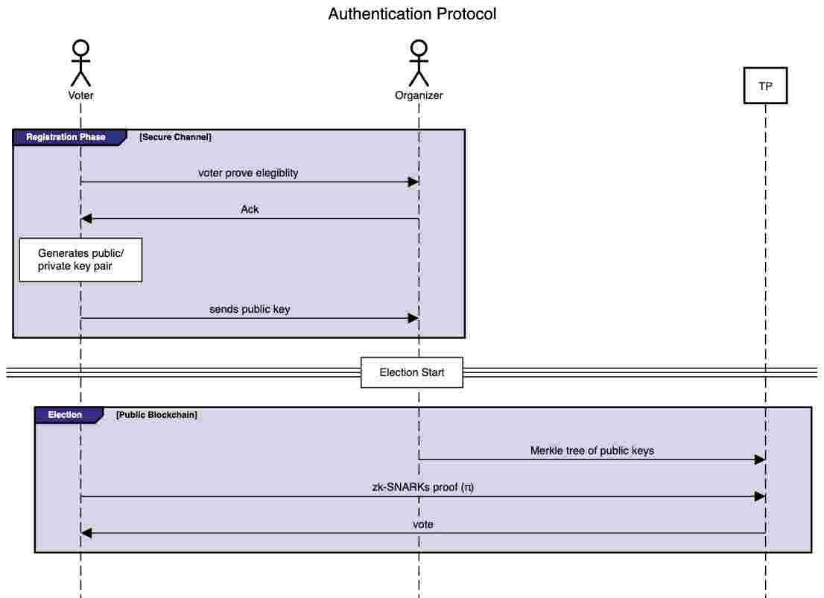

References
- https://www.youtube.com/watch?v=84Vbj7-i9CI
- https://ethresear.ch/t/zero-knowledge-proof-of-membership/3084

