QUBBESoft P/D
PD & Shareware Software New & Used Hardware For The
Sinclair Q.L.
38, Brunwin Road Tel/Fax: +44 (0)1376 347852 Braintree, Essex. CM7 5I3U Email: QUBBESoft@aol.corn
-----------------------------------------------------------------------------------------------------------------------
QPLANE
Powered Back Plane for the Sinclair QL

Disclaimer
In no circumstances will QUBBESoft P/D be liable for any direct, indirect or consequential damage or loss including but not limited to loss of use, stored data, profit or contracts which may arise from any error, defect or failure of QPLANE or incorrect connections of the P8 and P9 power connectors.

Power Connection
QPLANE has been designed to utilise a PC Power supply Unit, which can be found in Full, Midi, Mini Tower Case's and Desktop case's both Slimline and Normal, to supply the neccessary power requirements for the QL and it’s add on cards.

The PC Power Supply Unit has two special 6 way female connectors, normally labelled P8 and P9, whose power connections are as follows:-
WARNING !!!!!!!!

These connectors must be placed onto QPLANE with the correct orientation otherwise disastorous consequences could occur. The rule of thumb when placing these connectors is to always have the Black Wires in the centre.
P8 P9
Orange - Power Good Black - Ground
Red - +5V Black - Ground
Yellow -+12V White - -5V
Blue - -12V Red - +5V
Black - Ground Red - +5V
Black - Ground Red - +5V

QPLANE has the male connectors, labelled P8 & P9, suitable for mating up with the P8 & P9 female connectors of the PC Power Supply Unit.

QL Modification
To allow the QL to function properly with a PC Powers Supply attached to QPLANE a small modification has to be carried out on the QL as follows:-

Remove the large black heatsink that retains the 7805 Voltage Regulator. Remove the 7805 Voltage Regulator from its socket. Take a small length of insulated wire and strip both ends, push the stripped ends into the two outer holes of the socket, thus forming a loop and leaving the middle hole of the socket empty.

Providing the power connectors P8 and P9 have been correctly fitted to QPLANE the QL can now be powered up from the PC Power Supply Unit.

Trump Card Modification
If you are going to use a Trump Card with QPLANE a small modification will have to be carried out to the Trump Card as follows:-

Remove the large black metal casing of the Trump Card, this casing is not only used to cover the components of the Trump Card but is also used as a heatsink for the on board 7805 Voltage Regulator.

Strip a small piece of insulated wire and solder the Inds to the outer legs of the 7805 Voltage Regulator thus forming a loop across the 7805 Voltage regulator.

The reason for this modification is that normaly when the Trump Card is plugged into the QL it is being supplied with +9V rom the QL which is converted into +5V by the on board 7805 Voltage Regulator, The PC Power Supply Unit does not output +9V but does output +5V. QPLANE connects +5V onto the same place where their would normally have been +9V. Unfortunately the 7805 Voltage Regulator will not function with a supply of +5V, it need a minimun voltage of +7V to fuction correctly. By placing the loop of wire across the input and output of the 7805 Voltage Regulator we are thus short circuiting the Voltage Regulator and supplying the Trump Card directly with +5V which it requires to function.

WARNING !!!!! in no circumstances must the modified Trump Card be connected to a standard QL arrangement. If you wish to use the Trump Card in a standard QL you must remove the short circuit across the 7805 Voltage Regulator and replace the black metal heatsink.

Gold Card Modification
The modification required to make the Gold Card function correctly is a little bit more complicated than the Trump Card modification.

First of all you must locate the 7805 Voltage Regulator, normally found attached to the Gold heatsink. As with the Trump Card you must strip a small piece of insulated wire and solder the stripped ends to the outer legs of the 7805 Voltage Regulator thus forming a loop across the 7805 Voltage Regulator.

Now the tricky bit, the Gold Card has a battery backed clock that functions with a supply voltage of +9V we have to convert it to function from +5V. To make it function correctly two components have to be desoldered, and removed, plus a small piece of insulated wire has to be connected. The following diagram shows how this can be achieved:-

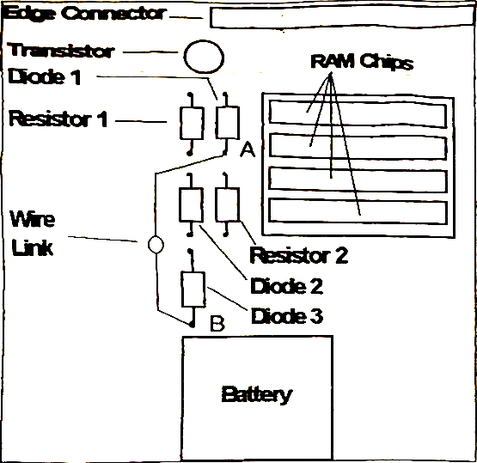
1. Locate and remove Diode 1 and Resistor 2 (see diagram)

2. Link points A and B with a short length of insulated wire.

Once the above has been achieved the battery backed clock will function correctly.

WARNING !!! In no circumstances must the modified Gold Card be connected to a standard QL arrangement. If you wish to use the Gold Card in a standard QL arrangement you must remove the short circuit across the 7805 Voltage Regulator. It is not neccessary to remove the clock modification.

If you are unsure about doing this modification, or any other modification, please contact QUBBESoft P/D.

Super Gold Card
No modification is neccessary when using the Super Gold Card with QPLANE as you can use the external power connector of the Super Gold Card. Please follow the instructions within the Super Gold Card Manual for the use of this connector.

Some people have reported problems using this connector and have reverted to placing a loop across the 7805 Voltage Regulator as with the Trump Card. This is an acceptable way of converting Super Gold Card to work on +5V but under no circumstances must the modified Super Gold Card be placed into a standard QL arrangement without removing the loop.

