Link

[Cómo implementar OCR en Python con tesseract Cómo implementar OCR en python (altaruru.com)](https://www.altaruru.com/tesseract-ocr-y-pytesseract/#:~:text=pytesseract%201%20Instalaci%C3%B3n%20de%20pytesseract%20sudo%20pip3%20install,cv2.imread%28%22imagendeprueba.tif%22%29%20...%203%20Referencias%20https%3A%2F%2Fpypi.org%2Fproject%2Fpytesseract%2F%20https%3A%2F%2Fpypi.org%2Fproject%2Fopencv-python%2F%20https%3A%2F%2Fgithub.com%2Ftesseract-ocr%20)

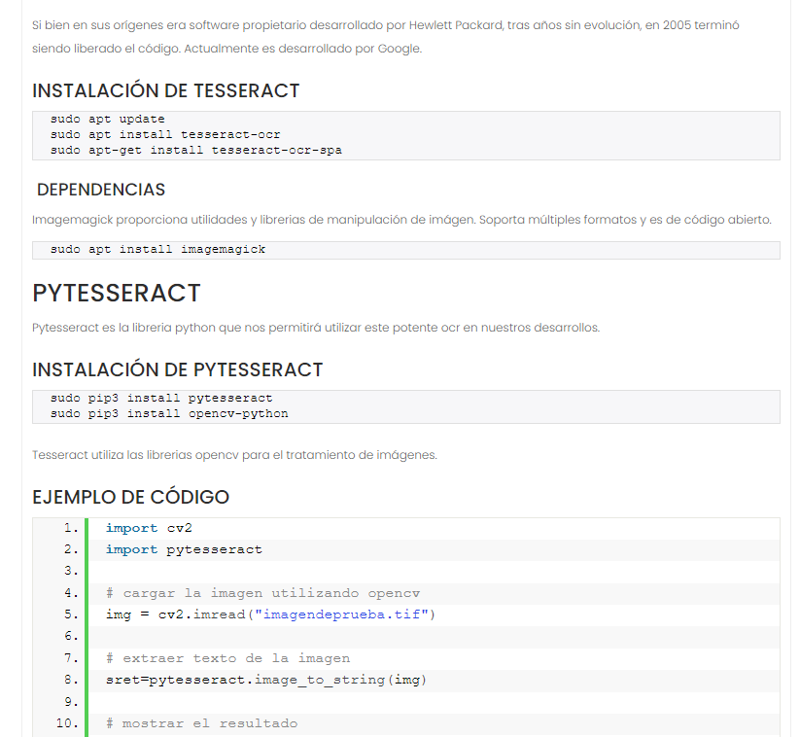

Para convertir docx a pdf

https://fedingo.com/how-to-convert-docx-to-pdf-in-linux/

