

Report

Case Study: A Student Class Scheduling

Investigação Operacional - Mestrado Integrado em Engenharia Informática e Computação

2019/2020

Álvaro Francisco Barbosa Miranda up201603694

Index

* Introduction
* The case
* First Question
* Second Question
* Third Question
* Fourth Question
* Conclusion

Introduction

In this case study, it was intended to better understand how a person can learn or to better understand how the decision theory and linear programming models works. Also, as a student, it talks about an interesting subject as it probably will help me in the future by allowing me to optimize my schedule accordingly to my preferences. It will also allow a better understanding of the Solver in Microsoft Excel as well as things like problem definition or model developments.

First, we will explain the case itself and after that we will analyze the questions proposed. Latter we talk about the conclusions of the current case study and report.

The Case Study

The case is about a student named Kelly, which wants to make the best schedule for her, to the last semester she will have at Smith University.

She needs 5 courses to make her schedule. She can choose different courses from the offered by the University. However, there are some minimal requirements she must respect when making her schedule. She then chooses the ones she may consider choosing which we see below.

1. She must attend Business Strategy (BS);
2. She must attend International Finance (IF);
3. She must attend one service-learning course which can be:
   1. Intergenerational Computing (IC);
   2. Web Design for Non-Profit Organizations (WDNPO).
4. She must attend two finance elective courses which can be:
   1. Data Analysis in Finance (DAF);
   2. Risk Management (RM);
   3. Options, Futures and Swaps (OFS);
   4. Fixed Instruments and Markets (FIM).

As she wants to choose the optimal schedule, she must have criteria to see which class appeals more to her. For this she says that her priorities are first the content of the course, second, the reputation of the instructor and last, the timing of the course. She then gives a grade from 1 to 5 for each of these three criteria. By joining the three, using a weighted average, she obtains a grade to each possibility of course in the corresponding schedule. The results of this we can see in the table below.

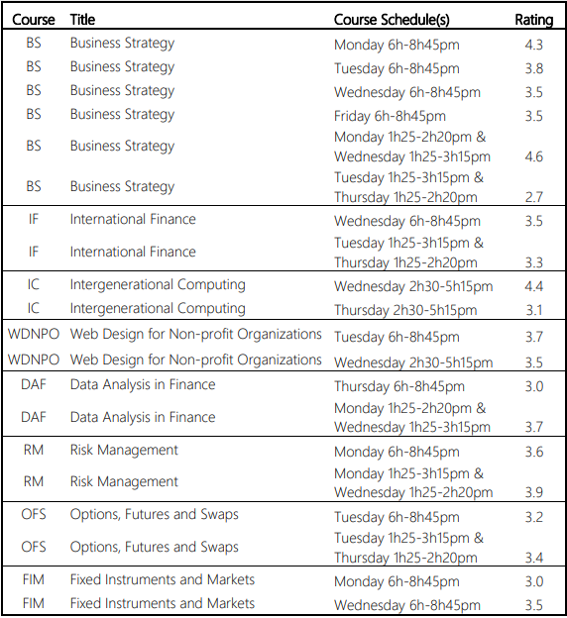

Image 1 – Available Courses Data with Rating

First Question

Here we will see the optimal schedule for Kelly. To obtain this we first must formulate the problem and collect data. As we already done this in the previous chapter we proceed to the next phase. Next, we to formulate and solve the problem. This is done in Excel.

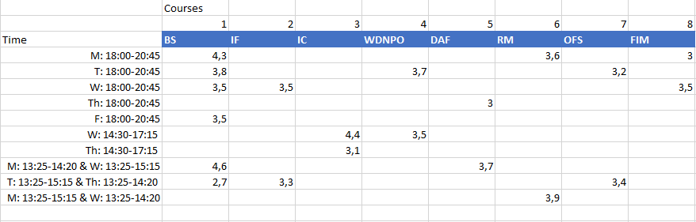

Image 2 – Course Data Table

First, we have the information about the different courses disposed in the table in Image 2. Then we need another table of the same size of binary values to choose which course to attend. If a value is 1, it means that Kelly must attend the course, corresponding to the same cell in table 2. As we can see the values are still 0 which means that in the moment, she would not attend no course. To see the optimal schedule, we also need to define the constraints and only then we can solve the problem.

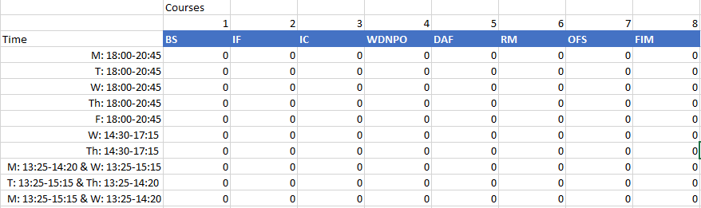

Image 3 – Decision Variables Table before any solving

Looking at Image 4, in the first row, each cell is the sum of every column of Image 3. That is the amount of times Kelly has the correspond course each week. This valor can’t be higher than 1 as she only has to the course in a singular time slot every week. In the lines below, in the first and second cell we have the sum of the column as is required to Kelly to have BS and IF. The third value is the sum of the column IC and WDNPO as it is required to her to have on of this two. The last valor is the sum of the last 4 columns of Image 3. This valor must be 2 as is required to Kelly to have 2 of the DAF, RM, OFS, FIM courses. The total amount of classes is 5, so the sum of the table in image 3 must also be 5.

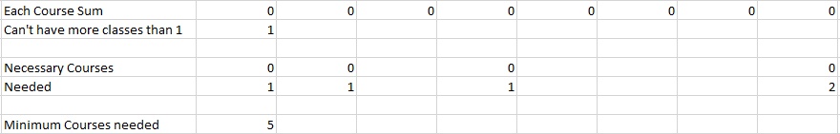

Image 4 – Constraints related to Courses

Looking at image 5 we see the constraints related to time. In the second column each cell is the sum of each time row of Image 3. Any of these values can’t be higher than 1 because it is only possible to be at a class in any moment. Also because of the same reason, there can’t be two classes in these schedules (W: 14:30-17:15 and M: 13:25-14:20 & W: 13:25-15:15) and M: 13:25-14:20 & W: 13:25-15:15 and M: 13:25-15:15 & W: 13:25-14:20) as they have simultaneous schedules. These valor are present In the first column of Image 5 and can’t be higher than 1.

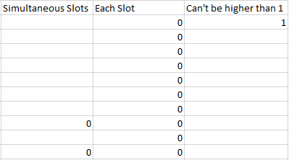

Image 5 – Constraints related to Time Slots

Having all constraints defined we need to use Microsoft Excel Solver to find the optimal solution. First, we need to define the Objective Function. To this we define the Sum Product of the two tables in Image 2 and 3. As we want to find the maximum total rating, we select the option to Max. After that, we selected the “By Changing Variable Cells” corresponding in this case as the cells of Image 3. Moving on we have the constraints where we defined all I said before as well as guarantying that all values in Image 3 are binary. After that we select the solving method as Simplex LP as it is better to solve Linear Problems.

By doing this we are prepared to hit the solve button and get the optimal solution to Kelly’s problem.

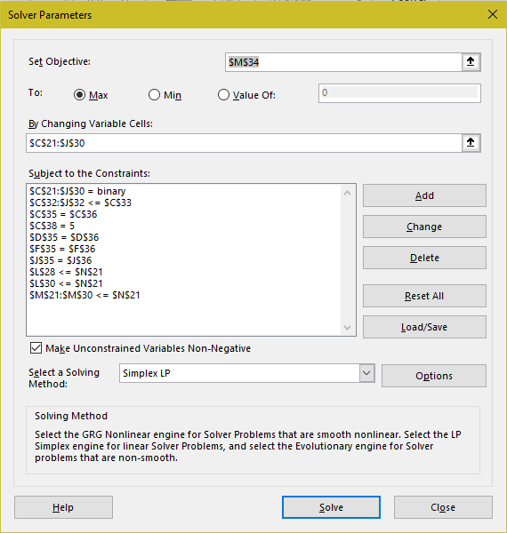

Image 6 – Microsoft Excel Solver with all defined

Finally, we analyze the result obtained. By looking at Image 7 we see that Kelly should choose BS at Mondays 18:00-20:45, IF at Wednesday 18:00-20:45, IC at Wednesday 14:30-17:15, RM at Monday 13:15-15:15 and Wednesday 13:25-14:20 and finally OFS at Tuesday 13:15-15:15 and Thursday 13:25-14:20. With this results it is obtained a maximum total rating of 19,5.

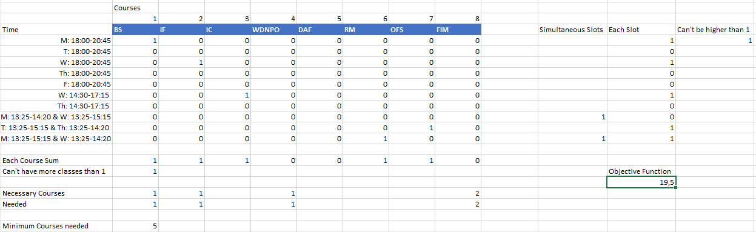

Image 7 – Optimal Solution found

Second Question

In this question it is offered to Kelly an option of having an online class of BS with Professor Dan Braun. She gives this class a rating of 5. And because of being online it will not interfere with any other class schedule.

To solve this, it is almost the same as demonstrated in question 1. We only need to add a new row to the first table as we see in Image 8.

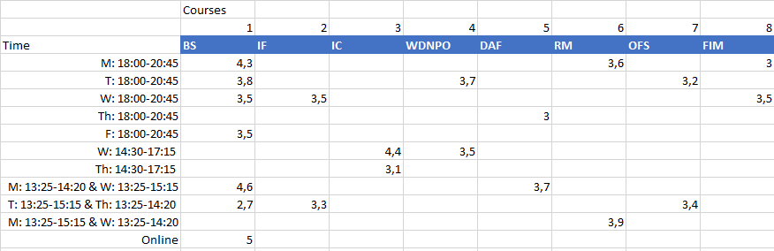

Image 8 - Course Data Table for Question 2

Then we also add a row to the second column as we can see in Image 9.

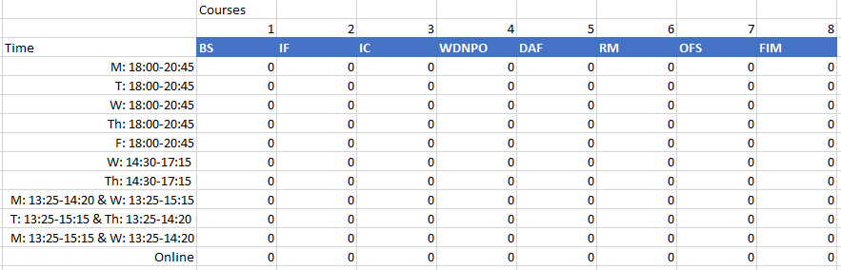

Image 9 – Initial Decision Variables Table for Question 2

After that we only need to change some restrictions. For the ones related to the courses we only need to change the sums to also include the new row. Related to the Time we don’t change any restriction because it will not interfere with any presential class that Kelly may choose.

As for the objective function it is also needed to add the news rows to the Sum Product. The Solver is equal to image 10.

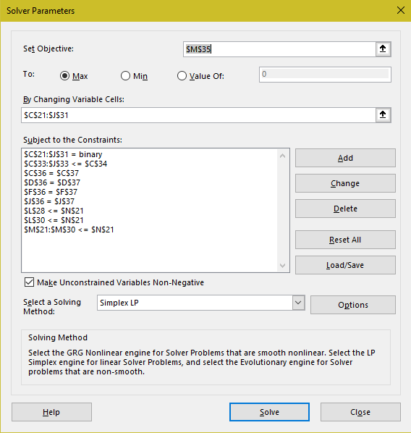

Image 10 – Microsoft Excel Solver for Question 2

By looking at image 11 we see that the optimal schedule has changed. She must choose the online class of BS instead of the one at Monday 18:00- 20:45. Apart from the other classes remains the same as question 1. By selecting this online class we obtain an optimal total rating of 20,2.

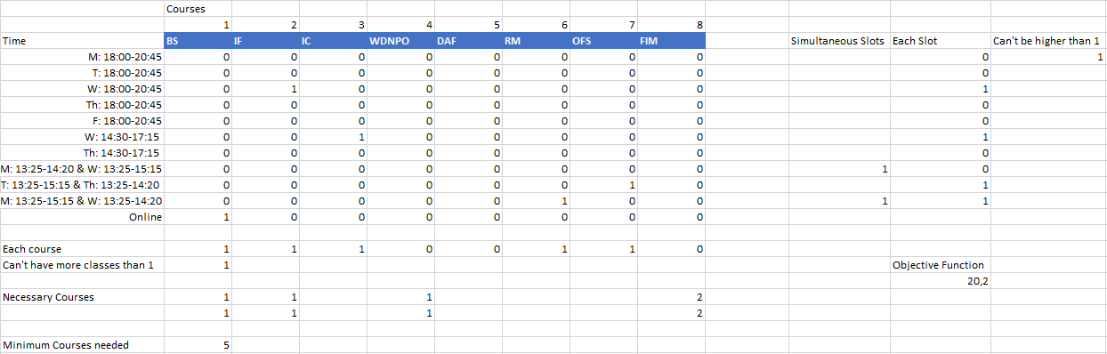

Image 11 - Optimal Solution found for question 2

Third Question

In this question Kelly is considering having a schedule where she only wants to have classes in three days of the week maximum. However, she only wants this schedule if it not lowers the rating too much.

First, as there are no extra classes offered, the first and second tables are equal to the first exercise, that is Image 2 and 3.

Also, the Objective Function and all the constraints of Question 1 are present here.

However, there are some new ones now. As the limit of days is three first, we need to check if there are classes in each day. For that we do a sum of the ones on the Decision Variables Table for each day. We do that in the second column of Image 12. After that we have a column of binary values which will indicate if the day has classes or not. This column will be added to the “By Changing Variable Cells” of the Solver. Later in that row we have the sum of that same column and it is required to be equal or lower than 3 as it is the limit Kelly wants. After that we have a new column to have absolute sure there is only three days with classes. We multiply each valor of the previous column with the valor 5 which is the maximum days Kelly can have classes during a normal week. Later we check if this valor is lower or equal to the number of classes Kelly has in one day.

With all this we are ready to use the solver as seen in image 13 and obtain the new optimal solution.

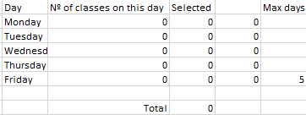

Image 12 – Constraints related to the three limit days

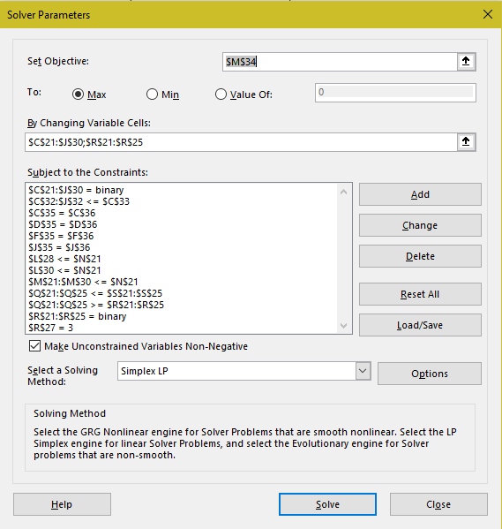

Image 13 – Microsoft Excel Solver for Question 3

We can see by the images below that the selected classes are the same as question 1 except OFS that was done in a Thursday. Instead she must choose OFS at Tuesday 18:00-20:45 and by doing this she only has classes in Monday, Tuesday and Wednesday. With this solution she obtains a rating of 19,3. By only lowering by 0,2 she may strongly consider to change to this alternative.

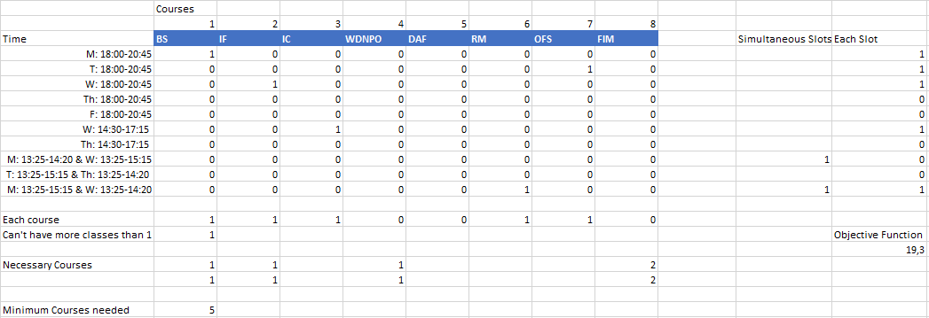

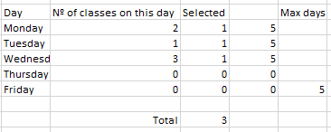

Image 14 and 15 – Solution Found for Question 3

Fourth Question

Like in exercise 2 it is offered an extra class. This one is of IC in Tuesday morning. But if Kelly chooses this class, she doesn’t want any class on the evenings of Mondays or Tuesdays.

Like in exercise 2 is added a new row with the new class offer as we see in image 16. In the second table is also added a new row with the new alternative.

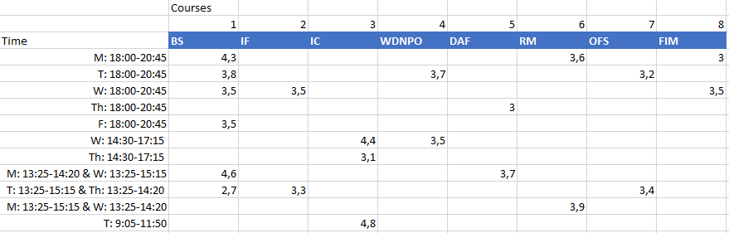

Image 16 - Course Data Table for Question 4

Like in question 2 all restrictions from questions are almost maintained. Only is needed to change the sums of how many classes are being taken for each course, that is adding the new line to the sum. Now there is only needed to add the new restrictions. This will be done by having a sum of the amount of times a class is chosen in Monday evening and Tuesday morning and guarantying it is never higher than 1. The same for the Tuesday. Having a sum of the amount of classes chosen in Tuesday morning and Tuesday evening and guarantying it will never be higher than 1. With all this we can use Solver to obtain the solution.

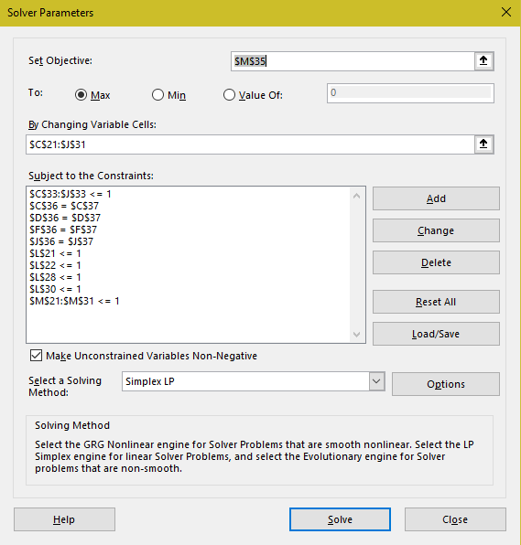

Image 17 – Microsoft Excel Solver for Question 4

In Image 18 we see that the solution obtained is the same as the one we obtained in Question 1.

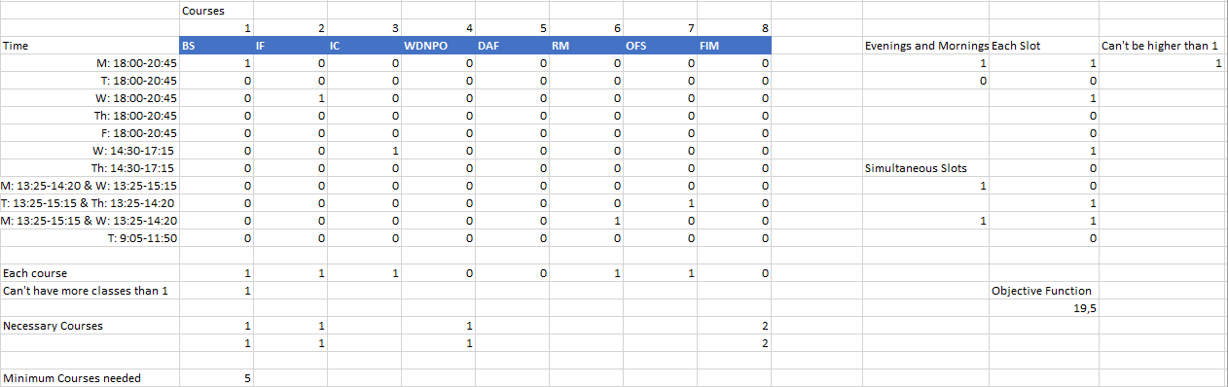

Image 18 – Solution for Question 4

If the new class was selected, we could see that the optimal rating would only be 14,5 which is a huge fall from the optimal solution.

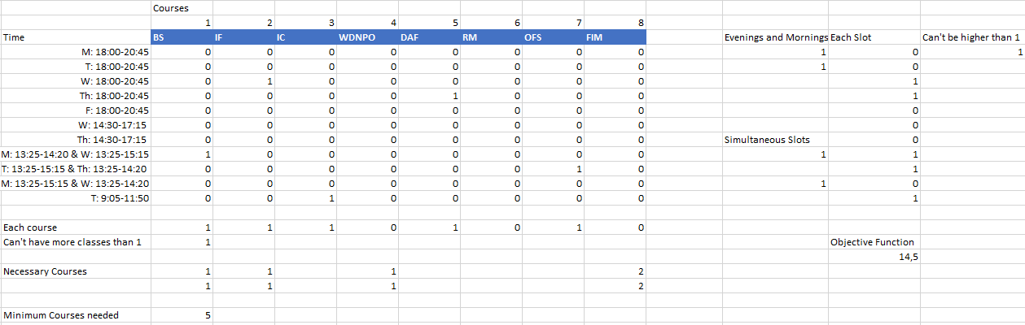

Image 19 – Solution if new class was selected

With this we conclude we conclude that she would maintain her previous schedule as is still better.

Conclusion

First, in this work I learned to better use the Microsoft Excel and, in particular, the Solver. This tool seems to be very powerful and useful to use in the future.

Second by realizing and analyzing this case study I learned a new and better way to choose my schedules, and probably in the next semester I give it a try to see if I can find the best one.

Finally, with this work, I learned a lot about decision theory, linear programming, problem definition, data analysis, model developments, optimal solutions, constraints and many more subjects.