
Animal-care veterinary clinic
420-DW4-AS Web Server Applications Development II

November 21, 2025
Rafat-Ahmed Islam (2311953), Shaquille Osborne Neil (2330041), Kevin Alinazar (2332512), Alvaro Eloy Limaymanta Soria (2311145)
Presented to
Houria Houmel

Table of Contents
Part I – Information System Analysis & Design 2
1-System Analysis by Rafat-Ahmed Islam 2
1.1- Identify the system objects to be automated. 2
1.2- Identify the characteristics of each object and their functionalities 3
2- Design (UML Disgrams) 4
2.1- Use Case Diagrams by Shaquille Osborne Neil 4
2.2- Class Diagram by Kevin Alinazar 8
2.3- Activity Diagram by Alvaro Eloy Limaymanta Soria 9
2.4- Sequence Diagram by Rafat-Ahmed Islam 12
Part II – Design & Database Implementation 13
1-Entity-Relationship Diagram – ERD 13
1.1 Identifying Entities and Their Characteristics 13
1.2 Relationship & Cardinalities 13
1.3 Entity-Relationship Diagram 14
2 – Relational Data Model – RDM 15
2.1 Identify parent tables and association tables 15
2.2 Define Domain-Level Constraints (Column-Level Constraints) 19
2.3 Define table constraints and relationship constraints between tables. 21
2.4 Relational Data Model 24
3 - Implementation of the Database Using Microsoft SQL Server 2019/2022 25
3.1 Overview 25
3.2 Database Creation & Setup 25
3.3 Views 25
3.4 Stored Procedures 28
3.5 Triggers 30
3.6 Indexes 33
3.7 Testing & Validation 35
3.8 Summary and Evaluation of Database Implementation 36

Part I – Information System Analysis & Design

System Analysis by Rafat-Ahmed Islam

1.1- Identify the system objects to be automated.
- User: Represents any person authorized to access the system (administrator, receptionist, veterinarian).
- Role: Represents the level of access permissions granted to a user.
- Administrator: Full access to all system functionalities.
- Receptionist: Manages owners, animals, and appointments.
- Veterinarian: Views schedules, manages their own appointments, and records medical histories.
- Veterinarian (Role): Can view schedules, manage their appointments, and record medical histories.
- Owner: Represents the clinic’s client.
- Animal: Represents the animal patient cared for by the clinic.
- Schedule: Represents the availability time slots of a veterinarian.
- Appointment: Represents a planned consultation between an owner (through their animal) and a veterinarian.
- MedicalHistory: Represents the animal’s medical record, keeping track of all treatments, diagnoses, and procedures performed.
- Notification: Represents the system for automatic alerts and reminders.

1.2- Identify the characteristics of each object and their functionalities
Object | Attributes | Main Functions
Owner | IdOwner, LastName, FirstName, Phone, Email, Address | - Register a new owner- Update owner information- View the list of their animals- Delete a client record
Animal | IdAnimal, Name, Species, Breed, Sex, BirthDate, Weight | - Add an animal to the owner’s record- View information and medical history- Modify data- Delete an animal
Veterinarian | IdVet, LastName, FirstName, Specialty, Phone, Email | - Manage availability- View upcoming appointments- Add notes or diagnoses to medical records- Update profile
Schedule / Availability | IdSchedule, IdVet (FK), Date, StartTime, EndTime, Status (Free / Busy) | - Define work time slots- Update veterinarian availability- Prevent double-booking of the same slot
Appointment | IdAppointment, IdVet (FK), IdAnimal (FK), StartDateTime, EndDateTime, Purpose, Status (Planned / Canceled / Completed) | - Create an appointment based on veterinarian availability- Modify or cancel an appointment- Display appointments for a given day- Link appointment ↔ animal ↔ veterinarian
User | IdUser, Login, Password, IdRole (FK), Active (Yes / No) | - Authenticate system users- Control access according to role (Admin, Receptionist, Veterinarian)- Manage account status (active/inactive)
Role | IdRole, RoleName (Administrator / Receptionist / Veterinarian) | - Define permission levels- Manage access rights to modules- Assign each user a role
Medical History / Record | IdHistory, IdAnimal (FK), ConsultationDate, Observations, Diagnosis, Treatment, IdVet (FK) | - Record each medical visit- View the complete history of an animal- Add or modify a diagnosis- Track treatments administered
Notification | IdNotification, IdAppointment (FK), NotificationType (Reminder / Cancellation / Change), SendDate, Channel (Email / SMS), Status (Sent / Pending) | - Automatically send appointment reminders- Notify the client of cancellations or changes- Manage notification status
View: MonthlyReport | Month, Year, NumberOfAppointments, NumberCanceled, NumberOfActiveVets, OccupancyRate | - Generate statistical reports- Visualize monthly activity trends- Assist administrators in decision-making
View: DailyAgenda | Date, VeterinarianName, StartTime, EndTime, AnimalName, OwnerName, Status | - Display daily appointments- Facilitate daily planning- Provide a real-time view of consultations

2- Design (UML Disgrams)

2.1- Use Case Diagrams by Shaquille Osborne Neil

Administrator Use Case Diagram
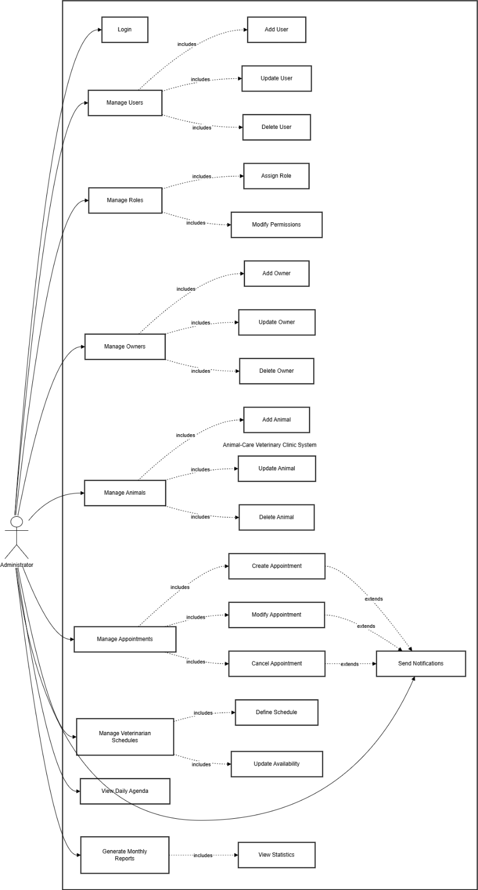

Receptionist Use Case Diagram
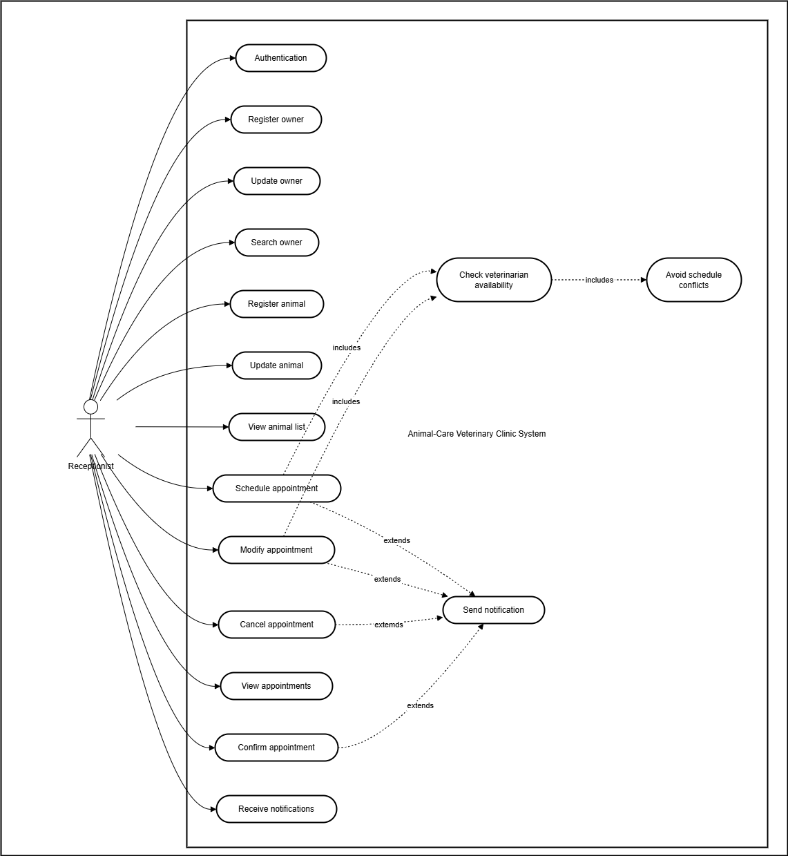

Veterinary Use case diagram
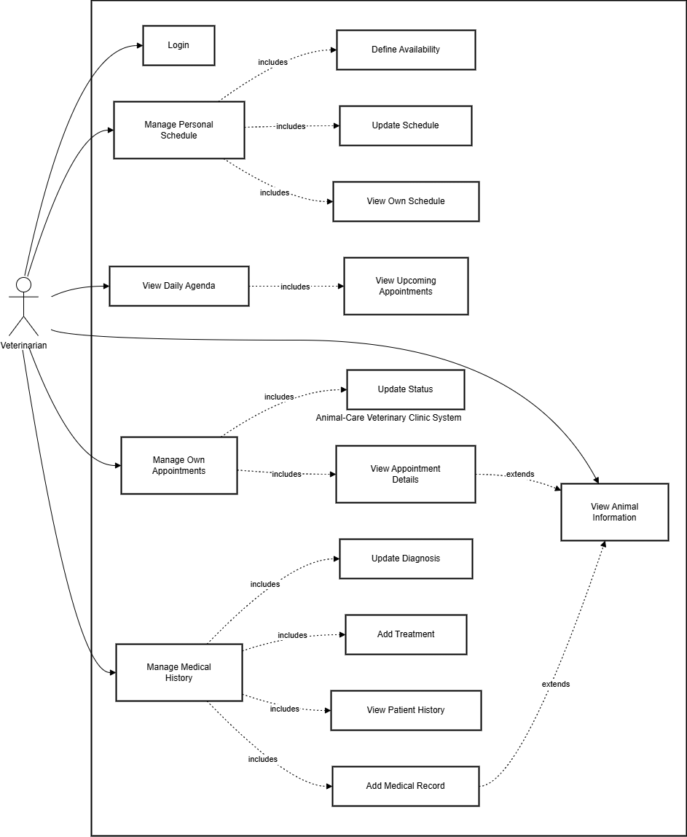

2.2- Class Diagram by Kevin Alinazar 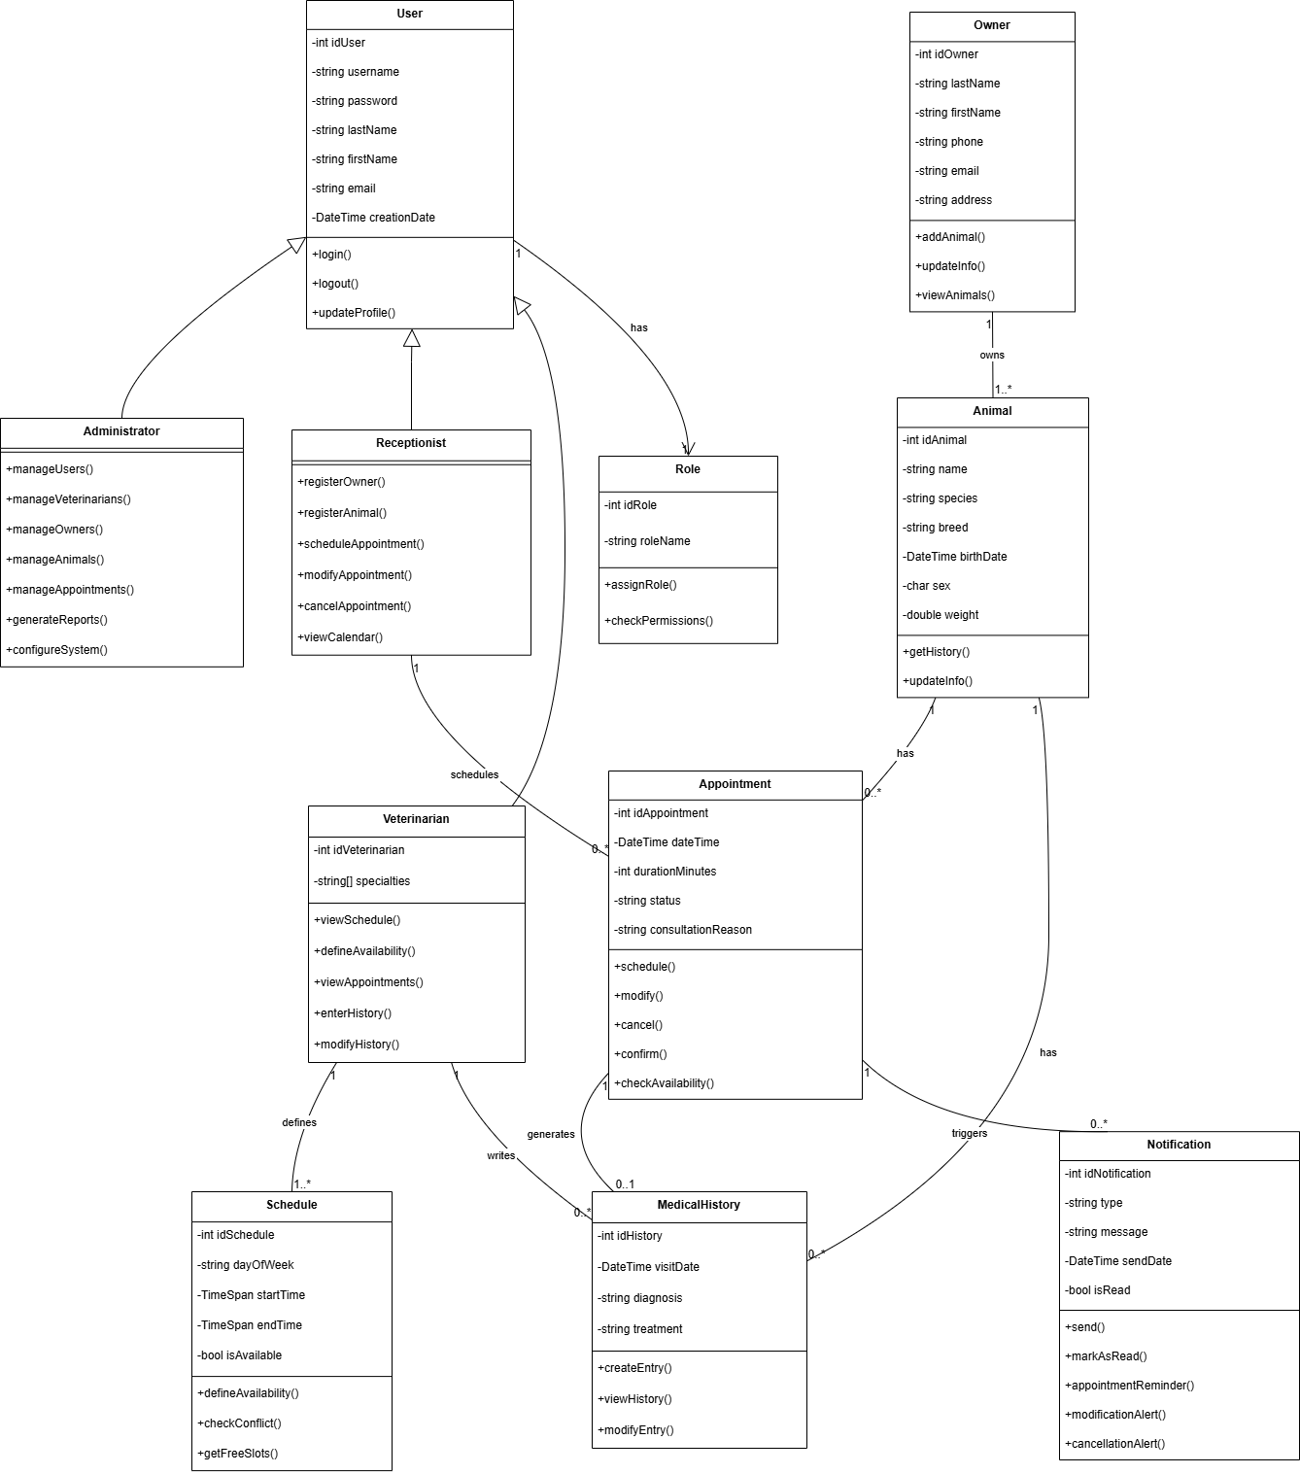

2.3- Activity Diagram by Alvaro Eloy Limaymanta Soria

Activity Diagram Administration
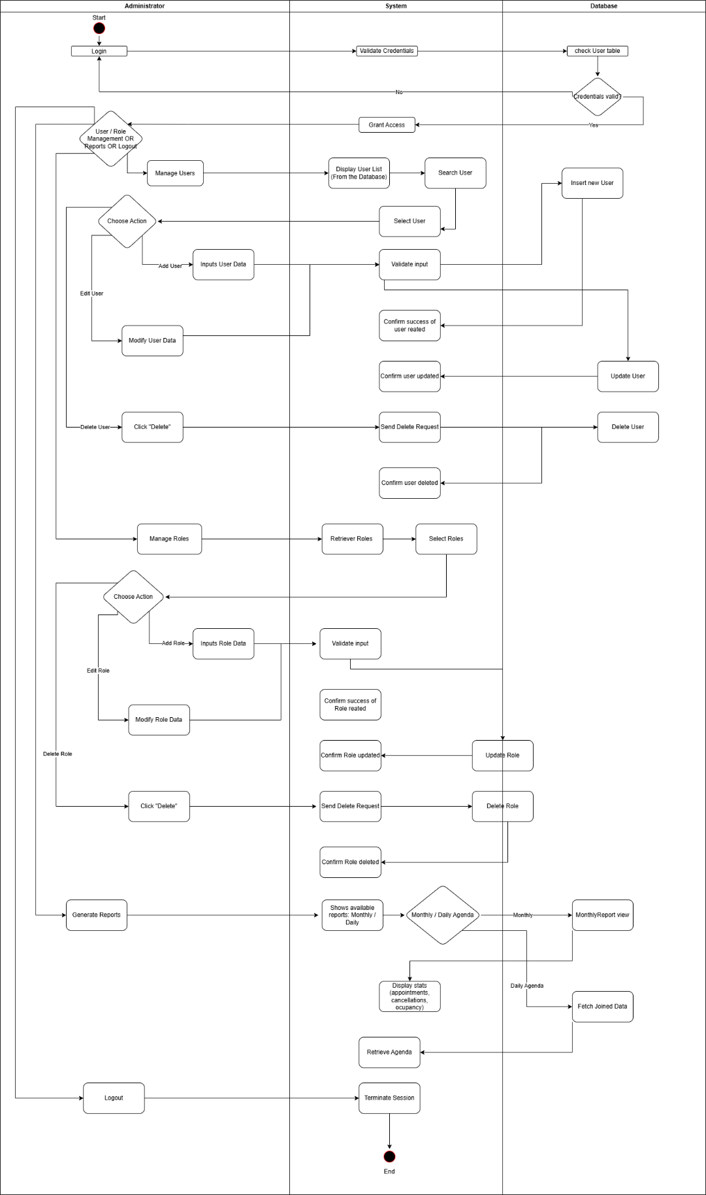

Activity Diagram Reception
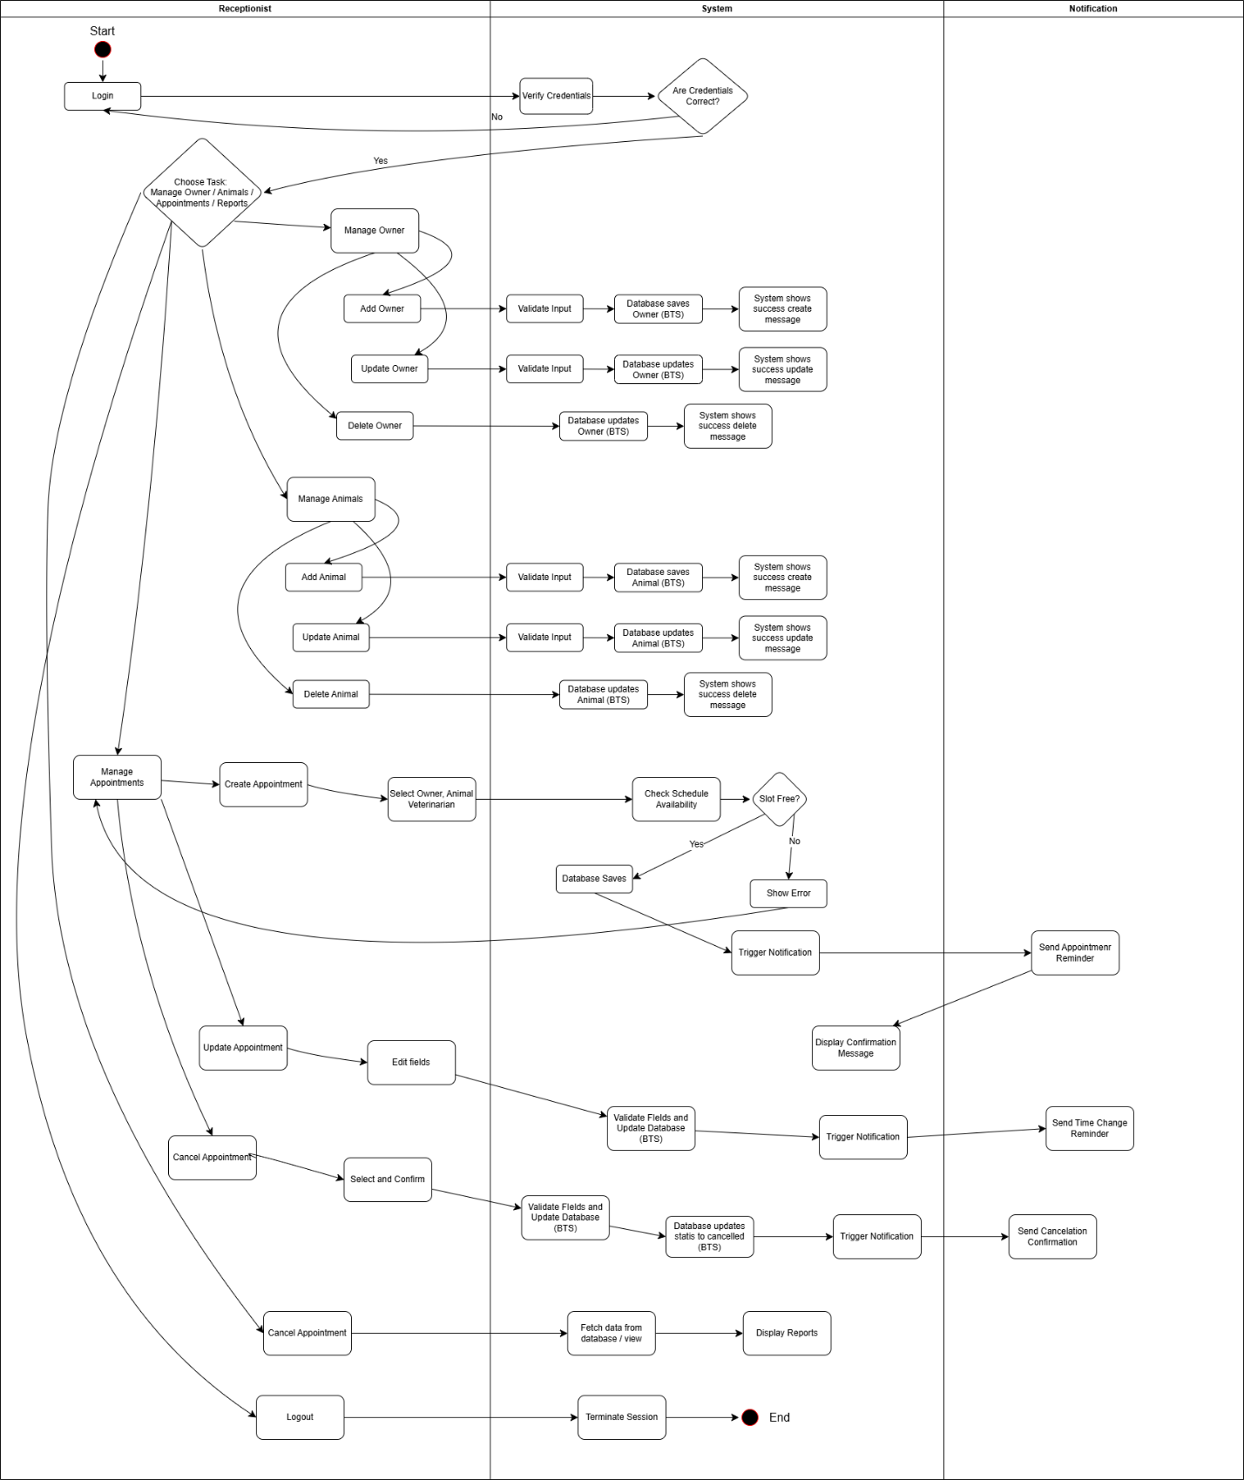

Activity Diagram Veterinarian
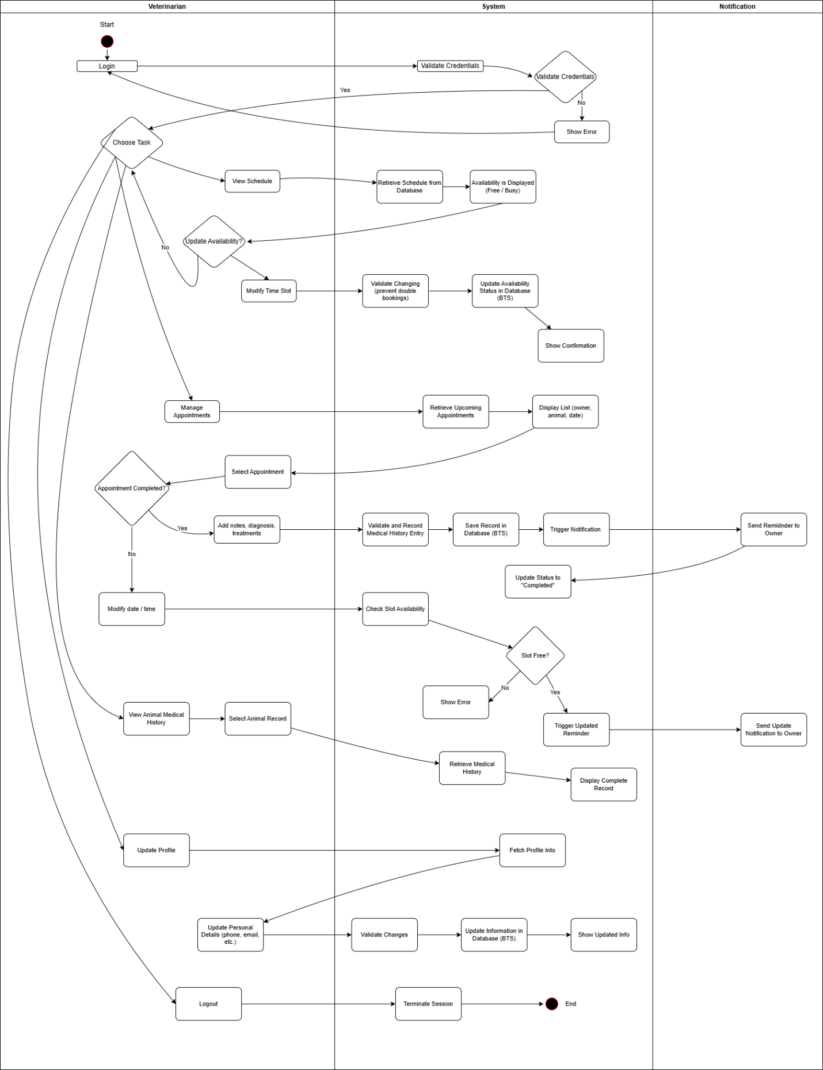

2.4- Sequence Diagram by Rafat-Ahmed Islam

Administrator Sequence Diagram
Note: Double click the PDF file to see Administrator Sequence Diagram in full screen.

Reception Sequence Diagram
Note: Double click the PDF file to see Reception Sequence Diagram in full screen.

Veterinary Sequence Diagram
Note: Double click the PDF to see Veterinary Sequence Diagram in full screen.

Note: You can only double-click the PDF files in the Word document. If you are viewing the PDF version of this document, you will need to open Animal_care_veterinary_clinic.docx to check the sequence, or you can access the folder that contains the images of the sequence diagrams along with all the other included diagrams.

Part II – Design & Database Implementation

Entity-Relationship Diagram – ERD

1.1 Identifying Entities and Their Characteristics
The main entities identified in the Animal-Care Veterinary Clinic system are:
- Owner --> stores the owner’s personal information (name, phone, email, address).
- Animal --> represents each pet; includes species, breed, age, and weight.
- Veterinarian --> contains details about each vet and their specialty.
- Schedule --> defines each veterinarian’s daily availability.
- Appointment --> links a vet and an animal for a consultation with start / end time.
- Medical History --> records each animal’s consultations, diagnoses, and treatments.
- Notification --> tracks appointment reminders, cancellations, or changes.
- UserAccount --> stores login credentials and activation status for system users.
- Role --> defines each user’s permission level (Administrator, Veterinarian, Receptionist).

1.2 Relationship & Cardinalities
  - One Owner can have many Animals (1 --> N).
  - One Veterinarian can have many Schedules and Appointments (1 --> N).
  - One Animal can have many Appointments and Medical History records (1 --> N).
  - Each Appointment can generate many Notifications (1 --> N).
  - Each Role can be assigned to many UserAccounts (1 --> N).

1.3 Entity-Relationship Diagram

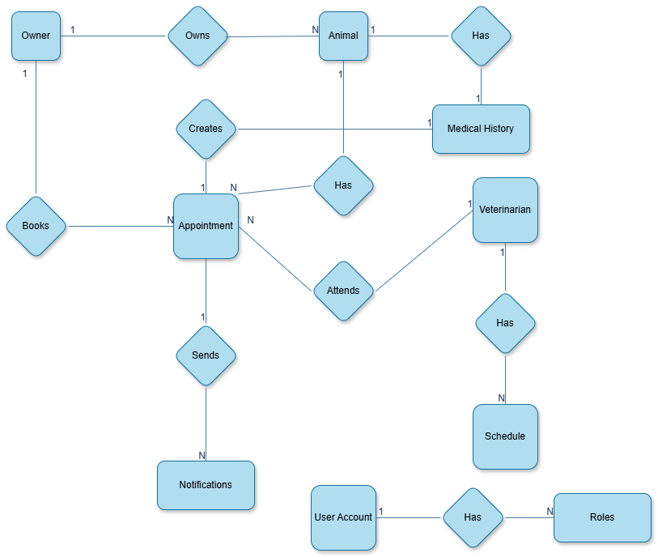

2 – Relational Data Model – RDM

2.1 Identify parent tables and association tables
Parent Tables
Parent tables are independent entities that other tables depend on through foreign keys.
They contain core information and are not dependent on any other table.
Parent Table | Description
Role | Defines user permission levels such as Administrator, Veterinarian, and Receptionist.
Owner | Stores client (pet owner) information such as name, contact, and address.
Veterinarian | Contains information about each veterinarian and their specialties.

Child / Association Tables
These tables depend on parent tables and use foreign keys to define relationships.
Child Table | Parent Reference | Description
UserAccount | FK → Role(RoleId) | Each user belongs to a specific role.
Animal | FK → Owner(OwnerId) | Each animal is linked to its owner.
Schedule | FK → Veterinarian(VetId) | Defines available work slots for each vet.
Appointment | FK → Veterinarian(VetId) and Animal(AnimalId) | Connects a vet with an animal for a scheduled visit.
MedicalHistory | FK → Animal(AnimalId), Veterinarian(VetId) | Stores past consultations and treatments for each animal.
Notification | FK → Appointment(AppointmentId) | Tracks appointment reminders, cancellations, or updates.

Columns and Attribute Types
Table Name | Column Name | Data Type | Constraints / Notes
Role | RoleId | INT IDENTITY(1,1) | Primary Key
 | RoleName | NVARCHAR(50) | NOT NULL
UserAccount | UserId | INT IDENTITY(1,1) | Primary Key
 | UserLogin | NVARCHAR(100) | UNIQUE, NOT NULL
 | UserPassword | NVARCHAR(255) | NOT NULL
 | RoleId | INT | Foreign Key → Role(RoleId)
 | UserActive | BIT | DEFAULT 1
Owner | OwnerId | INT IDENTITY(1,1) | Primary Key
 | OwnerLastName | NVARCHAR(50)
 | OwnerFirstName | NVARCHAR(50)
 | OwnerPhone | NVARCHAR(20)
 | OwnerEmail | NVARCHAR(100)
 | OwnerAddress | NVARCHAR(255)
Veterinarian | VetId | INT IDENTITY(1,1) | Primary Key
 | VetLastName | NVARCHAR(50)
 | VetFirstName | NVARCHAR(50)
 | VetSpecialty | NVARCHAR(100)
 | VetPhone | NVARCHAR(20)
 | VetEmail | NVARCHAR(100)
Animal | AnimalId | INT IDENTITY(1,1) | Primary Key
 | AnimalName | NVARCHAR(50)
 | Species | NVARCHAR(50)
 | Breed | NVARCHAR(50)
 | Sex | CHAR(1)
 | BirthDate | DATE
 | AnimalWeight | DECIMAL(5,2)
 | OwnerId | INT | Foreign Key → Owner(OwnerId)
Schedule | ScheduleId | INT IDENTITY(1,1) | Primary Key
 | VetId | INT | Foreign Key → Veterinarian(VetId)
 | ScheduleDate | DATE | NOT NULL
 | StartTime | TIME | NOT NULL
 | EndTime | TIME | NOT NULL
 | ScheduleStatus | NVARCHAR(10) | CHECK (‘Free’, ‘Busy’)
Appointment | AppointmentId | INT IDENTITY(1,1) | Primary Key
 | VetId | INT | Foreign Key → Veterinarian(VetId)
 | AnimalId | INT | Foreign Key → Animal(AnimalId)
 | StartDateTime | DATETIME | NOT NULL
 | EndDateTime | DATETIME | NOT NULL
 | Purpose | NVARCHAR(255)
 | AppointmentStatus | NVARCHAR(15) | CHECK (‘Planned’, ‘Canceled’, ‘Completed’)
MedicalHistory | HistoryId | INT IDENTITY(1,1) | Primary Key
 | AnimalId | INT | Foreign Key → Animal(AnimalId)
 | ConsultationDate | DATE | NOT NULL
 | Observations | NVARCHAR(MAX)
 | Diagnosis | NVARCHAR(MAX)
 | Treatment | NVARCHAR(MAX)
 | VetId | INT | Foreign Key → Veterinarian(VetId)
Notification | NotificationId | INT IDENTITY(1,1) | Primary Key
 | AppointmentId | INT | Foreign Key → Appointment(AppointmentId)
 | NotificationType | NVARCHAR(20) | CHECK (‘Reminder’, ‘Cancellation’, ‘Change’)
 | SendDate | DATETIME
 | Channel | NVARCHAR(10) | CHECK (‘Email’, ‘SMS’)
 | NotificationStatus | NVARCHAR(10) | CHECK (‘Sent’, ‘Pending’)

2.2 Define Domain-Level Constraints (Column-Level Constraints)

Each column in the database is restricted by appropriate domain-level constraints to ensure data validity. For example, enumerated attributes such as AppointmentStatus and ScheduleStatus use CHECK constraints to limit acceptable values. Columns like UserLogin and UserPassword are defined as NOT NULL to guarantee that required information is always present. Additionally, DEFAULT constraints (For example: UserActive = 1) automatically assign values when none are provided, maintaining data consistency.

Table | Column | Constraint Type | Description / Rule
Role | RoleName | NOT NULL | Every role must have a name.
UserAccount | UserLogin | UNIQUE, NOT NULL | Each user login must be unique and cannot be empty.
 | UserPassword | NOT NULL | Passwords must be provided for all users.
 | UserActive | DEFAULT 1 | Defaults to 1 (active) unless specified otherwise.
Schedule | ScheduleStatus | CHECK (ScheduleStatus IN ('Free','Busy')) | Limits the schedule state to only “Free” or “Busy.”
Appointment | AppointmentStatus | CHECK (AppointmentStatus IN ('Planned','Canceled','Completed')) | Restricts possible appointment statuses.
 | StartDateTime, EndDateTime | NOT NULL | Appointment time values must be defined.
Notification | NotificationType | CHECK (NotificationType IN ('Reminder','Cancellation','Change')) | Only allows three valid notification types.
 | Channel | CHECK (Channel IN ('Email','SMS')) | Notification channel limited to Email or SMS.
 | NotificationStatus | CHECK (NotificationStatus IN ('Sent','Pending')) | Restricts notification delivery state.
MedicalHistory | ConsultationDate | NOT NULL | Every record must include a consultation date.
Animal | Sex | CHECK (Sex IN ('M','F')) (optional enhancement) | Ensures the sex value is only M or F.
 | AnimalWeight | DECIMAL(5,2) | Limits the number to two decimal places and reasonable weight range.
All ID columns | Primary Key (IDENTITY(1,1)) | Auto-increments and uniquely identifies each record.
All Foreign Keys | FOREIGN KEY constraints | Enforce referential integrity between related tables.

2.3 Define table constraints and relationship constraints between tables.

Each table in the AnimalCareDB includes primary keys to uniquely identify records and foreign keys to maintain referential integrity between related entities. Table-level constraints such as CHECK, DEFAULT, and UNIQUE ensure that data stored in the system follows valid business rules. Relationship constraints enforce proper linkage between parent and child tables. For example, an Appointment must always reference an existing Veterinarian and Animal. Together, these constraints guarantee the overall consistency and reliability of the database.

A. Table Constraints
Table constraints ensure data integrity at the table level, by enforcing rules such as primary keys, unique values, and check limits within each table.
Table | Constraint Type | Definition / Purpose
Role | PRIMARY KEY (RoleId) | Ensures each role record is unique.
UserAccount | PRIMARY KEY (UserId) | Uniquely identifies each user.
 | UNIQUE (UserLogin) | Prevents duplicate login names.
 | DEFAULT (UserActive = 1) | Sets users as active by default.
Owner | PRIMARY KEY (OwnerId) | Ensures each owner record is unique.
Veterinarian | PRIMARY KEY (VetId) | Identifies each veterinarian uniquely.
Animal | PRIMARY KEY (AnimalId) | Ensures each animal record is unique.
 | CHECK (Sex IN ('M','F')) | Restricts valid values for gender.
Schedule | PRIMARY KEY (ScheduleId) | Identifies each schedule entry uniquely.
 | CHECK (ScheduleStatus IN ('Free','Busy')) | Restricts valid schedule statuses.
Appointment | PRIMARY KEY (AppointmentId) | Ensures every appointment has a unique ID.
 | CHECK (AppointmentStatus IN ('Planned','Canceled','Completed')) | Restricts allowed appointment states.
MedicalHistory | PRIMARY KEY (HistoryId) | Ensures every medical record is unique.
Notification | PRIMARY KEY (NotificationId) | Ensures each notification is unique.
 | CHECK (NotificationStatus IN ('Sent','Pending')) | Restricts delivery state values.

B. Relationship Constraints
Relationship constraints are implemented through foreign keys (FKs).
They enforce referential integrity between parent and child tables to ensure that related records exist before insertion and that deletions or updates are consistent.

Child Table | Foreign Key | References (Parent Table) | Relationship Type | Explanation
UserAccount | RoleId | Role(RoleId) | 1 → N | Each user belongs to one role; one role can have many users.
Animal | OwnerId | Owner(OwnerId) | 1 → N | Each animal belongs to one owner; an owner can have multiple animals.
Schedule | VetId | Veterinarian(VetId) | 1 → N | Each vet can have multiple scheduled time slots.
Appointment | VetId | Veterinarian(VetId) | 1 → N | Each vet can perform many appointments.
 | AnimalId | Animal(AnimalId) | 1 → N | Each animal can have multiple appointments.
MedicalHistory | VetId | Veterinarian(VetId) | 1 → N | Each vet can have multiple medical history records.
 | AnimalId | Animal(AnimalId) | 1 → N | Each animal can have multiple history records.
Notification | AppointmentId | Appointment(AppointmentId) | 1 → N | Each appointment can trigger multiple notifications.

C. Referential Integrity Rules
- Foreign key relationships ensure that child records cannot exist without their parent.
(e.g., an Appointment cannot exist without a valid Veterinarian and Animal.)
- Cascade behaviors (if implemented later) can be used to automatically remove dependent records when a parent is deleted.
- CHECK and DEFAULT constraints at the table level help maintain valid and consistent entries across all relationships.

2.4 Relational Data Model

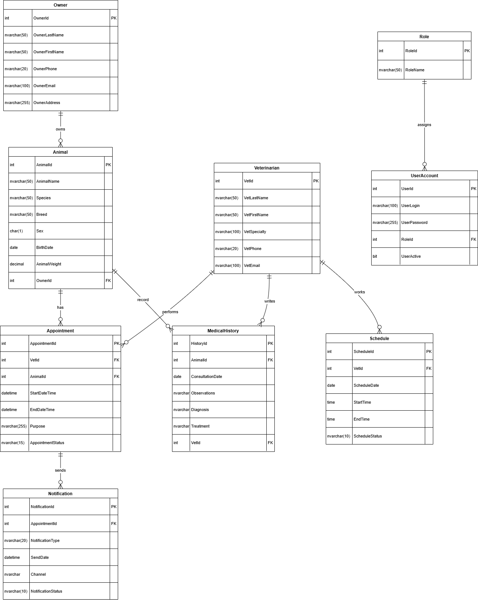

3 - Implementation of the Database Using Microsoft SQL Server 2019/2022

3.1 Overview
The database for the Animal-Care Veterinary Clinic system was implemented using Microsoft SQL Server 2022.
The implementation phase focused on translating the relational data model into an executable database schema using Transact-SQL (T-SQL).
This included the creation of all tables, relationships, constraints, views, stored procedures, triggers, and insertion of sample data for testing.

3.2 Database Creation & Setup
The database was created using the following command:
CREATE DATABASE AnimalCareDB;
USE AnimalCareDB;
- All tables, primary keys, foreign keys, and constraints were defined exactly as described in the relational data model (RDM).
- The script includes IF OBJECT_ID checks to safely drop and recreate objects when necessary.
- Sample data was inserted into each table for testing (one record per entity).

Example:
INSERT INTO Veterinarian (VetLastName, VetFirstName, VetSpecialty, VetPhone, VetEmail)
VALUES ('Shaqille', 'Osborne', 'General Care', '514-098-9876', 'shaquille@animalcare.com');

3.3 Views
Two main views were created to summarize and simplify the retrieval of frequently used data.
a) MonthlyReport View
This view provides statistical summaries for administrative reporting:
- Number of appointments and cancellations per month
- Total number of active veterinarians
- Monthly occupancy rate (percentage of used schedule slots)
CREATE VIEW MonthlyReport AS
SELECT
MONTH(A.StartDateTime) AS [Month],
YEAR(A.StartDateTime) AS [Year],
COUNT(A.AppointmentId) AS NumberOfAppointments,
SUM(CASE WHEN A.AppointmentStatus = 'Canceled' THEN 1 ELSE 0 END) AS NumberCanceled,
ISNULL(
(SELECT COUNT(DISTINCT V.VetId)
FROM Veterinarian V
INNER JOIN Schedule S ON V.VetId = S.VetId
WHERE S.ScheduleStatus IN ('Free','Busy')), 0
) AS NumberOfActiveVets,
ISNULL(
CAST(
(
SUM(CASE WHEN A.AppointmentStatus IN ('Planned','Completed') THEN 1 ELSE 0 END) * 100.0
/
NULLIF((SELECT COUNT(*) FROM Schedule S WHERE S.ScheduleStatus IN ('Free','Busy')),0)
) AS DECIMAL(5,2)
), 0
) AS OccupancyRate
FROM Appointment A
GROUP BY YEAR(A.StartDateTime), MONTH(A.StartDateTime);

Purpose: Helps administrators track monthly clinic activity and vet workload.

b) DailyAgenda View
This view consolidates all daily appointments into an easy-to-read format for veterinarians and receptionists.
CREATE VIEW DailyAgenda AS
SELECT
CAST(a.StartDateTime AS DATE) AS [Date],
v.VetLastName + ' ' + v.VetFirstName AS VeterinarianName,
CONVERT(TIME, a.StartDateTime) AS StartTime,
CONVERT(TIME, a.EndDateTime) AS EndTime,
an.AnimalName AS AnimalName,
o.OwnerLastName + ' ' + o.OwnerFirstName AS OwnerName,
a.AppointmentStatus
FROM Appointment a
JOIN Veterinarian v ON a.VetId = v.VetId
JOIN Animal an ON a.AnimalId = an.AnimalId
JOIN Owner o ON an.OwnerId = o.OwnerId;

Purpose: Displays daily consultation details for better scheduling and coordination.

3.4 Stored Procedures
Stored procedures were created to handle repetitive actions and automate logic at the database level.
a) sp_AddAppointment
Adds a new appointment while ensuring that there is no scheduling conflict for the selected veterinarian.
CREATE PROCEDURE sp_AddAppointment
@Vet INT,
@Animal INT,
@Start DATETIME,
@End DATETIME,
@Purpose NVARCHAR(255)
AS
BEGIN
IF EXISTS (SELECT 1 FROM Appointment WHERE VetId=@Vet AND AppointmentStatus<>'Canceled' AND @Start < EndDateTime AND @End > StartDateTime)
BEGIN
RAISERROR('Conflict: Veterinarian already booked.',16,1);
RETURN;
END
INSERT INTO Appointment(VetId, AnimalId, StartDateTime, EndDateTime, Purpose, AppointmentStatus)
VALUES(@Vet,@Animal,@Start,@End,@Purpose,'Planned');
END;

Purpose: Prevents double-booking and maintains consistent scheduling.

b) sp_UpdateAppointmentStatus
Updates the appointment’s status (Planned, Canceled, Completed).
CREATE PROCEDURE sp_UpdateAppointmentStatus
@Appointment INT,
@NewStatus NVARCHAR(15)
AS
BEGIN
UPDATE Appointment SET AppointmentStatus=@NewStatus WHERE AppointmentId=@Appointment;
END;

Purpose: Allows administrators or receptionists to manage appointment statuses efficiently.

c) sp_GetVetAgenda
Retrieves a veterinarian’s daily appointments from the DailyAgenda view.

CREATE PROCEDURE sp_GetVetAgenda
@Vet INT,
@TargetDate DATE
AS
BEGIN
SELECT * FROM DailyAgenda WHERE VeterinarianName IN (
SELECT VetLastName + ' ' + VetFirstName FROM Veterinarian WHERE VetId=@Vet
) AND [Date]=@TargetDate;
END;

Purpose: Provides quick access to a veterinarian’s daily schedule.

3.5 Triggers
Three database triggers were implemented to automatically enforce business rules and ensure that key operations occur without requiring manual intervention. These triggers help maintain data integrity, automate workflow steps, and enforce scheduling logic.

a) trg_PreventDoubleBooking
This trigger prevents the creation of an appointment if the veterinarian is already booked during the same time period.
CREATE TRIGGER trg_PreventDoubleBooking
ON Appointment
AFTER INSERT
AS
BEGIN
SET NOCOUNT ON;

IF EXISTS (
SELECT 1
FROM Appointment A
JOIN inserted I ON A.VetId = I.VetId
WHERE A.AppointmentId <> I.AppointmentId
AND A.AppointmentStatus <> 'Canceled'
AND I.StartDateTime < A.EndDateTime
AND I.EndDateTime > A.StartDateTime
)
BEGIN
RAISERROR('Error: Veterinarian already booked for this time slot.', 16, 1);
ROLLBACK TRANSACTION;
END
END;
Purpose:
Automatically enforces the clinic’s scheduling policy by blocking overlapping appointments for the same veterinarian. This ensures that invalid bookings cannot be inserted into the system.

b) trg_UpdateScheduleStatus
This trigger marks a veterinarian’s schedule as “Busy” when a new appointment is created.
CREATE TRIGGER trg_UpdateScheduleStatus
ON Appointment
AFTER INSERT
AS
BEGIN
UPDATE S
SET S.ScheduleStatus = 'Busy'
FROM Schedule S
JOIN inserted I ON S.VetId = I.VetId
WHERE S.ScheduleDate = CAST(I.StartDateTime AS DATE);
END;
Purpose:
Keeps the Schedule table synchronized with real appointments. When a veterinarian receives an appointment on a specific day, the system automatically updates their availability.
c) trg_AddReminderNotification
This trigger generates an automatic reminder notification whenever a new appointment is created.
CREATE TRIGGER trg_AddReminderNotification
ON Appointment
AFTER INSERT
AS
BEGIN
INSERT INTO Notification (AppointmentId, NotificationType, SendDate, Channel, NotificationStatus)
SELECT
I.AppointmentId,
'Reminder',
DATEADD(DAY, -1, I.StartDateTime),
'Email',
'Pending'
FROM inserted I;
END;
Purpose:
Automatically schedules reminder messages for clients, ensuring they are notified before their appointments. This supports customer service and reduces no-shows.

3.6 Indexes
To optimize query performance and improve the responsiveness of the database, several non-clustered indexes were created. These indexes accelerate common search operations such as looking up appointments by veterinarian, retrieving owner animals, and querying medical histories.
Indexes were added after table creation, because SQL Server requires the table to exist before an index can be defined.
a) Purpose of Indexes
Indexes are used to:
- speed up SELECT queries
- improve JOIN performance
- optimize lookups in foreign key relationships
- reduce table scan operations
- improve stored procedure and view execution times
In this project, indexes were added on the most frequently searched and JOINed columns.
b) Index List and Justification
Index Name | Table | Column(s) | Purpose
IX_UserAccount_RoleId | UserAccount | RoleId | Speeds up filtering of users by role.
IX_Animal_OwnerId | Animal | OwnerId | Improves lookups of animals by owner.
IX_Schedule_VetId | Schedule | VetId | Optimizes vet schedule searches.
IX_Appointment_VetId | Appointment | VetId | Speeds up all vet-related appointment queries.
IX_Appointment_AnimalId | Appointment | AnimalId | Accelerates appointment lookups for animals.
IX_Appointment_StartDateTime | Appointment | StartDateTime | Improves date-based queries and reporting.
IX_MedicalHistory_AnimalId | MedicalHistory | AnimalId | Speeds retrieval of medical records by animal.
IX_MedicalHistory_VetId | MedicalHistory | VetId | Useful for reviewing records created by a specific vet.
IX_Notification_AppointmentId | Notification | AppointmentId | Optimizes notification lookups for appointments.

c) Example Index Definition
CREATE INDEX IX_Appointment_StartDateTime
ON Appointment(StartDateTime);

Purpose:
This index improves the performance of monthly reports, daily agendas, and date-based filters used in the application.

3.7 Testing & Validation
All database objects were tested successfully using SQL Server Management Studio (SSMS).
Sample tests included:
- SELECT * FROM MonthlyReport;
- SELECT * FROM DailyAgenda;
- EXEC sp_AddAppointment ... (to test double-booking validation)
- EXEC sp_UpdateAppointmentStatus ...
- EXEC sp_GetVetAgenda ...
The test results confirmed:
- Data integrity was maintained.
- Views and stored procedures returned accurate, expected results.
- Constraints correctly prevented invalid or duplicate data.
All database objects were tested successfully using SQL Server Management Studio (SSMS).
Sample tests included:
- SELECT * FROM MonthlyReport;
- SELECT * FROM DailyAgenda;
- EXEC sp_AddAppointment ... (to test double-booking validation)
- EXEC sp_UpdateAppointmentStatus ...
- EXEC sp_GetVetAgenda ...
The test results confirmed:
- Data integrity was maintained.
- Views and stored procedures returned accurate, expected results.
- Constraints correctly prevented invalid or duplicate data.

3.8 Summary and Evaluation of Database Implementation

The implementation of the AnimalCareDB in Microsoft SQL Server 2022 successfully translates the logical database design into a functioning physical database. All tables, relationships, constraints, views, and stored procedures operate as intended, ensuring accurate data handling, efficient reporting, and a strong foundation for the next development stage (the ASP.NET Core MVC web application). Testing confirmed that referential integrity, domain constraints, and business logic were all correctly enforced, validating the reliability of the database implementation.
In addition, the implemented triggers automate essential business rules such as preventing double-booking, updating schedule availability, and generating reminder notifications. These automated processes increase reliability and reduce the need for manual intervention.
The creation of indexes further enhances system performance by optimizing search operations, JOIN conditions, and reporting queries. Testing confirmed that referential integrity, domain constraints, triggers, and stored procedures all behaved correctly, validating the overall robustness and efficiency of the database implementation.

