Software Architecture II Project
Tech Spec
Wave 1: Planning, Design, and Specification
Team TS-001
Assigned Case: FlashTix - Ticket Sales Platform
Members
Carlos Andrés Arteaga Garcia
Álvaro de Jesus Sotelo Galvis
Santiago Lopez Vallejo
Duvan Enrique Leal Marin
Juan Pablo Florez
October 2026

Wave 1: Planning, Design, and Specification (SDD - Spec Driven Development)

1. General Information
- Team Name: TS-001
- Assigned Case: FlashTix - Ticket Sales Platform
- Members: Carlos Andrés Arteaga - Álvaro Sotelo - Santiago Vallejo - Duvan Leal - Juan Pablo Florez
- Repository Link (GitHub): https://github.com/DarkViper-128/ARQ2-2026-TS-001

2. Problem Analysis (DDD)
- Identification of the Core Domain:
The Core Domain of FlashTix is Seat Reservation and Ticket Sales under extreme concurrency: guaranteeing that every seat is sold exactly once while hundreds of thousands of users compete for it at the same moment. This is where FlashTix differentiates itself and where it fails today: the current monolith protects seat uniqueness with a row-level lock that stays open during a 15-second payment call, which freezes the system and, when transactions break halfway, causes overbooking. Everything else (login, browsing, emails) is necessary but not what makes the business valuable or hard.

- Subdomains and Bounded Contexts:

Subdomain | Type | Bounded Context | Responsibility and main storage | Feature
Seat reservation and sale | Core | Reservation | Temporary seat hold with TTL (soft reservation) in Redis (hold-store) and the virtual queue. | 3
Event catalog and availability | Supporting | Catalog | Events, venues, seat maps and real-time availability as a read model. Redis for reads, MySQL as source of truth. | 2
Checkout and payments | Supporting | Order and Payment | Checkout saga, order lifecycle and final sale in MySQL (booking-db, sold_seats with a UNIQUE constraint per seat). Integration with the legacy gateway through an anti-corruption layer. | 4
Ticket issuing and delivery | Supporting | Ticketing and Notification | Digital ticket generation and email delivery driven by events. Message broker and email provider. | 5
Identity and access | Generic | Identity and Access | User authentication and session validation, enforced at the API Gateway. | 1

How the contexts relate:
- Identity and Access is enforced at the API Gateway (Kong), so no other context handles credentials.
- Catalog never queries MySQL on reads. It consumes seat.held, seat.released and order.confirmed to keep the availability in Redis fresh.
- Reservation holds seats in Redis with a TTL and publishes seat.held and seat.released. It releases the hold when the order is confirmed or fails.
- Order and Payment: the Order Service orchestrates a checkout saga. On POST /orders it locks the hold, saves the order as PENDING and writes payment.requested to its outbox in one transaction. The Payment Worker calls the legacy gateway and publishes payment.succeeded or payment.failed. On payment.succeeded the Order Service inserts the seats into sold_seats and publishes order.confirmed, in one transaction.
- Ticketing and Notification: the Ticket Service consumes order.confirmed, issues the ticket and publishes ticket.issued; the Notification Worker emails it.
- The legacy payment gateway sits behind an anti-corruption layer (timeout, retries, circuit breaker) so its slowness never leaks into the other contexts.

- Main technical challenges and explanation of how the architecture will solve the problematic scenario described in the case:

Challenge | Architectural solution
500,000 simultaneous logins overwhelm the system | The API Gateway authenticates and validates sessions (stateless tokens) and applies rate limiting, so unauthenticated or excessive traffic never reaches the services (Feature 1).
Every catalog view runs a SELECT and collapses the MySQL connection pool | Catalog and seat availability are served from a Redis read model. MySQL is not touched on reads, and the cache is refreshed by the catalog.updated event (Feature 2, ADR 001).
A row-level lock is held while waiting up to 15 seconds for payment, paralyzing the system | The lock is replaced by a soft reservation in Redis (atomic SET NX with TTL). The seat is held for a few minutes in memory and released automatically if payment is not completed. No database lock is open during payment (Feature 3).
The legacy gateway is slow, connections stay open and users get 504 Gateway Timeout | Payment is delegated to an asynchronous worker through a message queue. The API answers immediately with 202 Accepted and the user receives the result later. The gateway sits behind an anti-corruption layer with timeouts, retries and a circuit breaker (Feature 4).
Transactions fail halfway and cause overbooking | MySQL keeps the source of truth with a UNIQUE constraint on the seat as the final safety net. Before confirming, the worker re-checks that the hold is still valid, and failed or expired payments release the seat. Consumers are idempotent so retries cannot sell twice (Features 3 and 4).
A payment may complete after the hold expired | The worker verifies the hold before confirming. If the seat was already taken, the sale is rejected and the payment is voided or refunded, so the user is never charged for a seat they do not get.
Sending the ticket email must not slow down or break the sale | The ticket is generated and emailed by a separate consumer of reservation.confirmed. If the email fails, it is retried (with a dead-letter queue) without affecting the confirmed sale (Feature 5).

3. Architectural Design (C4 Model)
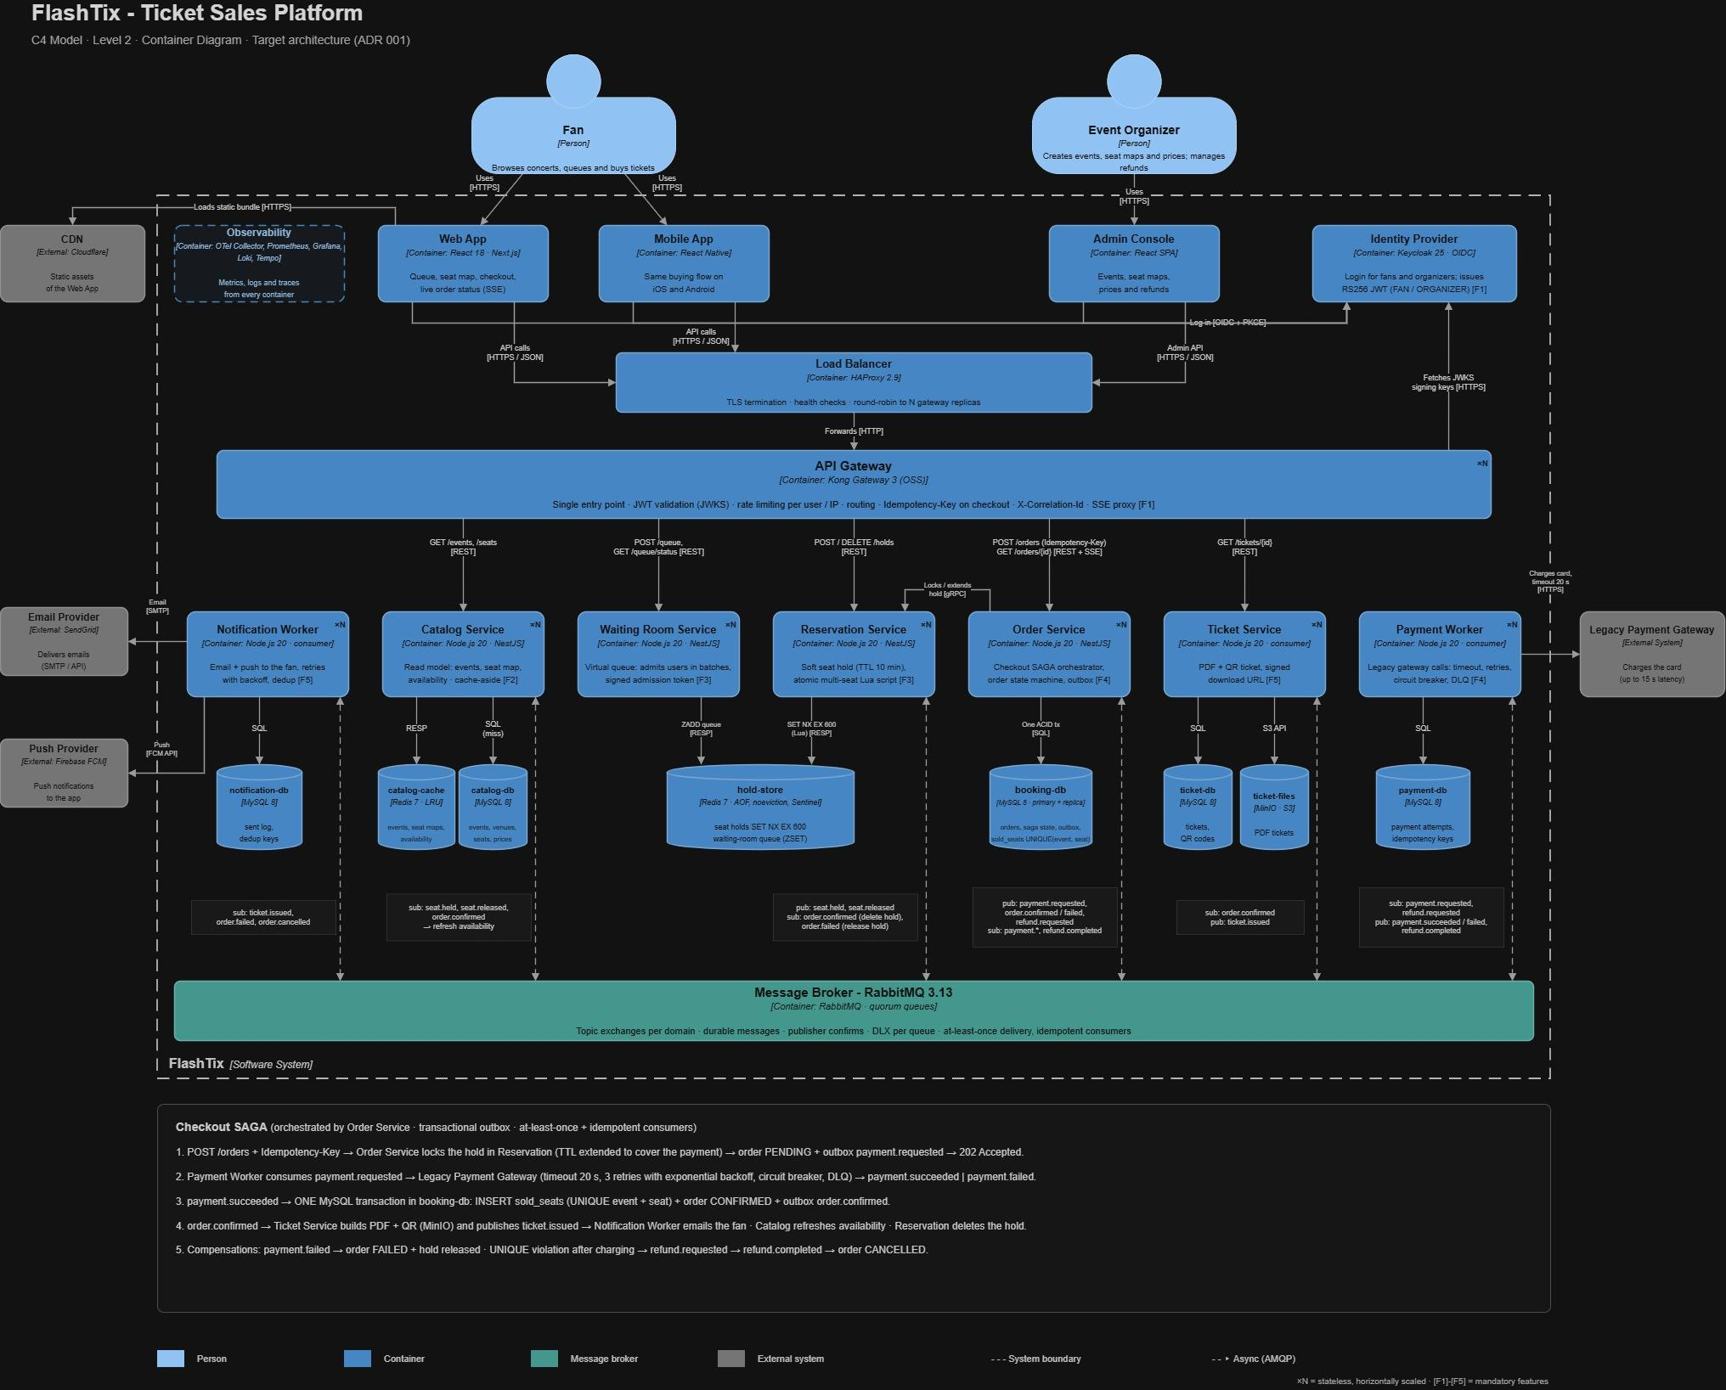

Interaction between components
Applications (Frontend / Mobile): Fans use the Web App (React / Next.js) or the Mobile App (React Native). Organizers use the Admin Console (React). Static files are served by a CDN, so our servers only receive API calls. Users log in with Keycloak (OIDC + PKCE), which returns a JWT with the role FAN or ORGANIZER. Every API call goes Load Balancer (HAProxy) → API Gateway (Kong) → service.
API Gateway: Kong is the single entry point. It validates the JWT with Keycloak’s public keys, applies rate limiting per user and IP, routes each request to the right service, and requires an Idempotency-Key on checkout so a double click never creates two orders. The HAProxy load balancer spreads traffic across several gateway replicas, and every service is stateless and horizontally scaled (×N).

Caching (Redis, NoSQL key-value): We use two Redis instances with different rules (ADR 001):
- catalog-cache (LRU eviction, no persistence) stores events, seat maps and availability. The Catalog Service reads from it (cache-aside) and only goes to MySQL on a cache miss.
- hold-store (AOF persistence, noeviction, Sentinel replicas) stores the virtual queue (sorted set) and the seat holds (SET NX EX 600). A hold must never be evicted, which is why it is separated from the cache.

Databases (SQL): Each service owns its data (database per service), all on MySQL 8: catalog-db, booking-db, payment-db, ticket-db and notification-db. booking-db is the source of truth for sales; its table sold_seats has UNIQUE (event_id, seat_id), the final safety net against overbooking. Ticket PDFs are stored in MinIO (S3-compatible object storage). We use SQL where we need ACID transactions and constraints (money, orders, seats), and NoSQL (Redis) where we need speed and expiration (cache, queue, holds).
Message queue (RabbitMQ): Slow or non-critical work runs asynchronously. Each service publishes and consumes domain events (payment.requested, payment.succeeded, order.confirmed, ticket.issued, among others) through topic exchanges and durable quorum queues. Delivery is at-least-once with publisher confirms, a transactional outbox in the Order Service, idempotent consumers, 3 retries with backoff and dead-letter queues. The Order Service orchestrates the checkout as a saga: payment → confirmation → ticket, with compensations (release the hold, refund).
Observability: OpenTelemetry, Prometheus, Grafana, Loki and Tempo collect metrics, logs and traces from every container.
How the components guarantee the 5 required features
Feature | Components | How it is guaranteed
F1 - Authentication at the API Gateway | Keycloak, Kong | No request reaches a service without a valid JWT and the right role; invalid tokens get 401 and wrong roles get 403 at the gateway.
F2 - Ultra-fast catalog without the transactional DB | Catalog Service, catalog-cache, CDN | Reads are served from Redis (p95 < 50 ms) and never touch booking-db; availability is kept fresh by seat.held, seat.released and order.confirmed events.
F3 - Soft reservation and virtual queue in memory | Waiting Room Service, Reservation Service, hold-store | The queue admits fans in batches; seats are held atomically for 10 min with SET NX in a Lua script (all or none), and expire by themselves through the TTL.
F4 - Asynchronous payment and confirmation | Order Service, Payment Worker, RabbitMQ, booking-db | Checkout returns 202 in milliseconds; the Payment Worker handles the 15 s gateway in the background with timeout, retries and circuit breaker. The sale is confirmed in one MySQL transaction protected by UNIQUE; if the seat was already sold, the saga refunds the payment.
F5 - Event-driven ticket generation and email | Ticket Service, Notification Worker, MinIO, SendGrid / FCM | order.confirmed triggers the PDF + QR ticket; ticket.issued triggers the email. Idempotent consumers make sure no ticket or email is duplicated.

4. Architecture Decision Records (ADRs)

ADR 001: Use of Redis for Catalog Cache, Virtual Queue and Seat Soft Hold

Context and Problem: FlashTix has a single “cash register”, MySQL. 500,000 people querying the catalog saturate the database. Every purchase locks the seat for the 15 seconds the payment gateway takes to answer. The result is 504 errors and seats sold twice (overbooking).

Considered Alternatives:

MySQL replicas: the 15 s locks would remain.

In-memory cache inside each service: replicas would not share the holds.

A single Redis for everything: the cache could evict holds.

Decision: Use two Redis instances:

catalog-cache: catalog and availability (F2). LRU, no persistence.

hold-store: holds with TTL and virtual queue (F3). AOF, noeviction, Sentinel.

The catalog is read from Redis and only goes to MySQL if the data is not in the cache. The virtual queue lets users in by batches. A seat is held for 10 minutes with SET NX EX 600; if several seats are selected, a Lua script holds all of them or none. MySQL remains the source of truth for the final sale.

Trade-offs:

Positives (What we gain): Instant reads, short locks instead of 15 s, control over who enters checkout, and MySQL working only on real purchases.

Negatives (Risks / What we lose): Risk of showing stale data, dependency on Redis, and holds that can be lost or expire during payment. Mitigations:

The cache is refreshed with RabbitMQ events (seat.held, seat.released, order.confirmed).

Redis has replicas and AOF persistence, so on a restart at most 1 second of data is lost.

When payment starts, the hold’s TTL is extended to cover the gateway time.

Safety net: UNIQUE (event_id, seat_id) in MySQL prevents selling a seat twice. If that rule fires after the customer has been charged, a refund is issued.

Final Justification: Redis stops “looking” from taking the database down and makes “holding” instant. MySQL guarantees the sale without duplicates. Using two instances is key: a cache may evict data when it fills up, but a hold must not be evicted, or the seat would look free while someone is paying for it. This solves the FlashTix bottleneck and satisfies Features 2 and 3.

ADR 002: Migration of the Transactional Database from MySQL to PostgreSQL (Rejected)

Context and Problem: Thanks to ADR 001, the database is no longer the bottleneck, but it is still the final judge of every sale. It must guarantee a single active sale per seat, even if a payment fails or is retried, and it must support schema changes while the monolith is being split.

Considered Alternatives:

Migrate to PostgreSQL: partial unique index (UNIQUE (seat_id) WHERE status = 'SOLD'), ON CONFLICT DO NOTHING for retries, and transactional DDL.

Keep MySQL 8.

NoSQL: relational constraints would be lost.

Distributed SQL: overkill for this case.

Decision: Rejected: We keep MySQL 8 as the transactional database. The overbooking problem is already solved without migrating:

sold_seats has PRIMARY KEY (event_id, seat_id), so MySQL itself rejects a second sale of the same seat.

Payment retries are idempotent by orderId (unique in payment-db) and duplicated events are ignored with processed_events.

The checkout saga refunds the payment if the seat was already sold.

Trade-offs:

Positives (What we gain by rejecting): No data-migration risk, no new learning curve, and no transition period with two databases.

Negatives (Risks / What we lose): We give up PostgreSQL’s partial unique index, ON CONFLICT and transactional DDL. This is mitigated because the uniqueness rule, idempotent payments and the saga refund already cover each case. Had we migrated, the cost would have been moving existing data (pgloader during a maintenance window, per-table count validation, MySQL read-only as backup, strangler pattern) and learning PostgreSQL.

Final Justification: A migration would not fix any requirement that the current design leaves open. The 504 errors are solved by Redis and asynchronous payments, and MySQL with the sold_seats primary key remains the last line of defense against overselling. The analysis is kept as the record of the option we evaluated.

ADR 003: Asynchronous Payment Processing with RabbitMQ (Checkout Saga)

Context and Problem: The legacy payment gateway takes up to 15 seconds to respond, and we cannot change it. Today the monolith calls it inside the purchase. Each buyer keeps a connection and a lock open for 15 seconds, connections run out and 504 errors appear. If the gateway fails, the purchase is left half-done.

Considered Alternatives:

Synchronous call with a longer timeout: the 504s remain.

Kafka: heavier to operate and has no native per-message retries or DLQ.

Gateway webhooks: the legacy gateway does not support them.

Choreography (no orchestrator): with refunds and timeouts the flow becomes hard to follow, so the Order Service orchestrates it.

Decision: Process payments asynchronously with RabbitMQ, orchestrated as a saga by the Order Service (Features 4 and 5):

On POST /orders, the Order Service asks the Reservation Service to lock the hold and extend its TTL, saves the order as PENDING and writes payment.requested to its outbox in one MySQL transaction, then responds 202 Accepted.

The Payment Worker consumes payment.requested, calls the gateway and publishes payment.succeeded or payment.failed.

On payment.succeeded, the Order Service inserts the seats into sold_seats, sets the order to CONFIRMED and publishes order.confirmed, all in one transaction.

The Ticket Service consumes order.confirmed, builds the PDF + QR ticket and publishes ticket.issued; the Notification Worker consumes it and emails the fan.

The client follows the order status with GET /orders/{id} or live through SSE.

Trade-offs:

Positives (What we gain): The API responds in milliseconds. A slow gateway no longer takes down the platform. More workers can be added during peaks, and failed payments are retried.

Negatives (Risks / What we lose): The user does not see “paid” instantly (eventual consistency), a message may arrive twice, the hold may expire during payment, and we now depend on RabbitMQ. Mitigations:

No lost events: transactional outbox, persistent messages and publisher confirms.

Idempotency: orderId is the payment idempotency key, so a retry never charges twice. Every consumer stores the eventId in processed_events and ignores repeats.

Retries: gateway calls have a 20 s timeout, 3 retries (2 s, 10 s, 30 s) and a circuit breaker. If they all fail, payment.failed is published, the order becomes FAILED and the hold is released. Broken messages go to the DLQ.

Hold TTL: extended when checkout starts to cover the whole payment.

Compensation: if the payment succeeds but the seat was already sold (UNIQUE violation), the saga publishes refund.requested, the Payment Worker refunds the card and the order ends as CANCELLED.

Final Justification: The 15 s gateway is the slowest piece of FlashTix, and the only way to keep it from blocking everyone is to take it out of the user’s request. RabbitMQ is built for work queues and comes with acknowledgements, retries and dead-letter queues. Together with the checkout saga, it keeps failed payments safe for retry or refund and fulfills Features 4 and 5.

5. Contract Specification (OpenSpec)

The full contract specification is a single Markdown file hosted in the repository:

docs/spec.md

The file defines:

Overview: The 10 services (Identity Provider, Load Balancer + API Gateway, Catalog, Waiting Room, Reservation, Order, Payment Worker, Ticket, Notification Worker and the Message Broker) and the responsibility, technology and data owned by each one.

Data schemas: The main domains (Event and Seat, QueueTicket, Hold, Order, Payment, Ticket) with their key fields and states, the Redis and MySQL storage layout, and the sold_seats table with its primary key as the final safety net against overbooking.

REST APIs: For each endpoint, the method, path, authentication, request body, responses with status codes (2xx, 4xx, 5xx) and an example. This covers the fan flow (catalog, queue, holds, orders, tickets) and the Event Organizer endpoints (create and publish events, refund orders).

Asynchronous events: 11 events published through RabbitMQ (for example seat.held, payment.requested, order.confirmed, refund.requested, ticket.issued). Each one lists its producer, consumers, exchange, payload schema and delivery guarantees: at-least-once delivery, idempotency key, ordering rules and retries with a dead-letter queue.

Requirements and scenarios: At least one WHEN/THEN scenario for each of the 5 mandatory features, for example: WHEN the payment succeeds but sold_seats rejects the seat as a duplicate, THEN the order is refunded and ends as CANCELLED, so the seat is sold only once.

