|  |  |
| --- | --- |
| Pre-lab Worksheet  Active Science Resources—Pre-class and In-class  Experiment 7.1B *(Book 2A, Ch. 7, pp. 10–11)* | Name: _______________ Class: ____________( ) Date: ________________ |

7 Living Things and Air

Testing water vapour

Before doing Experiment 7.1B, let’s recall the correct way of using a dropper learnt in Book 1A Ch. 1, as follows:

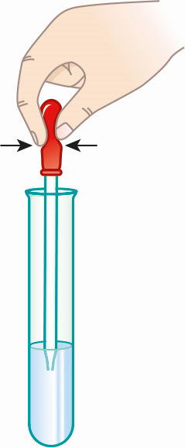

**1.** Gently squeeze the rubber bulb of a dropper.

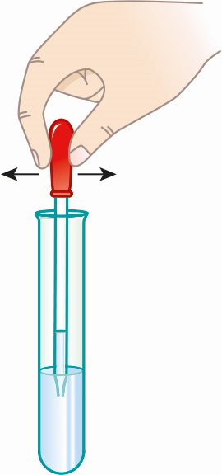

**2.** Put the tip of the dropper into the solution.

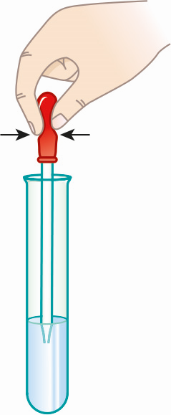

**3.** Release the bulb to obtain some solution.

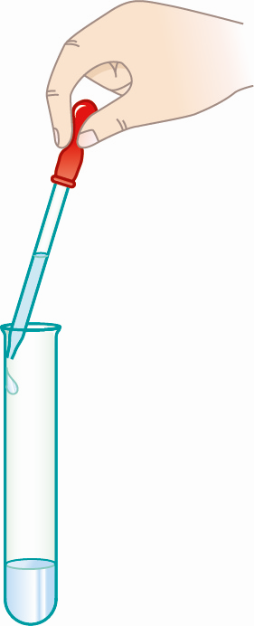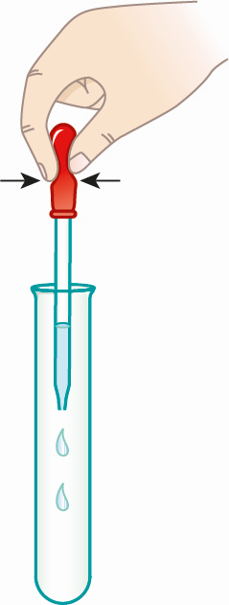

**4.** Let the tip of the dropper touch the inner wall of the test tube.

**5.** Vertically hold the dropper and an empty test tube. Gently squeeze the bulb to add the solution in drops.

**• Questions**

**1.** What is the purpose of step 4?

**2.** We should NOT hold the dropper upside down. Why?

ANSWERS

**1.** This is to remove the droplet at the tip of the dropper.

**2.** The solution in the dropper will run into the rubber bulb.