**DAILY ONLINE ACTIVITIES SUMMARY**

|  |  |  |  |  |  |  |  |  |
| --- | --- | --- | --- | --- | --- | --- | --- | --- |
| **Date:** | **01-06-2020** | | | | | **Name:** | **Md. Afnan Aman** | |
| **Sem & Sec** | **8th 'A'** | | | | | **USN:** | **4AL15CS058** | |
| **Online Test Summary** | | | | | | | | |
| **Subject** | | **SMS** | | | | | | |
| **Max. Marks** | | **60** | | **Score** | | | **45** | |
| **Certification Course Summary** | | | | | | | | |
| **Course** | **Introduction to Ethical Hacking** | | | | | | | |
| **Certificate Provider** | | | **Great learning** | | **Duration** | | | **6hr** |
| **Coding Challenges** | | | | | | | | |
| **Problem Statement: 1.** C program to print right angled triangle numbers star pattern | | | | | | | | |
| **Status:Solved** | | | | | | | | |
| **Uploaded the report in Github** | | | | | **Yes** | | | |
| **If yes Repository name** | | | | | **AFNAN_AMAN** | | | |
| **Uploaded the report in slack** | | | | | **Yes** | | | |

Online Test Details:

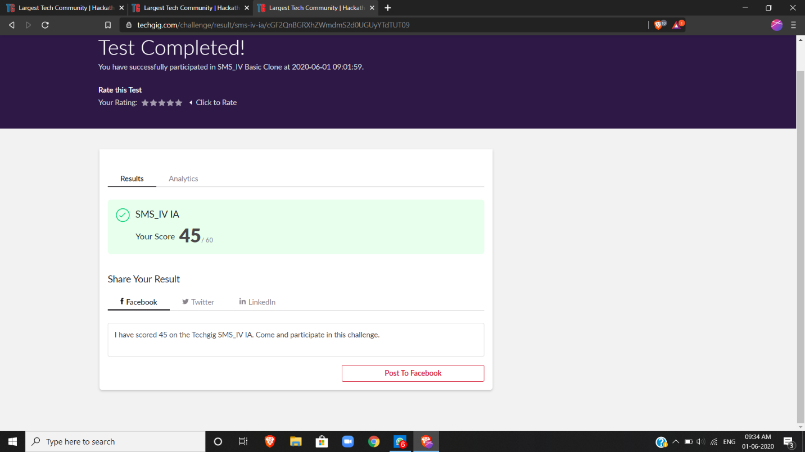

Certification Course Details: (Attach the snapshot and briefly write the report for the same)



Coding Challenges Details: (Attach the snapshot and briefly write the report for the same)

Cprogramtoprintrightangledtrianglenumbersstarpattern

intmain()

{

intRows,i,j;

printf("PleaseEntertheNumberofRows:");

scanf("%d",&Rows);

printf("\nPrintingRightAngledTriangle\n\n");

for(i= 1;i<= Rows;i++ )

{

for(j= 1;j<= i;j++ )

{

printf("*");

}

printf("\n");

}

return0;

}

intmain()

{

intRows,i,j;

printf("PleaseEntertheNumberofRows:");

scanf("%d",&Rows);

printf("\nPrintingRightAngledTriangle\n\n");

for(i= 1;i<= Rows;i++ )

{

for(j= 1;j<= i;j++ )

{

printf("*");

}

printf("\n");

}

return0;

}

THANK YOU……..