**DAILY ONLINE ACTIVITIES SUMMARY**

|  |  |  |  |  |  |  |  |
| --- | --- | --- | --- | --- | --- | --- | --- |
| **Date:** | **4/06/2020** | | | | **Name:** | **Md. Afnan Aman** | |
| **Sem & Sec** | **8th A** | | | | **USN:** | **4AL15CS058** | |
| Online Test Summary | | | | | | | |
| **Subject** | | **SMS** | | | | | |
| **Max. Marks** | | **60** | | **Score** | | **60** | |
| Certification Course Summary | | | | | | | |
| **Course** | **Python for machine learning** | | | | | | |
| **Certificate Provider** | | | **Great Learning Academy** | **Duration** | | | **5hrs** |
| Coding Challenges | | | | | | | |
| **Problem Statement:**  **1) Python Program to Find the Size (Resolution) of a Image** | | | | | | | |
| **Status: Solved** | | | | | | | |
| **Uploaded the report in Github** | | | | **YES** | | | |
| **If yes Repository name** | | | | **AFNAN_AMAN** | | | |
| **Uploaded the report in slack** | | | | **YES** | | | |

**Online Test:**

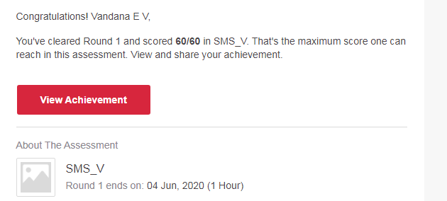

# CODE:

Program no:1

# Python Program to Find the Size (Resolution) of a Image

def jpeg_res(filename):

# open image for reading in binary mode

with open(filename,'rb') as img_file:

# height of image (in 2 bytes) is at 164th position

img_file.seek(163)

# read the 2 bytes

a = img_file.read(2)

# calculate height

height = (a[0] << 8) + a[1]

# next 2 bytes is width

a = img_file.read(2)

# calculate width

width = (a[0] << 8) + a[1]

print("The resolution of the image is",width,"x",height)

jpeg_res("img1.jpg")