**DAILY ONLINE ACTIVITIES SUMMARY**

|  |  |  |  |  |  |  |  |
| --- | --- | --- | --- | --- | --- | --- | --- |
| **Date:** | **5/06/2020** | | | | **Name:** | **Md. AFNAN AMAN** | |
| **Sem & Sec** | **8th A** | | | | **USN:** | **4AL15C058** | |
| Online Test Summary | | | | | | | |
| **Subject** | | **BDA** | | | | | |
| **Max. Marks** | | **30** | | **Score** | | **14** | |
| Certification Course Summary | | | | | | | |
| **Course** | **Introduction to Hadoop** | | | | | | |
| **Certificate Provider** | | | **Great Learning Academy** | **Duration** | | | **5hrs** |
| Coding Challenges | | | | | | | |
| **Problem Statement:**  **1) Write a Python program to convert seconds to day, hour, minutes and seconds.** | | | | | | | |
| **Status: Solved** | | | | | | | |
| **Uploaded the report in Github** | | | | **Yes** | | | |
| **If yes Repository name** | | | | **AFNAN_AMAN** | | | |
| **Uploaded the report in slack** | | | | **Yes** | | | |

Online Test D**etails:**

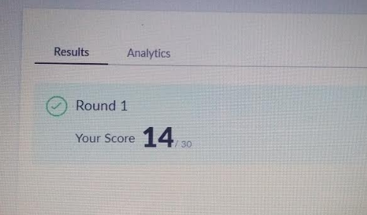

Certification Course Details :

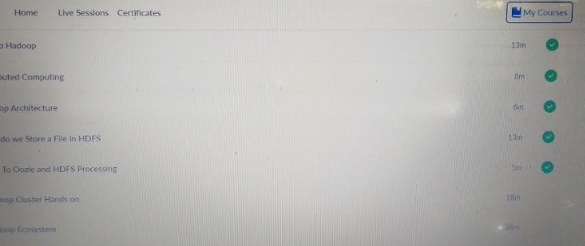

# CODE:

Program no:1

#Write a Python program to convert seconds to day, hour, minutes and seconds.

time = float(input("Input time in seconds: "))

day = time // (24 * 3600)

time = time % (24 * 3600)

hour = time // 3600

time %= 3600

minutes = time // 60

time %= 60

seconds = time

print("day:-> %d" % (day))

print("hour:-> %d" % (hour))

print("minutes:-> %d" % (minutes))

print("seconds:-> %d" % (seconds))