**DAILY ONLINE ACTIVITIES SUMMARY**

|  |  |  |  |  |  |  |  |
| --- | --- | --- | --- | --- | --- | --- | --- |
| **Date:** | **06/06/2020** | | | | **Name:** | **Md. AFNAN AMAN** | |
| **Sem & Sec** | **8th A** | | | | **USN:** | **4AL15C058** | |
| Online Test Summary | | | | | | | |
| **Subject** | | **IOT** | | | | | |
| **Max. Marks** | | **30** | | **Score** | | **30** | |
| Certification Course Summary | | | | | | | |
| **Course** | **Introduction to Hadoop** | | | | | | |
| **Certificate Provider** | | | **Great Learning Academy** | **Duration** | | | **5hrs** |
| Coding Challenges | | | | | | | |
| **Problem Statement:**  **1) Write a C program to rotate an array to n postion.** | | | | | | | |
| **Status: Solved** | | | | | | | |
| **Uploaded the report in Github** | | | | **Yes** | | | |
| **If yes Repository name** | | | | **AFNAN_AMAN** | | | |
| **Uploaded the report in slack** | | | | **Yes** | | | |

Online Test D**etails:**

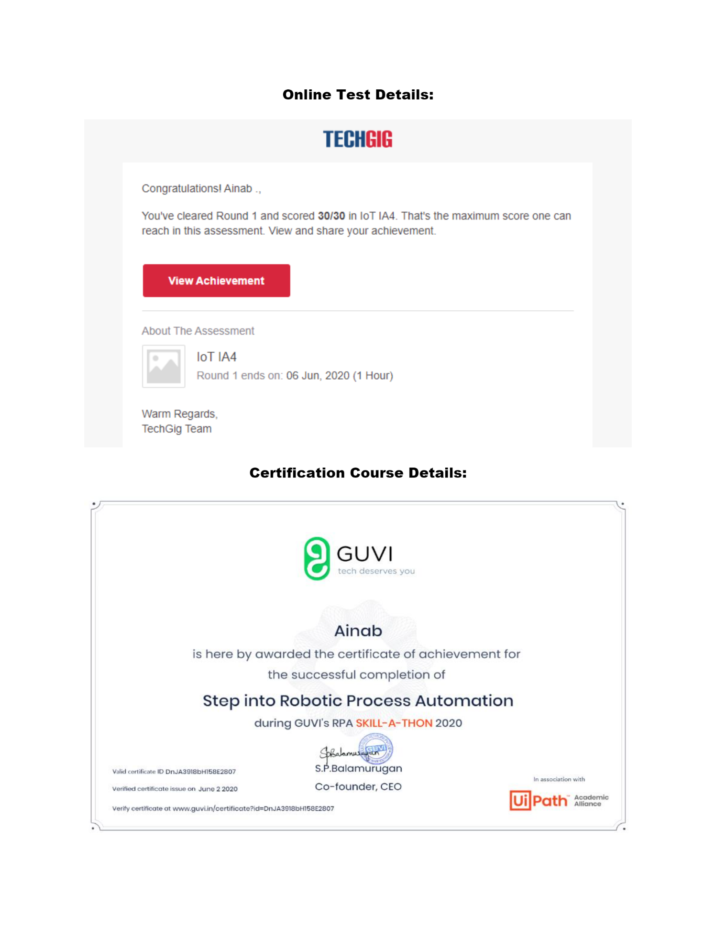

Certification Course Details :

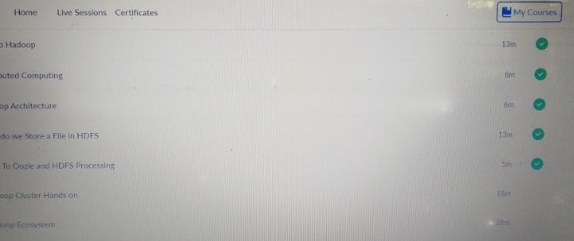

# CODE:

|  |
| --- |
| #include <stdio.h> |
|  | void leftRotatebyOne(int arr[], int n); |
|  | void leftRotate(int arr[], int d, int n) |
|  | { |
|  | int i; |
|  | for (i = 0; i < d; i++) |
|  | leftRotatebyOne(arr, n); |
|  | } |
|  | void leftRotatebyOne(int arr[], int n) |
|  | { |
|  | int temp = arr[0], i; |
|  | for (i = 0; i < n - 1; i++) |
|  | arr[i] = arr[i + 1]; |
|  | arr[i] = temp; |
|  | } |
|  | void printArray(int arr[], int n) |
|  | { |
|  | int i; |
|  | for (i = 0; i < n; i++) |
|  | printf("%d ", arr[i]); |
|  | printf("\n"); |
|  | } |
|  | int main() |
|  | { |
|  | int n,d; |
|  | printf("Enter the size of array : "); |
|  | scanf("%d",&n); |
|  | int arr[n]; |
|  | printf("\nEnter the array elements :\n"); |
|  | for(int i=0;i<n;i++) |
|  | scanf("%d",&arr[i]); |
|  | printf("Enter the Position N from where you want to |
|  | rotate : "); |
|  | scanf("%d",&d); |
|  | leftRotate(arr, d, n); |
|  | printArray(arr, n); |
|  | return 0; |
|  | } |