**DAILY ONLINE ACTIVITIES SUMMARY**

|  |  |  |  |  |  |  |  |
| --- | --- | --- | --- | --- | --- | --- | --- |
| **Date:** | **18/05/2020** | | | | **Name:** | **MOHAMED AFNAN AMAN** | |
| **Sem & Sec** | **8th, A sec** | | | | **USN:** | **4AL15CS058** | |
| Online Test Summary | | | | | | | |
| **Subject** | | **SMS** | | | | | |
| **Max. Marks** | | **60** | | **Score** | | **56** | |
| Certification Course Summary | | | | | | | |
| **Course** | **INTRODUCTION TO ETHICAL HACKING** | | | | | | |
| **Certificate Provider** | | | **GREATLEARNING** | **Duration** | | | **6HRS** |
| Coding Challenges | | | | | | | |
| **Problem Statement: 1:Using methods charAt() & length() of string class.**  **2:Print even and odd numbers series respectively from two threads t1 and t2.** | | | | | | | |
| **Status:solved** | | | | | | | |
| **Uploaded the report in Github** | | | | **yes** | | | |
| **If yes Repository name** | | | | **Mohamedafnanaman** | | | |
| **Uploaded the report in slack** | | | | **yes** | | | |

ONLINE TEST DETAILS:

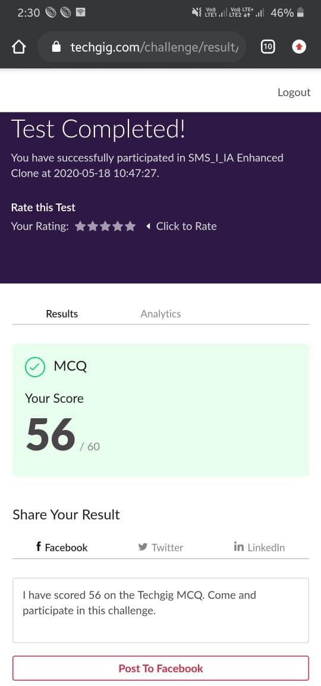

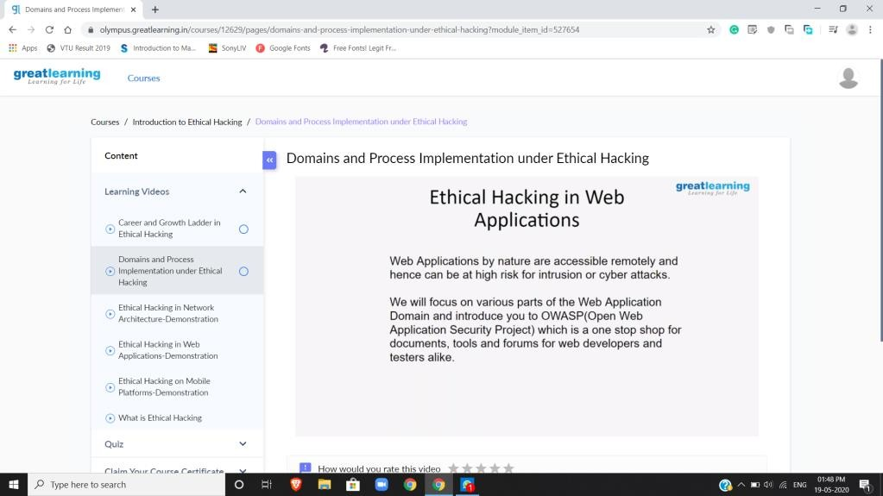Certification Course Details:

Coding Challenges Details:

Using methods charAt() & length() of String class, write a program to print the frequency of each character in a string.

import java.util.Scanner;

public class Main {

public static void main(String[] args) {

int i;

String str;

int count[] = new int[256];

Scanner s = new Scanner(System.in);

System.out.print("Enter a String : ");

str=s.nextLine();

for (i = 0; i < str.length(); i++)

{

count[(int) str.charAt(i)]++;

}

for (i = 0; i < 256; i++)

{

if (count[i] != 0)

{

System.out.println( (char) i + " : " + count[i]);

}

}

}

}

Program 2

Write a java program to print even and odd numbers series respectively from two threads:t1 and t2 synchronizing on a shared object Let t1 print message “ping -- >” and t2 print message “,--pong”. Take as command line arguments, the following inputs to the program: Sleep interval for thread t1. public class PingPong extends Thread

{

static StringBuilder object = new StringBuilder("");

public static void main(String[] args) throws InterruptedException

{

Thread t1 = new PingPong();

Thread t2 = new PingPong();

t1.setName("\nping");

t2.setName(" pong");

t1.start(); t2.start();

}

@override public void run()

{

working();

}

void working()

{

while (true)

{

synchronized (object) { try { System.out.print(Thread.currentThread().getName());

object.notify();

object.wait();

}

catch (InterruptedException e)

{ e.printStackTrace();

}

}

}

}

THANK YOU