**DAILY ONLINE ACTIVITIES SUMMARY**

|  |  |  |  |  |  |  |  |
| --- | --- | --- | --- | --- | --- | --- | --- |
| **Date:** | **19/05/2020** | | | | **Name:** | **MOHAMED AFNAN AMAN** | |
| **Sem & Sec** | **8th, A sec** | | | | **USN:** | **4AL15CS058** | |
| Online Test Summary | | | | | | | |
| **Subject** | | **BDA** | | | | | |
| **Max. Marks** | | **30** | | **Score** | | **13** | |
| Certification Course Summary | | | | | | | |
| **Course** | **INTRODUCTION TO ETHICAL HACKING** | | | | | | |
| **Certificate Provider** | | | **GREATLEARNING** | **Duration** | | | **52min** |
| Coding Challenges | | | | | | | |
| **Problem Statement:**  **1:To add some letters for a given word or letter then find the shortest palindrome possible. 2:To check whether the given linked list is palindrome or not.** | | | | | | | |
| **Status:solved** | | | | | | | |
| **Uploaded the report in Github** | | | | **yes** | | | |
| **If yes Repository name** | | | | **Mohamedafnanaman** | | | |
| **Uploaded the report in slack** | | | | **yes** | | | |

ONLINE TEST DETAILS:

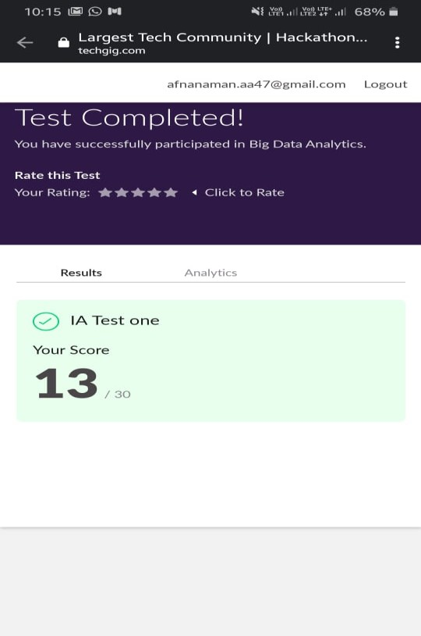

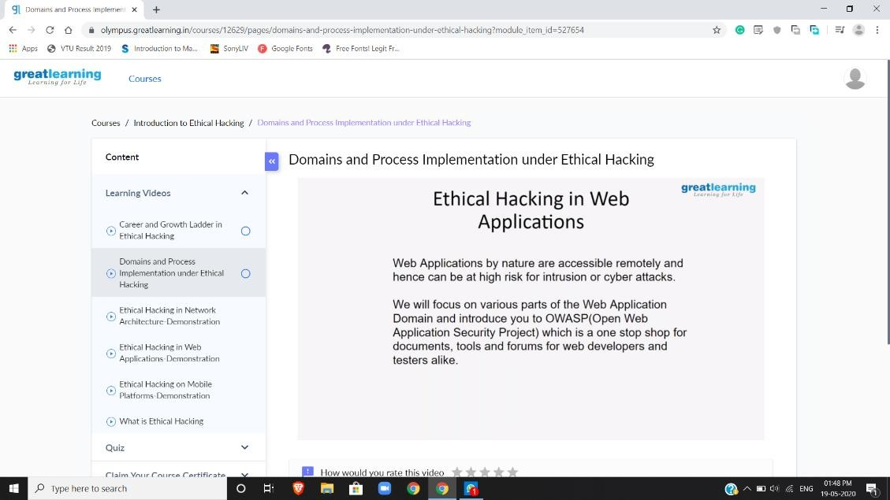Certification Course Details:

Coding Challenges Details:

|  |
| --- |
| To add some letters for a given word or letter then to find the shortest palindrome |
|  |
| package shortestpalindromeexample.java; |
| import java.util.Scanner; |
|  |
| public class ShortestPalindromeDemo { |
|  |
| public static String shortestPalindrome(String str) { |
|  |
| int x=0; |
| int y=str.length()-1; |
|  |
| while(y>=0){ |
| if(str.charAt(x)==str.charAt(y)){ |
| x++; |
| } |
| y--; |
| } |
|  |
| if(x==str.length()) |
| return str; |
|  |
| String suffix = str.substring(x); |
| String prefix = new StringBuilder(suffix).reverse().toString(); |
| String mid = shortestPalindrome(str.substring(0, x)); |
|  |
| return prefix+mid+suffix; |
| } |
|  |
| public static void main(String[] args) { |
|  |
| Scanner in = new Scanner(System.in); |
|  |
| System.out.println("Enter a String to find out shortest palindrome"); |
|  |
| String str=in.nextLine(); |
|  |
| System.out.println("Shortest palindrome of "+str+" is "+shortestPalindrome(str)); |
|  |
| } |
|  |
|  |
|  |
|  |
| Program 2 |
| To check whether the given linked list is palindrome or not |
|  |
| import java.util.Stack; |
|  |
| // Data Structure to store a linked list node |
| class Node { |
| int data; |
| Node next; |
|  |
| Node(int i) |
| { |
| this.data = i; |
| this.next = null; |
| } |
| }; |
|  |
| class Main |
| { |
| // Function to determine if a given linked list is palindrome or not |
| public static boolean isPalindrome(Node head) |
| { |
| // construct an empty stack |
| Stack<Integer> s = new Stack<>(); |
|  |
| // push all elements of the linked list into the stack |
| Node node = head; |
| while (node != null) { |
| s.push(node.data); |
| node = node.next; |
| } |
|  |
| // traverse the linked list again |
| node = head; |
| while (node != null) |
| { |
| // pop the top element from the stack |
| int top = s.pop(); |
|  |
| // compare the popped element with current node's data |
| // return false if mismatch happens |
| if (top != node.data) { |
| return false; |
| } |
|  |
| // advance to the next node |
| node = node.next; |
| } |
|  |
| // we reach here only when the linked list is palindrome |
| return true; |
| } |
|  |
| public static void main(String[] args) |
| { |
| Node head = new Node(1); |
| head.next = new Node(2); |
| head.next.next = new Node(3); |
| head.next.next.next = new Node(2); |
| head.next.next.next.next = new Node(1); |
|  |
| if (isPalindrome(head)) { |
| System.out.print("Linked List is a palindrome."); |
| } else { |
| System.out.print("Linked List is not a palindrome."); |
| } |
| }  } |

THANK YOU