**DAILY ONLINE ACTIVITIES SUMMARY**

|  |  |  |  |  |  |  |  |
| --- | --- | --- | --- | --- | --- | --- | --- |
| **Date:** | **21-05-2020** | | | | **Name:** | **MOHAMED AFNAN AMAN** | |
| **Sem & Sec** | **8th , A sec** | | | | **USN:** | **4AL15CS058** | |
| Online Test Summary | | | | | | | |
| **Subject** | | **SMS** | | | | | |
| **Max. Marks** | | **60** | | **Score** | | **43** | |
| Certification Course Summary | | | | | | | |
| **Course** | **INTRODUCTION TO ETHICAL HACKING** | | | | | | |
| **Certificate Provider** | | | **GREATLEARNING** | **Duration** | | | **56min** |
| Coding Challenges | | | | | | | |
| **Problem Statement:**  **1: Write C Program to create Singly Liked List with n elements and reverse the elements using C.**  **2: Python program in number right angled triangle**. | | | | | | | |
| **Status: solved** | | | | | | | |
| **Uploaded the report in Github** | | | | **yes** | | | |
| **If yes Repository name** | | | | **mohamedafnanaman** | | | |
| **Uploaded the report in slack** | | | | **yes** | | | |

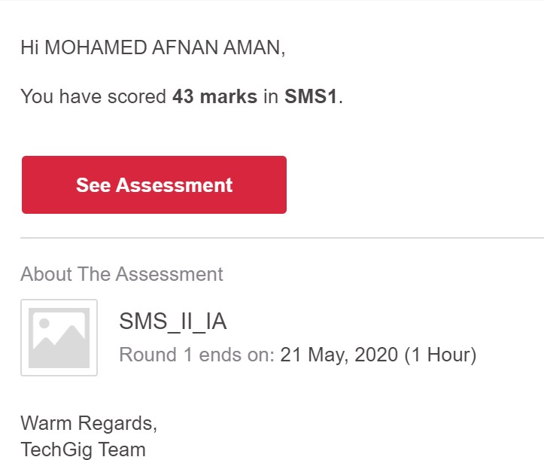Online Test Details:

Certification Course Details:

Coding Challenges Details:

|  |  |
| --- | --- |
|  | Prog 1  #include <stdlib.h> |
|  | struct node |
|  | { |
|  | int data; |
|  | struct node next; |
|  | }; |
|  | struct Node reverse(struct Node head,int k) |
|  | { |
|  | struct Node current= head; |
|  | struct Node next= Null; |
|  | struct Node prev= Null; |
|  | int count = 0; |
|  | while(current!=Null && count<k) |
|  | { |
|  | next= current->next; |
|  | current->next = prev; |
|  | prev= current; |
|  | current= next; |
|  | count++; |
|  | } |
|  | if ( next!=Null) |
|  | head->next= reverse( next,k); |
|  | return prev; |
|  | } |
|  | void push( struct Node ==head_ref,int new_data) |
|  | { |
|  | struct Node= new_node= (struct Node) malloc(sizeof(struct Node)); |
|  | } |
|  | } |
|  | int main() |
|  | { |
|  | Struct node *prev,*head,*p; |
|  | int n,i; |
|  | printf ("number of elements:"); |
|  | scanf("%d",&n); |
|  | head=NULL; |
|  | for(i=0;i<n;i++) |
|  | { |
|  | p=malloc(sizeof(struct node)); |
|  | scanf("%d",&p->data); |
|  | p->next=NULL; |
|  | if(head==NULL) |
|  | head=p; |
|  | else |
|  | prev->next=p; |
|  | prev=p; |
|  | } |
|  | return 0; |
|  | } |

THANK YOU…