**DAILY ONLINE ACTIVITIES SUMMARY**

|  |  |  |  |  |  |  |  |  |
| --- | --- | --- | --- | --- | --- | --- | --- | --- |
| **Date:** | **24-05-2020** | | | | | **Name:** | **Md. Afnan Aman** | |
| **Sem & Sec** | **8th 'A'** | | | | | **USN:** | **4AL15CS058** | |
| **Online Test Summary** | | | | | | | | |
| **Subject** | | **--** | | | | | | |
| **Max. Marks** | | **--** | | **Score** | | | **--** | |
| **Certification Course Summary** | | | | | | | | |
| **Course** | **Introduction to hadoop** | | | | | | | |
| **Certificate Provider** | | | **Great learning** | | **Duration** | | | **3hr** |
| **Coding Challenges** | | | | | | | | |
| **Problem Statement: 1.**rotation of array | | | | | | | | |
| **Status: Solved** | | | | | | | | |
| **Uploaded the report in Github** | | | | | **Yes** | | | |
| **If yes Repository name** | | | | | **AFNAN_AMAN** | | | |
| **Uploaded the report in slack** | | | | | **Yes** | | | |

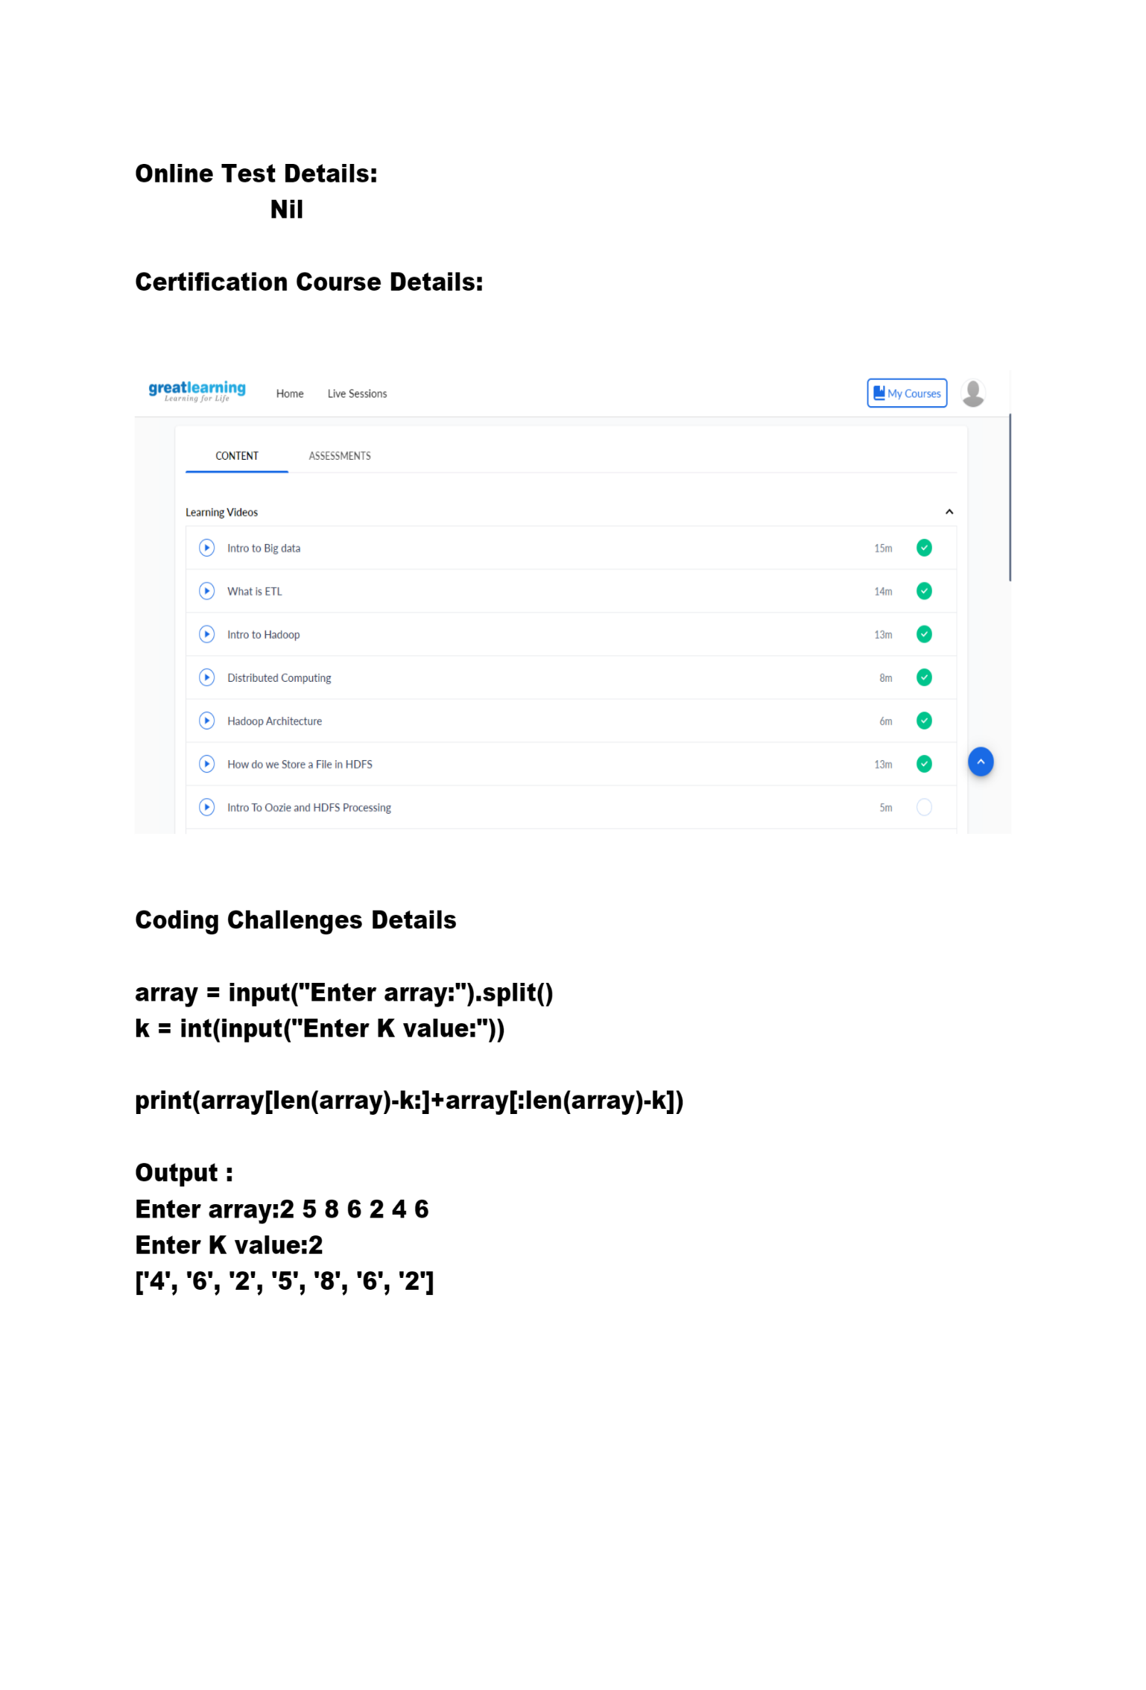THANK YOU……..