**DAILY ONLINE ACTIVITIES SUMMARY**

|  |  |  |  |  |  |  |  |  |
| --- | --- | --- | --- | --- | --- | --- | --- | --- |
| **Date:** | **26-05-2020** | | | | | **Name:** | **Md. Afnan Aman** | |
| **Sem & Sec** | **8th 'A'** | | | | | **USN:** | **4AL15CS058** | |
| **Online Test Summary** | | | | | | | | |
| **Subject** | | **BDA** | | | | | | |
| **Max. Marks** | | **40** | | **Score** | | | **30** | |
| **Certification Course Summary** | | | | | | | | |
| **Course** | **Introduction to Ethical Hacking** | | | | | | | |
| **Certificate Provider** | | | **Great learning** | | **Duration** | | | **52min** |
| **Coding Challenges** | | | | | | | | |
| **Problem Statement: 1.** Python Program to Check if a Number is a Palindrome  2. Write a program in C to print all permutations of a given string using pointers. | | | | | | | | |
| **Status:Solved** | | | | | | | | |
| **Uploaded the report in Github** | | | | | **Yes** | | | |
| **If yes Repository name** | | | | | **AFNAN_AMAN** | | | |
| **Uploaded the report in slack** | | | | | **Yes** | | | |

Online Test Details: 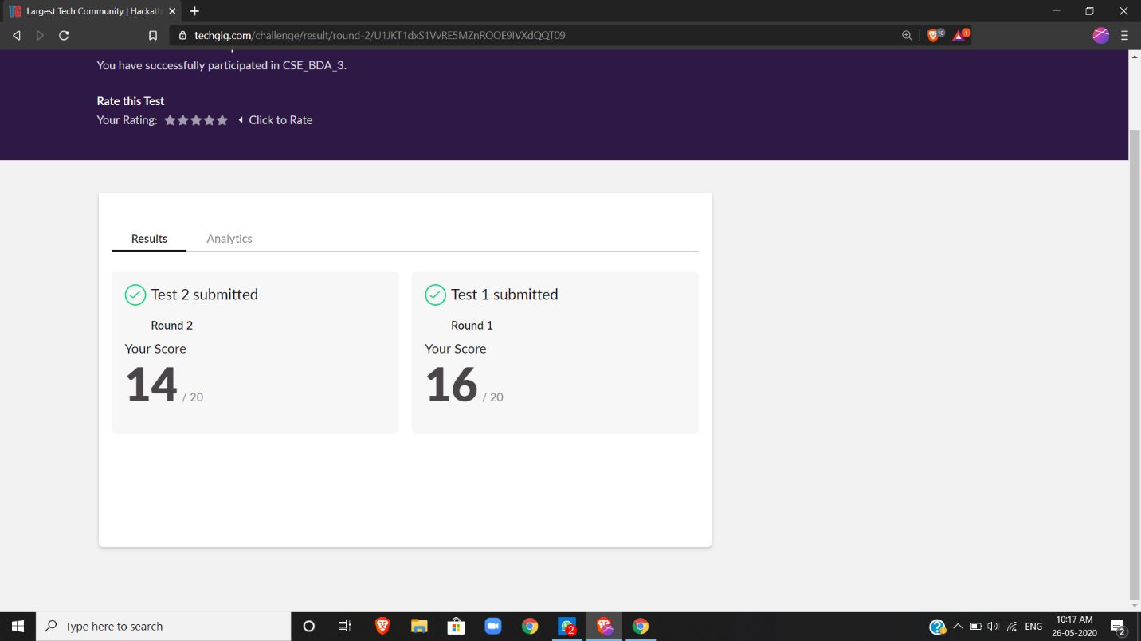

Certification Course Details: (Attach the snapshot and briefly write the report for the same)

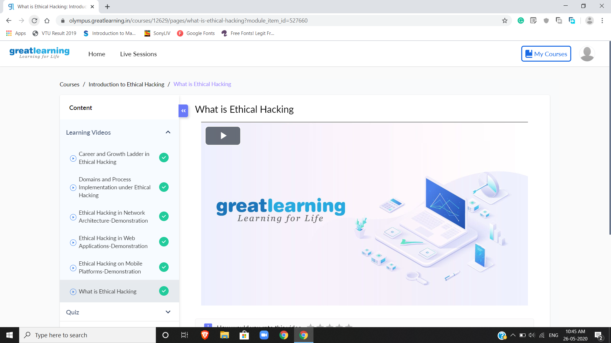

Coding Challenges Details: (Attach the snapshot and briefly write the report for the same)

**1.Python Program to Check if a Number is a Palindrome**

n=int(input("Enter number:"))  
temp=n  
rev=0  
while(n>0):  
dig=n%10  
rev=rev*10+dig  
n=n//10  
if(temp==rev):  
print("The number is a palindrome!")  
else:  
print("The number isn't a palindrome!")

2. Write a program in C to print all permutations of a given string using pointers.

#include <stdio.h>

#include <string.h>

/* Function to swap values at two pointers */

void swap (char *x, char *y)

{

char temp;

temp = *x;

*x = *y;

y = temp;

}

/ End of swap() */

/* Function to print permutations of string */

void permute(char *a, int i, int n)

{

int j;

if (i == n)

printf("%s\n", a);

else {

for (j = i; j <= n; j++)

{

swap((a + i), (a + j));

permute(a, i + 1, n);

swap((a + i), (a + j)); //backtrack

}

}

}

/* The main() begins */

int main()

{

char a[20];

int n;

printf("Enter a string: ");

scanf("%s", a);

n = strlen(a);

printf("Permutaions:\n");

permute(a, 0, n - 1);

getchar();

return 0;

}

THANK YOU……..