**DAILY ONLINE ACTIVITIES SUMMARY**

|  |  |  |  |  |  |  |  |  |
| --- | --- | --- | --- | --- | --- | --- | --- | --- |
| **Date:** | **27-05-2020** | | | | | **Name:** | **Md. Afnan Aman** | |
| **Sem & Sec** | **8th 'A'** | | | | | **USN:** | **4AL15CS058** | |
| **Online Test Summary** | | | | | | | | |
| **Subject** | | **IOT** | | | | | | |
| **Max. Marks** | | **28** | | **Score** | | | **30** | |
| **Certification Course Summary** | | | | | | | | |
| **Course** | **Introduction to Ethical Hacking** | | | | | | | |
| **Certificate Provider** | | | **Great learning** | | **Duration** | | | **52min** |
| **Coding Challenges** | | | | | | | | |
| **Problem Statement: 1.**Write a C Program to sort an array of integers in ascending order and display the sorted array and Number of passes performed for sorting.. | | | | | | | | |
| **Status:Solved** | | | | | | | | |
| **Uploaded the report in Github** | | | | | **Yes** | | | |
| **If yes Repository name** | | | | | **AFNAN_AMAN** | | | |
| **Uploaded the report in slack** | | | | | **Yes** | | | |

Online Test Details: 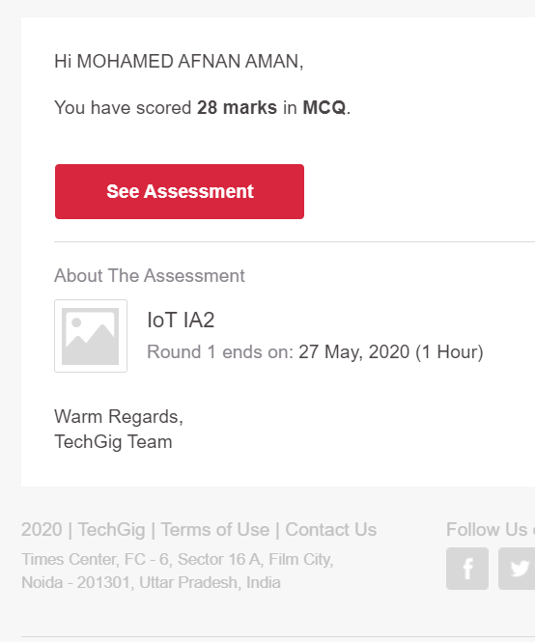

Certification Course Details: (Attach the snapshot and briefly write the report for the same)



Coding Challenges Details: (Attach the snapshot and briefly write the report for the same)

1. Write a C Program to sort an array of integers in ascending order and display the sorted array and Number of passes performed for sorting.

void swap(int *xp, int *yp)  
{  
int temp = *xp;  
*xp = *yp;  
*yp = temp;  
}  
int bubbleSort(int arr[], int n)  
{  
int i, j,count=0;  
int swapped;  
for (i = 0; i < n-1; i++)  
{  
swapped = 0;  
for (j = 0; j < n-i-1; j++)  
{  
if (arr[j] > arr[j+1])  
{  
swap(&arr[j], &arr[j+1]);  
swapped = 1;  
count++;  
}  
}  
if (swapped == 0)  
break;  
}  
return count;  
}  
void printArray(int arr[], int size)  
{  
int i;  
for (i=0; i < size; i++)  
printf("%d ", arr[i]);  
printf("\n");  
}  
int main()  
{  
int arr[50],num;  
printf("enter the number of elements");  
scanf("%d",&num);  
printf("enter the elements");  
for(int i=0;i<num;i++){  
scanf("%d",&arr[i]);  
}  
int c=bubbleSort(arr, num);  
printf("Sorted array: \n");  
printArray(arr, num);  
printf("Number of passes:%d\n",c);  
return 0;  
}

THANK YOU……..