**DAILY ONLINE ACTIVITIES SUMMARY**

|  |  |  |  |  |  |  |  |  |
| --- | --- | --- | --- | --- | --- | --- | --- | --- |
| **Date:** | **28-05-2020** | | | | | **Name:** | **Md. Afnan Aman** | |
| **Sem & Sec** | **8th 'A'** | | | | | **USN:** | **4AL15CS058** | |
| **Online Test Summary** | | | | | | | | |
| **Subject** | | **SMS** | | | | | | |
| **Max. Marks** | | **60** | | **Score** | | | **60** | |
| **Certification Course Summary** | | | | | | | | |
| **Course** | **Introduction to Ethical Hacking** | | | | | | | |
| **Certificate Provider** | | | **Great learning** | | **Duration** | | | **6hr** |
| **Coding Challenges** | | | | | | | | |
| **Problem Statement: 1) In Bubble sort, each pass consists of comparison each element in the file with its successor (i.e. x[i] with x[i+1]) and interchanging two elements if they are not in the proper order. The array may be sorted in any pass. If the array is sorted, then remaining passes should be skipped off. Write a C Program to sort an array of integers in ascending order and display the sorted array and Number of passes performed for sorting.**. | | | | | | | | |
| **Status:Solved** | | | | | | | | |
| **Uploaded the report in Github** | | | | | **Yes** | | | |
| **If yes Repository name** | | | | | **AFNAN_AMAN** | | | |
| **Uploaded the report in slack** | | | | | **Yes** | | | |

Online Test Details: 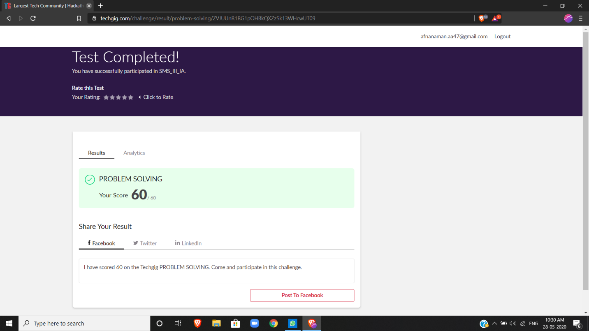

Certification Course Details: (Attach the snapshot and briefly write the report for the same)



**1) In Bubble sort, each pass consists of comparison each element in the file with its successor (i.e. x[i] with x[i+1]) and interchanging two elements if they are not in the proper order. The array may be sorted in any pass. If the array is sorted, then remaining passes should be skipped off. Write a C Program to sort an array of integers in ascending order and display the sorted array and Number of passes performed for sorting.**.

#include <stdio.h>

void swap(int *xp, int *yp)

{

int temp = *xp;

*xp = *yp;

*yp = temp;

}

int bubbleSort(int arr[], int n)

{

int i, j,count=0;

int swapped;

for (i = 0; i < n-1; i++)

{

swapped = 0;

for (j = 0; j < n-i-1; j++)

{

if (arr[j] > arr[j+1])

{

swap(&arr[j], &arr[j+1]);

swapped = 1;

count++;

}

}

if (swapped == 0)

break;

}

return count;

}

void printArray(int arr[], int size)

{

int i;

for (i=0; i < size; i++)

printf("%d ", arr[i]);

printf("\n");

}

int main()

{

int arr[50],num;

printf("enter the number of elements");

scanf("%d",&num);

printf("enter the elements");

for(int i=0;i<num;i++){

scanf("%d",&arr[i]);

}

int c=bubbleSort(arr, num);

printf("Sorted array: \n");

printArray(arr, num);

printf("Number of passes:%d\n",c);

return 0;

THANK YOU……..