**DAILY ONLINE ACTIVITIES SUMMARY**

|  |  |  |  |  |  |  |  |  |
| --- | --- | --- | --- | --- | --- | --- | --- | --- |
| **Date:** | **01-06-2020** | | | | | **Name:** | **Anusha** | |
| **Sem & Sec** | **6th sem & A sec** | | | | | **USN:** | **4AL17CS007** | |
| **Online Test Summary** | | | | | | | | |
| **Subject** | | **CNSC IA Test 2** | | | | | | |
| **Max. Marks** | | **60** | | **Score** | | | **52** | |
| **Certification Course Summary** | | | | | | | | |
| **Course** | **Python 101 for Data Science** | | | | | | | |
| **Certificate Provider** | | | **Cognitive Class** | | **Duration** | | | **3hr( spent daily by me to learn)** |
| **Coding Challenges** | | | | | | | | |
| **Problem Statement:**  1.Python Program to delete duplicate element from the list.  2. Write Python Program to accept the sequence of comma-separated numbers from user and generate a list and a tuple with those numbers. | | | | | | | | |
| **Status:Completed** | | | | | | | | |
| **Uploaded the report in Github** | | | | | **Yes** | | | |
| **If yes Repository name** | | | | | <https://github.com/AnushaR2416/Coding-assessment> | | | |
| **Uploaded the report in slack** | | | | | **Yes** | | | |

**Online test Detail:**

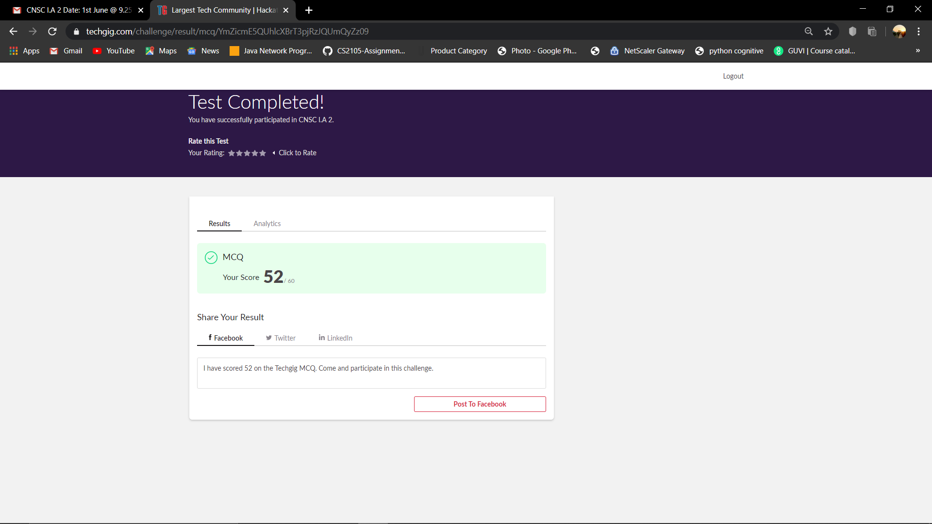

**Online Certification Details**

Modules completed:

### - About this course

### - Module 1 - Python Basics

### - Module 2 - Python Data Structures

### -  Module 3 - Python Programming Fundamentals

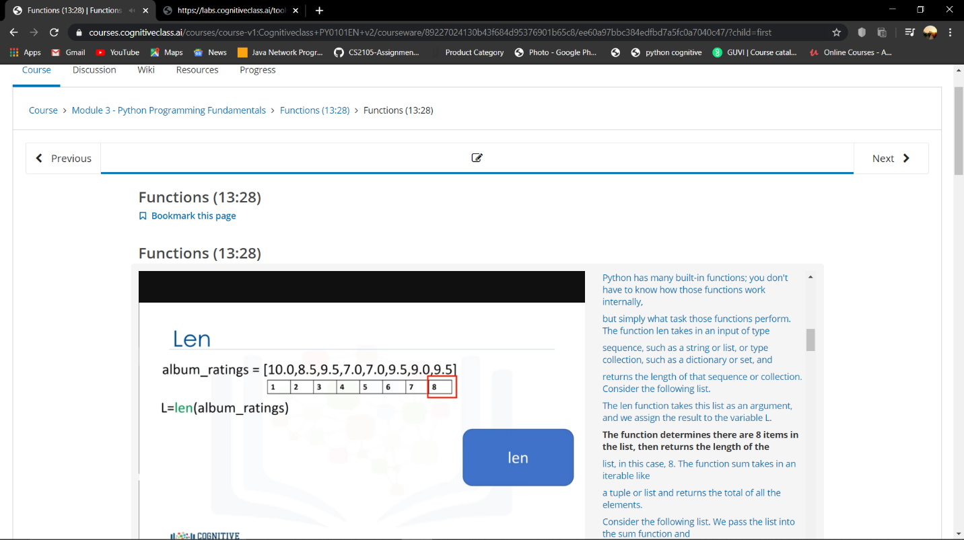

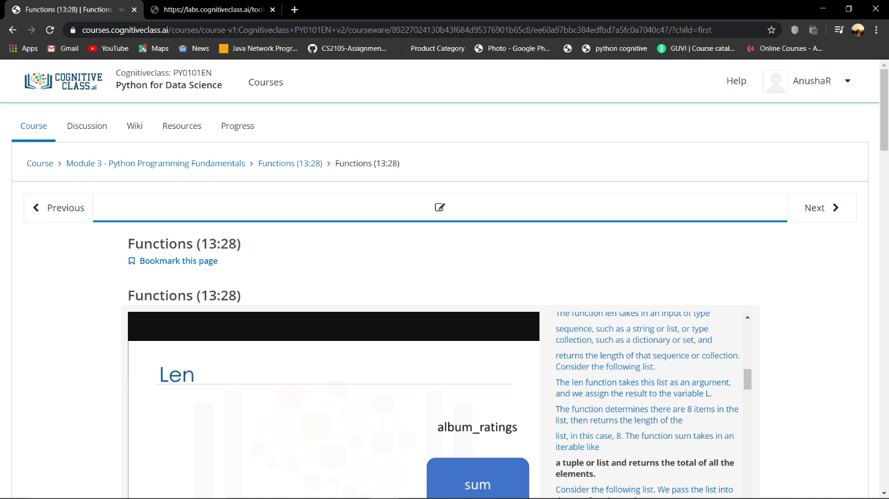

**Coding Challenge Details**

1. Python Program to delete duplicate element from the list.

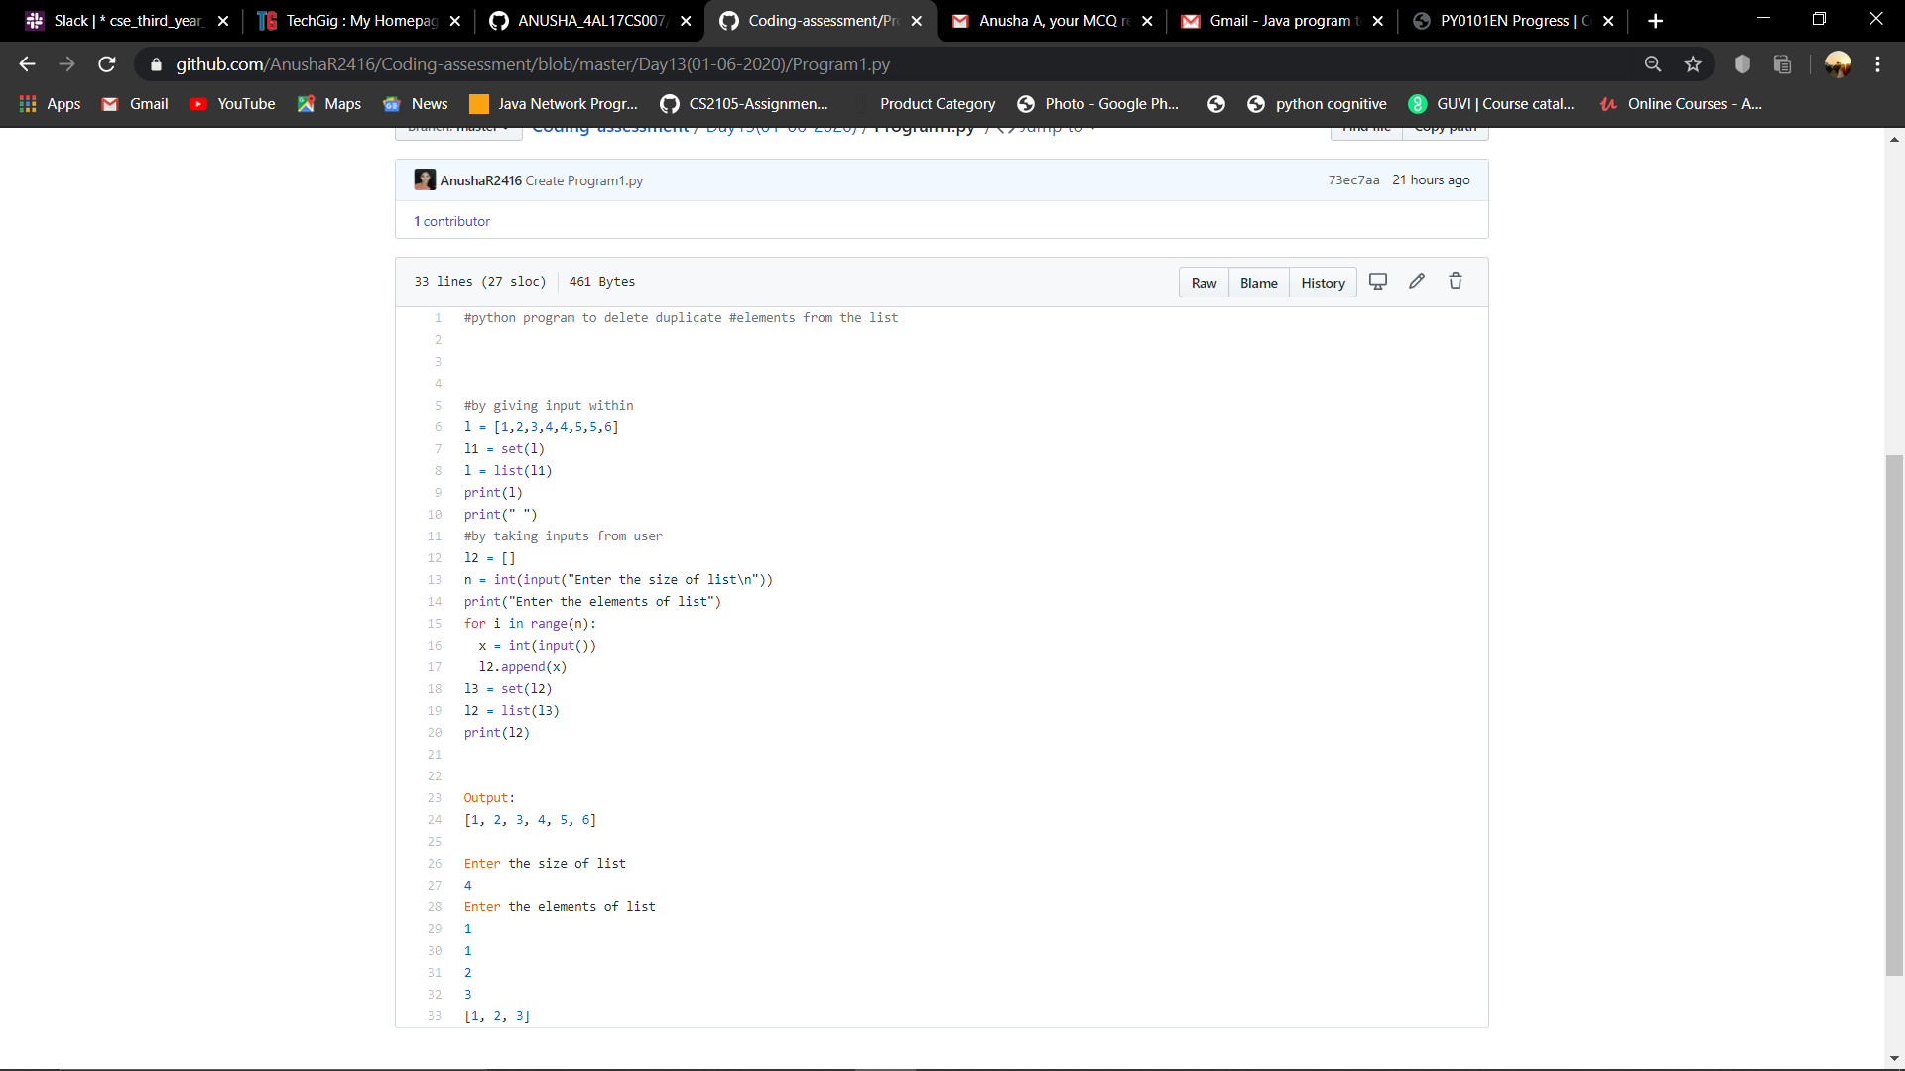

2. Write Python Program to accept the sequence of comma-separated numbers from user and generate a list and a tuple with those numbers.

