**DAILY ONLINE ACTIVITIES SUMMARY**

|  |  |  |  |  |  |  |  |  |
| --- | --- | --- | --- | --- | --- | --- | --- | --- |
| **Date:** | **03-06-2020** | | | | | **Name:** | **Anusha** | |
| **Sem & Sec** | **6th sem & A sec** | | | | | **USN:** | **4AL17CS007** | |
| **Online Test Summary** | | | | | | | | |
| **Subject** | | **PAP IA Test 1** | | | | | | |
| **Max. Marks** | | **20** | | **Score** | | | **18** | |
| **Certification Course Summary** | | | | | | | | |
| **Course** | **Learn SQL from scratch** | | | | | | | |
| **Certificate Provider** | | | **Udemy** | | **Duration** | | | **1.5 hr( spent daily by me to learn)** |
| **Coding Challenges** | | | | | | | | |
| **Problem Statement:**  1. Problem statement: Take a list of length 3 containing integers, find out which is larger, first or last one and set all the elements in the list to be that value. Print the updated list.  2. Write Python to print prime number in a range | | | | | | | | |
| **Status:Completed** | | | | | | | | |
| **Uploaded the report in Github** | | | | | **Yes** | | | |
| **If yes Repository name** | | | | | <https://github.com/AnushaR2416/Coding-assessment> | | | |
| **Uploaded the report in slack** | | | | | **Yes** | | | |

**Online test Detail:**

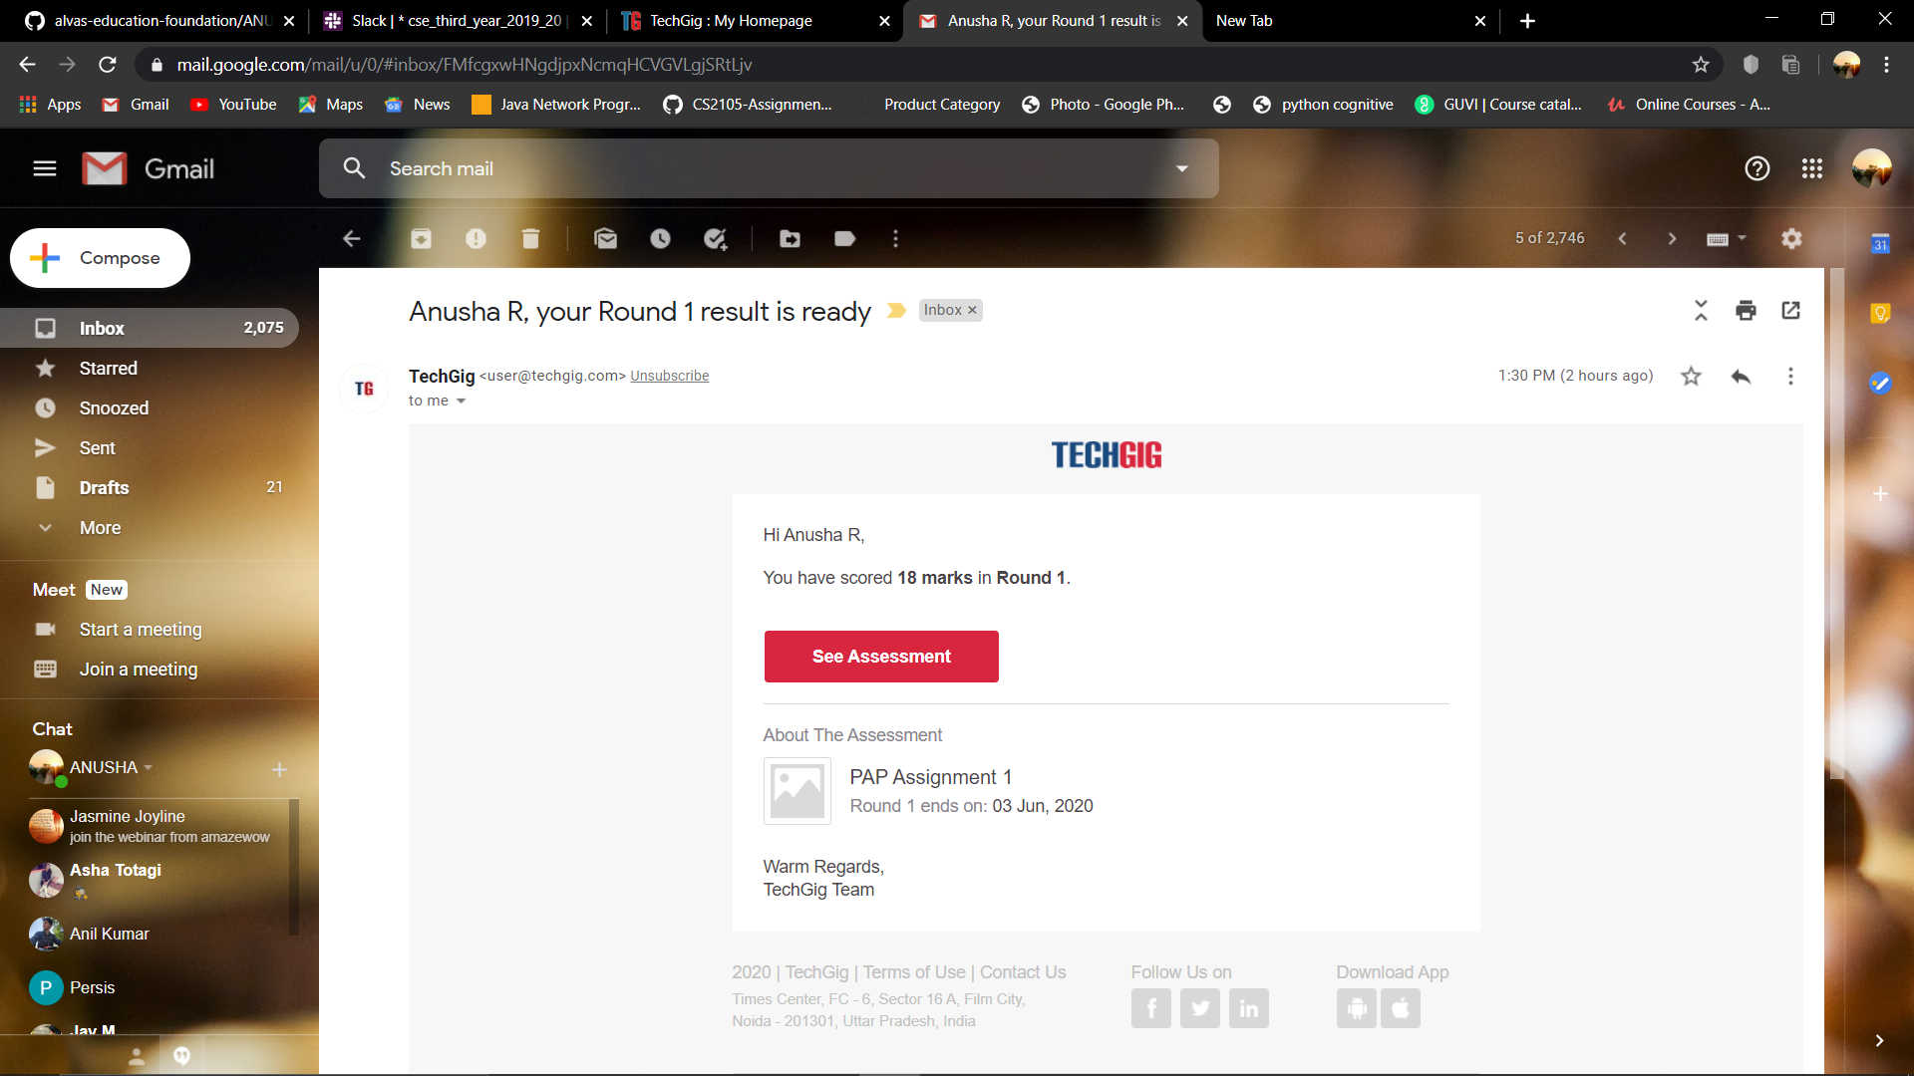

**Online Certification Details**

Modules completed:

### - Learn SQL from scratch

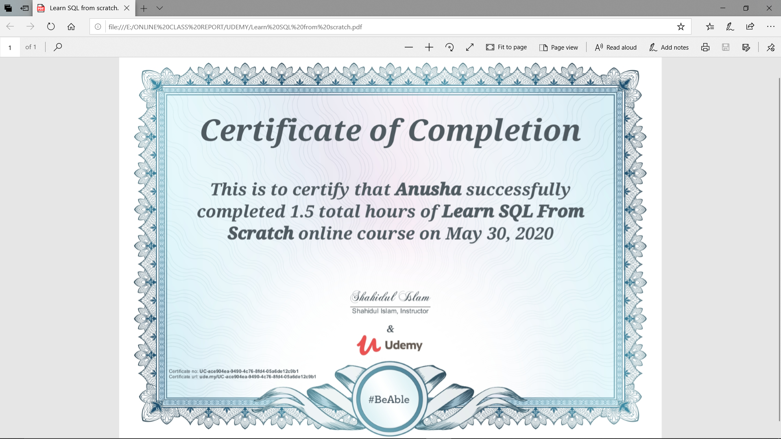

**Coding Challenge Details**

1. Problem statement: Take a list of length 3 containing integers, find out which is larger, first or last one and set all the elements in the list to be that value. Print the updated list

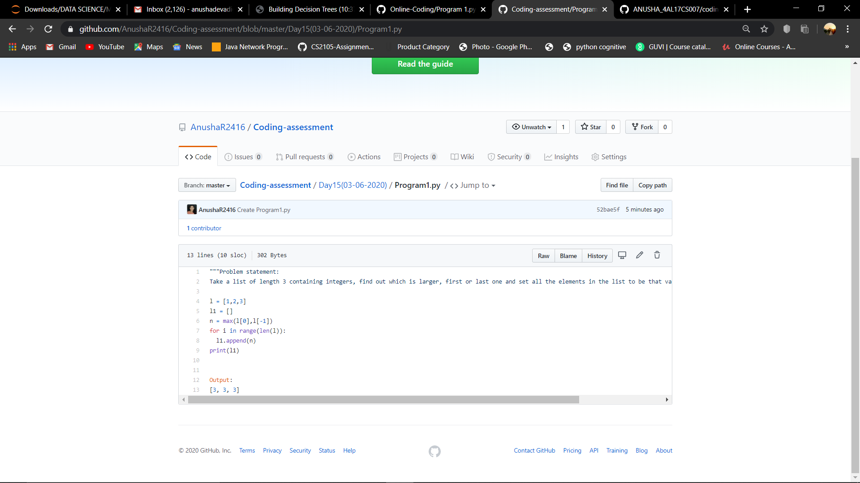

2. Write Python to print prime number in a range

