**DAILY ONLINE ACTIVITIES SUMMARY**

|  |  |  |  |  |  |  |  |  |
| --- | --- | --- | --- | --- | --- | --- | --- | --- |
| **Date:** | **31-05-2020** | | | | | **Name:** | **Anusha** | |
| **Sem & Sec** | **6th sem & A sec** | | | | | **USN:** | **4AL17CS007** | |
| **Online Test Summary** | | | | | | | | |
| **Subject** | | **No test** | | | | | | |
| **Max. Marks** | | **-** | | **Score** | | | **-** | |
| **Certification Course Summary** | | | | | | | | |
| **Course** | **Step into Robotic Process Automation** | | | | | | | |
| **Certificate Provider** | | | **GUVI** | | **Duration** | | | **1.30 hr( spent daily by Me to learn)** |
| **Coding Challenges** | | | | | | | | |
| **Problem Statement:**  1. Java program to detect loop in a linked list  2. Inversion count of array | | | | | | | | |
| **Status:Completed** | | | | | | | | |
| **Uploaded the report in Github** | | | | | **Yes** | | | |
| **If yes Repository name** | | | | | <https://github.com/AnushaR2416/Coding-assessment> | | | |
| **Uploaded the report in slack** | | | | | **Yes** | | | |

**Online Certification Details**

Modules completed:

- Introduction

- Uipath Components and Extensions

- Scraping, Conditions and Loops in Uipath

- Basic Automation Workflow

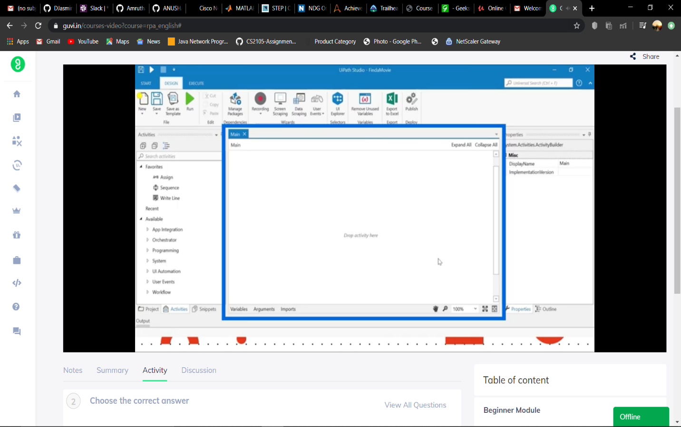

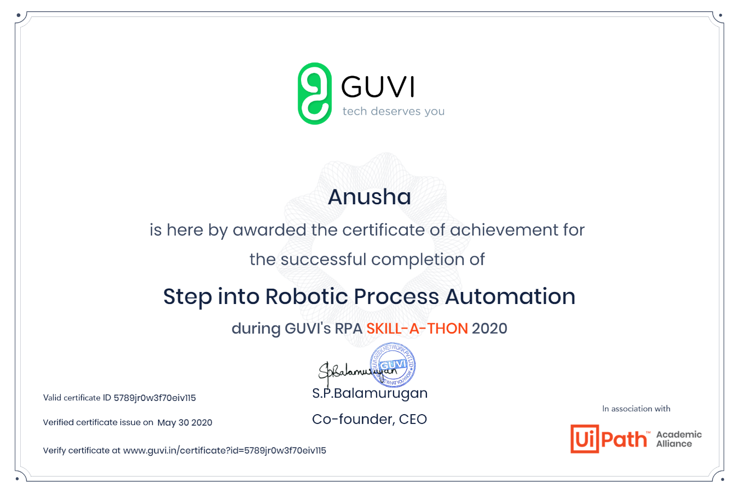

**Coding Challenge Details**

1. Java program to detect loop in a linked list

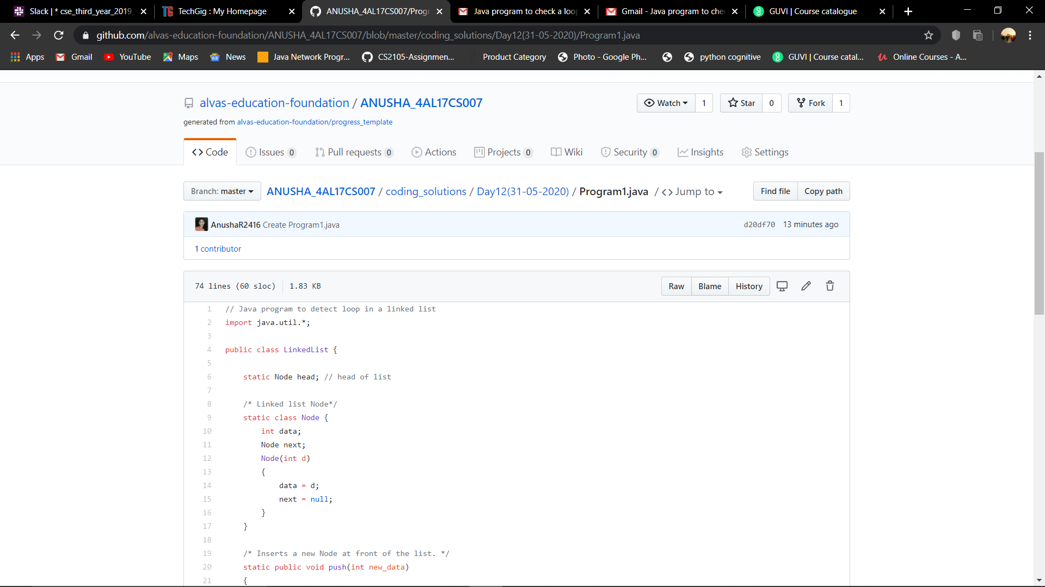

2. Inversion count of array

