**DAILY ONLINE ACTIVITIES SUMMARY**

|  |  |  |  |  |  |  |  |
| --- | --- | --- | --- | --- | --- | --- | --- |
| **Date:** | **01/06/2020** | | | | **Name:** | **AKASH KUMAR S** | |
| **Sem & Sec** | **8thA** | | | | **USN:** | **4AL16CS006** | |
| **Online Test Summary** | | | | | | | |
| **Subject** | | **SMS** | | | | | |
| **Max. Marks** | | **60** | | **Score** | | **60** | |
| **Certification Course Summary** | | | | | | | |
| **Course** | Introduction to Cyber Security | | | | | | |
| **Certificate Provider** | | | **Great learning**  **Academy** | **Duration** | | | **7 hours** |
| **Coding Challenges** | | | | | | | |
| **Problem Statement:** **Find the leaders in the array.** | | | | | | | |
| **Status: COMPLETED** | | | | | | | |
| **Uploaded the report in Github** | | | | **YES** | | | |
| **If yes Repository name** | | | | **Akash_Daily_Progress** | | | |
| **Uploaded the report in slack** | | | | **YES** | | | |

Online Test Details:

Snapshot of test

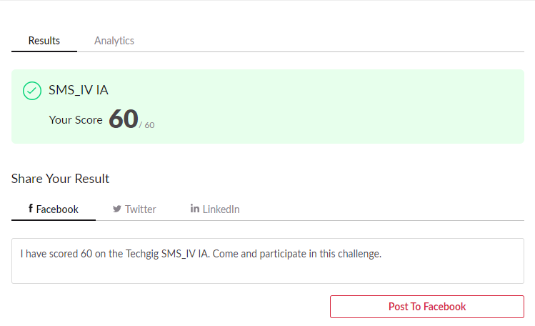

Certification Course Details:

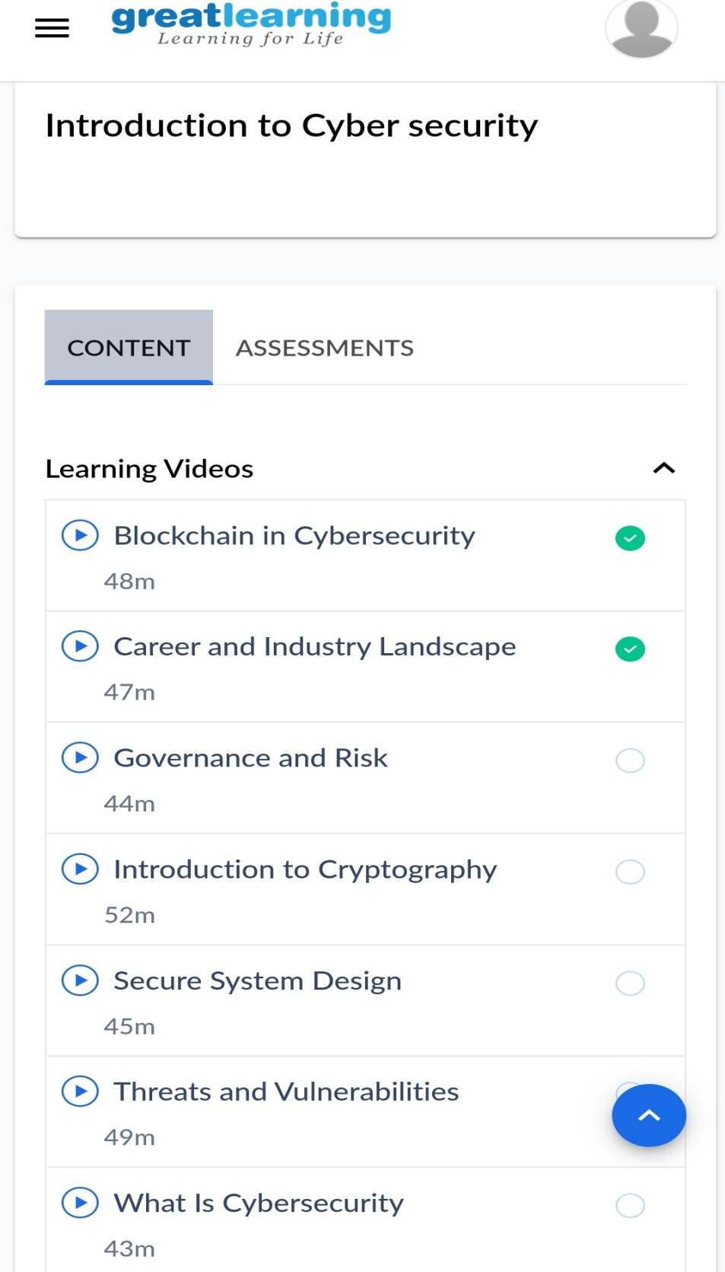

#### Introduction to Cyber Security

Coding Challenges Details :

# Find the leaders in the array.

|  |
| --- |
| #include<stdio.h> |
|  |  |
|  | void main() |
|  | { |
|  | int n, i, j, a[10]; |
|  | printf("Enter the value of n: "); |
|  | scanf("%d",&n); |
|  |  |
|  | printf("Enter the numbers:\n"); |
|  | for(i=0;i<n;i++) |
|  | scanf("%d",&a[i]); |
|  |  |
|  | printf("The leaders are\n"); |
|  | for (inti = 0; i< n; i++) |
|  | { |
|  | j = 0; |
|  | for (j = i+1; j < n; j++) |
|  | { |
|  | if (a[i] <= a[j]) |
|  | break; |
|  | } |
|  | if (j == n) |
|  | printf("%d ",a[i]); |
|  | } |
|  | } |