**DAILY ONLINE ACTIVITIES SUMMARY**

|  |  |  |  |  |  |  |  |
| --- | --- | --- | --- | --- | --- | --- | --- |
| **Date:** | **02/06/2020** | | | | **Name:** | **AKASH KUMAR S** | |
| **Sem & Sec** | **8thA** | | | | **USN:** | **4AL16CS006** | |
| **Online Test Summary** | | | | | | | |
| **Subject** | | **---** | | | | | |
| **Max. Marks** | | **---** | | **Score** | | **---** | |
| **Certification Course Summary** | | | | | | | |
| **Course** | Introduction to Cyber Security | | | | | | |
| **Certificate Provider** | | | **Great learning**  **Academy** | **Duration** | | | **7 hours** |
| **Coding Challenges** | | | | | | | |
| **Problem Statement:** Write a c++ program to find sum of digits until the number is a single digits. | | | | | | | |
| **Status: COMPLETED** | | | | | | | |
| **Uploaded the report in Github** | | | | **YES** | | | |
| **If yes Repository name** | | | | **Akash_Daily_Progress** | | | |
| **Uploaded the report in slack** | | | | **YES** | | | |

Online Test Details:

NIL

Certification Course Details:

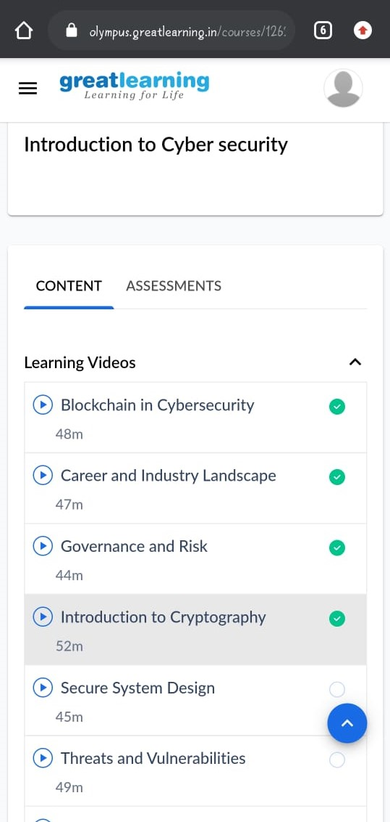

#### Introduction to Cyber Security

Coding Challenges Details

Program1 : Write a c++ program to find sum of digits until the number is a single digits.

#include

using namespacestd;

intmain()

{

intnumber=147;

//Any number.intres;

if(number) res=number%9==0?9:

number%9;

else res=0;

//printthe result cout<<res;

Return 0;

}