**DAILY ONLINE ACTIVITIES SUMMARY**

|  |  |  |  |  |  |  |  |
| --- | --- | --- | --- | --- | --- | --- | --- |
| **Date:** | **03/06/2020** | | | | **Name:** | **AKASH KUMAR S** | |
| **Sem & Sec** | **8thA** | | | | **USN:** | **4AL16CS006** | |
| **Online Test Summary** | | | | | | | |
| **Subject** | | **---** | | | | | |
| **Max. Marks** | | **---** | | **Score** | | **---** | |
| **Certification Course Summary** | | | | | | | |
| **Course** | Introduction to Cyber Security | | | | | | |
| **Certificate Provider** | | | **Great learning**  **Academy** | **Duration** | | | **7 hours** |
| **Coding Challenges** | | | | | | | |
| **Problem Statement: Find the subarray in the array whose first element & second element must be same.** | | | | | | | |
| **Status: COMPLETED** | | | | | | | |
| **Uploaded the report in Github** | | | | **YES** | | | |
| **If yes Repository name** | | | | **Akash_Daily_Progress** | | | |
| **Uploaded the report in slack** | | | | **YES** | | | |

Online Test Details:

NIL

Certification Course Details:

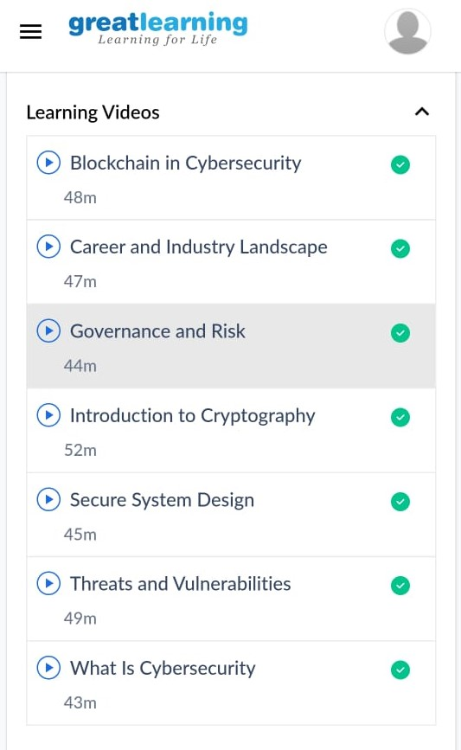

#### Introduction to Cyber Security

Coding Challenges Details:

Program1: Find the subarray in the array whose first element & second element must be same.

|  |
| --- |
| #include<stdio.h> |
| void main() |
| { |
| int a[] = {1, 2, 1, 5, 2}; |
| int n = sizeof(a) / sizeof(int); |
| int result = 0, val, i ,j; |
| |  | | --- | | for(i=0; i<n; i++) | | { | | result ++; | | val = a[i]; | | for(j=i+1; j<n; j++) | | { | | if(a[j] == val) | | result++; | | } | | } | | printf("%d",result); | | } | |