**DAILY ONLINE ACTIVITIES SUMMARY**

|  |  |  |  |  |  |  |  |
| --- | --- | --- | --- | --- | --- | --- | --- |
| **Date:** | **04/06/2020** | | | | **Name:** | **AKASH KUMAR S** | |
| **Sem & Sec** | **8thA** | | | | **USN:** | **4AL16CS006** | |
| **Online Test Summary** | | | | | | | |
| **Subject** | | **SMS** | | | | | |
| **Max. Marks** | | **60** | | **Score** | | **60** | |
| **Certification Course Summary** | | | | | | | |
| **Course** | Introduction to Serverless Development | | | | | | |
| **Certificate Provider** | | | **Amazon Web Service** | **Duration** | | | **25 min** |
| **Coding Challenges** | | | | | | | |
| **Problem Statement:** Write a Python program to convert seconds to day, hour, minutes and seconds | | | | | | | |
| **Status: COMPLETED** | | | | | | | |
| **Uploaded the report in Github** | | | | **YES** | | | |
| **If yes Repository name** | | | | **Akash_Daily_Progress** | | | |
| **Uploaded the report in slack** | | | | **YES** | | | |

Online Test Details:

Snapshot of test

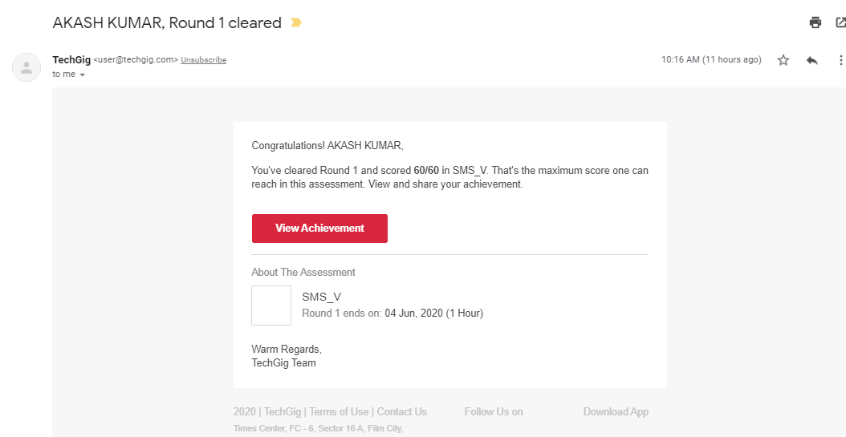

Certification Course Details:

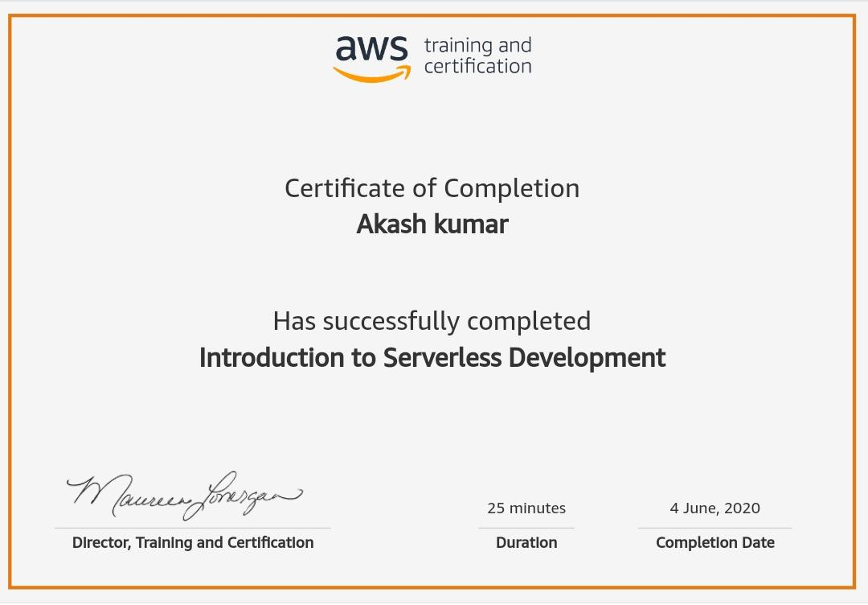

#### Introduction to Serverless Development

Coding Challenges Details

# Write a Python program to convert seconds to day, hour, minutes and seconds

time = float(input("Input time in seconds: "))

day = time // (24 * 3600)

time = time % (24 * 3600)

hour = time // 3600

time %= 3600

minutes = time // 60

time %= 60

seconds = time

print("day:-> %d" % (day))

print("hour:-> %d" % (hour))

print("minutes:-> %d" % (minutes))

print("seconds:-> %d" % (seconds))