**DAILY ONLINE ACTIVITIES SUMMARY**

|  |  |  |  |  |  |  |  |
| --- | --- | --- | --- | --- | --- | --- | --- |
| **Date:** | **05/06/2020** | | | | **Name:** | **AKASH KUMAR S** | |
| **Sem & Sec** | **8thA** | | | | **USN:** | **4AL16CS006** | |
| **Online Test Summary** | | | | | | | |
| **Subject** | | **BDA** | | | | | |
| **Max. Marks** | | **30** | | **Score** | | **14** | |
| **Certification Course Summary** | | | | | | | |
| **Course** | Introduction to EC2 Auto Scaling & AWS Deep Racer : Driven by Reinforcement Learning | | | | | | |
| **Certificate Provider** | | | **Great learning**  **Academy** | **Duration** | | | **1Hour 40 mins** |
| **Coding Challenges** | | | | | | | |
| **Problem Statement:** Write a Python program to convert seconds today, hour, minutes and seconds. | | | | | | | |
| **Status: COMPLETED** | | | | | | | |
| **Uploaded the report in Github** | | | | **YES** | | | |
| **If yes Repository name** | | | | **Akash_Daily_Progress** | | | |
| **Uploaded the report in slack** | | | | **YES** | | | |

Online Test Details:

Snapshot of test

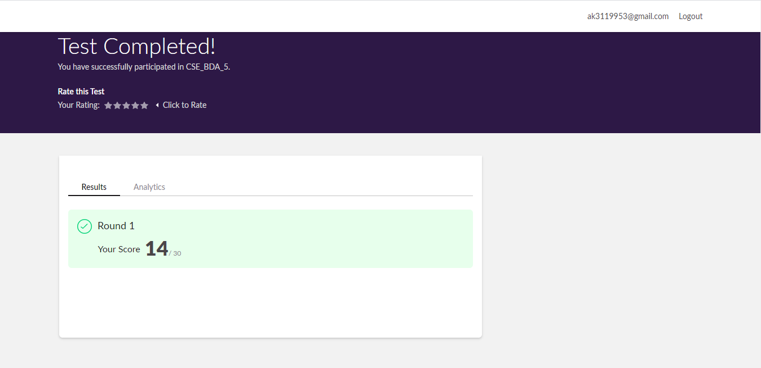

Certification Course Details:

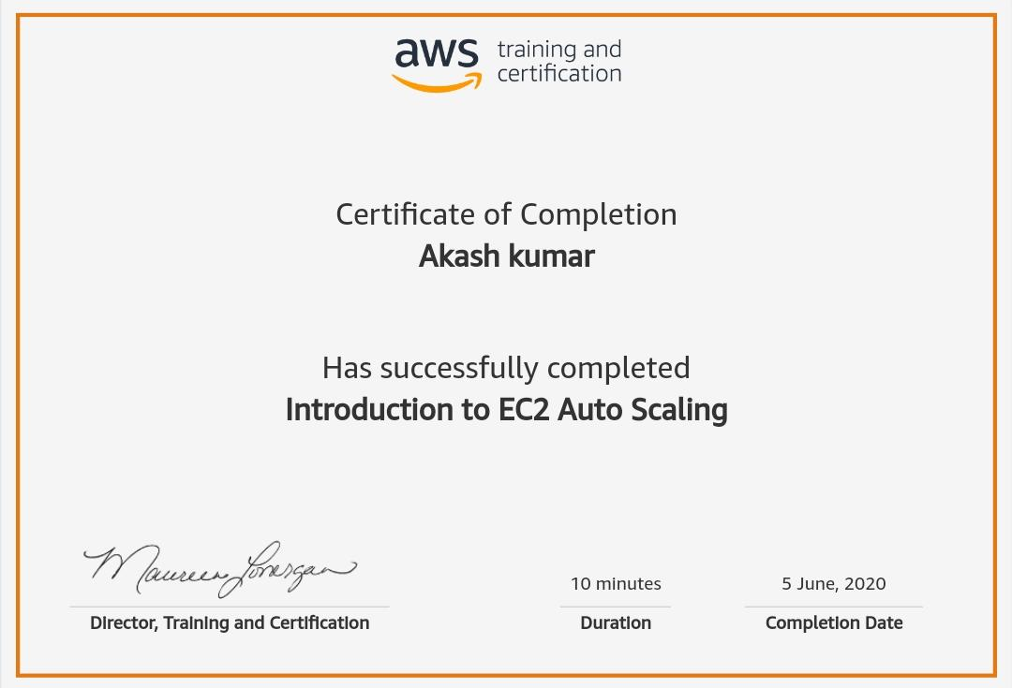

#### WhatsApp Image 2020-06-05 at 10.20.54 PM.jpeg

Coding Challenges Details

Program1 : Write a Python program to convert seconds today, hour, minutes and seconds

time=float(input("Input time in seconds:"))

day=time

//(24*3600) time=time%(24*3600)

hour=time//3600

time%=3600

minutes=time

//60 time%=60

seconds=time print("day:->%d"%(day))

print("hour:->%d"%(hour))

print("minutes:->%d"%(minutes))

print("seconds:->%d"%(seconds))

print('The minimum amount of time is :',differece)

testcase -= 1