**DAILY ONLINE ACTIVITIES SUMMARY**

|  |  |  |  |  |  |  |  |
| --- | --- | --- | --- | --- | --- | --- | --- |
| **Date:** | **06/06/2020** | | | | **Name:** | **AKASH KUMAR S** | |
| **Sem & Sec** | **8thA** | | | | **USN:** | **4AL16CS006** | |
| **Online Test Summary** | | | | | | | |
| **Subject** | | **IOT** | | | | | |
| **Max. Marks** | | **30** | | **Score** | | **Platform issue (Network Problem)** | |
| **Certification Course Summary** | | | | | | | |
| **Course** | Introduction to AWS Machine Learning Services & Machine Learning Terminology and Process | | | | | | |
| **Certificate Provider** | | | **Amazon Web Service** | **Duration** | | | **1 hours 5 mins** |
| **Coding Challenges** | | | | | | | |
| **Problem Statement: Write a program in C to rotate an array by N positions** | | | | | | | |
| **Status: COMPLETED** | | | | | | | |
| **Uploaded the report in Github** | | | | **YES** | | | |
| **If yes Repository name** | | | | **Akash_Daily_Progress** | | | |
| **Uploaded the report in slack** | | | | **YES** | | | |

Online Test Details:

NIL

Certification Course Details:

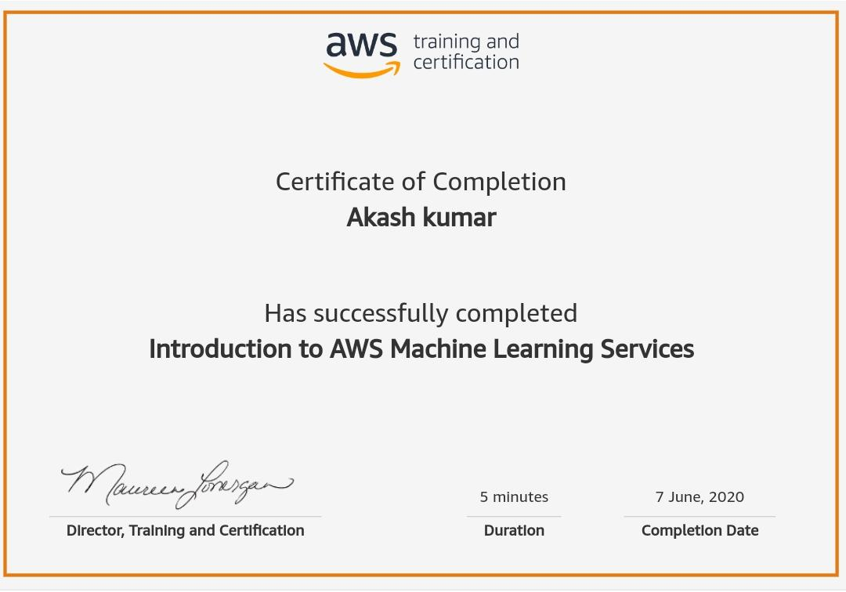

#### WhatsApp Image 2020-06-08 at 6.07.01 PM.jpeg

Coding Challenges Details

**Program1: Write a program in C to rotate an array by N positions**

**#include <stdio.h>**

**void leftRotatebyOne(int arr[], int n); void leftRotate(int arr[], int d, int n)**

**{**

**int i;**

**for (i = 0; i < d; i++)**

**leftRotatebyOne(arr, n);**

**}**

**void leftRotatebyOne(int arr[], int n)**

**{**

**int temp = arr[0], i;**

**for (i = 0; i < n - 1; i++)**

**arr[i] = arr[i + 1];**

**arr[i] = temp;**

**}**

**void printArray(int arr[], int n)**

**{**

**int i;**

**for (i = 0; i < n; i++)**

**printf("%d ", arr[i]); printf("\n");**

**}**

**int main()**

**{**

**int n,d;**

**printf("Enter the size of array : ");**

**scanf("%d",&n);**

**int arr[n];**

**printf("\nEnter the array elements :\n");**

**for(int i=0;i<n;i++)**

**scanf("%d",&arr[i]);**

**printf("Enter the Position N from where you want to rotate : ");**

**scanf("%d",&d);**

**leftRotate(arr, d, n);**

**printArray(arr, n);**

**return 0;**

**}**