**DAILY ONLINE ACTIVITIES SUMMARY**

|  |  |  |  |  |  |  |  |
| --- | --- | --- | --- | --- | --- | --- | --- |
| **Date:** | **07/06/2020** | | | | **Name:** | **AKASH KUMAR S** | |
| **Sem & Sec** | **8thA** | | | | **USN:** | **4AL16CS006** | |
| **Online Test Summary** | | | | | | | |
| **Subject** | | **---** | | | | | |
| **Max. Marks** | | **---** | | **Score** | | **---** | |
| **Certification Course Summary** | | | | | | | |
| **Course** | Introduction to Amazon Virtual Private Cloud & Introduction to Amazon Cloud Front | | | | | | |
| **Certificate Provider** | | | **Amazon Web Service** | **Duration** | | | **20 mins** |
| **Coding Challenges** | | | | | | | |
| **Problem Statement:** Program to multiply two floating point numbers | | | | | | | |
| **Status: COMPLETED** | | | | | | | |
| **Uploaded the report in Github** | | | | **YES** | | | |
| **If yes Repository name** | | | | **Akash_Daily_Progress** | | | |
| **Uploaded the report in slack** | | | | **YES** | | | |

Online Test Details:

NIL

Certification Course Details:

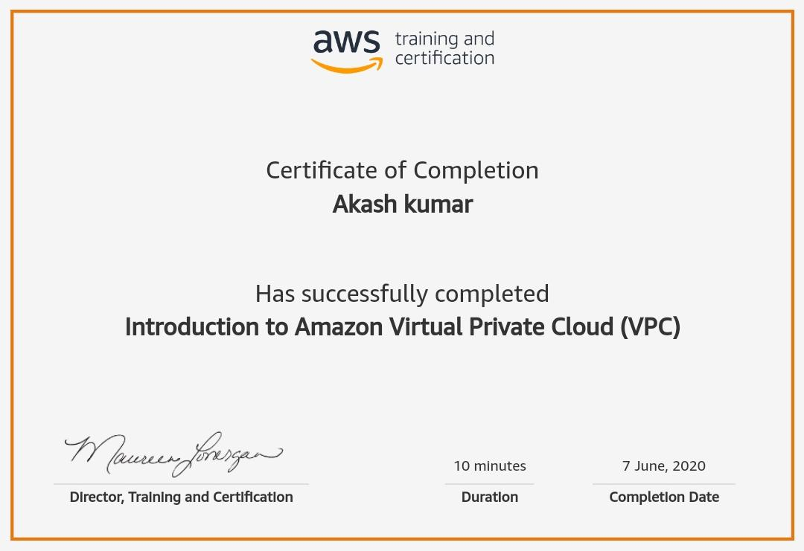

#### WhatsApp Image 2020-06-08 at 6.07.01 PM (2).jpeg

Coding Challenges Details

Program 1 : Write a Program to multiply two floating point numbers

#include<stdio.h>

int main()

{

double a,b,product;

printf("enter two numbers:");

scanf("%lf%lf",&a,&b);

product=a*b;

printf("Product=%.2lf",product);

return 0;

}