**DAILY ONLINE ACTIVITIES SUMMARY**

|  |  |  |  |  |  |  |  |
| --- | --- | --- | --- | --- | --- | --- | --- |
| **Date:** | **08/06/2020** | | | | **Name:** | **AKASH KUMAR S** | |
| **Sem & Sec** | **8thA** | | | | **USN:** | **4AL16CS006** | |
| **Online Test Summary** | | | | | | | |
| **Subject** | | **SMS** | | | | | |
| **Max. Marks** | | **60** | | **Score** | | **60** | |
| **Certification Course Summary** | | | | | | | |
| **Course** | AWS Development Tools Services Overview | | | | | | |
| **Certificate Provider** | | | **Amazon Web Service** | **Duration** | | | **3 hours** |
| **Coding Challenges** | | | | | | | |
| **Problem Statement:** C program to print character without using format specifiers | | | | | | | |
| **Status: COMPLETED** | | | | | | | |
| **Uploaded the report in Github** | | | | **YES** | | | |
| **If yes Repository name** | | | | **Akash_Daily_Progress** | | | |
| **Uploaded the report in slack** | | | | **YES** | | | |

Online Test Details:

Snapshot of test

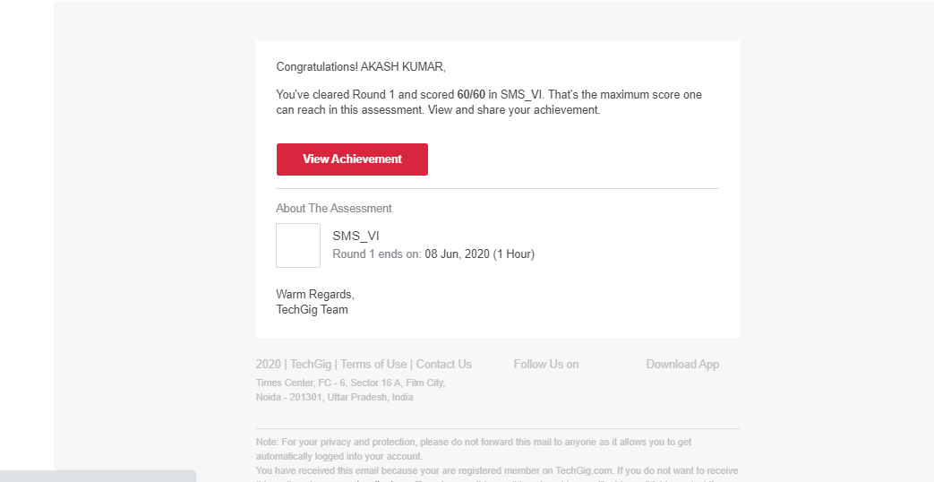

Certification Course Details:

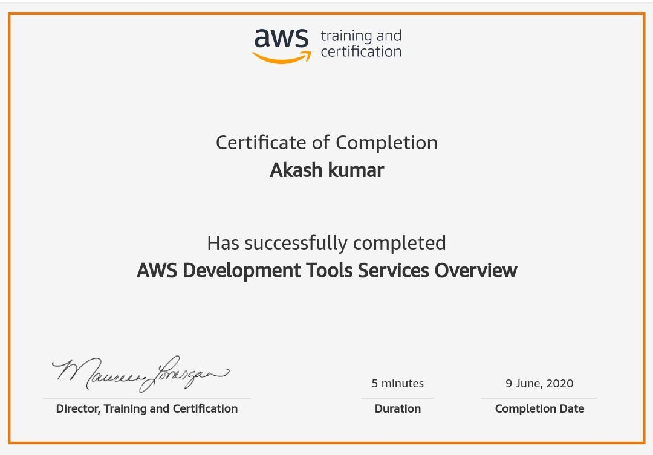

Coding Challenges Details

C program to print character without using format specifiers

#include<stdio.h>

int main()

{

printf("\x41");printf("\n");

printf("\x42");printf("\n");

printf("\x43");printf("\n");

printf("\x44");printf("\n");

return 0;

}