**DAILY ONLINE ACTIVITIES SUMMARY**

|  |  |  |  |  |  |  |  |
| --- | --- | --- | --- | --- | --- | --- | --- |
| **Date:** | **09/06/2020** | | | | **Name:** | **AKASH KUMAR S** | |
| **Sem & Sec** | **8thA** | | | | **USN:** | **4AL16CS006** | |
| **Online Test Summary** | | | | | | | |
| **Subject** | | **BDA** | | | | | |
| **Max. Marks** | | **30** | | **Score** | | **19** | |
| **Certification Course Summary** | | | | | | | |
| **Course** | Introduction to AWS Machine Learning Services | | | | | | |
| **Certificate Provider** | | | **Great learning**  **Academy** | **Duration** | | | **3 hours** |
| **Coding Challenges** | | | | | | | |
| **Problem Statement:** Program->Python Program To Display Powers of 2 Using Anonymous Function # Display the powers of 2 using anonymous function | | | | | | | |
| **Status: COMPLETED** | | | | | | | |
| **Uploaded the report in Github** | | | | **YES** | | | |
| **If yes Repository name** | | | | **Akash_Daily_Progress** | | | |
| **Uploaded the report in slack** | | | | **YES** | | | |

Online Test Details:

Snapshot of test

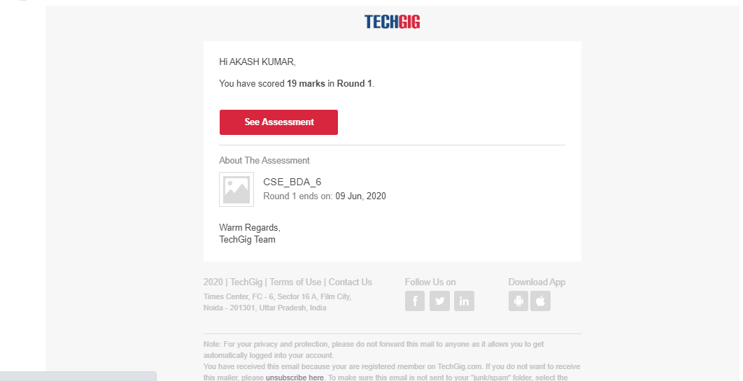

Certification Course Details:

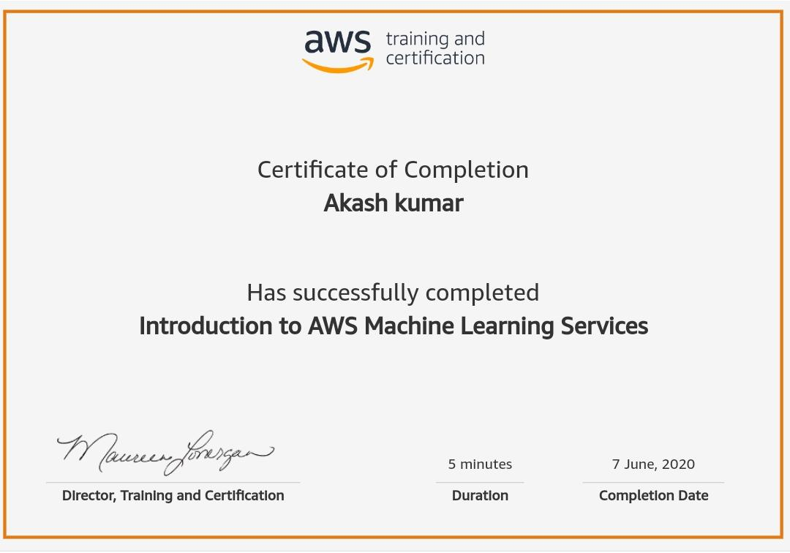

Coding Challenges Details

Program->Python Program To Display Powers of 2 Using Anonymous Function

# Display the powers of 2 using anonymous function

terms = 10

# Uncomment code below to take input from the user

# terms = int(input("How many terms? "))

# use anonymous function

result = list(map(lambda x: 2 ** x, range(terms)))

print("The total terms are:",terms)

fori in range(terms):

print("2 raised to power",i,"is",result[i])