**DAILY ONLINE ACTIVITIES SUMMARY**

|  |  |  |  |  |  |  |  |
| --- | --- | --- | --- | --- | --- | --- | --- |
| **Date:** | **11/06/2020** | | | | **Name:** | **AKASH KUMAR S** | |
| **Sem & Sec** | **8thA** | | | | **USN:** | **4AL16CS006** | |
| **Online Test Summary** | | | | | | | |
| **Subject** | | **SMS** | | | | | |
| **Max. Marks** | | **60** | | **Score** | | **60** | |
| **Certification Course Summary** | | | | | | | |
| **Course** | Step into RPA | | | | | | |
| **Certificate Provider** | | | **Guvi** | **Duration** | | | **3 hours** |
| **Coding Challenges** | | | | | | | |
| **Problem Statement: Python3 program to print the Minimum String length** | | | | | | | |
| **Status: COMPLETED** | | | | | | | |
| **Uploaded the report in Github** | | | | **YES** | | | |
| **If yes Repository name** | | | | **Akash_Daily_Progress** | | | |
| **Uploaded the report in slack** | | | | **YES** | | | |

Online Test Details:

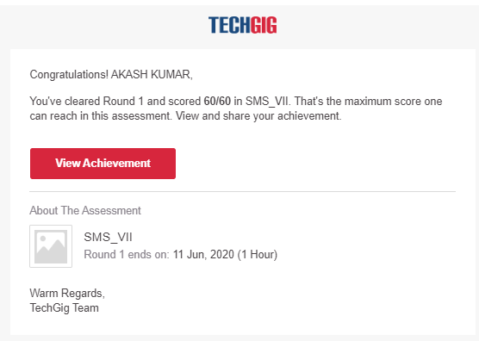

Certification Course Details:

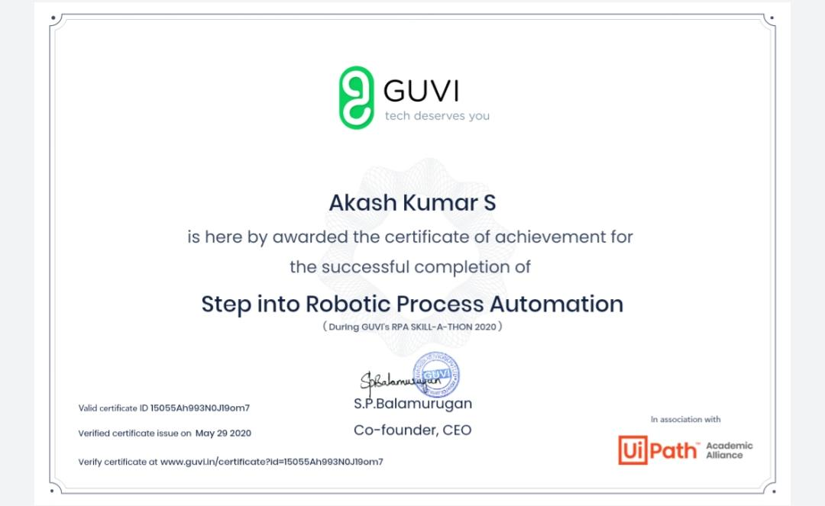

Coding Challenges Details

Program 1 : Python3 program to print the Minimum String length

test_list=['python','java','c++']

print("Theoriginallist:"+str(test_list))

res=min(len(ele)foreleintest_list)

print("Lengthofminimumstringis:"+str(res))