**DAILY ONLINE ACTIVITIES SUMMARY**

|  |  |  |  |  |  |  |  |
| --- | --- | --- | --- | --- | --- | --- | --- |
| **Date:** | **14/06/2020** | | | | **Name:** | **AKASH KUMAR S** | |
| **Sem & Sec** | **8thA** | | | | **USN:** | **4AL16CS006** | |
| **Online Test Summary** | | | | | | | |
| **Subject** | | **---** | | | | | |
| **Max. Marks** | | **---** | | **Score** | | **---** | |
| **Certification Course Summary** | | | | | | | |
| **Course** | Introduction to EC2 Auto Scaling | | | | | | |
| **Certificate Provider** | | | **Amazon Web Service** | **Duration** | | | **3 hours** |
| **Coding Challenges** | | | | | | | |
| **Problem Statement:** Python Program for QuickSort. | | | | | | | |
| **Status: COMPLETED** | | | | | | | |
| **Uploaded the report in Github** | | | | **YES** | | | |
| **If yes Repository name** | | | | **Akash_Daily_Progress** | | | |
| **Uploaded the report in slack** | | | | **YES** | | | |

Online Test Details:

NIL

Certification Course Details:

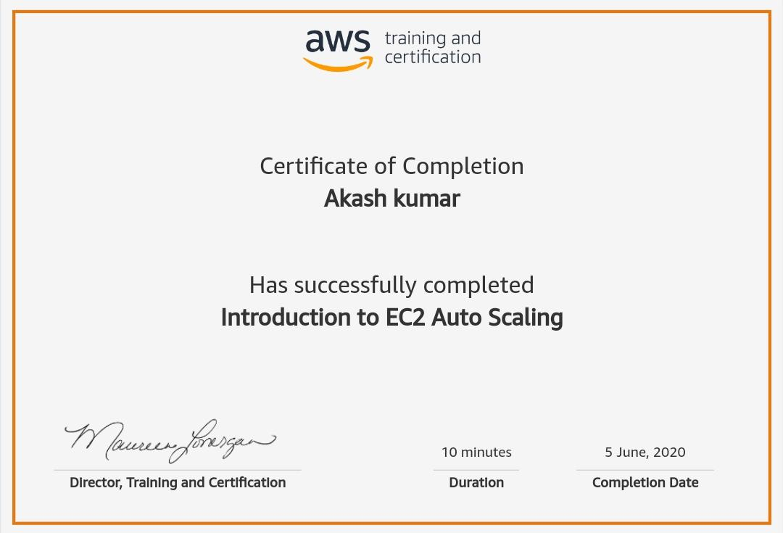

Coding Challenges Details

# Python Program for QuickSort.

def partition(arr,low,high):

i = ( low-1 )

pivot = arr[high]

for j in range(low , high):

if arr[j] <= pivot:

i = i+1

arr[i],arr[j] = arr[j],arr[i]

arr[i+1],arr[high] = arr[high],arr[i+1]

return ( i+1 )

# Function to do Quick sort

def quickSort(arr,low,high):

if low < high:

pi = partition(arr,low,high)

quickSort(arr, low, pi-1)

quickSort(arr, pi+1, high)

arr = [10, 7, 8, 9, 1, 5]

n = len(arr)

quickSort(arr,0,n-1)

print ("Sorted array is:")

for i in range(n):

print ("%d" %arr[i])