**DAILY ONLINE ACTIVITIES SUMMARY**

|  |  |  |  |  |  |  |  |
| --- | --- | --- | --- | --- | --- | --- | --- |
| **Date:** | **15/06/2020** | | | | **Name:** | **AKASH KUMAR S** | |
| **Sem & Sec** | **8thA** | | | | **USN:** | **4AL16CS006** | |
| **Online Test Summary** | | | | | | | |
| **Subject** | | **SMS** | | | | | |
| **Max. Marks** | | **60** | | **Score** | | **Didn’t receive mail** | |
| **Certification Course Summary** | | | | | | | |
| **Course** | AWS Deep Racer | | | | | | |
| **Certificate Provider** | | | **Amazon Web Service** | **Duration** | | | **3 hours** |
| **Coding Challenges** | | | | | | | |
| **Problem Statement: Python Program for simple interest.** | | | | | | | |
| **Status: COMPLETED** | | | | | | | |
| **Uploaded the report in Github** | | | | **YES** | | | |
| **If yes Repository name** | | | | **Akash_Daily_Progress** | | | |
| **Uploaded the report in slack** | | | | **YES** | | | |

Online Test Details:

NIL

Certification Course Details:

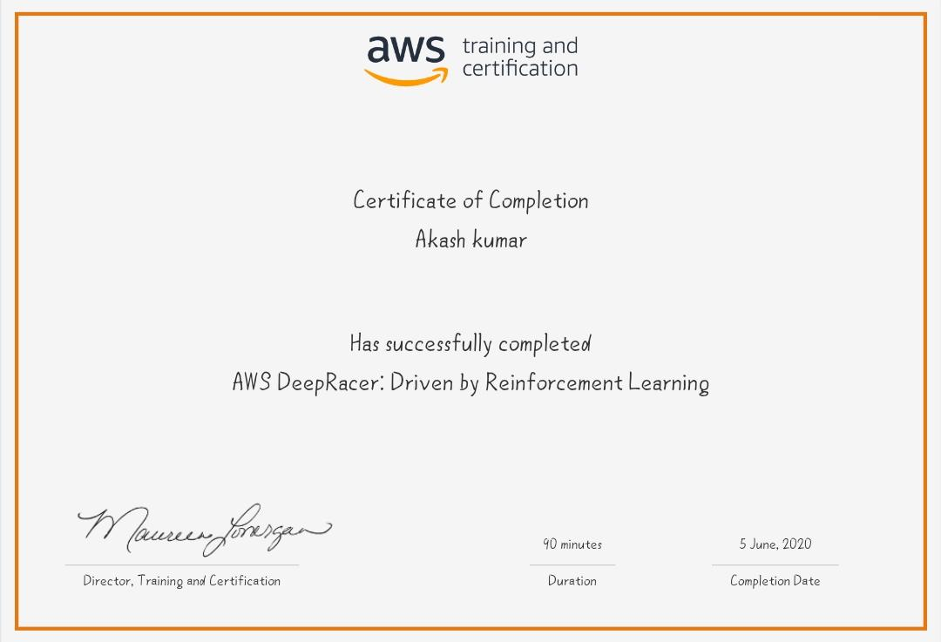

Coding Challenges Details

**Python Program for simple interest**

def simple_interest(p,t,r):

print('The principal is', p)

print('The time period is', t)

print('The rate of interest is',r)

si = (p * t * r)/100

print('The Simple Interest is', si)

return si

simple_interest(8, 6, 8)