**DAILY ONLINE ACTIVITIES SUMMARY**

|  |  |  |  |  |  |  |  |
| --- | --- | --- | --- | --- | --- | --- | --- |
| **Date:** | **19/05/2020** | | | | **Name:** | **AKASH KUMAR S** | |
| **Sem & Sec** | **8thA** | | | | **USN:** | **4AL16CS006** | |
| **Online Test Summary** | | | | | | | |
| **Subject** | | **BDA** | | | | | |
| **Max. Marks** | | **30** | | **Score** | | **21** | |
| **Certification Course Summary** | | | | | | | |
| **Course** | Introduction to Ethical hacking | | | | | | |
| **Certificate Provider** | | | **Great learning**  **Academy** | **Duration** | | | **6 hours** |
| **Coding Challenges** | | | | | | | |
| **Problem Statement:** | | | | | | | |
| **Status: COMPLETED** | | | | | | | |
| **Uploaded the report in Github** | | | | **YES** | | | |
| **If yes Repository name** | | | | **Akash-Repository** | | | |
| **Uploaded the report in slack** | | | | **YES** | | | |

Online Test Details:

Test on module 1

Snapshot of test

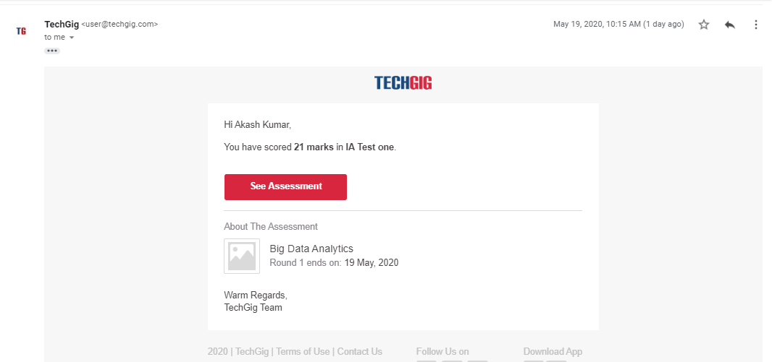

Certification Course Details:

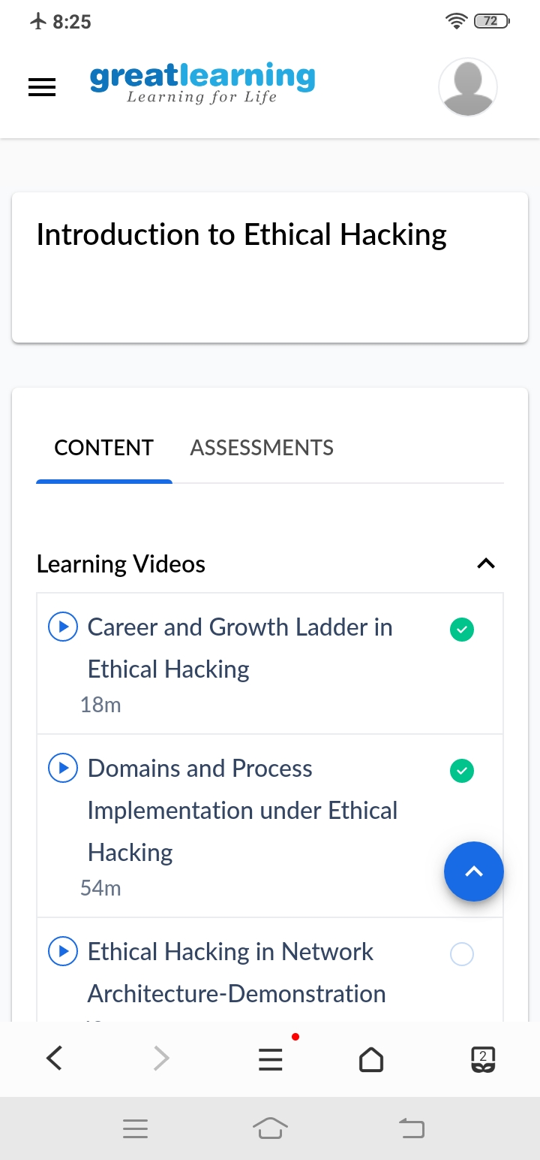

#### Introduction to Ethical Hacking

Coding Challenges Details

**Program1**

**package shortestpalindromeexample.java;**

**import java.util.Scanner;**

**public class ShortestPalindromeDemo {**

**public static String shortestPalindrome(String str) {**

**int x=0;**

**int y=str.length()-1;**

**while(y>=0){**

**if(str.charAt(x)==str.charAt(y)){**

**x++;**

**}**

**y--;**

**}**

**if(x==str.length())**

**return str;**

**String suffix = str.substring(x);**

**String prefix = new StringBuilder(suffix).reverse().toString();**

**String mid = shortestPalindrome(str.substring(0, x));**

**return prefix+mid+suffix;**

**}**

**public static void main(String[] args) {**

**Scanner in = new Scanner(System.in);**

**System.out.println("Enter a String to find out shortest palindrome");**

**String str=in.nextLine();**

**System.out.println("Shortest palindrome of "+str+" is "+shortestPalindrome(str));**

**}**

**Program2**

**import java.util.Stack;**

**// Data Structure to store a linked list node**

**class Node {**

**int data;**

**Node next;**

**Node(int i)**

**{**

**this.data = i;**

**this.next = null;**

**}**

**};**

**class Main**

**{**

**// Function to determine if a given linked list is palindrome or not**

**public static boolean isPalindrome(Node head)**

**{**

**// construct an empty stack**

**Stack<Integer> s = new Stack<>();**

**// push all elements of the linked list into the stack**

**Node node = head;**

**while (node != null) {**

**s.push(node.data);**

**node = node.next;**

**}**

**// traverse the linked list again**

**node = head;**

**while (node != null)**

**{**

**// pop the top element from the stack**

**int top = s.pop();**

**// compare the popped element with current node's data**

**// return false if mismatch happens**

**if (top != node.data) {**

**return false;**

**}**

**// advance to the next node**

**node = node.next;**

**}**

**// we reach here only when the linked list is palindrome**

**return true;**

**}**

**public static void main(String[] args)**

**{**

**Node head = new Node(1);**

**head.next = new Node(2);**

**head.next.next = new Node(3);**

**head.next.next.next = new Node(2);**

**head.next.next.next.next = new Node(1);**

**if (isPalindrome(head)) {**

**System.out.print("Linked List is a palindrome.");**

**} else {**

**System.out.print("Linked List is not a palindrome.");**

**}**

**}**

**}**