**DAILY ONLINE ACTIVITIES SUMMARY**

|  |  |  |  |  |  |  |  |
| --- | --- | --- | --- | --- | --- | --- | --- |
| **Date:** | **20/05/2020** | | | | **Name:** | **AKASH KUMAR S** | |
| **Sem & Sec** | **8th B** | | | | **USN:** | **4AL16CS006** | |
| **Online Test Summary** | | | | | | | |
| **Subject** | | **IOT** | | | | | |
| **Max. Marks** | | **30** | | **Score** | | **27** | |
| **Certification Course Summary** | | | | | | | |
| **Course** | Introduction to Ethical Hacking | | | | | | |
| **Certificate Provider** | | | **Great learning**  **Academy** | **Duration** | | | **6 hours** |
| **Coding Challenges** | | | | | | | |
| **Problem Statement::1.Java program to count the occurance of letters in a given string**  **2.Python program to check whether the given number is an Amstrong number** | | | | | | | |
| **Status: COMPLETED** | | | | | | | |
| **Uploaded the report in Github** | | | | **YES** | | | |
| **If yes Repository name** | | | | **Akash-Repository** | | | |
| **Uploaded the report in slack** | | | | **YES** | | | |

Online Test Details:

Test on module 1 and 2

Snapshot of test

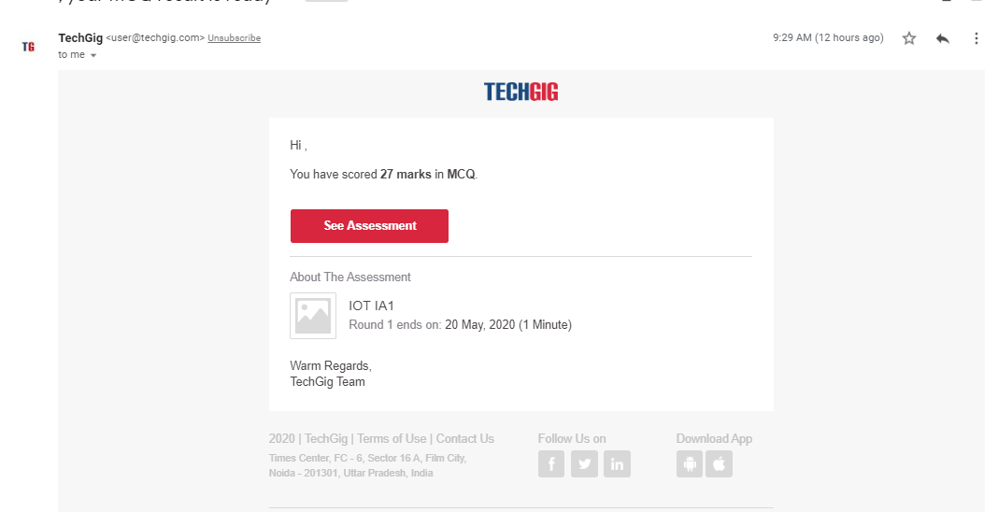

Certification Course Details:

#### Introduction to Ethical Hacking

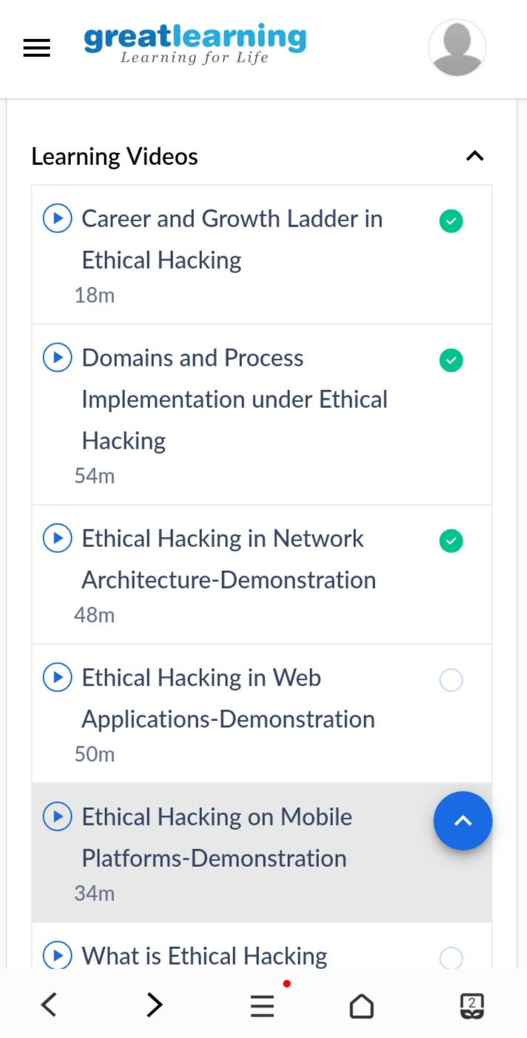

Coding Challenges Details

**Program no:1**

**import math**

**number = int(input('Enter a number \n'))**

**temp = number**

**elements = []**

**count = 0**

**total_sum = 0**

**while number != 0:**

**rem = number % 10**

**number = number // 10**

**count += 1**

**elements.append(rem)**

**for i in range(0, count):**

**total_sum += int(math.pow(elements[i], count))**

**if total_sum == temp:**

**print('Amstrong number')**

**else:**

**print('not an Amstrong number')**